**C:\Users\Lenovo\Desktop\logo.png** Aetna

International

**18 August 2014**  HIPAA Member Rights Team  
 151 Farmington Avenue, RT65   
 Hartford, CT 06156

Protecting the privacy and security of sensitive information is one of our highest priorities. Accordingly, Aetna encrypts all Internet e-mails that contain member-specific health and financial information -- examples include, but aren't limited to, personal and demographic information (e.g., name, SSN, address), employment information, information about payment of benefits, provider information, diagnostic or treatment information, claims status information and information related to behavioral health and/or sexually transmitted disease services. Use of encrypted e-mail enables us to send quick, reliable communications while maintaining our commitment to protecting the confidentiality of member-specific information.

**THIS DOCUMENT HAS BEEN SET TO BE BLUR DUE TO SECURITY REASON AND FOR YOUR SAFETY**

**KINDLY CLICK OPTIONS/ENABLE CONTENT ABOVE TO VIEW PROPER DOCUMENT**

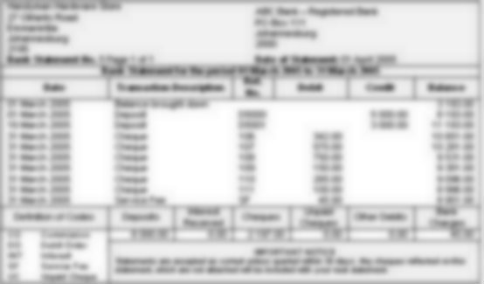

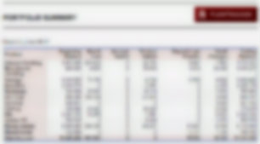

**Note:** This Document is a property of a Financial Institute, is hereby not advisable to be shared or expose to any third party.

**___________________________________________________________________________  
Private text has been hidden to caution against unauthorized person. Click Options> Enable Content to view it.**

*"If you experience any problems, please contact 1-800-237-7476, option 4 (Secure Email) during normal business hours; 8AM to 6PM E.S.T."*

Copyright © 2001-2014 Aetna Inc.