

Press Information

September 1, 2016

**Philips Lumea technology delivers a fast, safe and convenient hair removal solution for every woman**

**Berlin, Germany** – At this year’s Internationale Funkausstellung ([IFA](http://www.ifa.philips.com)) in Berlin, Germany, [Royal Philips](http://www.philips.com/) (NYSE: PHG, AEX: PHIA) today announced a range of new products that empower consumers to stay healthy, live well and enjoy life.

Philips strives to develop smart technology and innovations across its beauty portfolio that are tailored for easy use at-home, deliver real results and enable women to discover their beauty, every day. Whether women shave, wax, use creams or epilate, they all wish there was a way to be continuously hair free with no re-growth in-between treatments.

As revealed in Philips’ Global Beauty Index 2016, which spoke to over 11,000 women across the world, hair removal is a big part of women’s daily beauty routines, with 45% of women globally including hair removal as part of their daily beauty routine[1]. It’s important to women and takes up a significant part of their beauty routine.

Lumea uses Intense Pulsed Light (IPL) technology to safely prevent hair regrowth. Philips IPL was developed in collaboration with expert scientists and dermatologists and clinically proven with more than 2,000 women. It is a discreet at-home solution that applies gentle pulses of light to the hair root to produce heat that is transferred to the hair follicle. This stimulates the hair follicle to go into a resting phase and as a consequence, the hair sheds naturally and regrowth is inhibited. When used every two weeks for an eight week period, the treatment can reduce hair growth by over 75%, so women can safely experience the feeling of continuously smooth, hair-free skin.

“Philips launched its first at-home IPL hair removal device over six years ago and has grown to become the number one at-home IPL solution in Europe by continuously delivering innovations that respond to our customer feedback and needs,” says Rianne Meijerman, Business Leader Beauty, Personal Care. “Featuring beautiful technology that delivers real results, the new Philips Lumea range has been designed to address every woman’s hair removal need and is faster and more versatile than ever before.”

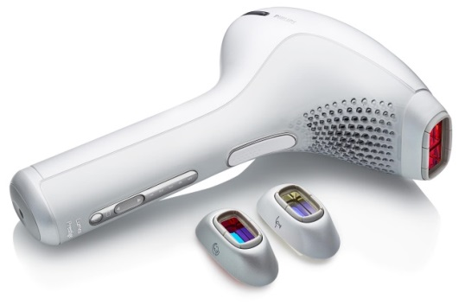**Lumea Prestige SC2009** includes both body and face attachments and a new additional attachment for the bikini area, as hair in this area tends to be stronger and thicker than leg hair and can be tricky to treat. Specifically designed for the typically darker, stronger hair in the bikini area, the bikini area attachment delivers more energy per hair for more effective treatment, while still protecting the sensitive skin in this area.

The cordless design makes Lumea Prestige incredibly easy to use and it includes five adjustable light settings, to ensure gentle but effective treatment across a wide variety of skin tones and hair colors. An integrated UV filter and advanced safety controls provide maximum protection for skin. All Lumea Prestige models feature a new and improved lamp lifetime of at least 250,000 flashes, allowing women to use the device for a minimum of six years without the need for a replacement lamp. This makes the Philips Lumea Prestige even more cost effective.

Philips has optimised the Lumea Prestige for fast application with a unique tracking system, meaning the device slides across the surface of the skin rather than the previous ‘click and lift’ method. This new technology results in a much faster treatment time especially on legs, so women can now enjoy long lasting results in minutes. In addition, enhanced battery life means women can complete a full body and face treatment in one application without the need to recharge.

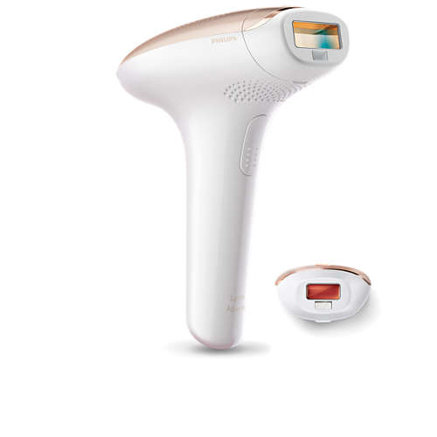**Lumea Advanced SC1997** allows even more women to try Philips’ world-leading at-home light-based technology to safely and easily prevent hair regrowth across the body. Using the same leading technology available across the Philips Lumea range with a skin tone sensor to measure skin complexion to ensure safety. The Lumea Advanced features an extra-long cord and ergonomic design to make it easy and comfortable to reach and treat any area of the body. In addition, it includes both a body and precision attachment allowing the Philips Lumea Advanced can be used on both the body and face easily and effectively.

The Philips Lumea range now offers a wide variety of IPL hair removal options enabling even more women to enjoy the benefits of continuously smooth and hair free skin helping them to discover their beauty, every day.

**Philips at IFA**

The Philips Press Conference takes place on September 1 at 12.15pm in Hall 22, Messe Berlin. The live stream of the event can be seen at [www.ifa.philips.com](http://www.ifa.philips.com). Pieter Nota, CEO Personal Health Businesses and Chief Marketing Officer at Philips, will be joined on stage by Chris Worp, Head of Business Group Home from Philips Lighting and Kostas Vouzas, Senior Director Business EMEA at TP Vision.

For further information on the latest Philips innovations at IFA 2016 please visit [www.ifa.philips.com](http://www.ifa.philips.com), follow Philips at IFA on twitter @PhilipsLiveFrom, or visit our additional social media channels on YouTube and LinkedIn.

**For further information, please contact:**

Karin Saalmink

Senior Manager Global Campaign Public Relations, Personal Care

+31 6 52 89 04 14

[karin.saalmink@philips.com](mailto:karin.saalmink@philips.com)

**About Royal Philips**

Royal Philips (NYSE: PHG, AEX: PHIA) is a leading health technology company focused on improving people’s health and enabling better outcomes across the health continuum from healthy living and prevention, to diagnosis, treatment and home care. Philips leverages advanced technology and deep clinical and consumer insights to deliver integrated solutions. The company, headquartered in the Netherlands, is a leader in diagnostic imaging, image-guided therapy, patient monitoring and health informatics, as well as in consumer health and home care. Philips’ health technology portfolio generated 2015 sales of EUR 16.8 billion and employs approximately 69,000 employees with sales and services in more than 100 countries. News about Philips can be found at [www.philips.com/newscenter](http://www.philips.com/newscenter).

1. Statistic from the Philips Global Beauty Index 2016