

**UNIVERSITI TUNKU ABDUL RAHMAN**

Name: Ong Kar Heing

Student No: 1506881

Title: Game Research Mock Proposal

Year: Year 2 Semester 1, 2016

Faculty: Faculty of Creative Industries

Subject: UJMM2113 Games & Society

Course: Bachelor of Arts (Hons) Game Design

Lecturer: Tai Liang Kwang

**Evaluation on VR Technologies in Educational games and the Classroom Learning Experience**

**Introduction**

Virtual Reality rapidly growing in popularity all the world especially in educational games. (VR) is an immersive experience that bring a virtual real or imagined environment and allows users to interact by using head mounted display and data-gloves in order to let the player to interact in the virtual world.

This research study is mainly focus on classroom learning experience which will affect player after playing VR. I believe this methodology will clearly certify that studying virtual reality in education games will help me to understand the process learning through the research, knowledge, and technologies. [Try to write in a third-person’s style]

Educational games are being developed for hardware ranging from personal computers to the contemporary VR technologies ~~has develop from Pc to VR technology~~. ~~It had been created as a form of software and hardware interactivity.~~ Many researchers in the pedagogic field still see potential in interactive software as effective tools to enrich the students’ learning experience, despite a lot of experimentation and discovery of various factors to design the most effective software. Virtual Reality has been use as an external educational material for student to learn new knowledge. It also provide military training, education, law enforcement and medical surgeon training. There are different ways to explore the VR world through this research [cite]. It can be capture by 360 degree for user experiences.

It is a new education learning technology for children and adults alike. VR had became one of the entertainment, health care and education gadget for students. After years of decades of popularity, VR may brought positive and negative factors towards classroom experiences. Through this research, it is to identify and evaluate the factors that cause in VR education games.

Mihaly had created a flow theory. It is about how the player enjoy the game flow. Flow happen that after student had experiences playing game. It also create chances of learning through games. [If you intend to emphasize on this theory, put this under a later section]

Currently in 2016, VR has become one of the top technology advance in education game training. Tablets, phones and pad has oculus interactive touch mode. [cite]

**Problem Statement**

Long term of motivation and addiction may cause ergonomic factors happen due to the accident while playing VR. Addiction and motivation psychology also will affect player to lose their way back to reality world. This main research is to identify the problem and find out the final result among student experiences through game flow. Will student prefer play VR for their course training or study theory through class will be a better issues for them in future? How game flow psychology will affect student to play in classroom? Will it will be better if VR as a main education learning material sources. [I’m somewhat confused on what exactly, on the theoretic aspect, what your research focus is]

**Research Objective**

This research is to find out how the student feel after experience their medical surgery through VR [Now, I’m more confused; is your research on student learning experience or medical training?]. ~~P~~ The popularity of VR Technology in educational games have been improve with advance technology, it has become part of the VR Classroom Learning material experiences. This research is focus more on user experiences and the factors involves in VR classroom learning. It is to increase our knowledge and to help game developer for future technology study.

This is one of the research method to analyze and understand what are the student like play it in VR. Why do lecturer give students a chance to experiences VR? Is the VR really give student a good education learning or is that any factor that may cause student to play VR in classroom? How game flow affect medical student for training through VR technology? Is it a best material for medical student use it as a sub medical training in the classroom?

**Scope of Study**

The purpose of this research is to let medical student [if this is your focus, this topic should be introduced as part of the title and introduction and problem statement clearly, with more referred papers about these subjects] train under Surgery Simulation. It also help us to identify how the game really train the medical student and learn medical knowledge while playing VR through this experiment. To test how game flow bring to the training in education game. Besides attend class in learning medical surgery, student can learn knowledge fast by using VR technology.

**Significant of Study**

It is to keep as a data collection record of the experiment for future VR improvement. Lastly, it is to experiment the factor impacts that may cause by VR. It helps game developer to enhance the technology product in future.

Currently VR is one of the material which can be adapt into education material for future. Medical training facilities do not have enough resources and through this surgery simulator. It helps medical students to be aware and save patient life not only in real life but also based on this training. It can provides medical student a suitable place for surgery training and help to develop more different types of medical game through this training which bring beneficial to the society for future

**Literature Review**

**~~Research Article 1:~~Video Game Research in Cognitive and Education Science**

The article of that I references for my topic is "Video Game Research in Cognitive and Education Science". This article explain more about video games in education Science. It helps researches to understand the effects, benefit of playing video games in education.

Until now, video game is still the best tools for education because it motivate students and adults to play. It can help them to and learn some vocabulary words that you would not learn in daily life.

**~~Research Article 2:~~Immersion vs. Interactivity: Virtual Reality and Literacy Theory**

Based on this article research of Virtual Reality(VR). VR enables player to explore reality and brought immersion and interactivity gameplay. Sheridan stated that to feel immersed the user must be able to move around the virtual space and to apprehend it under various points of view.

This article do evaluate the relationship between VR and immersion with interactivity. It has explained detail about what is VR and how it interact with player. VR contain both immersion and interactivity in gameplay. Through this article, it does not show what are methodology that they apply in this research. But they provide the detail research about VR based on the others researches theory.

It also contribute some of the relevant research based on the philosopher and the theory that they research. It is a good references of VR. It helps me build up new knowledges through this research.

**~~Research Article:~~ The Concept of FLOW**

This article is research about how flow bring impact on human. The flow theory is based on Mihaly Flow and definition of flow. Experiencing flow will allow a person want to play more because of the rewards, your level skill and the factor causes player to continue motivated or not. It helps me to understand more about Mihaly theory. Emotional feeling may cause the impact of game flow. [How does psychological flow contribute to your research?]

**Relevant Topics**

* "Video Game Research in Cognitive and Education Science" by Cyril Rebetez, Mireille Betrancourt
* Evaluation of Neuroanatomical Training using 3D Visual Reality Model by Danielle N BREWER, Timothy D WILSON, ROY EAGLESON and Sandrine DE RIBAUPIERRE

### "Immersion vs. Interactivity: Virtual Reality and Literacy Theory" by Marie- Laure Ryan

* "Immersion"by Carl Therrien
* "The Concept of Flow" by Jeanne Nakamura & Mihaly Csikszentmihalyi
* "Assessing the Core Elements Of Gaming" experiences by Eduardo H. Calvillo-Gamez, Paul Cairns and Anna L.Cox. [This feels like these should be put in Bibibliographies/Reference section]
* "The benefits of Playing Video Games" by Isabela Granic, Adam Lobel and Rutger C.M.E.Engels
* "The educational benefits of videogames" by Mark Griffiths
* "Introduction to Virtual Reality" Gilson Giraldi, Rodrigo Silva, Jauvane C.de Oliveira
* "Video Games For Entertainment and Education by Uta Ritterfeld and Rene Weber

**Methodology**

**Sampling Methods**

Before the game start, I will give student a survey to fill up and to make a record of electroencephalogram (EEG) before they play. EEG will detect the student emotion during experiences VR. This is to compare the differences between before and after they played the game for our experiments. Brain flow [what is brain flow?] will told us about how their brain react now and what make them to have motivation through playing Medical training Simulator as a training and experimental material.

For this experiments, I will invite 5 medical female students and 5 medical male students to participate in the classroom [from where?]. The participants from medical university. Interview and write down all their personal info for our data collection. All of the participants must measure their heart beat before they participate this experiments to test for before and after they play VR "Medical training Simulator" in experiments.

Medical students already gain some basic knowledge about medical. So the medical students who participate this experiments must have knowledge through surgery. This experiment estimates for a week to achieve. It is to measure the flow, whether the student will feel bored after play the same medical game for a week or it is the training still motivated them to play continually.

They need to wear electroencephalogram (EEG) to test the brain reaction and brain message flow. EEg can test the emotion and their thoughts, behavior while playing game. Besides that, they also need to wear VR headset and the touch gloves in order for them to play and interact. Students are encouraged to take part as a active role play for their educational learning material.

"Medical training Simulator [cite this software if it’s an existing software]" is one of the VR educational games. The duration of playing this game is around 2 ~~hour~~ to 3 hours. One of the scenario of this game is about a man who got into accident and it ends up to emergency hospital. So, the student required to do surgery in order to save him. The medical student can do anything in the game world. So, student are not necessary to save a patient in the game. They can do anything that they want because of emergent gameplay. Mistakes can made a through this surgery training but the experiment is to test the game flow and training them through let virtual world. I will record the video VR of the medical student play and analyze the behavior and emotion

After all students have experiences the VR game, they need to fill up ~~the~~ another survey form as a record. The electroencephalogram (EEG) will record the student's brain flow until the game end. Memory game will be tested as a mini test for medical students. It is to proof whether they can remember the content of the training or they will just forgot what they had experiences.

Before the day of activity start, students need to pass up their medical health report as a proof for our references and they need to interview and record their profile information. Survey form will be given to student after and before they experience the VR through. They need to write down emotion and their feeling for that one week experiment. So we can know the improvement of the experiments.

[As in students’’ or the patients’? ] Heart Beat will be record for everyday. Every students must do examine twice a day as a research sample. This is a quantitative experiments due to the calculation of the heart beat, and electroencephalogram (EEG) which may cause while during playing VR in classroom.

Through this quantitative method, I can know the percentage chances that might affect the brain flow and heart beat which impact them while playing VR in classroom. All the experiment records as a sample, and it will be keep as data collection for final analysis. Analysis will be provided after the student experiments had ended.

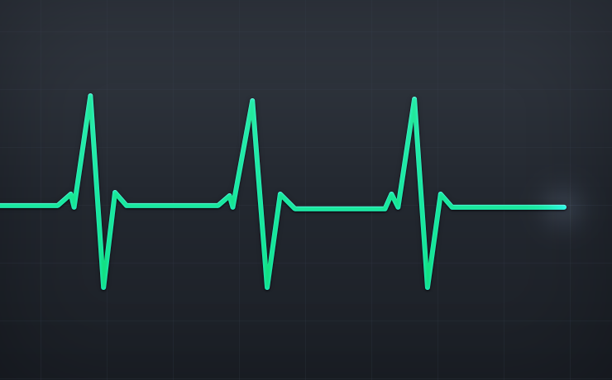

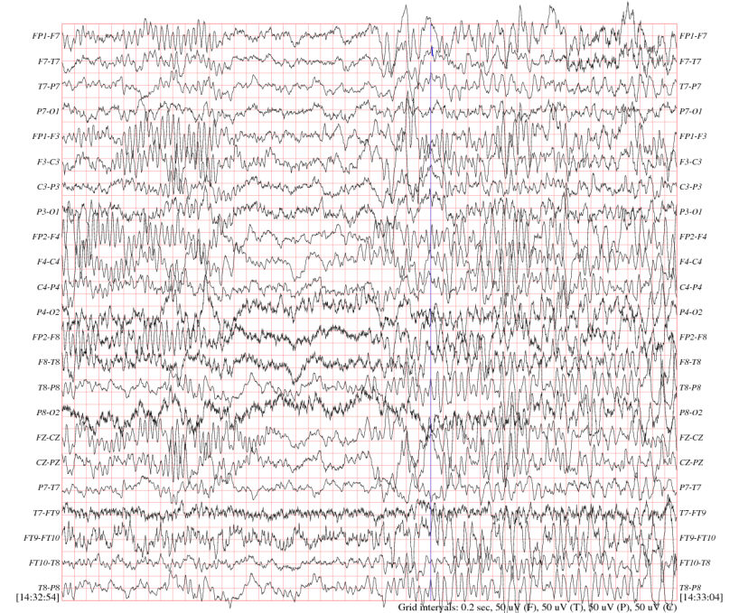

**Data Collection Methods**

After the data collection has been completed, statistics analysis will be created to show the brain flow, heart beat that will affect medical student behavior movement in VR. Data must be deals with number and variable ratios. Observant student through their emotion behavior. Students will be group through the same range and analyze. There will be calculation to conduct for the heart beat, brain wave which affect the game flow.

[I do not get why you need to monitor the testers’ heart beats to determine the players’ learning attention]

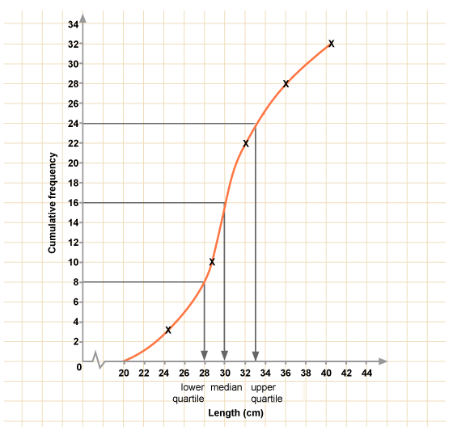

It combine all the data and draw the graph to find out the game flow and identify the problem by using calculative systems. Evaluate and draw a cumulative frequency graph for analysis. Flow can be evaluate on this stage. After that, the whole experiments will be ended after the result and factor has been examine.

[I seriously having problems understanding on what you intend to study; I get that you want to test VR technologies, but I would suggest to focus on what type of VR tech; also, are you focusing on learning experience or medical student training performances; Psychological flow [by Mihaly] implies the mental state of the person when being immersed in a favored activity, but I still fail to see on how flow help in the students’ learning performance?]

**References**

Wolf, Mark J P., and Bernard Perron, eds. *The Routledge Companion to Video Game Studies*. Routledge Companions. Hoboken: Routledge, 2014. Accessed December 4, 2016. <http://public.eblib.com/choice/publicfullrecord.aspx?p=1588622>.

Marie-Laure Ryan - Immersion vs. Interactivity: Virtual Reality and Literary Theory - Postmodern Culture 5:1

Kotler, S. (2014, January 15). Legal heroin: Is virtual reality our next hard drug. *Forbes*. Retrieved from http://www.forbes.com/sites/stevenkotler/2014/01/15/legal-heroin-is-virtual-reality-our-next-hard-drug/#2e10ff637472

Vernon, M. (2016, March 6). What’s to fear from virtual reality? Retrieved December 4, 2016, from http://www.markvernon.com/friendshiponline/dotclear/index.php?post/2016/03/06/What-s-to-fear-from-virtual-reality

Davis, N. (2016, March 19). Long-term effects of virtual reality use need more research, say scientists. *The Guardian*. Retrieved from https://www.theguardian.com/technology/2016/mar/19/long-term-effects-of-virtual-reality-use-need-more-research-say-scientists

Abrosimova, K. (2014, September 7). 5 ways virtual reality will change education. Retrieved December 4, 2016, from http://www.hypergridbusiness.com/2014/09/5-ways-virtual-reality-will-change-education/

Walz, Steffen P., and Sebastian Deterding, eds. *The Gameful World: Approaches, Issues, Applications*. Cambridge, Massachusetts: The MIT Press, 2014. Accessed December 4, 2016.

Egenfeldt-Nielsen, Simon, Jonas Heide Smith, and Susana Pajares Tosca. *Understanding Video Games: The Essential Introduction*. third ed. New York: Routledge, 2016.

Kolb, David A. 1984. Experiential Learning: Experience as the Source of Learning and Development. Prentice-Hall, Inc., Englewood Cliffs, N.J.

Flow (Csíkszentmihályi) - Learning Theories. (2016). Retrieved December 05, 2016, from https://www.learning-theories.com/flow-csikszentmihalyi.html

Carlton. Retrieved December 05, 2016, from http://playwithlearning.com/2012/01/26/experiential-learning-and-games/