**Roast Grissingham Duck, caramelized carrot puree, roast carrots and fig jus**

**By Sam Dunleavy**

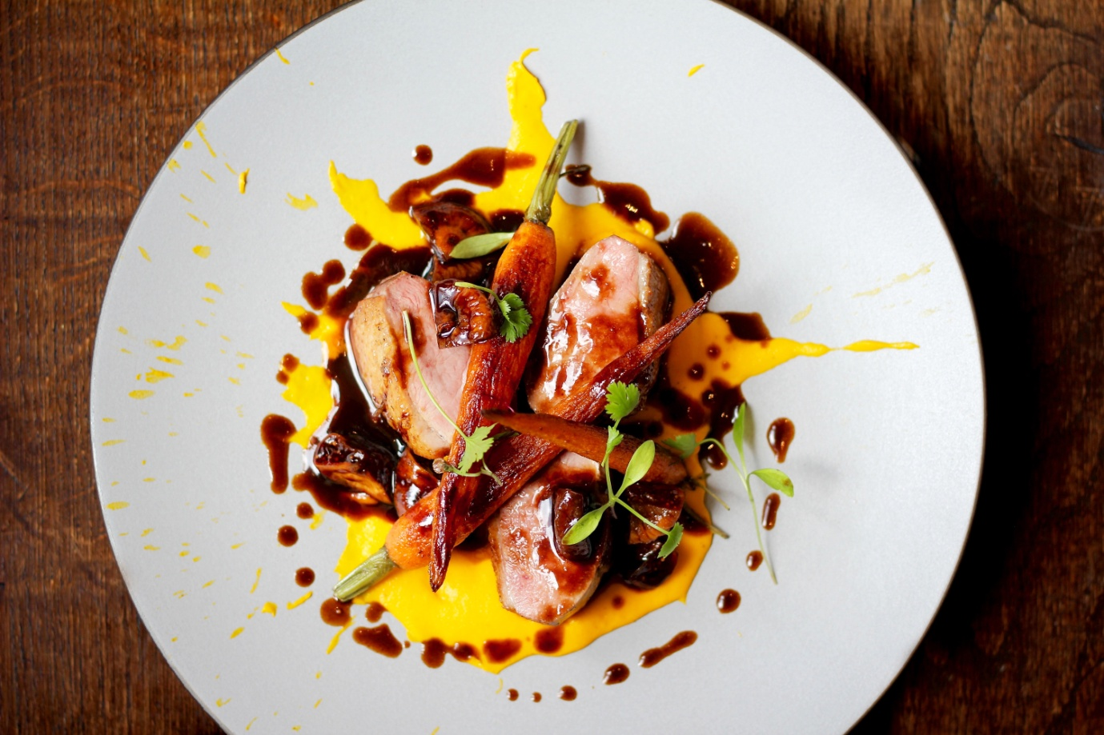

**Ingredients**

Duck breast - 4

Large carrots - 500g

Baby carrots - 3 per person

Butter - 150g

Dried figs - 100g

Beef stock 1lt

Salt and pepper

Corriander cress to garnish

**Method**

1. **Caramelized Carrot puree –** top and tail and peel your large carrots and then roughtly chop the carrots and place them in a saucpan and cover with water and add a pinch off salt
2. Cook the carrots till soft about 30 to 40 minutes
3. Whilst the carrots are cooking we can make our brown butter. So add the **butter** to a sauce pan a place on a stove and what we are looking for is the milk to seperate from the butter and we remove this then we wait for the golden liquid to turn brown and smell a little nutty.
4. Once the carrots are cooked drain thenm from the cooking liquid keeping some to puree the carrots
5. Put your cooked carrots in a blender with your brown butter and blend add a little bit of the carrot cooking liquid if your puree is to thick (should be easy spreadable ) check if puree needs salt
6. **Fig jus** – reduce 1lt of beef stock to 300ml then add your dried figs
7. **Roast duck** – remove your duck breast from the fridge 20 minutes before your cooking check to see if you need to trim any of the fat from the duck. Season your duck breasts with salt and pepper then in a hot pan place your ducks cooking on each side for 2 minutes then cooking in an oven at 170 degrees for 5 minutes then let rest for 5 minutes for a prerfect pink duck
8. Whist duck is resting cook your **baby carrots** in the same pan you cooked the duck constantly moving and getting nice golden colour

