COMPONENT A: MAYOR’S FORWARD



CLLR JP PHAKATHI

HER WORSHIP THE MAYOR

I have the honour of submitting the Report of the Dannhauser Municipality for the period starting from 1 July 2013 to 30 June 2014. The report has been prepared in full compliance of the 121 of the MFMA. Whilst the Annual Report reflect the achievements of the Municipality, it also highlights some challenges we had to overcome to effectively deliver the services at localised levels. I therefore table this report in accordance and compliance with section 121 (1) of the Municipal Finance Management Act No. 56y of 2003 and Section46 of the Municipal Systems Act No. 32 of 2000.

As part of our development priorities for the year in question, we committed to enhance basic service delivery, stimulate economic growth through impact driven LED initiatives, provide public amenities, enhance public participation and strive for financial viability. Hence we have managed to increase and accelerate our expenditure on infrastructure improvement, which included access roads, community halls, electricity, town improvement and industrial area upgrading. In the process we have created a number of job opportunities for local communities, even though some remained temporary.

We have managed to achieve clean audit opinion for the 2013/2014 financial year.

The municipality has managed to deliver houses in the area and further partnered with the local mining company Shanduka who has contributed an amount of R10 million towards the housing project. The municipality is proud of its effort to eradicate electricity backlog in Dannhauser**.**

On the economic development front, we have commenced with industrial Revitalization programme that seeks to attract investors and industries to the area. Council is confident that amount of work achieved in 2013/14 financial year will surely serve as a base of improved and bigger interventions in the future.

I would like to thank Dannhauser communities for believing in us, participating in our community programmes, providing constructive criticisms, their willingness to be part of the collective and for taking care of their assets and investments. To my fellow councillors, I am thrilled to see the level of commitment displayed towards assisting our communities. Finally I thank the municipal management and staff for their effective executive of council’s development agenda.

**Her Worship, the Mayor Councillor J.P Phakathi**

COMPONENT B: EXECUTIVE SUMMARY

MUNICIPAL MANAGER’S OVERVIEW



MR NKOSI WB

MUNICIPAL MANAGER

The responsible interpretation of political mandate and its translation therefore to a strategic framework and guideline of Council has poved to be a cornerstone of our success. The administrative wing of Council has tried unabated to achieve the set targets with the given limited capacity and resources.

The municipality has enjoyed the guidance of key national priorities that the enabled council to assess each priority and attempt to find solution that will result in good governance, institutional transformation, improved financial viability, broad based economic development and accelerated infrastructure investment. The institutional development aspect has for the better part of the financial year undermined municipal capacity to realise its development objectives. The critical positions such as that of a Chief Financial Officer and Director Community Services were filled towards the end of the financial year. Prior to this intervention, Council relied heavily on consultants. Nevertheless, the appointment of these senior officials and other junior officials on critical positions enabled he council to expedite the implementation of the programme and meet the basic needs of our community.

Through the support of external services provider the Council has managed to expedite implementation of key infrastructure projects and accelerate the capital expenditure for the year in question. To this end, the Municipal Infrastructure Grant was spent on time, electrification grant from Cogta was also utilised effectively and timeously, thus benefiting the masses who needed it the most.

The concerted effort exerted in 2013/14 has encouraged the council to excel and do more during the next financial year. I am therefore grateful to Dannhauser municipal management and staff members who have made it possible for council to make a positive impact to local communities. The unity, commitment and dedication that prevailed during the year in question will remain a fundamental building block for Dannhauser future’ growth and development. The latter was indicative of the clean audit achieved by the municipality. Thus building the confidence of the community in particular and government and investors in general.

**Mr. W. B. Nkosi Municipal Manager**

**1.2 MUNICIPAL FUNCTIONS, POPULATION AND ENVIRONMENTAL OVERVIEW**

The Dannhauser 2013/14 Annual Report is submitted within the legal framework the Municipal Management Act 56 of 2003, Section 121(1) an Municipal Systems Act 32 of 2000, Section 46 which requires municipalities and its entities, where applicable, to prepare annual reports and annual performance reports for the year under review.

The purpose of this report is to provide information required to assess the municipality’s performance primarily on service delivery and organisational development and management against the budget for the year under review. While this report provides a vivid reflective of the extent to which municipal performance goals and objectives were achieved, it also gives account on the challenges that were experienced in pursuit thereof.

**OVERVIEW**

Dannhauser local municipality is located in the north-west corner of KwaZulu Natal Province and is one of three local municipality within the Amajuba District Municipality. It is the smallest municipality within the District Municipality and cover an area of approximately1516 squares kilometres. The main towns are Dannhauser, Hattingspruit, inverness, Kilegethe, Klipbank, Milford, Normandien, Nyanyadu, Rutland, Tendeka, Witteklip.

Located along the southern boundary of the Amajuba District Municipality, it adjoins Newcastle and Emadlngeni Local Municipality to the east and Emnambithi to the south.

**Map 1: Location of Dannhauser Municipality located in Amajuba District**

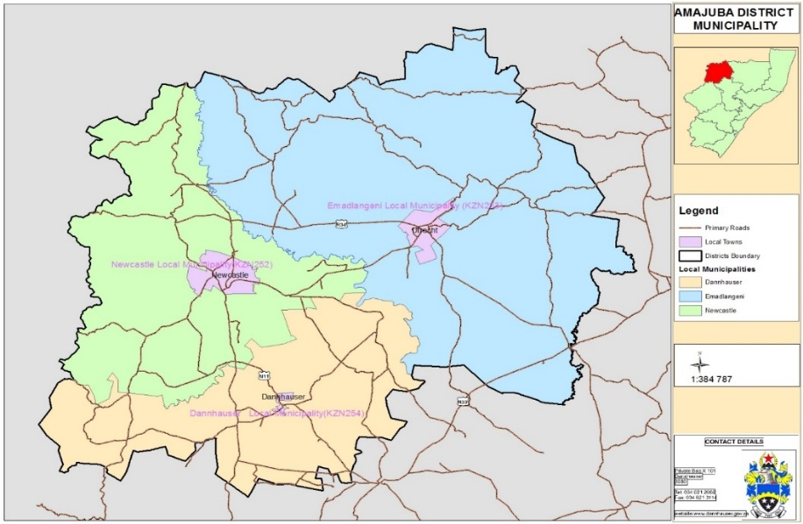

**Map 2: Dannhauser Base Map**

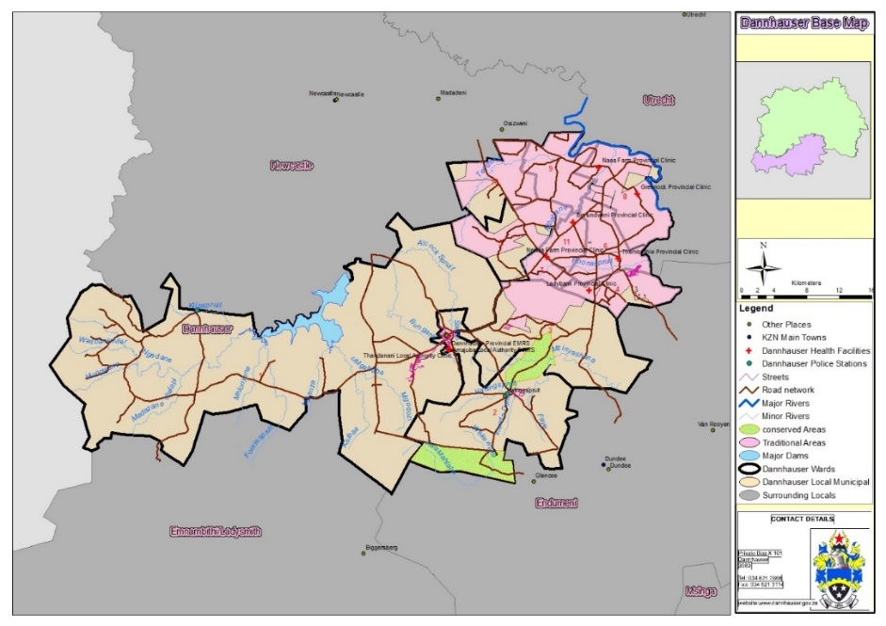

The town of Dannhauser is located midway between Durban and Johannesburg on the main railway line, about eight kilometres off the national road between the two cities. Some of the largest coal-producing mines in KwaZulu Natal surround it. Numerous rivers flow through the municipal area, the most important being the Ngagane and uMzinyathi Rivers and there are scenic landscape in the western portion of the municipality.

Despite its strategic location, Dannhauser functions as a small rural service centre (providing commercial and service facilities and agricultural industries and services), and is not a large employment generator. Residents of the municipal area rely on the larger urban centres of Dundee and Newcastle for employment opportunities and higher order goods and services. Mining sector also provides employment, which is another contributing factor in terms of the economic development to the district growth

**Graph 1: Population by ward**

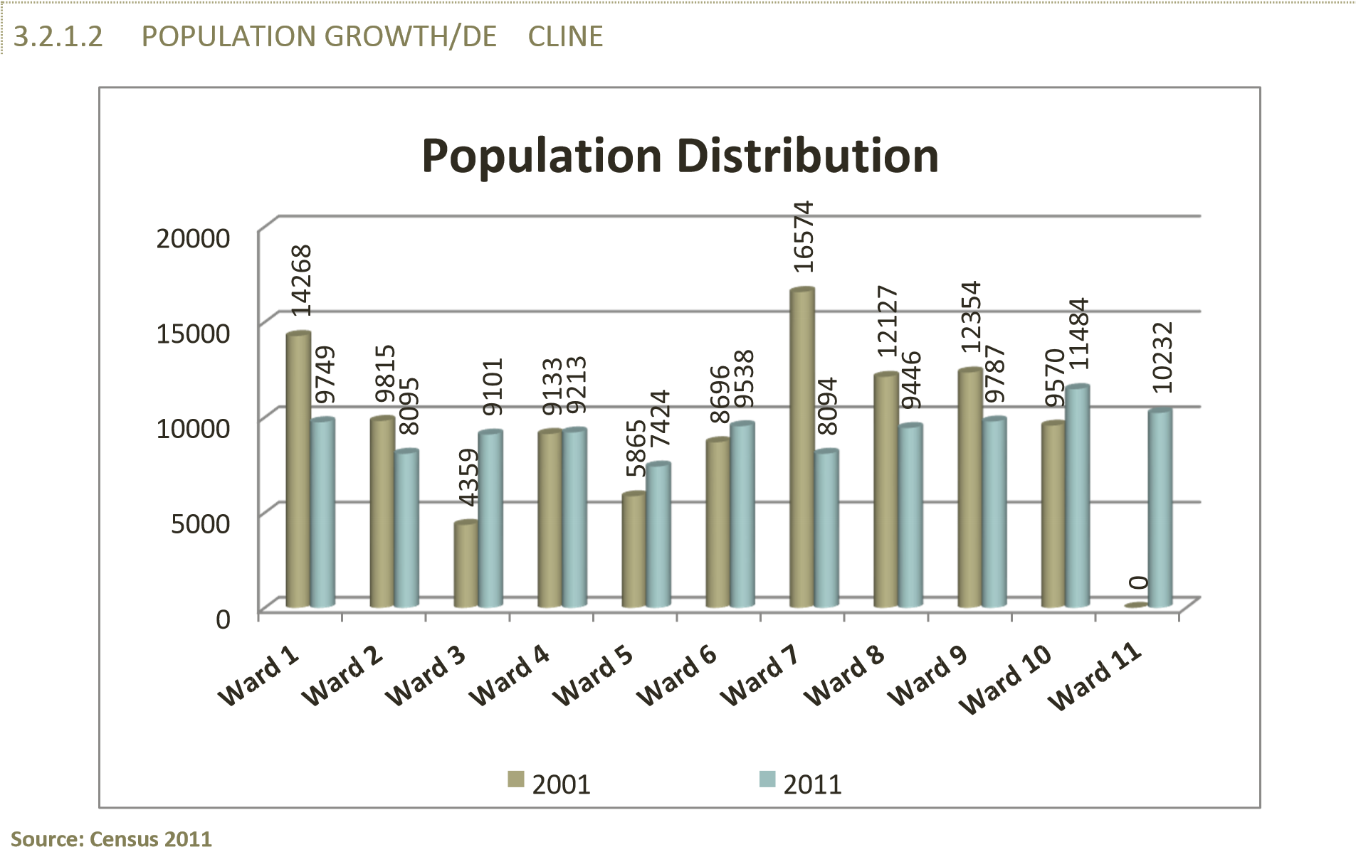

**Graph 2: Population by age group**

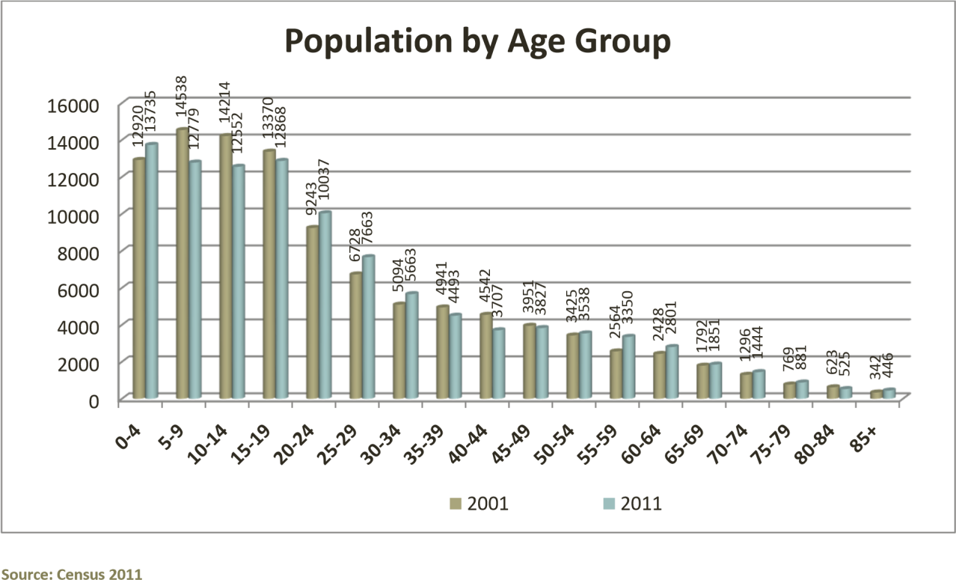

**Graph 3: Population by Gender**

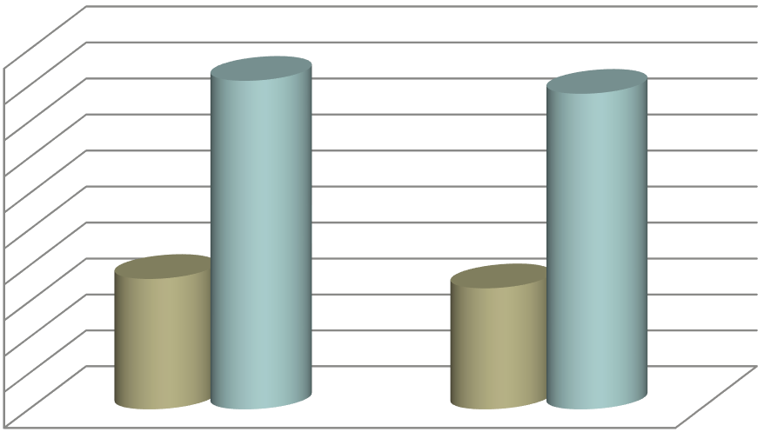

45000



46000



47000



48000



49000



50000



51000



52000



53000



54000



55000



**Population by Gender**



Male



Female

The two graphs depict the population by age and gender analysis. Approximately 38.2% of the population are below the age of 15 year and 5% are over 65 year. Within his phenomenon, it is noted that the ratio of male to female in Dannhauser has not changed much since 2001. In 2001 there were 90 males in every 100 females.

**Graph 4: Households analysis**



18 500



19 000



19 500



20 000



20 500



2001



2011



2001



2011



Series1



19 320



20 439



**Households**

The number of households in the municipal area slightly increased to 20, 439 in 2011 from 19, 320 in 2001. These households are predominantly rural settlements and scattered households which significantly contribute to challenges in providing basic services for the municipality.

**Table 1: Socio Economic Status**

|  |  |  |  |  |
| --- | --- | --- | --- | --- |
| **Socio Economic Status** | | | | |
| year | Housing backlog as proposition of current demand | Unemployment rate | Proportion of Household with on income | Illiterate people older than 14 years |
| Year -2 | N/A | 67% | 82% | 23% |
| Year -1 | N/A | 80% | 80% | 17% |
| Year 0 | 10 700 | 80% | 80% | 17% |

**Table 2: Natural Resources**

|  |  |
| --- | --- |
| **Natural resource** | |
| **Major natural resource** | **Relevance to Community** |
| Ntshingwayo Dan | Conservation area |
| Southern Boundary Game Ranch | Conservation area |
| Chelmsford Dam | Biodiversity |
| Buffelsriver Catchment | Contains significant and endangered ecosystems and plant species thus is considered as high conservation value |
| Buffelsriver Catchment |
| Ngagane Catchments | Vegetation |
| Income Sandy Grassland |
| Glencoe Moist Grassland |
| Northern KwaZulu Natal Moist Grassland |
| KwaZulu Natal Highland Thornville |
| Low Escarpment Grassland |

**1.3 SERVICE DELIVERY OVERVIEW**

During the 2013/14 financial year, the municipality received a total amount of R 18 604 000 on Municipal Infrastructure Grant. It is pleasing to report that all MIG registered projects namely; Rural Roads phase 4 (ward 3, 6 and 7) and Community Sport Centre (ward 2), for the year under review were completed, insulting in a total expenditure of R 18 498 797.68

A further amount of R 10 000 000.00 was received form Corporative Governance and Traditional Affairs (COGTA) Small Towns Rehabilitation Program for the implementation of Dannhauser Precinct Plan. To date R 6 500 000.00 has been spent on infrastructure rehabilitation which includes rehabilitation of roads, pavements and street lighting in some areas of the CBD

Electrification of Moy; Peachill; Hattingspruit; Rooipor; Mafahlawane and Doringkop during 2011 and 2012 has decreased the number of household without electricity. During the year under review, 363 households in Moy/Peachill and 138 households in Hattingspruit were electrified resulting in a total of 501 households which were electrified. Dannhauser Municipality intends to achieve a universal access by 2013/14 financial year.

The housing development section has achieved 20% completion on the Ramaphosa Slums Clearance Project. The municipality has appointed implementing agents for Dannhauser and Ubuhle Bomzinyathi Housing projects. A total number of 1734 housing units have been constructed within the Dannhauser municipal area; these units are constituted by the Emafusini phase 1 and 2. Strijbank and Springboklaage housing project.

The municipality is made up of only 1 urban ward and 1 semi-urban ward of a total of eleven wards. As a results, removal of waste service is only provided to 3000 households within the above urban and semi urban wards.

**1.4 FINANCIAL HEALTH OVERVIEW**

**FINANCIAL OVERVIEW**

The municipal financial position has been stable over time, but merely based and supported by equitable Share and other government grants. The revenue generated has not yet gained momentum due to a number of challenges. Amongst other things, the limited number of households entitled to pay rates and services are not paying on time and some households that are billed form part of indigent list. Undoubtedly, the municipality is compelled to engage in data cleansing exercise in order to ensure that proper household billed accordantly.

The council is in the process of formulating a comprehensive Revenue Enhancement Strategy that will present ideas and means for improved collection and revenue generation.

**Table 3: Financial Overview for the year ended June 2013**

|  |  |  |  |
| --- | --- | --- | --- |
| **Financial overview** |  |  |  |
|  |  |  | R'000 |
| **Details** | **Original budget** | **Adjustment budget** | **Actual** |
| INCOME: |  |  |  |
| GRANTS | R 111 574 000.00 | R 114 774 000.00 | R 97 627 142.00 |
| TAXES,LEVIES AND TARIFFS | R 9 312 916,00 | R 9 964 519.56 | R 13 743 405.00 |
| REFUSE REMOVAL | R 905 674.00 | R 905 674.00 | R 852 014.00 |
| OTHER | R 6 466 196.00 | R 10 127 129.02 | R 10 007 355.00 |
| SUB TOTAL | **R 128 258 786.00** | **R135 771 322.58** | **R 122 357 163.00** |
| LESS: EXPENDITURE | R 128 255 364.00 | R 135 754 062.75 | R 117 011 489.00 |
| NET TOTAL | **R 3 422.00** | **R 17 259.83** | **R 5 345 674.00** |

**Table 4: Operating Rations**

|  |  |
| --- | --- |
| Operating Ratios | |
| Details | % |
| Employee Cost | 14.82 |
| Repair and Maintenance | 3.32 |

**Table 5: Total Capital Expenditure**

|  |  |  |  |
| --- | --- | --- | --- |
| Total Capital Expenditure: Year – to Year 0 | | | |
| R’000 | | | |
| Detail | Year-2010/2011 | Year- 2011/2012 | Year-2012/2013 |
| Original Budget |  |  | 37 139 |
| Adjustment Budget |  |  | 37 139 |
| Actual | 228 790 | 0 | 37 193 |

The steady increase in Capital budget has indeed accelerated the investment infrastructure thereby curb the services backlog on critical basic services. Again, number of short term job opportunities were created in the process. Hence such growth in capital expenditure has served as a springboard for broad development in Dannhauser.

**1.5 ORGANISATIONAL DEVELOPMENT OVERVIEW**

During the year under review, the municipality adopted its organogram of which, Section 56 and 57 Managers positions such as the Municipal Manger, Manager Corporate Services, Chief Financial Officer and Manager Technical Services were filled. However the position for Manager Community Services was not filled during the year in question. Another critical post that was filled was that of the Income Accountant. The position for SCM Officer, SCM Clerk and Human Resource Officer remained vacant.

The municipality has developed and approved a number of policies with regards to human resource development.

Undoubtedly the human capacity challenges have compromised the envisage standards of performance within Council. It is therefore part of the new financial agenda to improve staff complement and ensure fulfilment of council objectives.

**1.6 AUDITORS GENERAL REPORT FOR THE 2013/2013 FINANCIAL YEAR**

The AG’s comments have in the main delved into the shortcomings on adherence to certain financial controls and further exposed poor performance management systems of Council. While then council presented a detailed plan of action on how to address the raised issues, however, the need still persist to exist for Council to improve its capacity in the area of Performance Management.

Undoubtedly, this allows reporting to be consistent with the set KPAs. Again, the communities will be in better position to assess the Council’s performance in future.

On the other hand, AG’s report has not specifically pointed out any irregularities on the Supply Chain Management, however, the emphasis is on the strict adherence to the procedures at all times.

**1.7 STATUTORY ANNUAL REPORT PROCESS**

Table 6 reflects the Statutory Annual Report Process to ensure compliance with chapter 12 of the Municipal Finance Management Act 56 0f 2003 and section 46 of the Municipal Systems Act 32 of 2000.

Submission of the draft annual report to AG: The 2013/2014 draft Annual Report including consolidated annual financial statements and performance report to the Auditor general on the 31 August 2014 for auditing purposes.

The 2013/14 draft annual report was tabled to council on the 23 January 2014. Subsequently, the Municipal Public Accounts Committee was scheduled to convene on the 14th February 2014 to conduct oversight on the draft annual report as required by the Municipal Finance management Act 56y of 2003.

**Table 6: Statutory Annual Report Process**

|  |  |  |
| --- | --- | --- |
| No. | Activity | Timeframe |
| 1 | Consideration of next of next year’s budget and IDP process plan. Except for the legislative content, the process plan should confirm in-year reporting formats to ensure that reporting and monitoring feds seamlessly into the Annual Report process at the end of the budget/IDP implementation period | July |
| 2 | Implementation and monitoring of approved Budget and IDP commences (In-year financial reporting) |
| 3 | Finalise the 4th quarter Report for previous financial year |
| 4 | Submit draft year 0 Annual Report to internal audit and Auditor General |
| 5 | Municipal entities submit draft annual reports to MM |
| 6 | Audit/Performance committee consider draft Annual Report of municipality and entities (where relevant) | August |
| 7 | Mayor tables the unaudited Annual Report |
| 8 | Municipality submits draft Annual Report including consolidated annual financial statements and performance data |
| 9 | Annual performance Report as submitted to the Auditor General to be provided as input to the IDP Analysis Phase |
| 10 | Auditor General audits Annual Report including consolidated Annual Financial Statements and performance data | September – October |
| 11 | Municipalities receives and start to address the Auditors General’s comments | November |
| 12 | Mayor tables Annual Report and audited financial statements to Council complete with the Auditor-General’s Report |
| 13 | Audited Annual Report is made public and representation is invited |
| 14 | Oversight Committee assesses Annual Report |
| 15 | Council adopts Oversight report | December |
| 16 | Oversight report is made public |
| 17 | Oversight report is submitted to relevant provincial councils |
| 18 | Commencement of draft budget/IDP finalisation for next financial year. Annual Report and Oversight Reports to be used as input | January |

**Vision**

To create a financially viable municipality and providing integrated quality services hereby with creating a better life for all.

**Mission Statement**

Dannhauser municipality will utilize its available resources to achieve a sustainable economy by creating job opportunities through agrarian reform, mining and industrial development. This will be enhanced and supported by its transformed staff.

“**Core values**

To create a sound, balanced and effective administration

To promote and enhance a cultural participatory governance and strengthen the capacity for participation

Forster a cultural transparency and accountability

Establish a sustainable and quality living environment

Create a central, viable, and conductive environment for growth of the economy, and enhance a developmental standard for infrastructure investments

**COMPONENT A: POLITICAL AND ADMINISTRATIVE GOVERNANCE**

**2.1 POLITICAL GOVERNANCE**

**In terms of the municipal structures Act, the municipality established the following governance structures**

**Executive Committee**

The executive Committee consist of four members, representative of three political parties, namely; African National Congress (ANC), National Freedom Party (NFP) and Inkatha Freedom party (IFP). The Executive Committee is the principal structure that governs the municipal operations and as such, convenes on a monthly basis. The Executive Committee makes recommendations to the council emanating from discussion made at council commitees level.

**Council**

In terms of section 152 of the constitution, the council has convened to ensure the adoption of the IDP/Budget and PMS Process Plan, Integrated Development Plan (IDP) and Budget. Organisational Scorecard, SDBIP, Performance Management related reports and other service delivery related deliberations.

**Portfolio Committees**

The establishment of Portfolio Committee was in the line with Section 79of the Municipal Structures Act 117 of 1998.During the year under review, the municipal it established six portfolio committee namely; Engineering Portfolio committee, Local Economic Development Portfolio Committee, Public Participation Portfolio Committee, Corporate Services Portfolio Committee and Community Services Portfolio Committee.

**Municipal Public Accounts Committee**

The Municipal Public Account Committee (MPAC) is a structure that is responsible for exercising oversight on both the executive and administration. During the year in review the MPAC conducted eight oversight meetings.

POLITICAL STRUCTURE



FRONT ROW – CLLR MA SIBEKO- EXCO MEMBER, HONOURABLE SPEAKER- CLLR ZS NGUBENI, HONOURABLE DEPUTY MAYOR- CLLR VM NDABA, HONOURABLE MAYOR- CLLR JP PHAKATHI, MUNICIPAL MANAGER- NKOSI WB, CLLR TV MABANGA- EXCO MEMBER

MIDDLE ROW- CLLR SN NDLOVU, CLLR AN RADEBE, CLLR PP NENE, CLLR K SITHOLE, CLLR MN HLONGWANE, CLLR H BUTHELEZI, CLLR M NGIDI, CLLR NJ MHLUNGU, CLLR MB SHABALALA, CLLR ES KUNENE

BACK ROW- CLLR MA BUTHELEZI, CLLR VH MDAKANE, CLLR R NYEMBE, CLLR NM MAJOLA, CLLR NGJ MANYATHI

Cllr JP Phakathi, her worship the mayor joined council in 2006 as an ordinary councillor and represented Dannhauser Municipality at Amajuba District Municipality.in May 2011 she was elected as Mayor and appointed as Chairperson of EXCO in June 2011. She served in a range of Community structures and top leadership political structures. She is also the Chairperson of Operation Sukuma Sakhe in the Dannhauser area and a member of the Amajuba District Mayors Forum. She is a member of African National Congress.



Cllr VM Ndaba, joined council in May 2011, and was appointed as Deputy Mayor in June 2011. He is Chairperson of the Engineering Portfolio Committee and LED Portfolio Committee. He is an active Community servant and serves in a range of political structures. He is a member of the SLGA infrastructure Committee. He is a member of African National Congress.



Cllr ZS Ngubeni, joined council in January 2009 and was a member of Engineering Portfolio Committee, he was again elected as councillor in May 2011 and appointed Speaker on the 9th of June and became Chairperson of Council and Ex-officio to all Portfolio Committees. He is also heading the Public Participation Portfolio, CWP and CDW programme. He is a member of African National Congress (ANC)



Cllr TV Ngubeni, joined council in May 2011, she was appointed as an EXCO member in June 2011, and she is the Chairperson of the Corporate Services Portfolio Committee and member of Local Labour Forum. She serves as an active member in the religious structure of the community. She is the member of the National Freedom Party.



Cllr MA Sibeko, joined Council in 2000, and served as EXCO Member in 2000 to 2006. On the 1 March 2006 he was appointed as Deputy Mayor and from August 2006 until May 2011, he was appointed as an EXCO member, and later appointed as Chairperson of the Community Services Portfolio Committee. He is also served in different NGO’s community structures, youth structures. He is a member of the LED and Land committee. He is a member of Inkatha Freedom Party

**COUNCILLORS**

The council of Dannhauser Municipality comprises of political representatives or councillors from various political parties. The African National Congress has 11 Councillors, Inkatha Freedom party has 6 councillors, and National Freedom Party has 2 councillors, while DA and Azapo have one Councillor per party. In total, the council is made up of 21 councillors (11 ward councillors and 11 PR councillors)

**POLITICAL DECISION TAKING**

The Portfolio Committees of the Council do not have any executive powers. Matters that fall within the functional arears of portfolio Committee are submitted to the relevant Committee for consideration and the development of recommendations. Those recommendations are then submitted to the Executive Committee which deposes of the matter if it falls within its delegated powers or refers the recommendation, with or without amendment, to the council for determination.

**2.2 ADMINISTRATIVE GOVERNANCE**

During the 2013/2014 financial year, the municipality had the following structures to ensure effective service delivery

Office of the Municipal Manager

Budget and Treasure

Corporate services

Technical services

The management committee (MANCO) is a structure that was established to ensure consistency in communication, reporting and efficiency in administration. This committee is served by top and middle management and convenes on a weekly basis

The diagram below depict the administrative structure and the powers and function therefore

**Administrative Structure – Top Management**

MUNICIPAL MANAGER



NKOSI WB

BUDGER & TREASURY CORPORATE SERVI COMMUNITY SERVICE TECHNICAL SERVICE

   

MOHAPI DM NAROTHUM S NAIDOO S NENE M

**Power and function**

OFFICE OF THE MUNICIPAL MANAGER

Strategic planning

Municipal Management

Financial Management

Development Planning

Local Economic

Development

Public Relations

HIV/AIDS/Youth/Culture and

Gender

BUDGET & TREASURY

OFFICE

DEPARTMENT OF

CORPORATE SERVICES

DEPARTMENT OF COMMUNITY SERVICES

DEPARTMENT OF TECHNICAL SERVICES

Financial Management

Municipal Valuation

Assets Management

General Administration

Secretariat

Legal matters

Office facilities Management

Human Resources & Labour Relations (Excluding Payroll)

Security Services

Ward Committee

Cleaning Services

Property Management

Occupational Health & Safety

Pollution

Child care Facilities

Fire – Fighting Services

Trading Regulations

Cemeteries, Funeral Parlours and Crematoria

Cleansing

Control of undertaking that sell liquor to the public

Facilities for accommodation

Care and burial of animals

Licensing and control of undertaking that sell food to the public

Local sport facilities

Municipal Parks and Recreation

Pounds

Public places

Refuse removal, refuse dumps & solid waste

Street trading

Traffic and parking

Disaster Management

Environmental Management

Building regulations

Storm water management

Billboards

Municipal roads

Public works and asset maintenance

Housing and Land

Fleet & Engineering maintenance

Municipal infrastructure

Town planning/LUMS/GIS

Engineering Health & Safety

**2.3 STAFF COMPLEMENT**

**Table 7: Staff Complement as at 30 June 2013**

|  |  |
| --- | --- |
| DEPARTMENT | NUMBER OF STAFF MEMBERS |
| Office of the Municipal Manager | 6 |
| Corporate Services | 12 |
| Financial Services | 14 |
| Engineering Services | 17 |
| Community Services | 45 |
| **THOTAL NUMBER OF STAFF** | 94 |

During the period under review, the municipality had staff complement of 94

88 - Permanent

05 - Contract and

01 - Section 57 contract managers

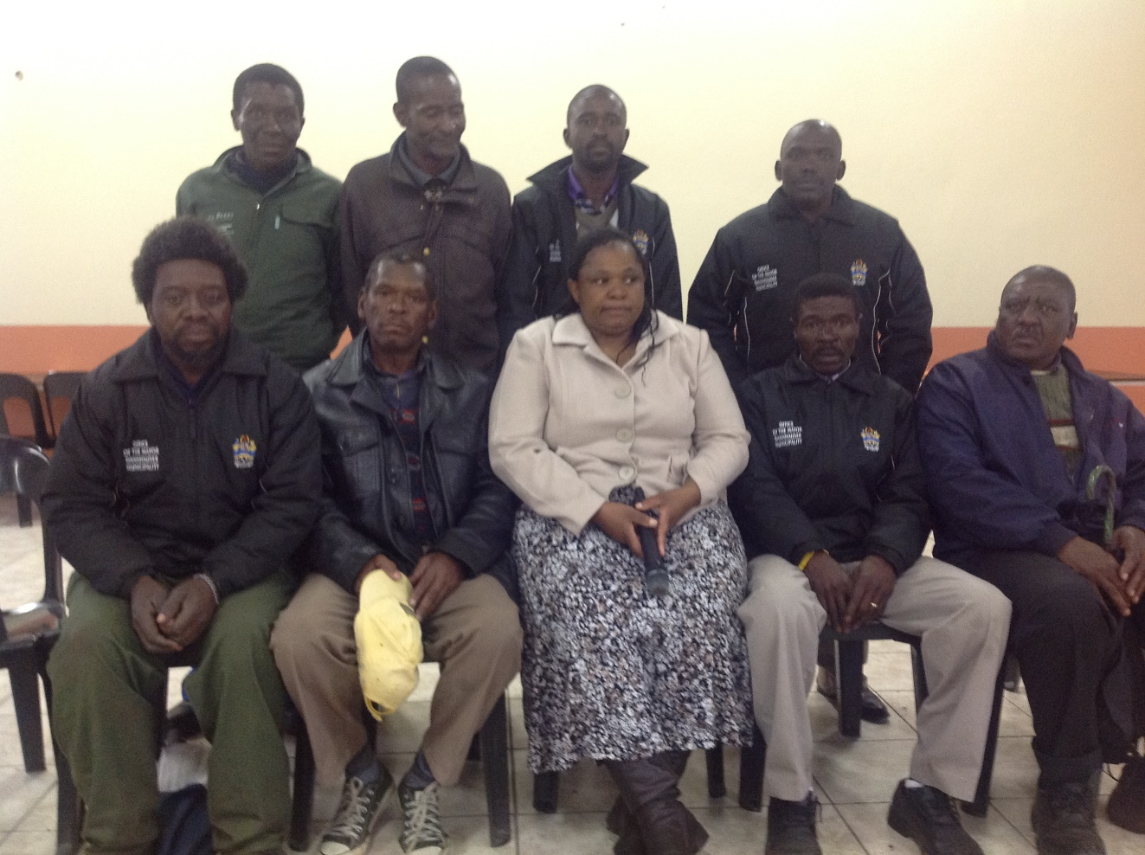

COMPONENT B: INTERGOVERNMENTAL RETAIONS

Section 3 of the Municipal Structures Act, read in conjunction with 41 of the Constitution, requires that municipalities exercise their executive and legislative authority within the constitutional system of co-operative

During the year under review, the municipality participated in the following inter-Governmental Structure

**National Inter-Governmental Structures:**

Municipal Managers Forum

South African Local Government Associated Forum

**Provincial Inter-Government Structure:**

Provincial Planners Forum

Premier Coordinating Forum

Muni MEC

South African Local Government Associated Technical Forum

Provincial Private Partnership Steering Committee

**District Inter-Governmental Structures:**

Mayors Forum

Municipal Managers forum

Chief Financial Officers Forum

Corporate Services Forum

Technical Services Forum

Community Services Forum

Planners’ forum

District Technical Advisory Committee

Amajuba Forum for Local Economic Development

COMPONENT C: PUBLIC ACCOUNTABILITY AND PARTICIPATION

**2.4 PUBLIC MEETING**

The public participation process serves to achieve informed identification needs, appropriate ness of solutions and to ensure community ownership and empowerment. Having realised this, the following mechanisms were put in place to ensure that all residents within Dannhauser Municipality area of jurisdiction have equal rights to participate in the IDP/Budget process.

**IDP Representation Forum**

**The IDP** Representation Forum represents all stakeholders who actively participate through the IDP process to ensure alignment and integration of the IDPs. During the 2013/14 financial year, the IDP Representative forum had only one meeting which was convened as follows:

**Table 8: IDP Representation Forum Meeting**

|  |  |  |
| --- | --- | --- |
| **No.** | **Date** | **Purpose** |
| **1** | **10 November 2013** | **To table Process plan and SDBIP** |

**IDP Imbizo/Road-shows**

IDP imbizo/Road-shows were held as follows

**Table 9: Imbizos/Roadshow**

|  |  |  |
| --- | --- | --- |
| No. | Date | Venue |
| 1 | 11 November 2013 | Uitkyk (Open Space) |
| 2 | 13 November 2013 | Durnacol Sports Complex |
| 3 | 30 October 2014 | Opposite Easborne Hall |
| 4 | 04 November 2014 | Dorset Sports Ground |

**Ward Constituency meetings**

The Ward constituency meeting a platform where Ward Committees are briefed on the IDP planning implantation progress. They are then required to liaise with residents in each Ward to provide feedback and facilitating public participation. These meetings are convened by the Speaker on a quarterly basis and were held as follows:

**Table 10: Ward Constituency Meetings**

|  |  |  |  |  |
| --- | --- | --- | --- | --- |
| **Ward No** | **Quarter 1** | **Quarter 2** | **Quarter 3** | **Quarter 4** |
| 1 | 21 November 2013 | 03 March 2014 | N/A | N/A |
| 2 | 21 November 2013 | 03 March 2014 | N/A | N/A |
| 3 | 19 November 2013 | 13 March 2014 | N/A | N/A |
| 4 | 20 November 2013 | 10 March 2014 | N/A | N/A |
| 5 | 24 November 2013 | 11 March 2014 | N/A | N/A |
| 6 | 20 November 2013 | 10 March 2014 | N/A | N/A |
| 7 | 22 November 2013 | 12 March 2014 | N/A | N/A |
| 8 | 23 November 2013 | 04 March 2014 | N/A | N/A |
| 9 | 23 November 2013 | 04 March 2014 | N/A | N/A |
| 10 | 24 November 2013 | 11 March 2014 | N/A | N/A |
| 11 | 22 November 2013 | 12 March 2014 | N/A | N/A |

**Media**

Amongst other platforms, the municipality made use of the local press to inform the community of the progress regard to the IDP process.

**2.5 IDP PARTICIPATION AND ALIGNMENT**

**Table 11: IDP Participation and Alignment Criteria-**

|  |  |
| --- | --- |
| **IDP Participation and Alignment Criteria** | **Yes/No** |
| Does the municipality have impact, outcome, input indicator | No |
| Does the IDP have priorities, objectives, KPIs, development strategies | Yes |
| Does the IDP have multi-year targets? | Yes |
| Are the above aligned and can they calculate into a score | Yes |
| Does the budget align directly to the KPIs in the strategic plan? | Yes |
| Do the IDP KPIs align to the Section 57 Managers | Yes |
| Do the IDP KPIs lead to the functional area KPIs as per the SDBIP | Yes |
| Do the IDP KPIs align with the provincial KPIs on the 12 Outcome | Yes |
| Were the indicators communicated to the public | Yes |
| Were the four quarter aligned reports submitted within stipulated time frame? | Yes |

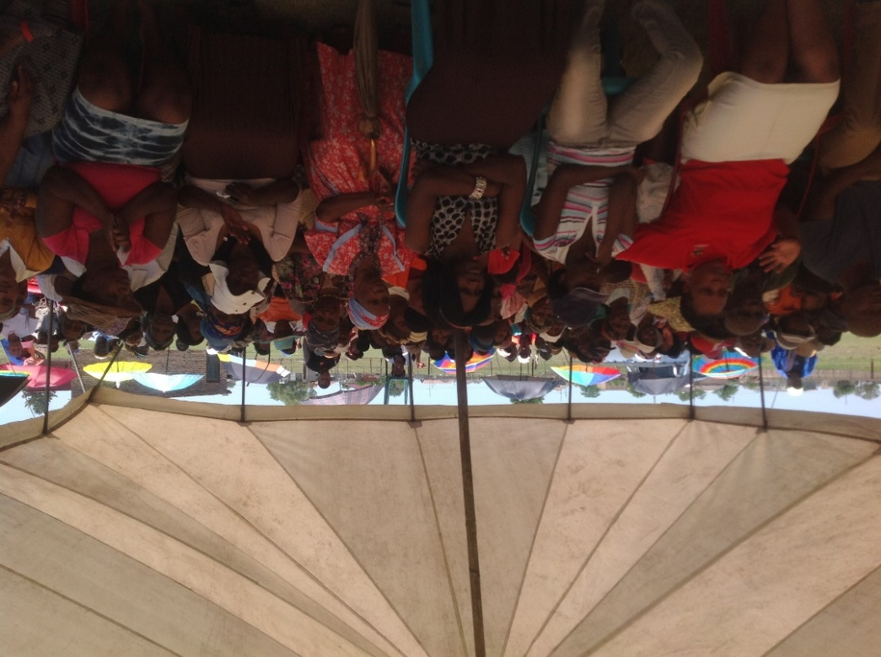

COMPONENT D: CORPORATE GOVERNANCE

**Municipal Website**

During the year under review, the municipality made due of its website for the community to have online access to information required to make in public in terms of the Municipal Systems Act and Municipal Financial Management Act such as the IDP, Budget, Polices, Performance Agreements, and SDBIP etc.

**Municipal Oversight Committee**

**Audit Committee**

The municipality has entered into a Shared Service Agreement or arrangement with Amajuba District Municipality. The Shared Service arrangement covers both Performance and Financial Matters. Members of the Audit Committee are:

Chairperson- Mr B Mbange

Member - Mrs TC Ndlela

Member- Mr B Dladla

Member- Mr SE Ngwenya

Member- Mr S Ngwenya

**Internal Auditors**

The Municipality has contracted an Audit Firm to conduct Internal Audit Function for the period of three years commencing in November 2013 to October 2016. The contract was extended for the remaining period ending 2013/2014.

**2.6 RISK MANAGEMENT**

The municipality, with the support of Provincial Treasury conducted a risk assessment for the 2013/2014 financial year. The risk areas that were identified were as follows:

Assets register

Filing of critical positions

Performance Management System

Equitable allocated of budget amongst municipal wards

Lack of revenue base.

**2.7 SUPPLY CHAIN MANAGEMEN**

MFMA section 110 – 119; SCM Regulation 2005; and relevant MFMA circulars set out required processes and guidance manuals to help ensure that that SCM arrangements provide appropriate goods and services, offer best value for money and minimize the opportunities for fraud and corruption.

In compliance to the above legislative stipulations, the supply management of Council has been functional over years despite limited capacity and growing challenges to comply all costs. The municipal has since priorities the appointment of suitable qualified and competent incumbents to assume full responsibility of the SCM unit and ensure that it grows from strength to strength.

The office of the AG has also registered few concerns over the functioning of SCM and action plans were immediately designed to address the shortcomings as they identified.

**2.8 POLICIES AND BY –LAWS**

**Table 12: By –Laws Introduced during 2013/2014 Financial Year**

|  |  |
| --- | --- |
| **Polices and By-laws Introduced during Year 0** | |
| **Newly Developed** | **Date of Publication** |
| Outdoor Advertising By - laws | 21/10/2012 |
| Asset Management Policy | 24/10/2012 |
| Banking and Investment Policy | 24/10/2012 |
| Budget Policy | 24/10/2012 |
| Credit Control Policy | 24/10/2012 |
| Dannhauser Rates Policy | 24/10/2012 |
| Grants and Donations Policy | 24/10/2012 |
| Indigent Support Policy | 24/10/2012 |
| Overtime and Standby Policy | 24/10/2012 |
| Risk Management Policy | 24/10/2012 |
| S and T Policy | 24/10/2012 |
| SCM Policy | 24/10/2012 |
| Tariffs Policy | 24/10/2012 |



**2.9 WEBSITE**

**Table 13: Municipal Website Content and Currency of Material**

|  |  |
| --- | --- |
| **Municipal Website: Content and Currency of Material** |  |
| **Documents published on the Municipality’s /Entity Website** | **Yes/No** |
| Current annual and adjustments budget and all budget –related documents | Yes |
| All current budget –related policies | Yes |
| The previous annual report (Year -1) | Yes |
| The annual report (Year – 0) published/to be published | Yes |
| All current performance agreements required in terms of section 57 (1)(b) of the Municipal Systems Act (Year 0) and resulting scorecards | Yes |
| All service delivery agreements (Year 0) | No |
| All long - term borrowing contract (Year 0) | No |
| All supply chain management contacts above a prescribe value (give value) for Year 0 | No |
| An information statement containing a list or assets over a prescribe value that have been disposed of in terms of section 14(2) or during Year 1 | No |
| Contracts agreed in Year 0 to which subsection (1) of section 33 apply, subject to subsection (3) of that section | No |
| Public-private partnership agreements referred to in section 120 made in Year 0 | No |
| All quarterly reports tabled in the council in terms of section 52 (d) during Year 0 | Yes |

During the 2013/2014 financial year, the municipality has a fully functional website that was hosted and managed in-house.

This section focuses on the assessment of the ability of municipalities to deliver infrastructure and basic services through the provision of basic services such as housing, electricity and sanitation for all communities.

The 2013/2014 Integrated Development Plan (IDP) is based on the premise of the national Key Performance Areas namely; Municipal Transformation and organisational Development, Basic Service Delivery, Local Economic Development and Environmental Management.

Based on the above, the 2013/2014 IDP identified key development priorities upon which service delivery would be focused. These priorities are as follows:

**Table 14: Municipal Development priorities**

|  |  |
| --- | --- |
| Development Priorities | Development Objectives |
| Integrated Basic Municipal Services | To ensure provision of all basic services to the entire community of Dannhauser |
| To meet the national norms and standards on accessibility of basic municipality services |
| Promotion of Local Economic Development | To ensure that Dannhauser enjoys economic growth |
| To ensure that Dannhauser attracts investors for industrialization |
| Essential public facilities and amnesties | To ensure provision of public facilities and amnesties in all wards enabling economic engagements. |
| To provide community with space for public engagements between themselves and with the entire government of the Republic. |
| Municipal self-financial sustainability and best management | To ensure full compliance with pieces of legislation relevant to local government |
| To build municipality with adequate revenue for self-sustainability. |
| To eradicate dependency on grants by the municipality |
| To enhance the achievement of a clean audit report by 2014 onwards |
| To create culture of good financial management with special emphasis on revenue; expenditure; controls and systems improvement |
| Good co-operative governance and strategic public participation | To establish political structures and ensure election of respective office-bearers within the ambit of law. |
| To formulate legislative and other delegations for all office-bear; political structure and officials. |
| To foster a culture of public participation and government of the people. |

**Basic Service Backlog**

The 2012/2013 IDP presented the basic services backlog as follows:

Housing Backlog = 10 700

Sanitation Backlog = 12 528

Water supply Backlog = 3 760

Waste Removal = 17 439

In addressing the backlogs above, the municipality instituted a number of initiatives whose performance highlights are as follows:

Completion of all registered MIG projects for the 2013/2014 financial year, resulting in 99.43% expenditure.

The municipal received an amount of R18 604 000. 00 towards MIG allocation. During the year under review an amount of R5 829 275.55 was spent towards the completion of the community sports center and 12 668 681.86 was spent towards rural roads in wards 3, 6 and 7 resulting in a total of R18 497 597.20 expenditure.

Progress on the Ramaphosa Housing Project is currently at 20% completion

Implementing Agents have been appointed for the Dannhauser and Ubuhle Bomzinyathi Housing Projects respectively.

During the 2011/2012 financial year, the MEC of Co-operate Governance and Traditional Affairs (COGTA) declared a state of “Universal Access” to electricity throughout the Dannhauser municipal area of jurisdiction. Electrification Project resulted in a total of 1734 households being electrified during the year under review. The Universal Access goal is anticipated to be achieved by the end of the 2013/2014 financial year.

Completion of Dannhauser Precinct Plan

Implementation of phase 1 of the Dannhauser Pricinct Plan with an expenditure of 65% of the allocation budget.

**Key Challenges**

The Municipality Infrastructure Grant allocation for the year 2013/2014 financial was not enough to address the service delivery backlog that the municipality is currently facing.

The prolonged IDP re-alignment and project prioritization process resulted in the delay in commencement of projects.

There is no PMU Unit within the municipality. The section has acquired the projects Coordinators. However, it is felt that the municipality requires a fully functional PMU unit.

COMPONENT A: BASIC SERVICES

**Table 16: Access to Adequate Services within the Municipality**

|  |  |  |  |  |  |  |  |  |  |  |  |
| --- | --- | --- | --- | --- | --- | --- | --- | --- | --- | --- | --- |
| **2010/2011** | | | | **2011/2012** | | | | **2012/2013** | | | |
| **Refuse removal** | | **Electricity** | | **Refuse removal** | | **Electricity** | | **Refuse removal** | | **Electricity** | |
| **Target** | **Actual** | **Target** | **Actual** | **Target** | **Actual** | **Target** | **Actual** | **Target** | **Actual** | **Target** | **Actual** |
| **3000** | **3000** | **15000** | **15000** | **3000** | **3000** | **15000** | **15000** | **3000** | **3000** | **15000** | **15000** |

**3.1 ELECTRICITY**

During the 2011/2012 financial year, the MEC of Corporate Governance and Traditional Affairs (COGTA) declared a state of “Universal Access” to electricity throughout the Dannhauser municipality area of jurisdiction. Electrification Project resulted in a total of 1734 households being electrified during the year under review. The universal Access goal is anticipated to be achieved by the end of the year 2013/2014 financial year.

**3.2 WASTE MANAGEMENT (THIS SECTION TO INCLUDE: REFUSE COLLECTIONS, WASTE DISPOSAL, STREET CLEANING AND RECYCLING)**

In accordance with powers and functions of spheres of government, Waste Management Service is the function of the municipality. Here below is a summary of provision of domestic waste collection services for the year under review.

Number of household in the municipality 20439 Number of households receiving waste collection services 3 000 Number of household NOT receiving waste collection services 17439 Number of indigent households 99

**Waste Collection Schedule**

Waste collection is done on weekly basis as follows:

Monday Commercial (Dannhauser) Tuesday Commercial (Hattingspruit) Wed Domestic (Durnacol) Thursday Domestic (Dannhauser) Friday Commercial (Emafusini)

The municipality makes provision for twenty refuse bags per end-user (domestic and commercial) on a monthly basis. Furthermore, the municipality has installed skip bins within the CBD area and within areas where waste collection is not done on a regular basis as the means to ensure extension of this basic service. CBD street sweeping is conducted on a daily basis and refuse removal thereof.

The municipal Integrated Waste Management Plan (IWMP) was last reviewed in the 2010/2011 financial year. However, the municipality has implemented its objectives and as a result has established a regional Landfill Site situated in Durnacol. During the year under review, the municipality secured an amount of R 3 100 00.00 from the Department of Agriculture and Environmental Affairs to licence the Landfill site.

**Achievements**

The municipality has initiated a Recycling program in line with the existing Integrated Waste Management Plan. The municipality also actively participated in the Zibambele Waste Reduction programme. Through this programme, the municipality has created a total of 110 jobs opportunities which is comprised of ten community members per ward.

The licencing process of the landfill site will commence in the 2013/2014 financial year. The licencing of the landfill site will ensure that there is compliance with relevant regulations especially since the Newcastle municipality has entered into an agreement for the use of the Dannhauser Regional Landfill Site.

**Challenges**

Despite the achievements accomplished, it is still a grave concern that the Landfill site is still not yet licenced. Furthermore, it is also acknowledged that the Waste Management Section is currently under capacitated to provide adequate service delivery and to meet the current service demands.

**Table 17: Solid Waste Service Delivery Level**

|  |  |
| --- | --- |
| **Solid Waste Service Delivery Levels** | |
|  | **Households** |
| **Description** | **Year 0** |
| **Actual** |
|  | **No.** |
| **Solid Waste Removal: (Minimum level)** |  |
| Removal at least once a week | 3000 |
| Minimum Service Level and Above sub-total | 3000 |
| Minimum Service Level and Above percentage | 14.7% |
| **Solid Waste Removal: (Below minimum level)** |  |
| Removed less frequently than once a week | 17439 |
| Using communal refuse dump | 79 |
| No rubbish disposal | 17360 |
| Below Minimum Service Level sub-total | 17360 |
| Below Minimum Service level percentage | 84.9% |
|  | **20439** |

**Table 18: Capital Expenditure on Waste Management Services**

|  |  |  |
| --- | --- | --- |
| **Capital Expenditure Year 0: Waste Management Services**  **R’ 000** | | |
|  |  | |
|  | **Adjudication Budget** |
| Total All | 410 475 | 410 475 |

**3.3 HOUSING**

The Dannhauser municipality currently has outdated Housing Sector Plan that need to be reviewed. Over the years, a total number of 1734 housing units have been constructed within the Dannhauser municipal area. These units are constituted by the Emafusini phase 1 and 2, Strijbank and Springboklagte housing projects. During the year under review, the following housing projects were registered:

Ubihlebomzinyathi Rural Development – 2500 units

Dannhauser Urban Housing Development – 1000 units

Ramaphosa Slums Clearance – 100 units

From the above projects, the municipality has only been to achieve 20% completion on the Ramaphosa Slums Clearance Project. However, it is encouraging to not that the municipality appointed the implementing agents for the Dannhauser and Ubuhle Bomzinyathi Housing Projects respectively.

**Table 19: Housing Service Objectives**

|  |  |  |  |
| --- | --- | --- | --- |
| **Housing Service Policy Objectives Taken From IDP** | | | |
| **Service Objectives**  **Service Indicators** | **Outline Service Targets**  **(ii)** | **Year 0** | |
| **Target** | **Actual** |
| **\*Previous Year**  **(iii)** |  |
| **(i)** | **(iv)** |
| Dannhauser Urban Housing Development Phase 2 | Establishment of 1000 housing units | Commencement of beneficiary registration process | Appointment of implementing agents. |
| Ubuhlebomzinyathi Rural Housing Development | Establishment of 2500 housing units | Commencement of beneficiary registration process | Appointment of implementing agents. |
| Ramaphosa Slums Clearance Phase 2 | Establishment of 100 housing units | Construction of 100 housing units | Construction of 20 units has been completed |

**3.4 FREE BASIC SERVICES AND INDIGENT SUPPORT**

**Table 20: Status on the Provision of Basic Services for the year ended June 2013**

|  |  |  |  |  |  |  |  |  |
| --- | --- | --- | --- | --- | --- | --- | --- | --- |
| Municipality | Electricity | | Water | | Sanitation | | Refuse Removal | |
| No of households Receiving Free Service | Units Per household (Kwh) | No of households Receiving Free Service | Units Per House-Hold (K) | No of households Receiving Free Service | Units/R Value Pm per House-Hold | No of households Receiving Free Service | Units/R Value Pm per House-Hold |
| Dannhauser | 15 000 | 40kwh | N/A | N/A | N/A | N/A | 99 | 42,50 |

**Table 21: Financial Performance on Free Basic Service Delivery**

|  |  |  |
| --- | --- | --- |
| **Financial Performance Year 0: Cost to Municipality of Free Basic Services Delivered** | | |
| **Service Delivered** | **Year 0** | |
| **Budget** | **Adjustment Budget** |
| Electricity | 500 000 | 705 830 68 |
| Waste Management (Solid Waste) | 36 000.00 | 36 000.00 |
| **Total** | **1 116 326.00** | **1 116 326.00** |

**Table 22: Indigent Policy and Registers**

|  |  |  |  |  |  |  |  |  |  |  |  |
| --- | --- | --- | --- | --- | --- | --- | --- | --- | --- | --- | --- |
| **2010/11** | | | | **2011/12** | | | | **2012/13** | | | |
| **Reviewed/**  **Developed Indigent Policies** | **Indigent**  **Policy**  **Implemented** | **Indigent Registers in Place and date last updated** | | **Reviewed/**  **Developed Indigent Policies** | **Indigent**  **Policy**  **Implemented** | **Indigent Registers in Place and date last updated** | | **Reviewed/**  **Developed Indigent Policies** | **Indigent**  **Policy**  **Implemented** | **Indigent Registers In Place and date last updated** | |
|  |  | **Yes/No** | **Date** |  |  | **Yes/No** | **Date** |  |  | **Yes/No** | **Date** |
| Yes | Yes | Yes |  | Yes |  | Yes | 31/20/12 | Yes | Yes | Yes | 30/6/13 |

The structure of the municipality indigent support provides for 40kwh units of electricity and R42.50 in waste removal services per registered indigent household on a monthly basis.

During the 2013/2014 financial year there were only 79 beneficiaries recorded as indigents within the municipal area. It is acknowledged that the information contained in the municipal indigent register is currently outdated. However, it will be reviewed and updated in the 2013/2014 financial year.

COMPONENT B: ROAD AND TRANSPORT

**3.5 ROADS**

During the 2013/14 financial year the municipality conducted roadwork in rural areas through the Municipal Infrastructure Grant funding. Road works were completed in ward 3, 6, and 7.

The municipality received a further R10 000 000.00 grant funding from COGTA – Small Town Rehabilitation Programme for partial implementation of the Dannhauser Precinct Plan. During the year under review, a portion on this amount was utilised as per the business plan for the rehabilitation of a total of 470m on Dannhauser CBD roads and Dannhauser pavement lighting.

**Table 23: Cost of Construction and Maintenance of Roads**

|  |  |
| --- | --- |
| **Cost of Construction/Maintenance** | |
| **R’000** | |
|  | **Gravel** |
| **New** |
| **Year 0** | **2 600 000** |

**Table 24: Road Services Objectives**

|  |  |  |
| --- | --- | --- |
| **Road Service Policy Objectives Taken From IDP** | | |
| **Service Objectives** | **Outline Service Targets** | **Year 0** |
|  | **Actual** |
| **Service Indicator** | **\*Current Year** |
| **(i)** | **(ii)** | **(vi)** |
| Provision of roads services | Isibili Road Development | 13.6Km |
| Ndwandwa Road Development | 15Km |
| Zamisanani Road Development | 10.2Km |

**3.6. EXPANDED PUBLIC WORKS PROGRAM (EPWP)**

Dannhauser Municipality did not participate in the Extended Public Works Programme for the year under review. However from the projects that were implemented, a total of 145 job opportunities were created for the community of Dannhauser.

**3.7. WASTE WATER (STORMWATER DRAINAGE)**

During the year under review, the municipality constructed three roads as highlighted above. As required, the municipality also constructed storm-water infrastructure as part of the infrastructure development. The total cost of the storm-water drainage system constructed is R 951 500.00.

**Table 25: Storm-water infrastructure**

|  |  |  |
| --- | --- | --- |
| **Storm-Water Infrastructure** | | |
| **Service Objectives** | **Outline Service Targets** | **Year 0** |
|  | **Actual Cost** |
| **Service Indicators** | **\*Current Year** |
| **(i)** | **(ii)** | **(vi)** |
| Provision of Storm-Water Infrastructure | Isibili | R 234 000 |
| Ndwandwe | R329 500 |
| Zamisanani | R 288 000 |
|  | West Street | R 100 000 |
| **Total** |  | **R 951 500** |

COMPONENT C: PLANNING AND DEVELOPMENT

The main objective of the planning and development section is to ensure a safe, healthy and sustainable environment for community of Dannhauser through proper land use management system. This section is responsible for Land Use Management System, Local Economic Development and physical planning within the municipal area.

**3.8. PLANNING**

The municipality formulated the following strategies to ensure effective and efficient planning and development services within the municipal area.

To effectively address the socio-economic needs of all sectors of the community

To develop and sustain a strong local economic base which recognizes the importance of tourism in the development of the Dannhauser as a whole

To facilitate the development of a functional and diverse yet will integrate convenient, economically efficient and comprehensive urban environment and region

To restore and conserve the character of the town, while improving it

It is pleasing to report that out of 29 applications received, only 8 applications were outstanding as at the end of the 2013/14 financial year.

The table below reflects the building plans and zoning applications status.

**Table 26: Building plans and Zoning Applications**

|  |  |  |  |
| --- | --- | --- | --- |
| **Category** | **Number of new applications received 2012/2013** | **Total value of applications received Rands** | **Applications outstanding 30 June 2013** |
| Residential New |  |  |  |
| Residential additions |  |  |  |
| Commercial |  |  |  |
| Industrial |  |  |  |
| Other (Specify) AGRI |  |  |  |
| PDA APPLICATIONS:  Sub – Division  Sub- Division & Consolidation  Mining  Housing  Hospital |  |  |  |

**Table 27: Capital Expenditure on Planning Services**

|  |  |  |
| --- | --- | --- |
| **Capital Expenditure Year 0: Planning Services**  **R’000** | | |
| **Capital Projects** | **Year 0** | |
|  | **Budget** | **Adjustment** |
| Total All |  | 4686 |

**3.9. LOCAL ECONONOMIC DEVELOPMENT (INCLUDING TOURISM AND MARKET PLACES)**

In terms of local economic development, the core function of the municipality is to ensure a facilitative role to create a conductive environment in order to attract investment which will in turn ensure job creation.

During the year under review, the municipality formulated the following strategies in order to address economic disparities that the municipality is currently characterized by.

It is acknowledged that the current LED strategy and the Tourism Strategy were formulated in 2006 and has never been reviewed to date, however, the municipality is of the view that the programme and projects that were identified therein are still of relevance to the community.

In light of the above, the municipality successfully implemented the following LED anchor projects taken from the current LED strategy:

Rural Technology and Genius Centre: - The project entails training of forty Cooperatives in leather production. The main goal of the programme is to establish a Tannery Incubation Centre.

Small Enterprise Development and Support:-The municipality has initiated a training programme that is implemented through the involvement of community members in each ward within the municipal area. The main goal of the programme is to capacitate local businesses to ensure economic sustainability at the lower levels of economic participants.

Informal Trading administration and infrastructure: - The KZN Provincial Informal Trading Policy requires municipalities to assume an active role in the administration, development and support of the local informal trading sector. In this regard, the municipality has initiated a process to administer this sector. As a result, the municipality secured funding from COGTA to erect starter shops for informal traders. The construction thereof has been delayed due to the delay in land acquisition. It is anticipated that the project will be completed in the 2013/14 financial year.

Aqua Cultural project: - This project privately owned but was identified as a potential for private partnerships. The Department of Economic Development has invested funding for the implementation of this project. However, land still needs to be acquired in order for the project to commence.

In order to improve the current socio-economic status quo, the municipality implemented some capacity development and ward based community programme.

**Capacity development**

Tertiary financial Aid programme: - The municipality allocated a substantial amount to address skills shortages within the municipal area to ensure that disadvantaged learners who performed well in their matric study year are able to proceed to higher learner institutions. During the year under review, 8 learners benefited from the Tertiary Financial Aid Program.

Placement Program: - The municipality established partnerships with local and neighbouring businesses for the placement of local graduates to acquire skills and experience in their field of expertise which ensure and advantageous position to secure more sustainable jobs in future. During the year under review, 7 local graduates benefited from the Placement Program.

**Ward Based Community Programme**

The municipality is committed to actively participate in the Zibambele Programme. This programme is an initiative to ensure economic activities in communities within the municipal area. It has been rolled out in all eleven wards of the municipality. During the year under review, 110 jobs opportunities were created through the Zibambele Program.

As part of its endeavour to create sustainable job opportunities and economic base, the municipality procured a farm consisting of 256 hectares of arable land at the SweetWater area in ward 1 which was previously utilised for poultry farming. The main objective for the use of this land was to continue to conduct agro processing (poultry farming and dairy production). However, a feasibility study is still underway to validate this aspiration.



**Challenges**

A number of challenges were experienced in the 2013/14 financial year. Some of these challenges were perceived to be the main contributors to minimal service delivery achievements during the financial year. These challenges are as follows:

Outdated strategic documents (LED Strategy and Tourism Strategy)

Lack of infrastructure to encourage investment

Most of the programmes have potential for sustainable spin-offs are still at planning stage

Most identified LED initiatives depend on external funding for implementation

COMPONENT D: COMMUNITY & SOCIAL SERVICES

Due to capacity (financial and human) constraints, the municipality has only been able to provide one library for the entire municipal area. Only 3 community halls have erected which have also been subjected to vandalism. Regrettably the municipality has not been able to provide some of the community and social services such as the museum.

The following community halls were built was Ward6 community and it hall has been practically completed.

There is currently one official cemetery in Dannhauser, which is the Dannhauser Town Cemetery.

During the year under review, the following community and social services were achieved by the municipality.

Ward6 Community Hall

Mast Lights Ward 3, 9, 10, 1, 2, and 5

Construction of a community Sports Centre at Durnacol ward1

Rural Roads Ward1, 9, and 10

Rural Cemeteries

14x2Rooms

Ramaphosa Housing Projects 100Units

Electrification Project 840 Units

Industrial Area Extension

15Solar Panels

The 2013/14 IDP process identified a number of intervention and support programs for the vulnerable groups. The municipality has institutionalised the programme for Vulnerable Groups, and the Organogram had made provision for this Sector. To this effect, the municipality has established all necessary committees such as the Disability Forum, Local AIDS Council, Women’s Forum, Men’s Forum, and Youth, these committees are all functional.

The municipality made the budget provision for the Vulnerable Groups for the implementation of programs which programmes that are aligned in term of National, Provincial Programmes, district and the national Calendar. The following programs have been undertaken through this initiative:

Local AIDS Council, VCT programme, aids awareness programme

Youth- national youth day, skills development, drugs and alcohol programme, placement incentive programme

Women and children- awareness on abuse of women and children

Men’s Forum- real men don’t abuse, brothers for life programme

This budget is managed by the Mayor through the office of the Municipality Manager.

**Challenges**

The municipality had established Ward Based Committees for the Vulnerable Sector, however there are capacity constraints and shortage of resources to ensure complete functionality of these committees.

COMPONENT E: ENVIRONMENTAL PROTECTION

**3.10. BIO-DIVERSITY; LANDSCAPE (INCL. OPEN SPACES); AND OTHER (EG. COASTAL PROTECTION)**

The Dannhauser municipal area is characterised by an array of environmental assets which are as follows:

The Chelmsford Nature Reserve- this is the only reserve KZN Wildlife protected area in the municipal area. It is a 6014 ha reserve and is located around the Ntshingwayo Dam.

Important Escarpments- These are found along the western and southern boundary of the municipality and are characterised by high conservation value. They also form part of the upper catchment of the Ngagane River.

Important species sites- these include the wetland e.g. Paddavlei (which provides a habitat for the globally endangered White winged Fluffy tail), threatened plant species and grasslands.

Important ecosystems- the municipalities falls within the Acocks Veld Type 66 (Natal sour sandveld) which is endemic to KwaZulu-Natal. The area has a high incidence of Red Data species, forest patches and medicinal plants.

In terms of management and maintenance of open spaces and community amenities, the municipality ensured that these are kept at an acceptable condition for community use. The Dannhauser CBD Precinct Plan that was implemented during the year under review realized some of the landscaping projects that were identified within the study area.

Due to capacity constraints, no programs were implemented during the year under review.

COMPONENT F: SECURITY AND SAFTETY

**3.11. LAW ENFORCEMENT**

The establishment of this unit has improved capacity to enforce the relevant municipal and national legislation. The main focus of this section is to enforce municipal by-law and regulations and they deal with all complaints from uncontrolled dogs, illegal dumping, hawker control and general anti-social behaviour.

Although the traffic and law enforcement section enjoys a good working relationship with the SAPS and other law enforcement agencies, it is with regret to acknowledge that the section is currently under capacitated as it reflected on table 35 here below, that the Law Enforcement section is only made up of a total of five Law Enforcement Office who are expected as, per the municipal mandate, to carry out functions of the section including traffic services which is the enforcement of various provisions of Road Traffic Legislation. Other services rendered including motor vehicle licensing, vehicle roadworthy testing as well as learner and driver testing. Along with Provincial Road Traffic Authorities we exercise joint responsibility for law enforcement and road safety initiatives within the municipal area. During the year under review, the municipality appointed two licensing casuals in order to improve delivery of this service to the community.

As alluded to here above. The main challenge that this section has experienced during the year under review as that of the capacity constrains which have resulted in current staff to perfume multiple responsibilities thus hindering the successful provision of this service. It is also noted that migration from previous systems to the ARTO system setback which will be resolved during the systems migration process.

On a positive note. It is anticipated that the rollout of Administrative Adjudication of Road Traffic Offensives (AARTO) of will immensely improve municipal revenue and capacity within the Law Enforcement Section.

**Table 28: Municipal Police Services**

|  |  |  |
| --- | --- | --- |
| Municipal Police Services Data | | |
|  | Details | Year 0 |
| Actual No |
| 1 | Number of road traffic accidents during the year | 214 |
| 2 | Number of by-law infringement attended | 1543 |
| 3 | Number of police officers in the field on an average day | 3 |
| 4 | Number polices officers on duty on an average day | 4 |

**Table 29: Police Officers**

|  |  |  |  |  |
| --- | --- | --- | --- | --- |
| Employees: Police Officers | | | | |
| Job level | Year - 1 | Year 0 | | |
| Police | Employee | Posts | Employees | Vacancies(fulltime equivalents) |
| Administrators | No. | No. | No. | No. |
| Chief Police officer & Deputy | 0 | 1 |  |  |
| Other Police Officers |  | 4 |  |  |
| Total | 0 | 5 | 0 | 0 |

**3.12 FIRE AND OTHER (DISTASTER MANAGEMENT, ANIMALS LICENCING AND CONTROL OF PUBLIC NUISANCES AND OTHER)**

**Fire**

Fire Services is the function of the Dannhauser Municipality. According to the 2012/13 approved organogram, the Fire services component is placed under Protection Service section. The mandate of the municipality is to provide adequate Fire Protection Service and Disaster Management System.

In order to ensure delivery on this mandate, the municipality formulated the following strategies:

Improve fire-fighting and rescue capabilities

Improve personal safety of fire-fighters

Improve public knowledge of fire prevention

Improve fire safety standards of premises

During the year under review the municipality purchased a new Fire-Fighting vehicle to ensure efficiency in the delivery of this service.

**Disaster management**

The Disaster Management function is a shared function between the Amajuba District Municipality and Dannhauser Local Municipality. The municipality has developed a Disaster Management policy. The purpose of this to give effect to constitutional and legislative obligations of the Dannhauser Local Municipality in this case of the local state of disaster. This policy is part of and substitutes for the disaster management plan of local municipality. Specifically, the policy seeks to simplify and clarify the responsibility of the municipality for co-ordination and management of local disaster by:

Defining the role and responsibilities of our local government and department in respect to Disaster Management;

Setting out the objectives of Disaster Management Continuum (The Continuum comprises the following phases: - response, disaster recovery, development, mitigation, prevention; preparedness and awareness):

Ensuring the funding for Disaster Management is sufficient, streamlined and efficient;

Setting out the objectives of development of adequate capacity to deal with Disaster Management

In light of the above, the Dannhauser Municipality plays a responsive and facilitative role as the local sphere of government. However, in realising that the area is highly prone to floods and fire and due to the intensity cases that have been recorded and proximity of rescue services, the municipality has committed itself to make budget allocation of R500 000.00 annually commencing in the 2013/14 financial year for emergency relief to communities that are affected by disasters taking into consideration the intensity of each case.

COMPONENT G: SPORTS AND RECREATION

There are number of sports facilities that’s are available in Dannhauser Municipality. These facilities include South Park which is identified as being in a poor condition, Emafusini Park, Durnacol Sports Stadium. The KwaMdakane indoors sports centre is identified as the only sports facility that is a relatively good condition. During the year under review, the municipality constructed a Combined Sports Complex which is based in Durnacol Ward 1 that was funded through MIG Programme.

The municipality is actively involved in SALGA games and indigenous games. Municipality host a local marathon event focusing on the youth on an annual basis. The objectives of this is to sensitise and prepare local athletes for the annual international Comrades Marathon.

These are only two community parks within the municipal area which are situated in Ward 1 and 2 (urban and semi-urban). The municipality has, within its limited resources, ensured that these parks are maintained and kept in a condition that is suitable for community use.

Account, preparation and implementation of the municipal budget, management of assets and liabilities and T

The Budget &Treasury Office is amongst other things, responsible for administration of the municipal’s bank management of revenue and expenditure.

COMPONENT H: FINANCIAL SERVICES

**3.13 FINANCIAL SERVICES**

The Budget & Treasury Office is amongst other things, responsible for the administration of the municipal’s bank management of revenue and expenditure.

The department comprise of four sections which are Supply Chain Management. Budget and Compliance, Income and Expenditure. The department currently has a staff complement of 12 (twelve)personal which consist of the Accountant Income, Accountant Expenditure, Senior Debtors Controller, Debtors Controller, Senior Creditors Controller, Creditors Controller, the Buyer(i.e. for procurement ) and the Cashier. In addition, it has two Interns how also assist in the operations of the department. The sections function in the following manner.

## **REVENUE SECTION**

Roles and responsibilities

This section is responsible for revenue management in terms of section 64 of the MFMA, which entails taking all reasonable steps to ensure the following:

1. That the municipality has effective revenue collection systems consistent with section 95 of the Municipal Systems Act and the municipality’s credit control and debt collection policy;
2. That the revenue due to the municipality is calculated on a monthly basis;
3. That accounts for municipal tax and charges for municipal services are prepared on a monthly basis;

That all monies received are promptly deposited into the municipality’s bank accounts;

1. That the municipality has and maintains a management, accounting and information system which –
   1. recognizes revenue when it is earned;
   2. accounts for debtors; and
   3. accounts for receipts of revenue;
2. That the municipality has and maintains a system of internal control in respect of debtors and revenue;
3. That the municipality charges interest on arrears in accordance with its policies; and
4. That all revenue received by the municipality is reconciled regularly.

Highlights of 2013/2014

During the year we carried out a data cleansing exercise, which sought to ensure that our debtor’s database contains up to date personal information of all our ratepayers and other debtors. The project was closed out in June 2014 however the first batch of corrected personal details, including addresses, had already been updated when the interim report was released during the year. This resulted in more bills reaching the right people, which in turn will result in a higher collection rate.

Another intervention made during the year was the workshopping of the rates policy with all ratepayers from wards 4 to 11, who were first included in the rates net in 2009, when the municipality implemented its first valuation roll in terms of the Municipal Property Rates Act. There are other ongoing attempts to engage this group of ratepayers through the Land Resource Committee to further familiarize them with their responsibilities in terms of the MPRA. As a result of the interventions made during the year the municipality achieved a collection rate of 66 %, which is an improvement from previous years.

**Supply Chain Management**

The main objectives of this section are as follows:

To ensure the provision of a supply chain management system, which is transparent, efficient, equitable, competitive, ensure best value for money for the Municipality, applies the highest possible ethical standards and promotes local economic development.

To ensure provision of professional and legal financial services to manage the supply chain / procurement administration process.

**Achievements**

In terms of SCM regulation 28(2) (a) and (b) the bid evaluation committee must be composed of officials from departments requiring the goods and services; and at least one SCM practitioner of the municipality

* The SCM Officer was appointed in November 2013,and was also appointed as a Bid Evaluation Committee member

In terms of SCM regulation 27 (2) (g), bid specifications must be approved by the accounting officer prior to publication of the invitation for bids

* The members of the Bid Specification committee were appointed, the committee is functioning and the bid specifications are approved by the accounting officer before being advertised on the newspaper.
* A file for audit purpose is kept by SCM, Technical Services & CFO’s office also keeps files for all advertised services.

In terms of SCM regulation 18 (a) state that all requirements in excess of R30 000 (VAT Included) that are to be procured by means of formal written price quotations must, in addition to the requirements of regulation 17, be advertised for at least seven days on the municipal website and an official notice board of the municipality or municipal entity.

* All invitation for quotation in excess of R30 000 (VAT Included) are advertised on the Municipal Website and notice board and advert are attached together with the official order when the voucher is prepared.

In terms of Section 22(3) of the CIDB, All construction contracts above the prescribed tender value must be advertised and recorded in the CIDB website. This was the only compliance issue picked up by Auditor General in the previous audit.

* Construction tenders are now being advertised on the CIDB website

**Challenges facing this section**

The SCM Unit has the following challenges;

* Provincial Treasury did assessment of SCM unit during 2013/2014 financial year. One of the challenges identified was appointment of clerk to assist in the SCM unit for segregation of duties. The unit is currently using in-service trainee to fulfil these duties while management is in the process of reviewing the organogram and inclusion of this additional personnel in the organogram to be approved by Council in the next financial year.

**Budget and Compliance**

The main objective of this section is to provide professional services to Council , financial management to external stakeholders in respect of year-end and in –year financial reporting, financial management of the operational and capital budget, and the implementation of the Municipal Financial Management Act (MFMA) and International Accounting Standards,

**Income**

The main objective of this function is to ensure the levying of service charges, property rates and collection of all income owing to the Municipality.

**Expenditure**

The main purpose of this service area is the provision of professional financial services to management and council respect of the salary budget process, payroll and creditors administration.

**Employee Cost**

The unit has the following challenges during the 2013/2014 financial year.

**Challenges**

* The unit had the challenge on overtime worked greater than the permitted hours and overtime exceeding 30% in terms of Employment Act of the Republic of South Africa, 1997 ( Act No. 75 of 1997) of income limit for essential employees.
* Penalties and interest appearing on SARS Statements and unallocated payments.
* Payroll section has one official.

**How these challenges were overcome**

* Adequate controls were implemented and the policy on overtime was updated to ensure overtime does not exceeds permitted limits as required by Employment Act. Hours permitted were reduced to twenty hours as a control measure. Application was made to the department of labour for essential services to work more than permitted hours.
* Meeting with SARS consultants and application to waive interest and penalties was made as these was due to credit push and processes and procedures implementation to ensure all statutory submission are adhered to and submission of returns and payment are made on time was ensured by this unit.
* Plans are on track to employ an additional staff member to assist so that there will be segregation of duties.

**Creditors Section**

**Challenges**

* In prior years we had problem of invoices for petrol getting lost by officials after they’ve filled petrol.
* The unit has long outstanding amounts on the age analysis due to delayed submission of invoices to finance.

**Achievements**

* The meeting was held with the Petrol Service Providers to reconcile all outstanding petrol payments for prior years and an agreement was reached that in future all invoices must be submitted together with bank statements monthly to finance department.
* There is a significant improvement in terms of paying creditors within 30 days as required by section 65 ( 2) of the Municipal Finance Management Act of the Republic of South Africa, 2003 ( Act No. 56 of 2003).
* There are no long outstanding amounts on the age analysis. Suppliers age analysis and creditors reconciliation are performed and reviewed on a monthly basis outstanding payment are followed timeously.
* Finance department maintain a system of internal control in respect of creditors by implementing invoice register, all invoices are received by finance Secretary stamped and signed and paid within 30 Days.

**Value Added Tax**

**Challenge**

* For the past five years VAT 201’s has been prepared and submitted by consultants ( Max Prof)
* Currently VAT parameters on Munsoft system are incorrect.

**Achievement**

* VAT is now prepared in-house by the municipality this will decrease amount paid to consultants, this will also eliminates VAT Adjustments. The Municipality is on the ongoing process to correct parameters on all VAT accounts by liaising with Munsoft accounting system.

**GRANTS**

**Challenge and Achievement**

There was no contracts register. The register is now in place and its being reviewed.

Below is a summary of grants for the 2013/2014 financial year:

|  |  |  |  |  |
| --- | --- | --- | --- | --- |
|  | **Balance as at** | **Income to Date** | **Expenditure to Date** | **Balance as at** |
| **Grant** | **01 July 2013** | **2013/2014** | **2013/2014** | **30 June 2014** |
|  |  |  |  |  |
| Finance Management Grant (FMG) | - | -1,650,000.00 | 1,649,854.58 | (145.42) |
|  |  |  |  |  |
|  |  |  |  |  |
| Municipal Infrastructure Grant (MIG) | - | -19,228,000.00 | 19,228,000.00 | - |
|  |  |  |  |  |
|  |  |  |  |  |
| MSIG | - | -890,000.00 | 883,984.05 | (6,015.95) |
|  |  |  |  |  |
|  |  |  |  |  |
| Public Participation Grant | (40,094.86) | - | 40,094.86 | - |
|  |  |  |  |  |
|  |  |  |  |  |
| Small Town Rehabilitation Grant | (6,408,383.19) |  | 6,093,923.51 | (314,459.68) |
|  |  |  |  |  |
|  |  |  |  |  |
| Library Grant | 225,518.56 | -514,000.00 | 288,481.44 | - |
|  |  |  |  |  |
| Library Grant - Cyber Cadet | - | -120,000.00 | 120,000.00 | - |
|  |  |  |  |  |
|  |  |  |  |  |
| Electrification Programme Grant (INEG) | 2,139,479.74 | - |  | 2,139,479.74 |
|  |  |  |  |  |
|  |  |  |  |  |
| Electrification Programme | (15,375,000.00) | - | 15,375,000.00 | - |
|  |  |  |  |  |
| Expanded Works |  | -1,000,000.00 | 853,572.20 | (146,427.80) |
|  |  |  |  |  |
|  |  |  |  |  |
| Storm relief | (2,154,759.00) |  |  | (2,154,759.00) |
|  |  |  |  |  |
| Tourism support grant | (61,379.00) |  |  | (61,379.00) |
|  |  |  |  |  |
| GIS Grant | **(66,053.40)** |  |  | (66,053.40) |
|  |  |  |  |  |
| Emafusini KNPA roads project | (112,437.00) |  |  | (112,437.00) |
|  |  |  |  |  |
| Rural Infrastructure | (344,148.00) |  |  | (344,148.00) |
|  |  |  |  |  |
| Land use management systems | (102,354.00) |  |  | (102,354.00) |
|  |  |  |  |  |
| IMP Monitoring system (KZN Province) | (58,829.80) |  |  | (58,829.80) |
|  |  |  |  |  |
| Health RSC - Cemetery project | (58,336.46) |  |  | (58,336.46) |
|  |  |  |  |  |
| Kwagule bakery - reserves | (53,439.52) |  |  | (53,439.52) |
| **Add Retention** |  |  |  |  |
| MIG Retention | (174,564.00) |  |  | (174,564.00) |
| MIG Guarantee | (767,742.99) |  |  | (767,742.99) |
| Extended Public Works Programme |  |  |  |  |
| **TOTALS** | **(23,412,522.92)** | **(23,402,000.00)** | **44,532,910.64** | **(2,281,612.28)** |

**Conclusion**

The Financial Performance of the municipality has significantly improved for the current financial year, due to appointment of key personnel with correct skills. The improvement is also as a result of co – operation and support of our leadership, ward committees EPWP, Zibambele officials, community, council, management, internal audit, the audit committee and External Auditors.

**Table 30: Capital Expenditure on Financial Service**

|  |  |  |
| --- | --- | --- |
| Capital Expenditure Year 0:Financial Service  R’000 | | |
| Capital Project | Year 0 | |
| Budget | Adjustment Budget |
| Total All |  | 53 500 |

**COMPONENT I: HUMAN RESOURCES SERVICES**

**3.14 HUMAN RESOURCES SERVICES**

During the year under review, the municipality had a total staff complement of 94 which is broken down as follows:

Office of the Municipal Manager : 7

Corporate Services : 13

Financial Services : 17

Engineering Services : 24

Community Services : 37

Permanent : 98

Contract : 14

Section 57 Contract Managers : 01

**Total : 113**

The Dannhauser Municipality has an approved employment equity plan. The goals and objectives developed in the plan have taken cognizance of the purpose and scope of the Employment Equity Plan Act. Affirmative action measures have been developed to ensure achievement of these goals and objectives but also taken into account the constrains present by the labour market and significant shortage of designated employees with the qualifications, skills and work experience necessary to occupy senior occupational levels with organizations.

**Table 31: Capital Expenditure on Financial Services**

|  |  |  |  |
| --- | --- | --- | --- |
| **Employment Equity Implementation** | **Designation *Group** | **Non-Designated Group** | **Women** |
| Senior Management | 66% | **33%** | **02** |
| Middle Management | 66% | 33.34% | 33.34% |
| Professional Staff | 77.78% | 22.23% | 33.34% |

Latest analysis reflects that 60% of the senior management of the Dannhauser Municipality is currently occupied by the designated group. Reflecting clearly, is that there is two women representative in the senior management of the Dannhauser Municipality. Progress still needs to be made to address these imbalances.

At middle management level, Dannhauser Municipality has achieved beyond the expectations and has employed more than 80% of the designated group at this level. Of the total middle management individuals, 50% are women.

**Table 32: Representation by Occupational Level**

|  |  |  |  |  |  |  |  |  |  |
| --- | --- | --- | --- | --- | --- | --- | --- | --- | --- |
|  | **Male** | | | | **Female** | | | |  |
| **Occupational Level** |  | | | |  | | | | **Total** |
|  | **African** | **Coloured** | **Indian** | **White** | **African** | **Coloured** | **Indian** | **White** |
| Senior Management | 3 | 0 | 1 | 0 | 1 | 0 | 1 | 0 | 6 |
| Middle Management | 2 | 0 | 2 | 0 | 2 | 0 | 2 | 0 | 7 |
| Other Staff | 58 | 0 | 3 | 0 | 17 | 2 | 2 | 3 | 85 |
| Total | 63 | 0 | 6 | 0 | 19 | 2 | 5 | 3 | 98 |

**Skills Development**

Skills Development has been implemented accordingly during the 2013/2014 financial year. With this process, employees have been enrolled on different courses for acquiring necessary skills.

The following training was provided:

**Table 33: Training provided in 2013/2014**

|  |  |
| --- | --- |
| Category | No. of Employees |
| Drivers Licence | 10 |
| Finance Program | 12 |
| **Total** | **22** |

Dannhauser Municipality has also developed a comprehensive Workplace Skills Development Plan for 2013/2014 in line with the Skills Development Act and the plan was submitted to the Department of Labour as required by the Act. The internship programme of Dannhauser Municipality was strength by increasing the number of interns from four to five.

Expenditure Management of Employees and Council

In particular, section 66 of the Local Government Municipal Finance Management Act 56 of 2003 provides for reporting on staff expenditure including pensions and overtime payments. In line with the said provisions, the below tables show the expenditure:

**Table 34: Personnel expenditure over a period of four years**

|  |  |  |  |
| --- | --- | --- | --- |
| Financial Year | Municipal Audit Expenditure –Section 12(6)R | Personnel Expenditure R | Personnel Expenditure as a% of administration – Section 12(6) R |
| 2008/2009 | 35 156 990 | 14 275 547 | 41% |
| 2009/2010 | 34 815 000 | 13 423 977 | 40% |
| 2010/2011 | 13 826 786 | 12 062 576 | 87% |
| 2011/2012 | 16 998 772 | 14 400 967 | 84% |
| 2012/2013 | 19 887 243 | 14 632 302 | 74% |
| 2013/2014 | 17 754 122 | 17 903 676 | 101% |

Table 35: Councillors’’ expenditure for the four years

|  |  |  |  |
| --- | --- | --- | --- |
| Financial Year | Municipal Audit Expenditure –Section 12(6)R | Councillors’ Expenditure R | Personnel Expenditure as a% of administration – Section 12(6) R |
| 2008/2009 | 35 156 990 | 3 839 328 | 11% |
| 2009/2010 | 34 815 000 | 13 423 977 | 40% |
| 2010/2011 | 34 170 00 | 40 886 90 | 119% |
| 2011/2012 | 4 344 060 | 4 344 060 | 100% |
| 2012/2013 | 503 2084 | 5 249 788 | 104% |
| 2013/2014 | 435 6576 | 4 821 313 | 111% |

**Pension and Medical Aids Funds – Statistics**

The table below indicates a summary of pension and medical aid funds utilized by council employees and councillors from 01 July 2013 to 30 June 2014

**Table 36: Summary of pension Funds**

|  |  |  |  |  |
| --- | --- | --- | --- | --- |
| **Description** | **Number of Members** | **Employee Contributes**  **R** | **Employer Contribution**  **R** | **Total**  **R** |
| Joint Mun. Employees’ Pension Fund | 94 | 602009 | 133490 | 2190435 |
| Municipal Councillor Pension Fund | 21 | 1147128 | 847970 | 1147128 |
| **Total Pension Fund** | **115** | **1749137** | **1588426** | **3337563** |
| Global Health Medical Scheme | 6 | 90 363 | 191 153 | 281516 |
| Bonitas | 5 | 81 231 | 107 871 | 189102 |
| LA Health | 4 | 58 492 | 108 698 | 167190 |
| SAMWUMED | 9 | 60 188 | 105 728 | 165916 |
| **Total Medical Aid Fund** | **24** | **290 274** | **513 450** | **803 724** |

3.**15 INFORMATION AND COMMUNICATION TECHNOLOGY (ICT) SERVICES**

The main priority of this function is to establish proper IT management, upgrade of the IT network and communication infrastructure and entrenchment of IT disciplines and training.

The municipality formulated a number of strategies in order to ensure efficiency and reliability of this function. These strategies are as follows:

Stabilization, upgrade, development and management of IT network and communication infrastructures.

Establishment of proper backup, disaster recovery and business continuity procedures.

Establishment of full corporate management of IT by establishing an IT steering committee, monitoring of usage of IT facilities, measurement of IT service delivery and full corporate participation in development and integration of IT system and infrastructure.

Provision of IT solutions and service delivery required by the business at reasonable cost.

However, the municipality faces challenges such as insufficient investment on IT, inadequate and outdated IT infrastructure and networks and lack of management of IT.

COMPONENT A: MANAGING THE MUNICIPAL WORKFORCE

The MSA 2000 S67 requires municipalities to develop and adopt appropriate systems and procedures to ensure fair efficient; and transparent personnel administration in accordance with the Employment Equity Act 1998.

During the year under review, the municipality but in place a total number of five policies to ensure adequate management of the municipal workforce. These policies were Recruitment, Selection and Appointments Policy, Official Working Hours and Overtime Policy, Information Technology Policy, Delegations, Authorisation and Responsibility Policy and Code of Conduct Policy. Although these policies were implemented and adhered to, the council takes note of the outstanding policies that still need to be formulated for more effective municipal workforce management.

It is further acknowl edged that these policies are all currently outdated. This will be addressed in the financial year to come.

**4.1** **POLICIES**

**Table 37: HR Policies and Plans**

|  |  |  |  |  |
| --- | --- | --- | --- | --- |
| **HR Policies and Plans** | | | | |
|  | **Name of Policy** | **Completed**  **%** | **Reviewed**  **%** | **Date adopted by council for comment on failure to adopt** |
| 1 | Affirmative Action | No |  |  |
| 2 | Attraction and Retention | No |  |  |
| 3 | Code of Conduct for employees | 100% | No | No |
| 4 | Delegations, Authorisation & Responsibility | 100% | Yes | 18 June 2010 |
| 5 | Disciplinary Code and Procedures | **No** |  |  |
| 6 | Essential Services | No |  |  |
| 7 | Employee Assistance/Wellness | No |  |  |
| 8 | Employment Equity | No |  |  |
| 9 | Exit Management | No |  |  |
| 10 | Grievance Procedures | No |  |  |
| 11 | HIV/Aids | No |  |  |
| 12 | Human Resource and Development | No |  |  |
| 13 | Information Technology | 100% | No |  |
| 14 | Job Evaluation | No |  |  |
| 15 | Leave | No |  |  |
| 16 | Occupational Health and Safety | No |  |  |
| 17 | Official housing | No |  |  |
| 18 | Official Journeys | No |  |  |
| 19 | Official transport to funerals | No |  |  |
| 20 | Officials Working Hours and Overtime | 100% | No | 20 March 2010 |
| 21 | Organisational Rights | No |  |  |
| 22 | Payroll Deductions | No |  |  |
| 23 | Performance Management and Development | No |  |  |
| 24 | Recruitment, Selection and Appointments | 100% | Yes | 11 November 2012 |
| 25 | Remuneration Scales and Allowances | No |  |  |
| 26 | Resettlements | No |  |  |
| 27 | Sexual Harassment | Yes | No |  |
| 28 | Skills Development | No |  |  |
| 29 | Smoking | No |  |  |
| 30 | Special Skills | No |  |  |
| 31 | Work Organisation | No |  |  |
| 32 | Uniforms and Protective Clothing | No |  |  |
| 33 | Other | No |  |  |

**Suspension and Cases of Financial Misconduct**

It is with pleasure to report that there were no suspensions that took place within the reporting financial year.

COMPONENT B: CAPACITATING THE MUNICIPAL WORKFORCE

MSA 2000 S68 (1) requires municipalities to develop their human resource capacity to a level that enables them to perform their functions and exercise their powers in economical, efficient and accountable way.

Due to financial constraints, only three employees received skills development programs during the year under review.

**4.2 SKILLS DEVELOPMENT AND TRAINING**

**Table 38: Skills Matrix**

|  |  |  |  |  |  |  |  |  |  |  |  |  |
| --- | --- | --- | --- | --- | --- | --- | --- | --- | --- | --- | --- | --- |
| **Skills Matrix** | | | | | | | | | | | | |
| **Management level** | **Gender** | **Employees in post as 30 June**  **Year 0** | **Number of skilled employees required and actual as at 30 June Year 0** | | | | | | | | | |
| **Learnerships** | | | **Skills programmes & other short course** | | | **Other forms of training** | | | **total** |
| **No** | **Actual:End of Year -1** | **Actual:End of Year -0** | **Year – 0 Target** | **Actual:End of Year -1** | **Actual:End of Year -0** | **Year – 0 Target** | **Actual:End of Year -1** | **Actual:End of Year -0** | **Year – 0 Target** | **Actual:End of Year -0** |
| MM and s57 | Female | 0 | 0 | 0 | 0 | 0 | 0 | 0 | 0 | 0 | 0 | 1 |
| Male | 1 | 0 | 0 | 0 | 0 | 0 | 0 | 0 | 0 | 0 | 0 |
| Councillors,  Senior officials and manager s | Female | 11 | 0 | 0 | 0 | 7 | 0 | 0 | 0 | 0 | 0 | 0 |
| Male | 17 | 0 | 0 | 0 | 8 | 2 | 0 | 0 | 0 | 0 | 0 |
| Technicians and associates professionals* | Female | 0 | 0 | 0 | 0 | 0 | 0 | 0 | 0 | 0 | 0 | 0 |
| Male | 8 | 0 | 0 | 0 | 0 | 0 | 0 | 0 | 0 | 0 | 0 |
| Professionals | Female | 21 | 0 | 0 | 0 | 0 | 0 | 0 | 0 | 0 | 0 | 0 |
| Male | 17 | 0 | 0 | 0 | 0 | 0 | 0 | 0 | 0 | 0 | 0 |
| Sub total | Female | 32 | 0 | 0 | 0 | 0 | 0 | 0 | 0 | 0 | 0 | 0 |
| Male | 43 | 0 | 0 | 0 | 0 | 0 | 0 | 0 | 0 | 0 | 0 |
| **Total** |  | **75** | **0** | **0** | **0** | **15** | **2** | **0** | **0** | **0** | **0** | **3** |

COMPONENT C: MANAGING THE WORKFORCE EXPENDITURE

**4.3 EMPLOYEE EXPENDITURE**

**COMMENT ON WORKFORCE EXPENDITURE:**

**Table 39: Number of Employees Whose Salaries were increase due to positions being upgraded**

|  |  |  |
| --- | --- | --- |
| **Number of Employees Whose Salaries were increase due to positions being upgraded** | | |
| **Beneficiaries** | **Gender** | **Total** |
| Lower Skilled( Levels 1-2) | Females | - |
| Males | - |
| Skilled (Levels 3-5) | Females | 1 |
| Males | 1 |
| Highly skilled production (Level 6-8) | Females | - |
| Males | 1 |
| Highly skilled supervisors (Level 9-12) | Females | - |
| Males | - |
| Senior management (Level 13-16) | Females | 1 |
| Males | 1 |
| MM and S57 | Females | 1 |
| Males | - |
| Total |  | 6 |

**Table 40: Employees whose Salary Levels Exceed the Determined grade**

|  |  |  |
| --- | --- | --- |
| **Employees whose Salary Levels Exceed The Determined grade** | | |
| **Occupation** | **Number of employees** | **Jobs evaluation level** |
| General workers | 3 | Task grade 2 |
| Secretary | 2 | Task grade 6 |
| Clerks | 5 | Task grade 5 and 6 |
| Foreman | 2 | Level 7 |