WORK INSTRUCTIONS

AR – CREDIT/DEBIT MEMO ENTRY

PURPOSE: To provide instruction on entering a credit memo or debit memo to a customer’s account. This process should be done ONLY when you cannot process a credit through customer RMA or re-invoice a customer through order entry. Do NOT use this process if you need to add or subtract inventory quantities as the credit/debit process does not affect inventory counts.

1. ACCOUNTING BAND > ACCOUNTS RECEIVABLE > TRANSACTION > CREDIT/DEBIT MEMOS

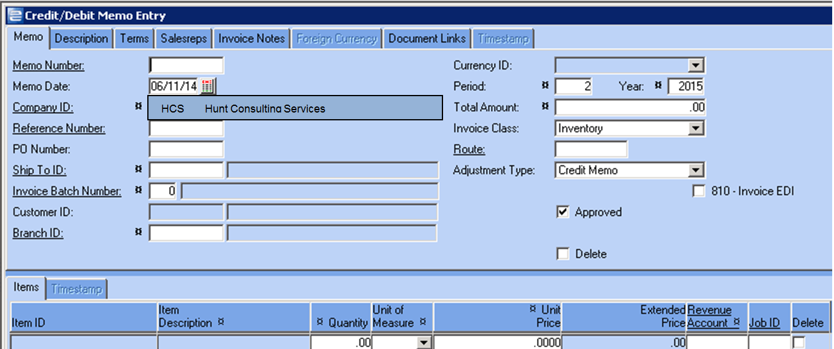

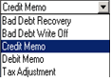

1. ADJUSTMENT TYPE: The default is CREDIT MEMO – meaning you will subtract funds from the customer’s accounts receivable. Use drop down box to select from Bad Debt Recovery, Bad Debt Writeoff, Debit Memo or Tax Adjustment.
2. MEMO NUMBER : This is a system-assigned number and is populated when you save your work.
3. REFERENCE NUMBER: If you want your credit/debit memo to be applied to a specific customer invoice, you may enter the invoice number in this field. If you want the transaction to show up separately on customer statements, etc., leave this field blank.
4. SHIP TO ID: If you use a reference number, the ship-to ID is automatically populated. If you did not use a reference number, enter the customer’s ship-to ID or browse.
5. PO NUMBER: If the transaction requires a customer PO number, key the number in this field.
6. INVOICE BATCH NUMBER: Defaults to the customer record; edit, if needed.
7. PERIOD and YEAR: Default to the current period/current year. Do not change unless specifically told to do so by accounting.
8. TOTAL AMOUNT: Key the total amount of the transaction (total credit amount, total tax to be adjusted, etc)
9. If your customer receives invoices via EDI and you want them to receive this transaction via EDI, check the checkbox 810-INVOICE EDI. Do NOT check this checkbox unless you are sure the customer is supposed to receive the copy electronically.
10. Click in the ITEM ID field. The ITEM ID does not have to be something set up in your Item database; you can key whatever is appropriate in this field. If you use an existing item in your item database, keep in mind this entry DOES NOT affect inventory counts.
11. ITEM DESCRIPTION: If you keyed an item ID that exists in the system, the description automatically populates. If the item does not exist in the item database, key an appropriate item description.
12. QUANTITY: Key the quantity you need to credit or debit. Usually this will be a quantity of 1.
13. UNIT OF MEASURE: Use the drop down arrow to select the correct unit of measure, such as EA.
14. UNIT PRICE: Key the unit selling price for the item. There is no cost of goods associated with this transaction.
15. EXTENDED PRICE: Calculates based on your unit selling price times quantity
16. REVENUE ACCOUNT: There will be a system default in this field, which is usually “sales”. Do not assume this is correct! Be sure you use the correct G/L account (you may browse). For example, you are crediting the customer $15 for freight charges. The “revenue account” would be Freight Revenue or Freight Charged to Customers.
17. If you have more than one item to credit or debit, press the enter key to get a new line. Repeat #17 for as many lines as needed.
18. Click SAVE.

TAX ADJUSTMENT

1. If you are making a tax adjustment against an invoice, you will have additional information to key in the bottom pane. When making a tax adjustment, you should always reference the original invoice so that your sales tax journal will be updated correctly for month end reporting.

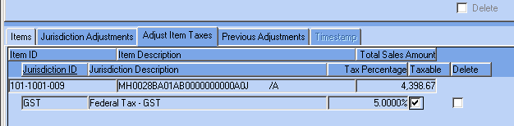

1. If the customer was charged tax, uncheck any of the TAXABLE checkboxes that apply to the transaction. In the example above, the customer was charged 5% tax on $4,398.67. We will uncheck the taxable checkbox.
2. The JURISDICTION ADJUSTMENTS tab will show you how the transaction will be completed. In the example below, you see where the taxable sales amount and tax charged are being credited, along with the TOTAL TAX ADJUSTMENT.

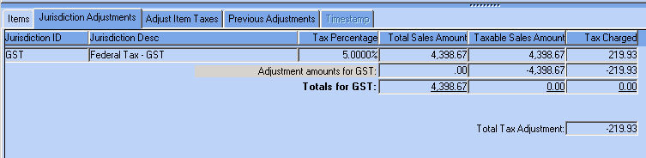

1. Click SAVE
2. If you are ADDING sales tax to an invoice, you will have the opportunity to enter the correct tax jurisdiction(s). When looking at the jurisdiction adjustment tab, you will see where the sales amounts are now added to your “taxable sales” and the sales tax adjustment will be added to the customer’s invoice and A/R.

BAD DEBT WRITEOFF

1. If you are writing off a large number of invoices for a customer for bad debt, you may choose not to create individual credits for each invoice.
2. In the credit/debit memo entry, select BAD DEBT WRITE OFF for your Adjustment Type
3. Key your ship-to ID, or browse.
4. Item ID will be BAD DEBT WRITEOFF
5. Key appropriate description.
6. Quantity will be 1
7. Unit of Measure will be EA
8. Unit Price will be the total of all of the invoices you plan to write off.
9. Revenue Account G/L number will be your Bad Debt G/L.
10. Click SAVE.
11. Once the credit to the AR has been created, you can go to Cash Receipts and post an adjustment to clear the open debits against the credit you issued for the bad debt.