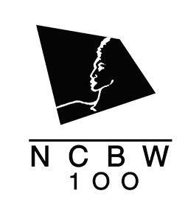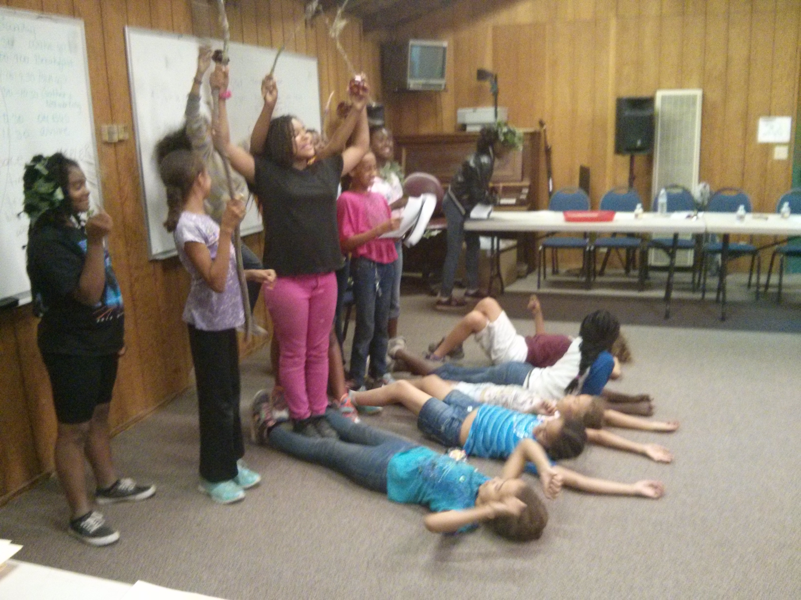

**ncbwpsmt@gmail.com**

8am-4pm

A STEM filled day hosted by the NCBW Silicon Valley Chapter on the campgrounds of Camp May Mac for colors of color in the grades of 4-6, encouraging girls of color to reach higher in STEM education. A continental breakfast and lunch will be served. Transportation to and from the camp is provided as well. For more information, please email ncbwpsmt@gmail.com

National Coalition of 100 Black Women Silicon Valley Chapter

## June 18, 2016

Camp May Mac

9115 E Zayante Road, Felton, CA 95018