**Welcome to Cheetah Paw Eco Lodge**

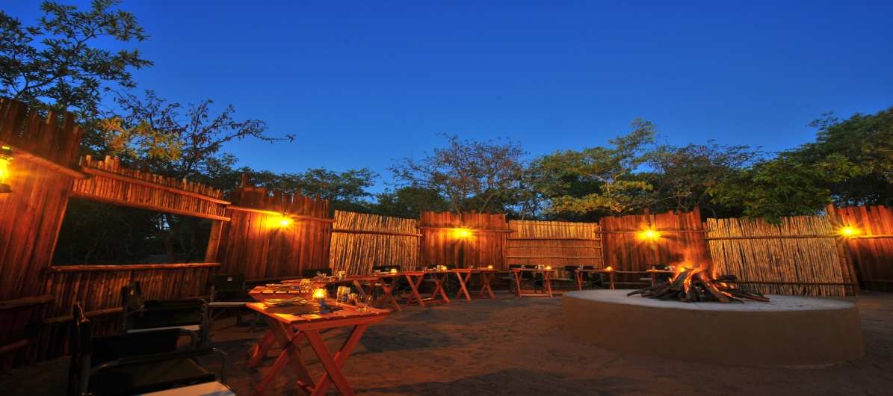

The new luxury tented camp, Cheetah Paw Eco Lodge, is a jewel in an almost untouched area of the African bush in the [**Guernsey Private Nature Reserve**](http://cheetahpaw.com/). The reserve is conveniently located close to Hoedspruit, South Africa and the gateway to the Kruger National Park.

Your hosts Doris and Juergen will warmly welcome you to **Cheetah Paw Eco Lodge**. You will find yourself in a familiar atmosphere that makes you feel much like you are staying with friends. We speak English and German.

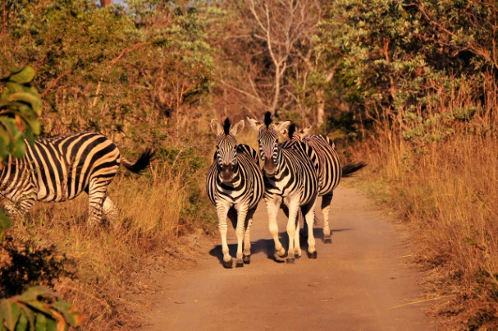

A fantastic [**affordable Lodge Safari to South Africa's Kruger area**](http://cheetahpaw.com/). Here the team of Eco Lodge decided to GO GREEN and supports the South African initiative to make people aware of the need to save their unique and precious environment.

Our team is dedicated to nature conservancy and the surroundings of the main lodge and the [**luxurious tented accommodations**](http://cheetahpaw.com/) are kept as natural as possible. Indigenous plants and trees grow all over the property and our animals find their way to our natural waterhole while peacefully grazing around the lodge in the bushes and on the natural greens.

**Address:**

Postnet Suite #16, Private Bag X3008

Hoedspruit 1380, South Africa

+27-79-563 4463

info@cheetahpaw.com