GE1201

Tutorial 11: Use of Work Personality Information for Career Planning

# Intended Learning Outcomes

* Explain the basic assessment of work personality information using the Holland Code Career Model and apply it for career planning (ILO2 & ILO 3)

Overview

**Holland Codes** are personality types created by psychologist John L. Holland as part of his theory of career choice. Holland's (1985) **Vocational Preference Inventory** **(VPI)** is the name of the test he created to measure an individual's type and match it with a list of career choices that would theoretically be good for that individual.

Holland mapped these types into a hexagon which he then broke down into the RIASEC job environments:

* 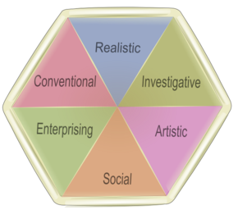**Realistic** - practical, physical, hands-on, tool-oriented
* **Investigative** - analytical, intellectual, scientific, explorative
* **Artistic** - creative, original, independent, chaotic
* **Social** - cooperative, supporting, helping, healing/nurturing
* **Enterprising** - competitive environments, leadership, persuading
* **Conventional** - detail-oriented, organizing, clerical

Holland argues that 2-3 types dominate in each person.

# Activity 1: Holland Code Quiz (Rogue Community College)

Visit <http://www.roguecc.edu/Counseling/HollandCodes/test.asp>

Each question is an opportunity for you to describe the kinds of things you (as a person) can do, might like to do or the action that most fits you.

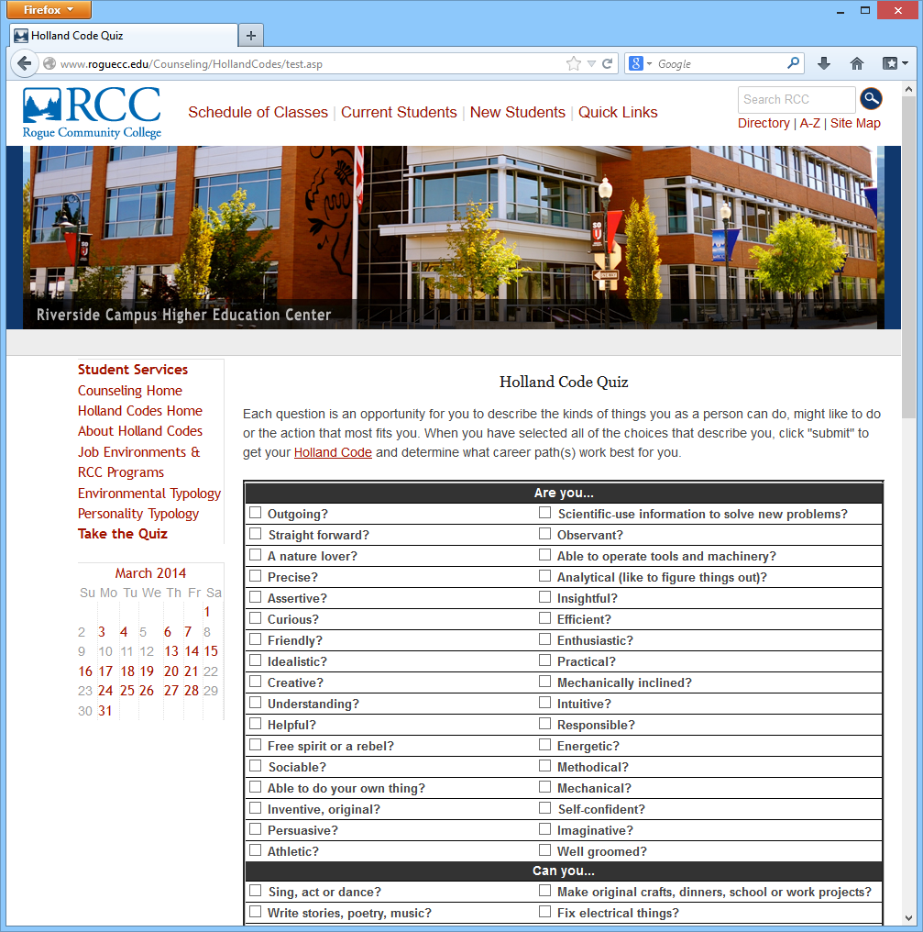

Check the appropriate checkbox **thoughtfully** and **seriously**.

When you have selected all of the choices that describe you, click “"**Submit answers and get your Holland code”** button to get your Holland Code and determine what career path(s) work best for you.

Dr. John Holland's theory that people and work environments can be **loosely classified** into six different groups. Different peoples' personalities may find different environments more to their liking. While you may have **some interests in and similarities to several of the six groups**, you may be **attracted primarily to two or three of the areas**. These two or three letters are **your Holland Code**.

## Example A:

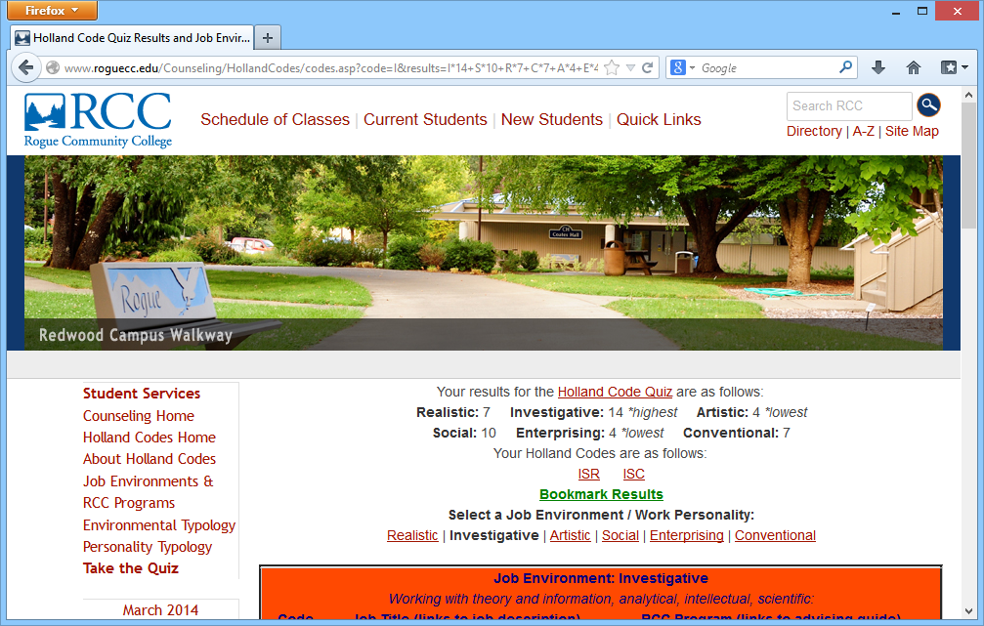

Mr. A’s Holland Code(s) are **ISR** and **ISC**, because of the tie in the results of **R** and **C** types. Click on the 3 letter code to view the suggested careers.

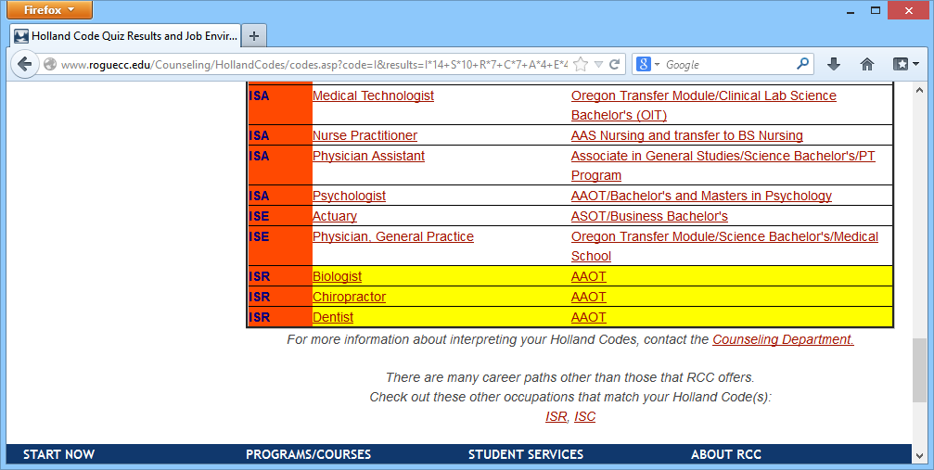

Based on Holland Codes model, the job titled Biologist, Chiropractor or Dentist is suitable for those whose result equal to ISR (Investigative, Social, and Realistic).

## Example B:

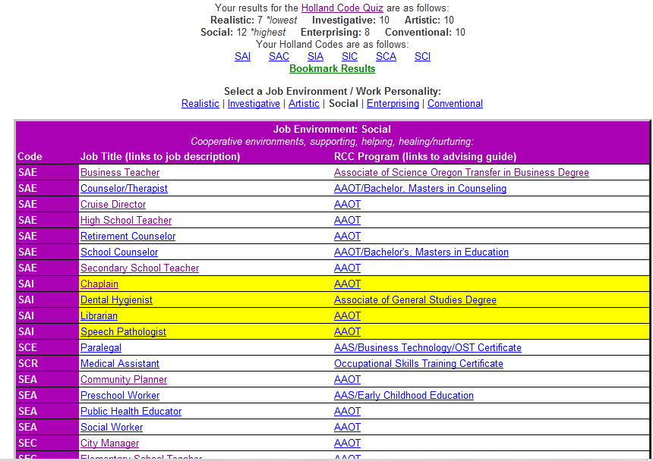

Mr. B’s Holland Code(s) are **SAI, SAC** and so on, because of the tie in the results of **S, A** and **C** types. Click on the 3 letter code to view the suggested careers.

# Activity 2: The Career Interests Game

<http://career.missouri.edu/career-interest-game>

For example, your Holland code result is ICR; if you choose I then C and then R you would most resemble the **Investigative** type, somewhat less resemble the **Conventional** type, and resemble the **Artistic** type even less. The types that are not in your code are the types you resemble least of all. Most people, and most jobs, are some combination of two or three of the Holland interest areas.

Now run your mouse across your first, then second and then third choices of the Holland categories below to find out more information on areas of study, career possibilities, co-curricular activities and identifications that correspond to your strongest interest areas.

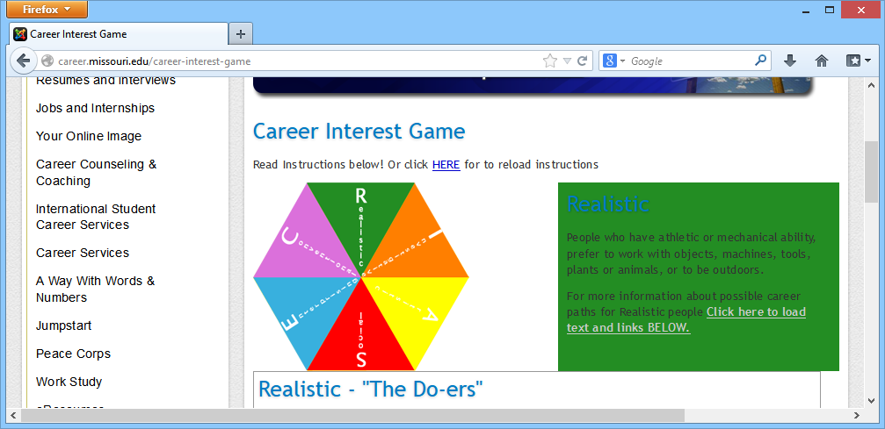

This will give you additional ways of checking out your career-related interests and getting involved in your career planning.

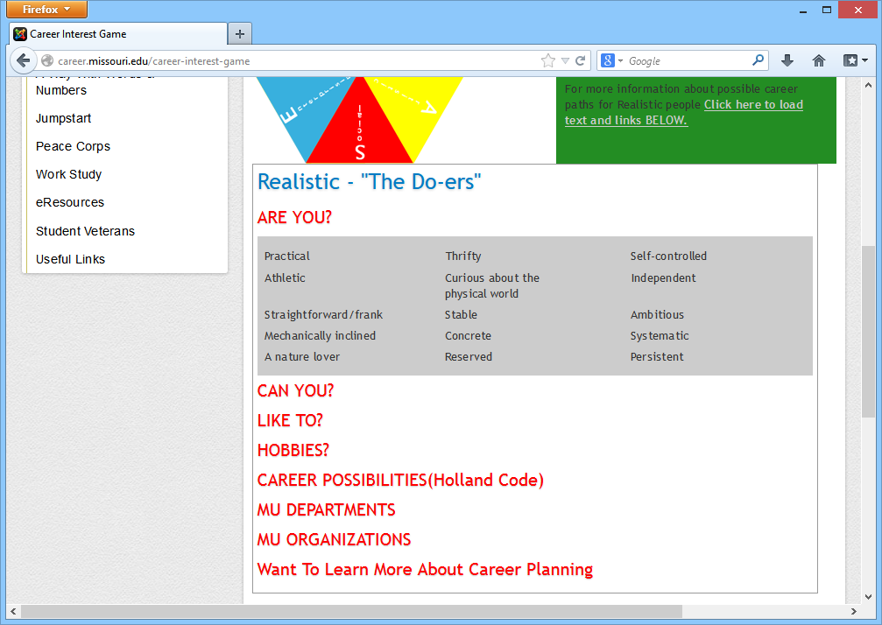

# Reference

<http://en.wikipedia.org/wiki/Holland_Codes>

[www.careerbuilder.com](http://www.careerbuilder.com)

<http://www.roguecc.edu/Counseling/HollandCodes/test.asp>

<http://career.missouri.edu/students/majors-careers/skills-interests/career-interest-game/?menu=student&expand=si>