****Republic of the Philippines

National Police Commission

**PHILIPPINE NATIONAL POLICE**

**POLICE REGIONAL OFFICE CALABARZON**

Camp Vicente Lim, Brgy. Mayapa, Calamba City

**MEMORANDUM**

FOR : PD, Cavite PPO

(Attn: Bacoor CPS)

FROM : C, CRMC

SUBJECT : SMS/TEXT MESSAGES with SFN 161201-0857

DATE : December 2, 2016

1. References:

a. PNP MEMO Cir No. 2000-20 dated February 6, 2000 re: Activation of the Complaints Referral and Action Center;

b. Letter of Instruction No. 66/09 (Integration of Complaint Center);

c. Memo from D, PCRG dated September 23, 2012;and

d. Renaming of Complaints and Referral Action Center (CRAC) into Complaints Referral and Monitoring Center (CRMC) effective October 3, 2012.

2. This pertains to the SMS/TEXT MESSAGES with SFN# 161201-0857**.** referred to this PRO for appropriate action by OCPNP SMS Center quoted as follow:

“Gd morning po sa Citihomes Molino 4 Bacoor Cavite napakaraming Pusher at mga Drug Addict wala pa pong nahuhuli ang mga Police Bacoor ditto lagi po, mga protector po kase ang mga Police ditto…saka napakarami pong colorum ditong mga sasakyan mga walang plaka halatang mga nakaw di din po hinuhuli ng mga pulis sa may bookies din po sa may gate ng citihomes…sana po makapasyal ditto si Chief PnpOR.”

3. In this regard, please acknowledge that you have received said messages/information by texting OCPNP SMS center mobile number 09178475757. Further, submit directly your action taken to the OCPNP (Attn: AC, CPNP CU/C, OCPNP SMS Center or send thru **fax # 02722-0650** or email at [pcrgncsu@yahoo.com](mailto:pcrgncsu@yahoo.com) and copy furnish this Office (Atnn: CRMC-ORPCRD or email at [crmc_pro4a@yahoo.com](mailto:crmc_pro4a@yahoo.com)) **NLT December 10, 2016** for the Regional Director’s information.

4. For priority action.

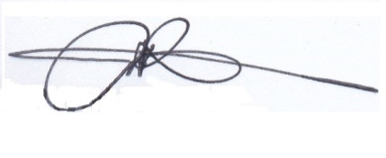

**ERWIN M OBAL**

Police Superintendent