# Leishmaniasis HPIM 18TH

## Definition

Encompassing a complex group of disorders, leishmaniasis is caused by unicellular eukaryotic obligatory intracellular protozoa of the genus *Leishmania* and primarily affects the host's reticuloendothelial system. *Leishmania* species produce widely varying clinical syndromes ranging from self-healing cutaneous ulcers to fatal visceral disease. These syndromes fall into three broad categories: visceral leishmaniasis (VL), cutaneous leishmaniasis (CL), and mucosal leishmaniasis (ML).

## Etiology and Life Cycle

Leishmaniasis is caused by ~20 species of the genus *Leishmania* in the order Kinetoplastida and the family Trypanosomatidae. Several clinically important species are of the subspecies *Viannia*. The organisms are transmitted by phlebotomine sandflies of the genus *Phlebotomus* in the "Old World" (Asia, Africa, and Europe) and the genus Lutzomyia in the "New World" (the Americas). Transmission may be anthroponotic (i.e., the vector transmits the infection from infected humans to healthy humans) or zoonotic (i.e., the vector transmits the infection from an animal reservoir to humans). Human-to-human transmission via shared infected needles has been documented in IV drug users in the Mediterranean region. In utero transmission to the fetus occurs rarely.

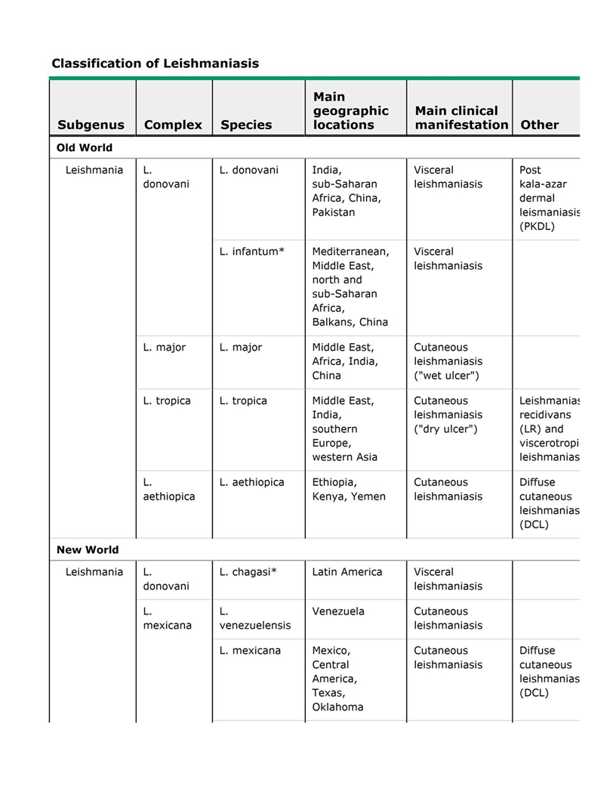

*Life cycle*

*Leishmania* organisms occur in two forms: extracellular, flagellate promastigotes (length, 10–20 µm) in the sandfly vector and intracellular, non-flagellate amastigotes (length, 2–4 µm) in vertebrate hosts, including humans. Promastigotes are introduced through the proboscis of the female sandfly into the skin of the vertebrate host. Neutrophils predominate among the host cells that first encounter and take up promastigotes at the site of parasite delivery. The infected neutrophils may undergo apoptosis and release viable parasites that are taken up by macrophages, or the apoptotic cells may themselves be taken up by macrophages and dendritic cells. The parasites multiply as amastigotes inside macrophages, causing cell rupture with subsequent invasion of other macrophages. While feeding on infected hosts, sandflies pick up amastigotes, which transform into the flagellate form in the flies' posterior midgut and multiply by binary fission; the promastigotes then migrate to the anterior midgut and can infect a new host when flies take another blood meal.

## Visceral Leishmaniasis

VL (also known as *kala-azar*, a Hindi term meaning "black fever") is caused by the *L. donovani* complex, which includes *L. donovani* and *L. infantum* (the latter designated *L. chagasi* in the New World); these species are responsible for anthroponotic and zoonotic transmission, respectively. India and neighboring Nepal, Bangladesh, Sudan, and Brazil are the four largest foci of VL and account for 90% of the world's VL burden, with India the worst affected. Zoonotic VL is reported from all countries in the Middle East, Pakistan, and other countries from western Asia to China. Endemic foci also exist in the independent states of the former Soviet Union, mainly Georgia and Azerbaijan. In the Horn of Africa, Sudan, Ethiopia, Kenya, Uganda, and Somalia report VL. In Sudan, large outbreaks are thought to be anthroponotic, although zoonotic transmission also occurs. VL is rare in West and sub-Saharan Africa.

Mediterranean VL, long an established endemic disease due to *L. infantum*, has a large canine reservoir and was seen primarily in infants before the advent of HIV. In Mediterranean Europe, 70% of adult VL cases are associated with HIV co-infection. The combination is deadly because of the impact of the two infections together on the immune system. IV drug users are at particular risk. Other forms of immunosuppression (e.g., that associated with organ transplantation) also predispose to VL. In the Americas, disease caused by *L. infantum* is endemic from Mexico to Argentina, but 90% of cases in the New World are reported from northeastern Brazil.

### Immuno-pathogenesis

The majority of individuals infected by *L. donovani* or *L. infantum* mount a successful immune response and control the infection, never developing symptomatic disease. Forty-eight hours after intradermal injection of killed promastigotes, these individuals exhibit delayed-type hypersensitivity (DTH) to leishmanial antigens in the leishmanin skin test (also called the Montenegro skin test). Results in mouse models indicate that the development of acquired resistance to leishmanial infection is controlled by the production of interleukin (IL) 12 by antigen-presenting cells and the subsequent secretion of interferon (IFN) γ, tumor necrosis factor (TNF) γ, and other pro-inflammatory cytokines by the T helper 1 (TH1) subset of T lymphocytes. The immune response in patients developing active VL is complex; in addition to increased production of multiple pro-inflammatory cytokines and chemokines, patients with active disease have markedly elevated levels of IL-10 in serum as well as enhanced IL-10 mRNA expression in lesional tissues. The main disease-promoting activity of IL-10 in VL may be to condition host macrophages for enhanced survival and growth of the parasite. IL-10 can render macrophages unresponsive to activation signals and inhibit killing of amastigotes by downregulating the production of TNF-α and nitric oxide. Multiple antigen-presentation functions of dendritic cells and macrophages are also suppressed by IL-10. Patients with such suppression do not have positive leishmanin skin tests, nor do their peripheral-blood mononuclear cells respond to leishmanial antigens in vitro. Organs of the reticuloendothelial system are predominantly affected, with remarkable enlargement of the spleen, the liver, and lymph nodes in some regions. The tonsils and intestinal submucosa are also heavily infiltrated with parasites. Bone marrow dysfunction results in pancytopenia.

### Clinical Features

On the Indian subcontinent and in the Horn of Africa, persons of all ages are affected by VL. In endemic areas of the Americas and the Mediterranean basin, immune-competent infants and small children and immune-deficient adults are affected especially often. The most common presentation of VL is an abrupt onset of moderate- to high-grade fever associated with rigor and chills. Fever may continue for several weeks with decreasing intensity, and the patient may become afebrile for a short period before experiencing another bout of fever. The spleen may be palpable by the second week of illness and, depending on the duration of illness, may become hugely enlarged. Hepatomegaly (usually moderate in degree) soon follows. Lymphadenopathy is common in most endemic regions of the world except the Indian subcontinent, where it is rare. Patients lose weight and feel weak, and the skin gradually develops dark discoloration due to hyperpigmentation that is most easily seen in brown-skinned individuals. In advanced illness, hypoalbuminemia may manifest as pedal edema and ascites. Anemia appears early and may become severe enough to cause congestive heart failure. Epistaxis, retinal hemorrhages, and gastrointestinal bleeding are associated with thrombocytopenia. Secondary infections such as measles, pneumonia, tuberculosis, bacillary or amebic dysentery, and gastroenteritis are common. Herpes zoster, chickenpox, boils in the skin, and scabies may also occur. Untreated, the disease is fatal in most patients, including 100% of those with HIV co-infection.

Leukopenia and anemia occur early and are followed by thrombocytopenia. There is a marked polyclonal increase in serum immunoglobulins. Serum levels of hepatic aminotransferases are raised in a significant proportion of patients, and serum bilirubin levels are elevated occasionally. Renal dysfunction is uncommon.

### Laboratory Diagnosis

Demonstration of amastigotes in smears of tissue aspirates is the gold standard for the diagnosis of VL. The sensitivity of splenic smears is >95%, whereas smears of bone marrow (60–85%) and lymph node aspirates (50%) are less sensitive. Culture of tissue aspirates increases sensitivity. Splenic aspiration is invasive and may be dangerous in untrained hands. Several serologic techniques are currently used to detect antibodies to *Leishmania*. An enzyme-linked immunosorbent assay (ELISA) and the indirect immunofluorescent antibody test (IFAT) are used in sophisticated laboratories. In the field, however, a rapid immunochromatographic test based on the detection of antibodies to a recombinant antigen (rK39) consisting of 39 amino acids conserved in the kinesin region of *L. infantum* is used worldwide. The test requires only a drop of finger-prick blood or serum, and the result can be read within 15 minutes. Except in East Africa (where both its sensitivity and its specificity are lower), the sensitivity of the rK39 rapid diagnostic test in immune-competent individuals is appx98% and its specificity is 90%. Qualitative detection of leishmanial nucleic acid by polymerase chain reaction (PCR) and quantitative detection by real-time PCR are confined to specialized laboratories and have yet to be used for routine diagnosis of VL in endemic areas. PCR can distinguish among the major species of *Leishmania* infecting humans.

### Differential Diagnosis

=VL is easily mistaken for malaria. Other febrile illnesses that may mimic VL include typhoid fever, tuberculosis, brucellosis, schistosomiasis, and histoplasmosis.

=Splenomegaly due to portal hypertension, chronic myeloid leukemia, tropical splenomegaly syndrome, and (in Africa) schistosomiasis may also be confused with VL.

=Fever with neutropenia or pancytopenia in patients from an endemic region strongly suggests a diagnosis of VL; hypergammaglobulinemia in patients with long-standing illness strengthens the diagnosis. In non-endemic countries, a careful travel history is essential when any patient presents with fever.

### Treatment: Visceral Leishmaniasis

#### General Considerations

Severe anemia should be corrected by blood transfusion, and other comorbid conditions should be managed promptly. Treatment of VL is complex, as the optimal drug, dosage, and duration vary with the endemic region. In spite of completing recommended treatment, some patients experience relapse (most often within 6 months), and prolonged follow-up is recommended. A pentavalent antimonial is the drug of choice in most endemic regions of the world, but there is widespread resistance to antimony in the Indian state of Bihar, where either amphotericin B (AmB) deoxycholate or miltefosine is preferred. Dose requirements for AmB are lower in India than in the Americas, Africa, or the Mediterranean region. In Mediterranean countries, where cost is seldom an issue, liposomal AmB is the drug of choice. In immunocompetent patients, relapses are uncommon with AmB in its deoxycholate and lipid formulations. Antileishmanial therapy has recently evolved as new drugs and delivery systems have become available and resistance to antimonial compounds has emerged.

Except for AmB (deoxycholate and lipid formulations), anti-leishmanial drugs are available in the United States only from the Centers for Disease Control and Prevention.

=Pentavalent Antimonial Compounds;Two pentavalent antimonial (SbV) preparations are available: sodium stibogluconate (100 mg of SbV/mL) and meglumine antimonate (85 mg of SbV/mL). The daily dose is 20 mg/kg by rapid IV infusion or IM injection, and therapy continues for 28–30 days. Cure rates exceed 90% in Africa, the Americas, and most of the Old World but are <50% in Bihar, India, as a result of resistance. Adverse reactions to SbV treatment are common and include arthralgia, myalgia, and elevated serum levels of aminotransferases. Electrocardiographic changes are common. Concave ST segment elevation is not significant, but prolongation of QTc to >0.5 s may herald ventricular arrhythmia and sudden death. Chemical pancreatitis is common but usually does not require discontinuation of treatment; severe clinical pancreatitis occurs in immunosuppressed patients.

=Amphotericin B;AmB is currently used as a first-line drug in Bihar. In others parts of the world, it is used when initial antimonial treatment fails. Conventional AmB deoxycholate is administered in doses of 0.75–1.0 mg/kg on alternate days for a total of 15 infusions. Fever with chills is an almost universal adverse reaction to AmB infusions. Nausea and vomiting are also common, as is thrombophlebitis in the infused veins. Acute toxicities can be minimized by administration of antihistamines like chlorpheniramine and antipyretic agents like acetaminophen before each infusion. AmB can cause renal dysfunction and hypokalemia and in rare instances elicits hypersensitivity reactions, bone marrow suppression, and myocarditis, all of which can be fatal.

=Paromomycin; is an aminocyclitol-aminoglycoside antibiotic with anti-leishmanial activity. Its mechanism of action against *Leishmania* has yet to be established. Paromomycin is approved in India for the treatment of VL at an IM dose of 11 mg of base/kg daily for 21 days; this regimen produces a cure rate of 95%. However, the optimal dose has not been established in other endemic regions. Paromomycin is a relatively safe drug, but some patients develop hepatotoxicity, reversible ototoxicity, and (in rare instances) nephrotoxicity and tetany.

### **Prognosis of Treated VL Patients**

Recovery from VL is quick. Within a week of the start of treatment, defervescence, regression of splenomegaly, weight gain, and recovery of hematologic parameters are evident. With effective treatment, no parasites are recovered from tissue aspirates at the post-treatment evaluation. Continued clinical improvement over 6–12 months is suggestive of cure. A small percentage of patients (with the exact figure depending on the regimen used) relapse but respond well to treatment with AmB deoxycholate or lipid formulations.

#### VL in the Immunocompromised Host

HIV/VL co-infection has been reported from 35 countries. VL behaves as an opportunistic infection in HIV-1-infected patients where both infections are endemic. HIV infection can increase the risk of developing VL several fold in endemic areas. Co-infected patients usually show the classic signs of VL, but they may present with atypical features due to loss of immunity and involvement of unusual anatomic locations, with, for example, infiltration of the skin, oral mucosa, gastrointestinal tract, lungs, and other organs. Sero-diagnostic tests are commonly negative. Parasites can be recovered from unusual sites such as broncho-alveolar lavage fluid and buffy coat. Liposomal AmB is the drug of choice for HIV/VL co-infection—both for primary treatment and for treatment of relapses. A total dose of 40 mg/kg, administered as 4 mg/kg on days 1–5, 10, 17, 24, 31, and 38, is considered optimal and is approved by the FDA, but most patients relapse within 1 year. Pentavalent antimonials and AmB deoxycholate can also be used where liposomal AmB is not accessible. Reconstitution of patients' immunity by antiretroviral therapy has led to a dramatic decline in the incidence of co-infection in the Mediterranean basin. In contrast, HIV/VL co-infection is on the rise in African and Asian countries. Ethiopia is worst affected: up to 30% of VL patients are also infected with HIV. Since restoration of the CD4+ T cell count to >200/µL does decrease the frequency of relapse, antiretroviral therapy (in addition to anti-leishmanial therapy) is a cornerstone for the management of HIV/VL co-infection. Secondary prophylaxis with liposomal AmB has been shown to delay relapses, but no regimen has been established as optimal.

## **Post–Kala-Azar Dermal Leishmaniasis**

On the Indian subcontinent and in Sudan and other East African countries, 2–50% of patients develop skin lesions concurrent with or after the cure of VL. Most common are hypo-pigmented macules, papules, and/or nodules or diffuse infiltration of the skin and sometimes of the oral mucosa. The African and Indian diseases differ in several respects;

|  |  |
| --- | --- |
| |  | | --- | | Table 212-2 Clinical, Epidemiologic, and Therapeutic Features of Post–Kala-Azar Dermal Leishmaniasis: East Africa and the Indian Subcontinent | |
| | **Feature** | **East Africa** | **Indian Subcontinent** | | --- | --- | --- | | Most affected country | Sudan | Bangladesh | | Incidence among patients with VL | ~50% | ~2% | | Interval between VL and PKDL | During VL to 6 months | 6 months to 3 years | | Age distribution | Mainly children | Any age | | History of prior VL | Yes | Not necessarily | | Rashes of PKDL in presence of active VL | Yes | No | | RX with sodium stibogluconate | 2–3 months | 2–4 months | | Natural course | Spontaneous cure in majority of patient | Spontaneous cure not reported |   In PKDL, parasites are scanty in hypo-pigmented macules but may be seen and cultured more easily from nodular lesions. Cellular infiltrates are heavier in nodules than in macules. Lymphocytes are the dominant cells; next most common are histiocytes and plasma cells. In about half of cases, epithelioid cells—scattered individually or forming compact granulomas—are seen. The diagnosis is based on history and clinical findings, but rK39 and other serologic tests are positive in most cases. Indian PKDL is treated with pentavalent antimonials for 60–120 days. This prolonged course frequently leads to noncompliance. The alternative—several courses of AmB spread over several months—is expensive and unacceptable for most patients. In East Africa, a majority of patients experience spontaneous healing. In those with persistent lesions, the response to 60 days of treatment with a pentavalent antimonial is good. |

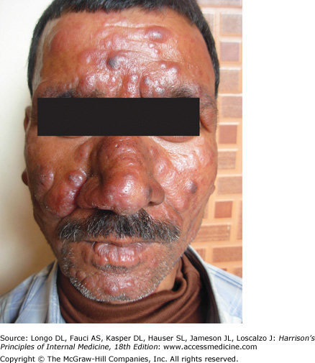 **Post–kala-azar dermal leishmaniasis in an Indian patient.** Note nodules of varying size involving the entire face. The face is erythematous, and the surface of some of the large nodules is discolored

# Cutaneous Leishmaniasis

CL can be broadly divided into Old World and New World forms. Old World CL caused by *L. tropica* is anthroponotic and is confined to urban or suburban areas throughout its range. Zoonotic CL is most commonly due to *L. major*, which naturally parasitizes several species of desert rodents that act as reservoirs over wide areas of the Middle East, Africa, and central and southern Asia. Local outbreaks of human disease are common. Major outbreaks currently affect Afghanistan and Pakistan in association with refugees and population movement. CL is increasingly seen in tourists and military personnel on mission in CL-endemic regions of countries like Afghanistan and Iraq and as a co-infection in HIV-infected patients. *L. aethiopica* is restricted to the highlands of Ethiopia, Kenya, and Uganda, where it is a natural parasite of hyraxes. New World CL is mainly zoonotic and is most often caused by *L. mexicana*, *L. (V.) panamensis*, and *L. amazonensis*. A wide range of forest animals act as reservoirs, and human infections with these species are predominantly rural. As a result of extensive urbanization and deforestation, *L. (V.) braziliensis* has adapted to peri-domestic and urban animals, and CL due to this organism is increasingly becoming an urban disease. In the United States, a few cases of CL have been acquired indigenously in Texas.

### Immuno-pathogenesis

As in VL, the pro-inflammatory (TH1) response in CL may result in either asymptomatic or subclinical infection. However, in some individuals, the immune response causes ulcerative skin lesions, the majority of which will heal spontaneously, leaving a scar. Healing is usually followed by immunity to reinfection with that species of parasite.

### Clinical Features

A few days or weeks after the bite of a sandfly, a papule develops and grows into a nodule that ulcerates over some weeks or months. The base of the ulcer, which is usually painless, consists of necrotic tissue and crusted serum, but secondary bacterial infection sometimes occurs. The margins of the ulcer are raised and indurated. Lesions may be single or multiple and vary in size from 0.5 to >3 cm (**Fig. 212-5**). Lymphatic spread and lymph gland involvement may be palpable and may precede the appearance of the skin lesion. There may be satellite lesions, especially in *L. major* and *L. tropica* infections. The lesions usually heal spontaneously after 2–15 months. Lesions due to *L. major* and *L. mexicana* tend to heal rapidly, while those due to *L. tropica* and parasites of subspecies *Viannia* heal more slowly. In CL caused by *L. tropica*, new lesions—usually scaly, erythematous papules and nodules—develop in the center or periphery of a healed sore, a condition known as *leishmaniasis recidivans*. Lesions of *L. mexicana* and *L. (V.) peruviana* closely resemble those seen in the Old World; however, lesions on the pinna of the ear are common, chronic, and destructive in the former infections. *L. mexicana* is responsible for chiclero's ulcer, the so-called self-healing sore of Mexico. CL lesions on exposed body parts (e.g., the face and hands), permanent scar formation, and social stigmatization may cause anxiety and depression and may affect the quality of life of CL patients.

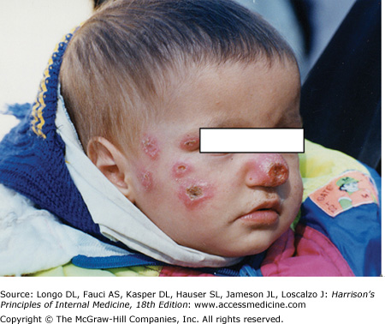

**Cutaneous leishmaniasis**. There are multiple ulcers resulting from several sandfly bites. The edges of the ulcers are raised.

### Differential Diagnosis

A typical history (an insect bite followed by the events leading to ulceration) in a resident of or a traveler to an endemic focus strongly suggests CL. Cutaneous tuberculosis, fungal infections, leprosy, sarcoidosis, and malignant ulcers are sometimes mistaken for CL.

Laboratory Diagnosis

Demonstration of amastigotes in material obtained from a lesion remains the diagnostic gold standard. Microscopic examination of slit skin smears, aspirates, or biopsies of the lesion is used for detection of parasites. Culture of smear or biopsy material may yield *Leishmania*. PCR is more sensitive than microscopy and culture and allows identification of *Leishmania* to the species level. This information is important in decisions about therapy since responses to treatment can vary with the species. Isoenzyme profiling is used to determine species for research purposes.

### Treatment: Cutaneous Leishmaniasis

Although lesions heal spontaneously in the majority of cases, their spread or persistence indicates that treatment may be needed. One or a few small lesions due to "self-healing species" can be treated with topical agents. Systemic treatment is required for lesions over the face, hands, or joints; multiple lesions; large ulcers; lymphatic spread; New World CL with the potential for development of ML; and CL in HIV co-infected patients.

A pentavalent antimonial is the first-line drug for all forms of CL and is used in a dose of 20 mg/kg for 20 days, as for VL. The exceptions to this rule are CL caused by *L. (V.) guyanensis*, for which pentamidine isethionate is the drug of choice (two injections of 4 mg of salt/kg separated by a 48-h interval), and CL due to *L. aethiopica*, which responds to paromomycin (16 mg/kg daily) but not to antimonials. Relapses usually respond to a second course of treatment.

# **Diffuse Cutaneous Leishmaniasis (DCL)**

DCL is a rare form of leishmaniasis caused by *L. amazonensis* and *L. mexicana* in South and Central America and by *L. aethiopica* in Ethiopia and Kenya. DCL is characterized by the lack of a cell-mediated immune response to the parasite, the uncontrolled multiplication of which thus continues unabated. The DTH response is negative, and lymphocytes do not respond to leishmanial antigens in vitro. DCL patients have a polarized immune response with high levels of immunosuppressive cytokines, including IL-10, transforming growth factor (TGF) β, and IL-4, and low concentrations of IFN-γ. Profound immunosuppression leads to widespread cutaneous disease. Lesions may initially be confined to the face or a limb but spread over months or years to other areas of the skin. They may be symmetrically or asymmetrically distributed and include papules, nodules, plaques, and areas of diffuse infiltration. These lesions do not ulcerate. The overlying skin is usually erythematous in pale-skinned patients. The lesions are teeming with parasites, which are therefore easy to recover. DCL does not heal spontaneously and is difficult to treat. If relapse and drug resistance are to be prevented, treatment should be continued for some time after lesions have healed and parasites can no longer be isolated. In the New World, repeated 20-day courses of pentavalent antimonials are given, with an intervening drug-free period of 10 days. Miltefosine has been used for several months with a good initial response. Combinations should be tried. In Ethiopia, a combination of paromomycin (14 mg/kg per day) and sodium stibogluconate (10 mg/kg per day) is effective.

### Mucosal Leishmaniasis

The subgenus *Viannia* is widespread from the Amazon basin to Paraguay and Costa Rica and is responsible for deep sores and for ML (Table 212-1). In *L. (V.) braziliensis* infections, cutaneous lesions may be simultaneously accompanied by mucosal spread of the disease or followed by spread years later. ML is caused typically by *L. (V.) braziliensis* and rarely by *L. amazonensis*, *L. (V.) guyanensis*, and *L. (V.) panamensis*. Young men with chronic lesions of CL are at particular risk. Overall, appx3% of infected persons develop ML. Not every patient with ML has a history of prior CL. ML is almost entirely confined to the Americas. In rare cases, ML may also be caused by Old World species like *L. major*, *L. infantum*, or *L. donovani*.

#### Immuno-pathogenesis and Clinical Features

The immune response is polarized toward a TH1 response, with marked increases of IFN-γ and TNF-α and varying levels of TH2 cytokines (IL-10 and TGF-β). Patients have a stronger DTH response with ML than with CL, and their peripheral-blood mononuclear cells respond strongly to leishmanial antigens. The parasite spreads via the lymphatics or the bloodstream to mucosal tissues of the upper respiratory tract. Intense inflammation leads to destruction, and severe disability ensues. Lesions in or around the nose or mouth (espundia; **Fig. 212-6**) are the typical presentation of ML. Patients usually provide a history of self-healed CL preceding ML by 1–5 years. Typically, ML presents as nasal stuffiness and bleeding followed by destruction of nasal cartilage, perforation of the nasal septum, and collapse of the nasal bridge. Subsequent involvement of the pharynx and larynx leads to difficulty in swallowing and phonation. The lips, cheeks, and soft palate may also be affected. Secondary bacterial infection is common, and aspiration pneumonia may be fatal. Despite the high degree of TH1 immunity and the strong DTH response, ML does not heal spontaneously.

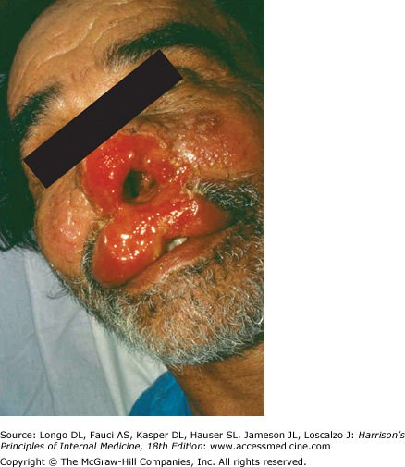

**Mucosal leishmaniasis**. There is extensive inflammation around the nose and mouth, destruction of the nasal mucosa, ulceration of the upper lip and nose, and destruction of the nasal septum.

#### Laboratory Diagnosis

Tissue biopsy is essential for identification of parasites, but the rate of detection is poor unless PCR techniques are used. The strongly positive DTH response fails to distinguish between past and present infection.

#### Treatment: Mucosal Leishmaniasis

The regimen of choice is a pentavalent antimonial agent administered at a dose of 20 mg of SbV/kg for 30 days. Patients with ML require long-term follow-up with repeated oropharyngeal and nasal examination. With failure of therapy or relapse, patients may receive another course of an antimonial but then become unresponsive, presumably because of resistance in the parasite. In this situation, AmB should be used. An AmB deoxycholate dose totaling 25–45 mg/kg is appropriate. There are no controlled trials of liposomal AmB, but administration of 2–3 mg/kg for 20 days is considered adequate. Miltefosine (2.5 mg/kg for 28 days) cured 71% of ML patients in Bolivia. The more extensive the disease, the worse the prognosis; thus prompt, effective treatment and regular follow-up are essential.

# **Prevention of Leishmaniasis**

No vaccine is available for any form of leishmaniasis. Inoculation with live *L. major* ("leishmanization") is practiced in Iran. Anthroponotic leishmaniasis is controlled by case finding, treatment, and vector control with insecticide-impregnated bed nets and curtains and residual insecticide spraying. Control of zoonotic leishmaniasis is more difficult. Use of insecticide-impregnated collars for dogs, treatment of infected domestic dogs, and culling of street dogs are measures that have been used with uncertain efficacy to prevent transmission of *L. infantum*. Personal prophylaxis with bed nets and repellants may reduce the risk of CL infections in the New World.