A CELEBRATION OF LIFE

IN LOVING MEMORY

OF

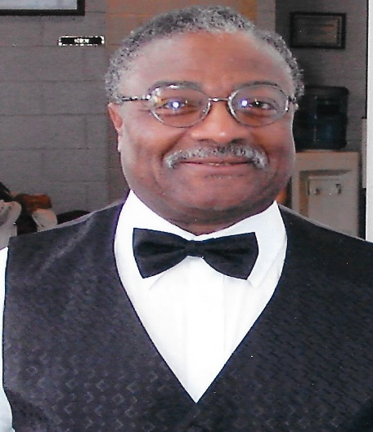

Alpha - July 10, 1932

Omega – May 17, 2016

Omega – May 17, 2016

TOMMY FRANKLIN

Thursday, June 2, 2016  
11:00 a.m.

First Baptist Church of brentwood  
4000 Wallace road  
North Brentwood, MD 20722

Dr. duane t. kay  
senior Pastor

***OBITUARY***

***T***ommy ***F***ranklin was born on July 10, 1932 in Orange, VA to the late Gladys Bowman. In the early morning hours on May 17, 2016, Tommy received his heavenly wings and took flight!

Tommy received his early education in the DC public schools system. In 1968, Tommy met the love of his life in the person of the late Jacqueline “Jackie” Franklin. The two were united in holy matrimony in 1971, and were together the proud parents of seven children.

Tommy joined First Baptist Church of North Brentwood in 1976, where he served faithfully until his health began to fail. He was a member of the Mass Choir, and was a staunch supporter of many of the other activities of the church.

He began his career with Kinsman Optometry where he remained employed for 30 years until his retirement in 2010. While there, Tommy was promoted several times, and he received many awards, accolades, and recognitions of achievement. Tommy’s entrepreneurial spirit was also evident in his personal business ventures; he was a true salesman, and had a special way of gaining support in his efforts.

Tommy is best described as a strong and true man -- strong minded, strong in his faith, strong in his display of love and devotion to family. He was a very loving and caring person who treasured his friendships and helping others. The very foundation of Tommy’s life was his family and friends. His home was an open door where anyone could visit and would receive good advice, lots of laughter, great food and overall comfort. He enjoyed his home and his favorite form of relaxation was to sit on the front porch with a cold glass of Pepsi. The lives that Tommy touched are immeasurable.

He has joined in his Maker’s arms’ his wife; Jackie, and his daughters -- Marie and Kelly. Left to cherish fond memories of Tommy are: his sons, Fred and Michael; daughters - Theresa Hall and Nancy Watts; his sister – Delores McCray; two grandsons - Keith Kearney and Darnell Franklin; 7 granddaughters - Amber Gross, Jackie Franklin, Sharrey McCombs, Edrea Dubose, Mimi Kyle, Kasia Hill and Mone’t Brown; two nephews - Tommy Ware and Gil Ware; 13 great-grandchildren; and a host of other relatives and friends who will miss him immensely.

Oder of Service

Prelude

Processional

Opening Selection Blessed Assurance - Hymn No. 508

Scripture Old Testament: Psalm 23  
 New Testament: John 14:1-6

Prayer of Comfort Rev. Edwin R James

Solo Trustee Frank Gaither

Acknowledgments

Reflections Michael Franklin and Fred Franklin

Obituary (Silent Reading-soft music)

Solo Rev. Janet Caldwell

Eulogy Rev. Dr Duane T. Kay  
 Senior Pastor

Benediction Rev. Kay

Recessional

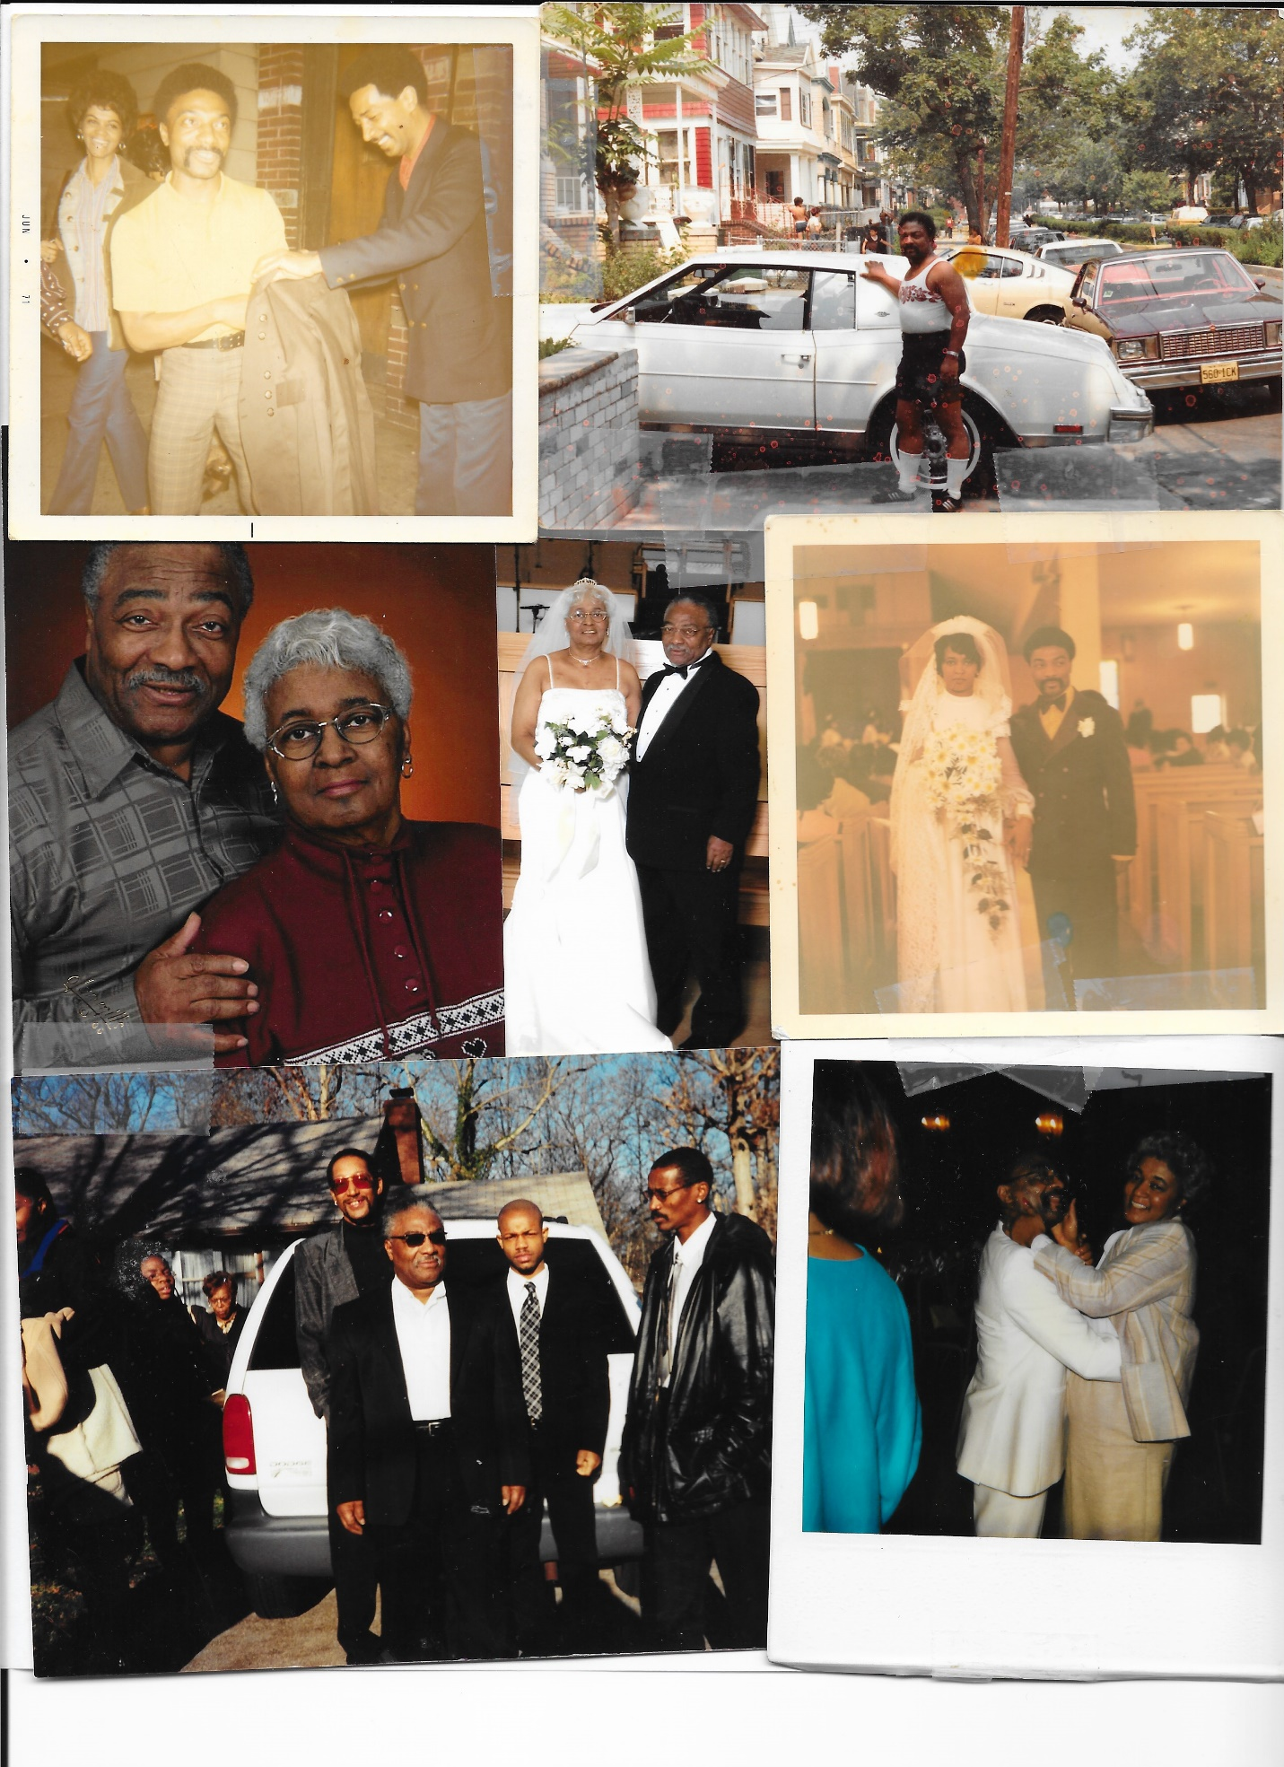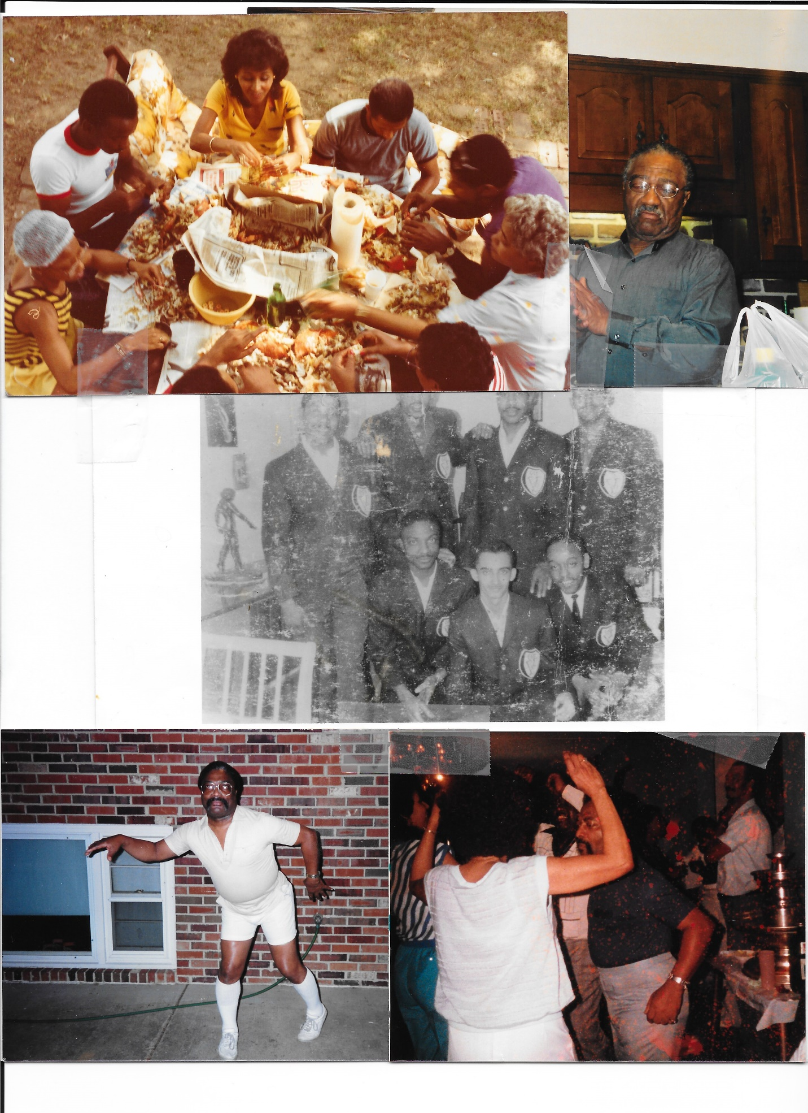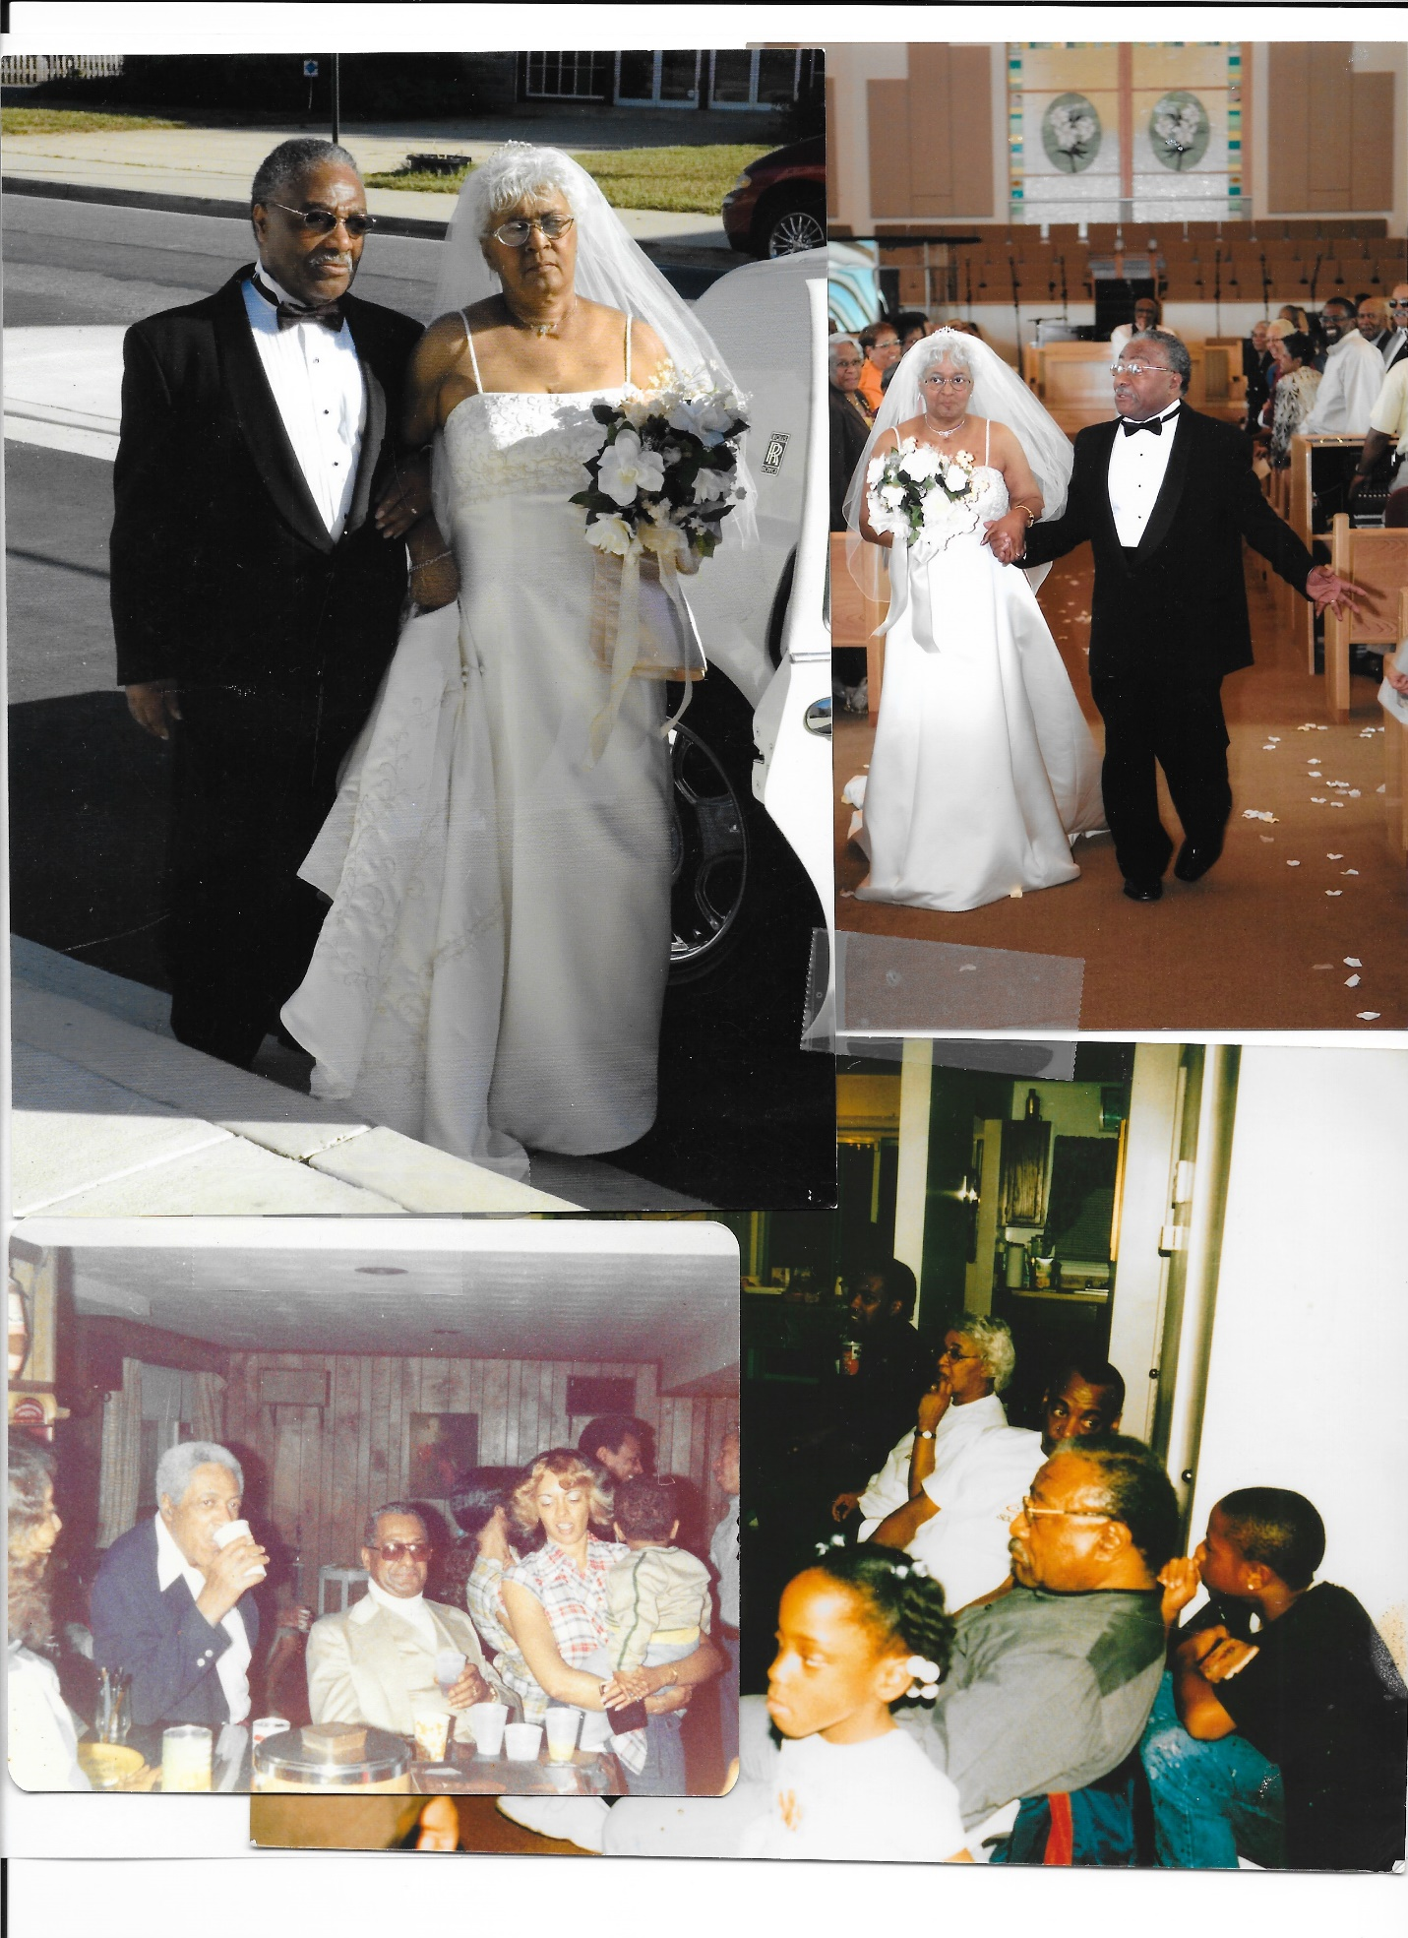

The repast will be held in the fellowship hall immediately following the service.

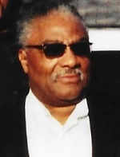

“I have fought the good fight; I have finished the race; I have kept the faith. Finally there is laid up for me a crown of righteousness, which the Lord, the righteous Judge, will give to me on that Day, and not me only, but also to all who have love His appearing.”

2 Timothy 4:7-8

The family of tommy franklin wishes to thank each and every one for your many acts of kindness during our time of bereavement. We extend Special thanks and appreciation to Rev. dr. duane T. kay and the First Baptist church of brentwood.