SU – SUPPLIER PRICE MAINTENANCE

Purpose: To provide instructions for setting up price maintenance for suppliers to accurate cost purchase orders. Note: This procedure covers only one type of price maintenance for suppliers. If you need to establish libraries, books and price pages because of quantity breaks or special discounts, see the work instruction SU – SUPPLIER PRICE LIBRARIES.

1. INVENTORY band > PURCHASING > MAINTENANCE > PURCHASE PRICING > SUPPLIER PRICING MAINTENANCE
2. Enter SUPPLIER ID (or browse)

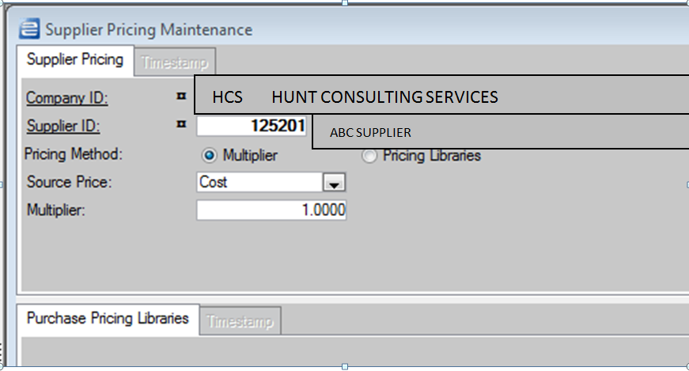

1. Check radio button PRICING METHOD as MULTIPLIER
2. Use drop down arrow to select SOURCE PRICE – Usually, this will be COST
3. Leave Multiplier at 1.0
4. Click SAVE.