|  |  |  |  |  |  |  |  |  |  |  |  |  |  |  |  |  |  |  |  |  |
| --- | --- | --- | --- | --- | --- | --- | --- | --- | --- | --- | --- | --- | --- | --- | --- | --- | --- | --- | --- | --- |
| |  | | --- | |  | |  |  | |  |  | |  |  | |  |  | |  |  | |  |  | |  |  | |  |  | | |  | | --- | | MobiSite v1 -Macrocell LTE eNodeB |  |  | | --- | | The MobiSite v1 is a self-contained macrocell eNodeB, containing the functions of the Baseband Unit (BBU) and the Remote Radio Head (RRH) in a single unit. As an integrated eNodeB, it does not require a CPRI and can work with any Ethernet backhaul. | |

|  |
| --- |
| * Benefits |
| |  | | --- | |  | |  | |  | | |  | | --- | | http://yatebts.com/images/black_bullet.png reduced civil infrastructure costs | | http://yatebts.com/images/black_bullet.png reduced time-to-market | | http://yatebts.com/images/black_bullet.png reduced costs for operation and support | | http://yatebts.com/images/black_bullet.png interconnects with any LTE core network and existing LTE RAN | | |

|  |
| --- |
|  |

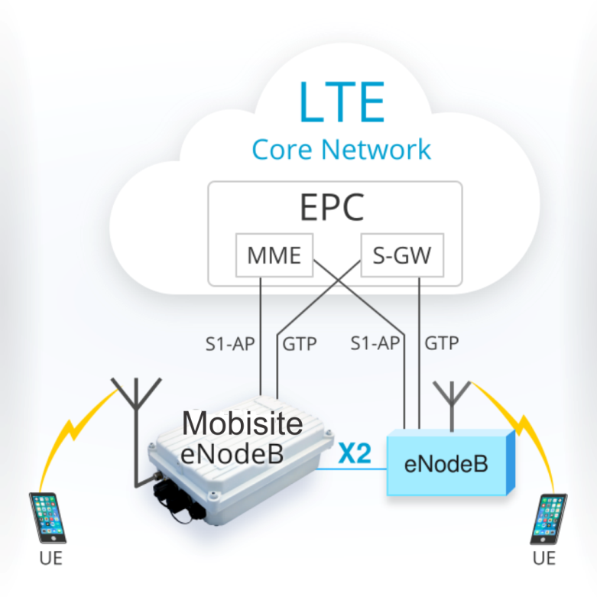http://yatebts.com/images/bullet_yate.png**Lightweight**  
The Mobisite eNodeB is a 31cmx20cmx10cm unit, weighing 5 kilograms with a power consumption of 65-80 Watts, which makes it easy to install.  
  
http://yatebts.com/images/bullet_yate.png**Local IP breakout**  
The Mobisite eNodeB supports local break-out of LTE IP traffic for edge computing.   
  
http://yatebts.com/images/bullet_yate.png**Interoperability**   
The eNodeB supports S1-AP and GTP to connect to any LTE EPC, and the X2 interface for peering with other eNodeB equipment.  
  
http://yatebts.com/images/bullet_yate.png**Linux-based OS**   
The Mobisite v1 uses a Linux operating system and COTS hardware for lower management and maintenance costs.