**Executive summary**

Tango Coffee Bar is a unique local coffee and bar house that provides a friendly, effective place where singles can meet. Our bar is not your typical bar where people go to meet other singles. The bar has a unique service called the structure conversation system that is quite effective for allowing singles to meet each other and provide them with valuable insight into the other person through reflective conversation. The structured system provides an atmosphere that lowers embarrassment and breeds confidence allowing singles to meet other singles and gain insight into their personality by way of thoughtful informal talking. Meeting people is one of the largest hurdles 25-45 year old singles face. Tango Coffee Bar provides this group with an effective solution to this problem.

**Current marketing situation**

**Target markets**

Tango Coffee Bar's customers can be broken down into two groups, singles, and non-singles. The non-singles groups are smaller than the singles groups by the fact that if you are meeting someone whom you already know, the two of you can come up with the topic of conversation yourself, therefore, Tango offers this group less value. The demographics for the non-singles is similar to the singles, to be listed below.

* **Single**: self evident.
* **Income over $40,000**: this to a large degree is correlated to the fact that they are professional.
* **Age 25-45**: the largest group of singles looking for a partner.

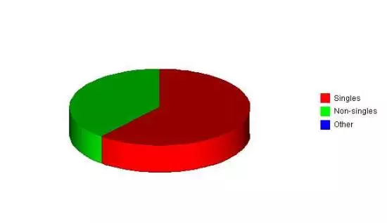

**Positioning**

The Tango will position itself as a reasonably priced bar and coffee house that has an innovative, effective system for allowing single to meet each other.

**Sales Forecast**

The first two months will be used to set up the physical location, hire personnel and obtain an alcohol license. The third month will be the grand opening. Business during the second month will be understandably slow as a steady customer base takes time to build. By month four it is forecasted that sales will steadily grow.

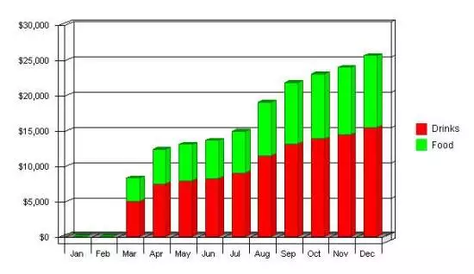

**Distribution**

All services and products will be distributed from tango's retail space.

**Advertising and promotion**

 The most successful advertising will be with Willamette Weekly.  Additionally, strategic relationships will be developed with companies such as Multnomah Athletic Club as well as use of a grassroots promotion system.

**Threats and Opportunities**

* **Threats**
* Competition from taverns.
* Competition from other sources of singles meeting events.
* A slump in the economy which will decrease discretionary spending
* **Opportunities**
* Increasing sales opportunities as people become familiar with the advantages of the structured conversation system.
* The ability to lower variable costs through efficiency gains

**Marketing Objectives**

* Develop brand awareness through a steady, month to month increase of new customers.
* Develop an increase in sales while achieving a decrease in marketing expenses.
* Develop awareness of the structured conversation system measured by customers coming to the tango coffee shop solely for meeting people

**Keys to Success**

* Attracting customers who find value in the Tango coffee shop offering and who will frequent the Shop regularly in order to meet like-minded single people.
* Excellent customer service.
* Maintaining a cost of goods on foods at below 50%

.

### Critical Issues

The tango coffee shop is still in the speculative stage as a retail operation. Its critical issues are: to continue to take a moderate fiscal approach to business operations and to build brand awareness which will drive customers to the tango coffee shop

**Marketing Strategy**

The single objective is to position The Tango Coffee Shop as the premier place for young professional singles to meet like-minded individuals.  The marketing strategy will seek to first create customer awareness regarding their services offered, develop that customer base, and work toward building customer loyalty and referrals.

The message Of Tango Coffee Shop will seek to communicate is that The Tango Coffee Shop is THE place to meet intelligent singles.  This message will be communicated through a variety of methods.  The first method will be advertisements.  The bulk of the advertisements will be in the Willamette Weekly, a weekly entertainment guide in Portland that has impressive readership numbers for the desired target population.

Another method will be through establishing strategic relationships with companies that have similar demographics such as the Multnomah Athletic Club.  Establishing a mutually beneficial relationship will allow both organizations to develop visibility for each other.

The other form of advertising will be using "grassroots" methods where customers will be given coupons for their friends to try Tango Coffee Shop for the first time.  The coupon will be an economic incentive for the newcomer to try Tango Coffee Shop The coupon also has the added force of a referral from a friend

**Action** **Programs**

No Action Programs

**Budgets**

### Break-even Analysis

The Break-even Analysis indicates that $20,299 will be needed in monthly revenue to reach the break-even point.

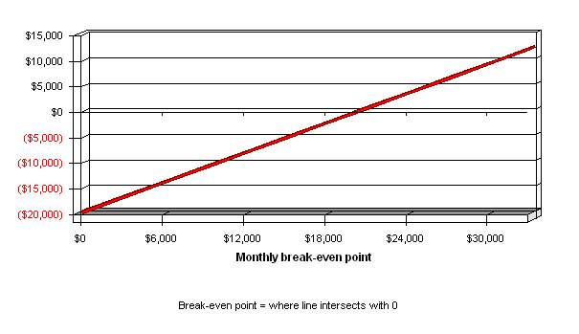

### Break-even Analysis

|  |  |
| --- | --- |
| **Break-even Analysis** | |
|  |  |
| Monthly Revenue Break-even | $20,299 |
|  |  |
| Assumptions: |  |
| Average Percent Variable Cost | 32% |
| Estimated Monthly Fixed Cost | $19,654 |

### Sales Forecast

|  |  |  |  |
| --- | --- | --- | --- |
| **Sales Forecast** | | | |
|  | 2001 | 2002 | 2003 |
| Sales |  |  |  |
| Drinks | $105,921 | $271,254 | $296,874 |
| Food | $69,908 | $179,028 | $195,937 |
| Total Sales | $175,829 | $450,282 | $492,811 |
|  |  |  |  |
| Direct Cost of Sales | 2001 | 2002 | 2003 |
| Drinks | $26,480 | $67,814 | $74,219 |
| Food | $29,361 | $75,192 | $82,293 |
| Subtotal Direct Cost of Sales | $55,842 | $143,005 | $156,512 |

### Expense Forecast

Marketing expenses are budgeted to remain fairly steady throughout the year.  There will be an initial ramp up of spending to generate visibility.  After this ramp up advertising will be fairly consistent month to month.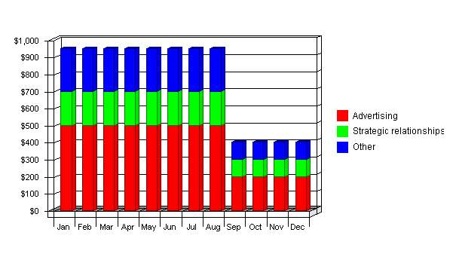

### Marketing Expense Budget

|  |  |  |  |
| --- | --- | --- | --- |
| **Marketing Expense Budget** | | | |
|  | **2001** | **2002** | **2003** |
| **Advertising** | **$4,800** | **$2,400** | **$2,400** |
| **Strategic relationships** | **$2,000** | **$1,200** | **$1,200** |
| **Other** | **$2,400** | **$1,200** | **$1,200** |
|  | **------------** | **------------** | **------------** |
| **Total Sales and Marketing Expenses** | **$9,200** | **$4,800** | **$4,800** |
| **Percent of Sales** | **5.23%** | **1.07%** | **0.97%** |

.