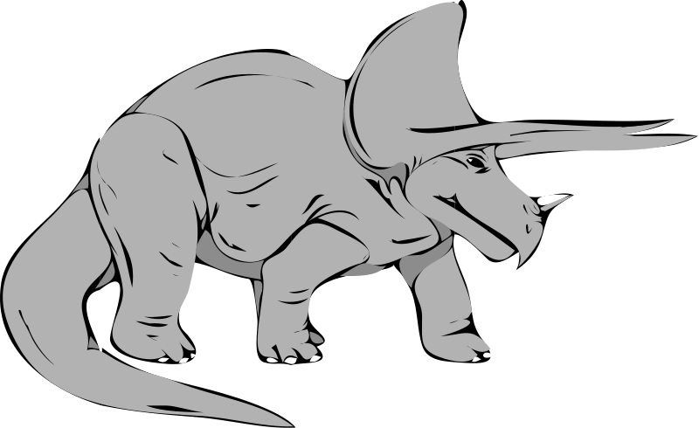Dangerous Dino

Research Project and Paper

**Teaching Tidbit:** This is a research project based off of the many dinosaurs that Sky meets in her topside adventure. Your students will choose a dinosaur and do research on it. Ask them to find out basics of what it looked like, what it might have eaten, who discovered it, how it might have lived, etc. Then ask them to write a research paper supporting the claim that THEIR dinosaur either should or should not win the “Dangerous Dino Award.” They will need to support their claim that their dinosaur is the most dangerous (or not the most dangerous) by utilizing textual evidence found in their research.

**Fun Idea**- Print off large pictures of each of the dinosaurs available for research and laminate them. Make sure you have the dinosaurs name listed somewhere on the picture you printed out. Use pushpins to put these up on your bulletin board. Make sure you have enough pictures so that each of your students can have a dinosaur. (this means you will have multiple pictures of the same dinosaur.) When it comes time to start the research project, tell your students it is going to work on a “first come, first serve” basis. As they enter the class that day, have instructions on the board that they should go to the bullion board and chose their dinosaur. Once they have written down their dinosaur’s name on their research packet, they will replace the dinosaur on the bulletin board for the next class. This is also helpful to have as you read the novel to act as a visual of the dinosaurs that Sky, Shawn, and Todd meet on their adventure.

**Standards:**

|  |  |
| --- | --- |
| **7.W.4** | Apply the **writing process** to –  ● Plan and develop; draft; revise using appropriate reference materials; rewrite; try a new approach; and edit to produce and strengthen writing that is clear and coherent, with some guidance and support from peers and adults.  ● Use technology to interact and collaborate with others to generate, produce, and publish writing and link to sources. |

|  |  |
| --- | --- |
| **7.RN.2.1** | Cite several pieces of textual evidence to support analysis of what a text says explicitly as well as inferences drawn from the text. |

|  |  |
| --- | --- |
| **7.ML.1** | Critically analyze information found in electronic, print, and mass media used to inform, persuade, entertain, and transmit culture. |

|  |  |
| --- | --- |
| **7.W.3.1** | Write **arguments** in a variety of forms that –  ● Introduce claim(s), acknowledge alternate or opposing claims, and use appropriate organizational structures.    ● Support claim(s) with logical reasoning and relevant evidence, using accurate, credible sources and demonstrating an understanding of the topic or text.    ● Establish and maintain a consistent style and tone appropriate to purpose and audience.    ● Use effective transitions to create cohesion and clarify the relationships among claim(s), reasons, and evidence.    ● Provide a concluding statement or section that follows from and supports the argument presented. |

|  |  |
| --- | --- |
| **7.W.5** | Conduct short research assignments and tasks to build knowledge about the research process and the topic under study.  ● Formulate a research question.    ● Gather relevant information from multiple sources, using search terms effectively, and annotate sources.    ● Assess the credibility and accuracy of each source.    ● Quote or paraphrase the information and conclusions of others.    ● Avoid plagiarism and follow a standard format for citation.    ● Present information, choosing from a variety of formats. |

**Assessment Materials:**

Dangerous Dino Project Overview

Dangerous Dino Poster

Dangerous Dino Mini Outline

**Practice Materials:**

“Libraries” Article (Read and annotate this as a class. Then use it to fill in the practice mini organizer)

<http://www.theguardian.com/books/2013/feb/13/libraries-horrible-histories-terry-deary>

Practice Mini Organizer for “Libraries” article (This could easily be adapted for ANY article with an obvious claim.)

**Suggestions for Scaffolding:**

**Experts:** Ask them to do additional research on their dinosaur, providing an extra source or two. If they finish early, allow them to help your “Not there yet” kids or a special needs student.

**Got it:** Give assessment as designed.

**Not There Yet:** Choose some of the easier researched dinosaurs (Spinosaurous or T-rex) for them to research.

**Special Needs:** Provide them a set of articles on one of the easier to research dinosaurs (T-rex or Spinosaurous). Allow them to highlight and annotate the articles with either a teacher’s aid or an “expert” level student. You could also have them do the mini organizer instead of writing the full paper, or only require them to write one body paragraph instead of three.

__________ School’s

Dangerous Dino

Research Project

Dinosaurs were dangerous but were some *more* dangerous than others? For this project, you will be responsible for researching the history, appearance, life style, and habits of one of the dinosaurs encountered by Sky in *Edge of Extinction.* You will ultimately write a research paper supporting the claim that your dinosaur either SHOULD or SHOULD NOT win the **Dangerous Dino Award**. To share your information, you will be creating a campaign poster for your dinosaur, filling in a mini outline that shows your arguments for why our dinosaur should win, and writing a formal research paper.

**Dinosaur Candidates (circle the dinosaur you are going to research so you don’t forget!)**

* Deinonychus
* Microceratus
* Tyrannosaurus Rex
* Troodon
* Allosaurous
* Ankylosaur
* Brachiosaur
* Microrraptor
* Spinosaurous
* Saltopus

**Dinosaur Poster Requirements:**

* Introduces your dinosaur
* Provides information on why that dinosaur should or should not win the award.
* Colorful and easy to read (not overly cluttered or sloppy)
* Shows time and effort
* Includes at least ONE picture of the dinosaur

**Mini Organizer Requirements:**

* Filled in completely and neatly
* Uses your research to choose the three STRONGEST pieces of evidence to support your claim.
* Completed prior to writing your actual research paper. This will be a guide to make sure your write a well-organized paper that uses lots of textual evidence.

**Paper Requirements:**

* Well written with an introduction, three body paragraphs, and a conclusion
* Includes a works cited page
* Uses Textual evidence to support your claim

In class you will learn the techniques that go into good research and supporting a claim. Some class time will be devoted to the project, but you need to budget your time so you’re not pulling an all-nighter the night before the project is due. The project must be ready to be presented on _______________. If you have questions, ask. Good Luck, and may the Force be with you.

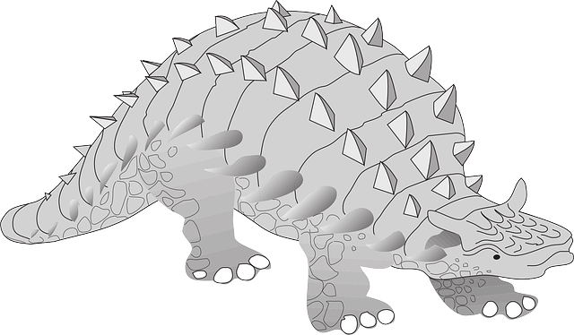

**Dinosaur’s Name**

For20___ Dangerous Dino Award

Nominated by:_______________________

Paste Photo Here

**Brief Information Overview**

Here you can insert information giving a brief overview of your dinosaur.

(This should be in your OWN words and not copy/ pasted from a website!)

**Reason #1: Key Words**

Here you can insert text (quotes) that back up your claim.

**Reason #3: Key Words**

Here you can insert text (quotes) that back up your claim.

**Reason #2: Key Words**

Here you can insert text (quotes) that back up your claim.

Works Cited:

“Name of Web Article.” *Name of Web Page*. Web page sponsor, date published. Web. Date accessed (Day

Month Year).



**Dangerous Dino MINI Outline**

I. Introduction   
My claim is that __________________________most deserves to win/lose the Dangerous Dino Award

Next provide some background information on your dinosaur. (Who discovered it… When it lived. Etc.)  
________________________________________________________________________________________________________________________________________________________________________________________________________________________________________________________________________________________________________________________________________________________________________________________________________  
II. BODY**-7.RI.8- Cite specific evidence that supports inferences drawn from multiple texts.**

|  |  |
| --- | --- |
| Claim 1:____________________________________________________________________________  Support from research: | |
| Claim 2: ____________________________________________________________________________  Support from research: | |
| Claim 3:____________________________________________________________________________  Support from research: | |
|  |

II. Conclusion (Why should your dinosaur win or not win this award? Provide some ideas for who SHOULD win if they don’t, or who they might beat and why. Possibly discuss what life would be like if this dinosaur were still a live today.)  
________________________________________________________________________________________________________________________________________________________________________________________________________________________________________________________________________________________________________________________________________________________________________________________________________And that is why I believe that __________________ most deserves to win/not win the Dangerous Dino Award.



**Tracing Arguments Practice- Libraries**

**Learning Targets- 7.RI.1 Cite specific evidence that supports inferences drawn from multiple texts.  
 7.RI.8 Trace arguments and claims**

**Directions:** Write the THREE strongest claims for why Terry Deary the author of “Libraries have had their day” doesn’t like libraries. Support each of the claims with textual evidence.

**CLAIM # 1: We should get rid of libraries because__________________________________.**

#1 Evidence from the article to support the claim:

What logical reason(s) will you give to tell how this evidence supports the claim?

**CLAIM # 2: We should get rid of libraries because ______________________________________________.**

#2 Evidence from the article to support the claim:

What logical reason(s) will you give to tell how this evidence supports the claim?

**CLAIM # 3: We should get rid of libraries because ______________________________________________.**

#3 Evidence from the article to support the claim:

What logical reason(s) will you give to tell how this evidence supports the claim?

**Is all of your evidence relevant and is all of your reasoning sound and logical? Explain.**

Which piece of evidence best supports the claim that **we should get rid of libraries**?

Do you think the evidence in this source alone is sufficient to make the claim that libraries should be banned? Why or why not?

What are two ways the evidence could be made stronger? (What could have been included in the article that would have made it more convincing?)

1.

2.