|  |
| --- |
| Module - Firefighting Airspace |
| Overview |
| Goal: Students will develop a picture of what the airspace above them looks like. This will help contribute to pilot safety and setting realistic and effective goals. |

Exercise

Match the resource to the job description in the matching section below. In the aviation stack-up and airspace configuration diagram, fill in the blanks with the correct resource.

Draw in a line to match the resource to the description.

|  |  |  |
| --- | --- | --- |
| ASM |  | Normally orbit at 1500 foot AGL and work with lead planes or ASM to coordinate retardant drops before going tactical. |
| LEAD PLANE |  | Typically operate in the 500 foot AGL and below level doing diverse missions |
| AIR TANKERS |  | My job is to put red stuff and wet stuff on the ground and give firefighters situational awareness. I’m a flying division supervisor who coordinates the airspace stack. Normally orbiting at 2500 feet AGL. |
| HELICOPTERS |  | The role of the aircraft is to guide the air tankers into a drop. Typically operating at 500 feet prior to a drop. |
| AIR ATTACK |  | Aerial Supervision Module, which is an Air Attack who’s qualified to go low level and fly in the lead plane and is capable of doing both Lead and Air Attack at the same time. |
| SEATS |  | Single engine air tankers. |

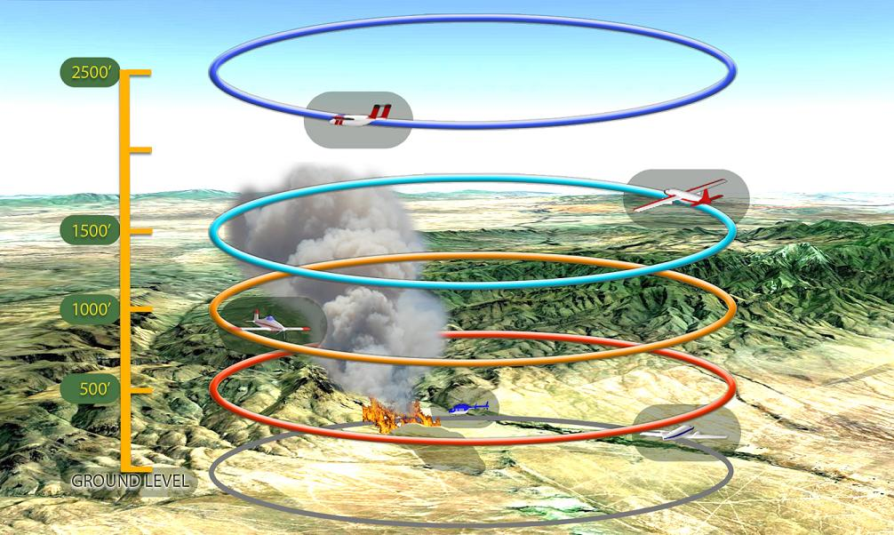

Fill in the Blanks of the airspace stack with the correct resource (altitudes are in AGL)

Tactical Maneuvering/ SEATS

Helicopters/Low Level ops

Air Attack orbit

Air Tankers orbit

Lead Plane

Special thanks to the following

Gil Dustin, Aerial Supervisor, Grand JCT CO, BLM

Steve Price, Aerial Supervisor, Boise ID, BLM

for their efforts towards the production of this module.