|  |  |
| --- | --- |
| FGDC LOGO | **Federal Geographic Data Committee**  **Standards Update**  **December 2014**    **Julie Binder Maitra,** [**jmaitra@fgdc.gov**](mailto:jmaitra@fgdc.gov)**, 703-648-4627** |

Contents

FGDC 1

INCITS Technical Committee L1, Geographic information systems – U.S. Technical Advisory Group to ISO Technical Committee 211, Geographic information/Geomatics 1

Open Geospatial Consortium 3

Geospatial-Intelligence Standards WG (GWG) 4

Other 4

## FGDC

The December 11 FGDC Standards WG meeting was canceled. The meeting will be rescheduled for March 2015. Potential topics:

* For information
  + NASA Earth Science Data and Information System (ESDIS) Standards Office (ESO)
  + USGS Standards DB Explorer
  + Canadian geospatial standards program
* For recommendation:
  + draft revised Geographic Information Framework Data Content Standard, Part 4: Geodetic Control
  + draft revised FGDC Standards WG charter
  + NSDI Strategic Plan task plan
  + final draft Shoreline Data Content Standard

## INCITS Technical Committee L1, Geographic information systems – U.S. Technical Advisory Group to ISO Technical Committee 211, Geographic information/Geomatics

The National Geospatial-Intelligence Agency (NGA) rejoined INCITS L1 on December 1.

Meetings

INCITS L1/U.S. TAG met Wednesday, December 10 at GMU CSISS. Its next meeting is scheduled for April 10, 2015.

ISO/TC 211 met November 24-28 in Shenzhen, China.

* The Control Body (CB) for the ISO Registry for Geodetic Codes and Parameters met on 11/26, co-chaired by Mike Craymer, Canadian Geodetic Survey, and Larry Hothem. An initial public release of the Registry had been planned for the Shenzhen meeting. However, because more work was required on the software to manage the Registry, official roll-out is delayed until March 2015. Monthly WebEx meetings of the CB will continue for the foreseeable future. As a side matter to the monthly CB meetings, discussion will continue with the goal of preparing a report on justification for required revisions for ISO 19111, Geographic information – Spatial referencing by coordinates, that would be distributed to TC211 by April 2015. This effort may lead to adoption of a New Work Item Project (NWIP) on revising 19111 at the TC211 Plenary, June 2015, in Southampton, UK.

The British Standards Institute (BSI) has offered to host the ISO/TC 211 meetings in Southampton, United Kingdom, in May/June 2015.

2015 Five-Year National Maintenance of INCITS Standards

On December 4, the INCITS Secretariat issued a call for the 2015 5-year national maintenance review of the standards listed in Table 1:

Table 1 5-year national maintenance review

| **Standard Designation [adoption year]** | **Title** |
| --- | --- |
| INCITS/ISO 19108:2002/COR1:2006[2010] | Geographic information - Temporal schema TECHNICAL CORRIGENDUM 1 |
| INCITS/ISO/TS 19139:2007[2010] | Geographic information - Metadata - XML schema implementation |
| INCITS/ISO/TS 19138:2006[2010] | Geographic information - Data quality measures |
| INCITS/ISO 19128:2005[2010] | Geographic information - Web Map server interface |
| INCITS/ISO/TS 19127:2005[2010] | Geographic information - Geodetic codes and parameters |
| INCITS/ISO 19136:2007[2010] | Geographic information - Geography Markup Language |
| INCITS/ISO 19125-2:2004[R2010] | Geographic information - Simple feature access - Part 2: SQL option |
| INCITS/ISO 19125-1:2004[R2010] | Geographic information - Simple feature access - Part 1: Common architecture |
| INCITS/ISO 6709:2008/COR 1:2009[2010] | Standard representation of geographic point locations by coordinates |
| INCITS/ISO 19144-1:2009[2010] | Geographic information - Classification Systems - Part 1: Classification system structure |
| INCITS/ISO 19111-2:2009[2010] | Geographic information - Spatial referencing by coordinates - Part 2: Extension for parametric value |
| INCITS/ISO/TS 19103:2005[2010] | Geographic information - Conceptual schema language |
| INCITS/ISO/TS 19104:2008[2010] | Geographic information - Terminology |
| INCITS/ISO 19110:2005[R2010] | Geographic information - Methodology for feature cataloguing |
| INCITS/ISO 19116:2004[R2010] | Geographic information - Positioning services |
| INCITS/ISO 19106:2004[R2010] | Geographic information - Part 6: Profiles |
| INCITS/ISO 19119:2005[R2010] | Geographic information - Services |

The INCITS due date for 2015 5-year national maintenance review is May 15, 2015.

Contact

Contact Julie Maitra, principal FGDC rep to L1, or your agency’s representative(s) to INCITS L1 for more information.

## Open Geospatial Consortium

TC/PC meetings

The OGC TC/PC meeting was held December 1-5 in Tokyo. The next OGC TC/PC Meeting is scheduled for March 9-13, 2015 in Barcelona, Spain.

2015 What’s Ahead

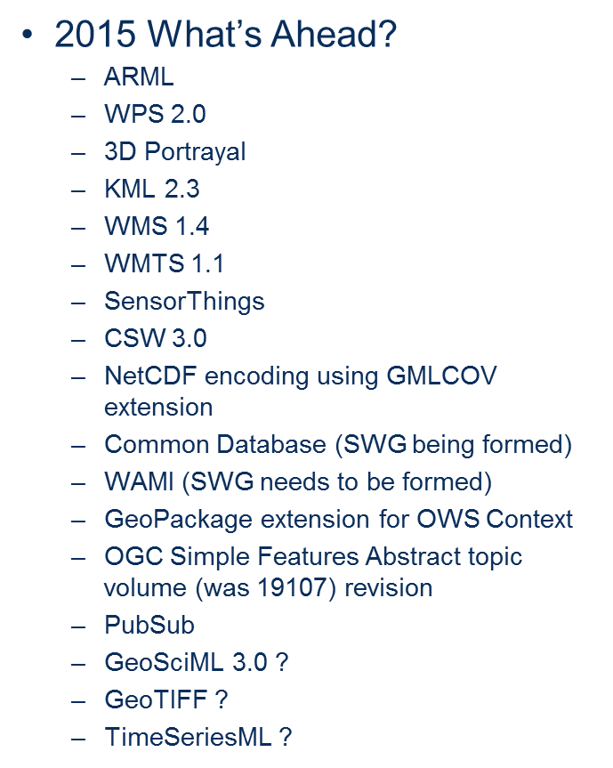

OGC and the World Wide Web Consotium (W3C)

The W3C and OGC will collaborate to improve interoperability and integration of spatial data on the Web. For this collaboration, W3C and OGC have each launched a Spatial Data on the Web Working Group: see <http://www.w3.org/2015/spatial/> and <http://www.opengeospatial.org/projects/groups/sdwwg>. The groups will coordinate closely and publish deliverables jointly. For W3C, this work is supported in part by the SmartOpenData project.

The World Wide Web Consortium (W3C) is an international consortium where Member organizations, full-time staff, and the public work together to develop Web standards that ensure long-term growth for the Web. The Open Web Platform is a current major focus. Over 400 organizations are Members of the Consortium. W3C is jointly run by the MIT Computer Science and Artificial Intelligence Laboratory (MIT CSAIL) in the USA, the European Research Consortium for Informatics and Mathematics (ERCIM) headquartered in France, Keio University in Japan, and Beihang University in China, and has additional Offices worldwide. For more information see <http://www.w3.org/>.

OGC/TC 211 Joint Advisory Group (JAG)

JAG Terms of Reference (ToR) were sent to ISO/TC 211 Secretariat and OGC TC Chair for comments. There is a need to introduce revision of joint standards. The revised ToR were submitted to ISO/TC 211 and OGC for circulation to members for final comments and approval. Anticipated adoption is June 2015.

JSON

The OGC Architecture Domain Working Group (DWG) recommended wide OGC discussion of these policy statements:

* “Future OGC documents that are put forward for adoption may reference GeoJSON (IETF version) as a normative reference.” This decision was deemed a bit incomplete, given that the current GeoJSON is still an Active Internet-Draft (individual) within IETF.
* “OGC documents that are put forward for adoption may reference GeoJSON (IETF version) as informative.” Once the IETF document is a standards track IETF RFC, then the OGC can resolve to allow GeoJSON references to be normative.
* *“OGC recognizes the need to specify encodings in JSON for requirements that go beyond GeoJSON, e.g., for complex schemas.”*
* *“Over time OGC SWGs should move toward common patterns for the OGC use of JSON”*

The DWG also recommended action to reconstitute the OWS “Common” SWG to develop guidance on OWS Common – JSON encoding. This could also include CSV patterns for encoding. It also encouraged Testbed 11 Engineering Report editors to produce a document that can be quickly made into an OWS Common – JSON encoding standard.

Contact

Contact your agency’s representative(s) to OGC for more information.

## Geospatial-Intelligence Standards WG (GWG)

The GWG Geospatial Web Services Focus Group will meet on March 5 at Scitor in Reston, Virginia.

The date for the 15-1 GWG voting meeting has not yet been set.

Contact

For more information, contact Julie Maitra, FGDC representative to GWG, or your agency’s representative to GWG.

## Other

Please refer to the standards tracking log for progress on FGDC, INCITS, ISO, OGC, and GWG standards.