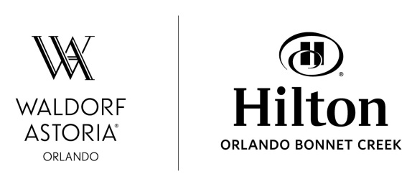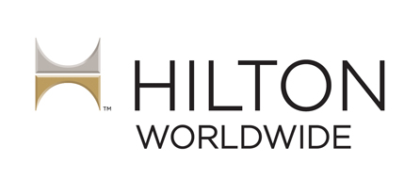

**CONTACTS:**

Liz Weeden

For Hilton Orlando Bonnet Creek & Waldorf Astoria Orlando

+1 212-868-1900 x253

lweeden@quinn.pr

Suzanne Stephan

Hilton Orlando Bonnet Creek & Waldorf Astoria Orlando

+1 407-597-3658

[suzanne.stephan@hilton.com](mailto:suzanne.stephan@hilton.com)

**Waldorf Astoria Orlando and Hilton Orlando Bonnet Creek Appoint David Wahba as Director of Sales**

**ORLANDO, Fla. – January 7, 2016 –** [Waldorf Astoria Orlando](http://www.waldorfastoria.com/orlando) and Hilton Orlando Bonnet Creek, two premier hotels surrounded by the Walt Disney World® Resort, have appointed David Wahba director of sales. Bringing nearly 20 years of managerial sales experience to his new role, Wahba will lead the development of sales strategies across the dual-hotel complex. As director of sales, Wahba will lead the execution of group room sales for both the Waldorf Astoria Orlando and Hilton Orlando Bonnet Creek, comprising a total of 1,498 guest rooms and 175,000 square feet of meeting space.

“We are excited to welcome David and know he will make a great addition to the sales team,” said Peter Kacheris, managing director, Waldorf Astoria Orlando and Hilton Orlando Bonnet Creek. “An avid marathon runner, David employs the same race training determination in the workplace, coaching our team to continued success.”

While the complex is already a renowned meetings destination in the Orlando area, Wahba will continue to drive the development of new sales initiatives and growth opportunities, enhancing the high-service standards and high-touch hospitality that group guests have come to expect. The Waldorf Astoria Orlando prides itself on True Waldorf Service, Authentic Moments, and Inspirational Environments, and the Hilton Orlando Bonnet Creek champions the customization cornerstone offers a compelling and flexible setting for large conventions as well as small meetings.

Wahba’s career spans many of the most influential hotel groups in the hospitality industry. Most recently, he led the group global sales effort as senior director for Wyndham Hotel Group. Eleven years with Starwood Hotels & Resorts included tenure as director of sales for the Walt Disney World Swan and Dolphin Resort where he also garnered valuable experience with dual-hotel properties. He led the sales and marketing teams at the Westin Beach Resort Ft. Lauderdale and Sheraton Ft. Lauderdale Beach Hotel complex, managing revenue generation for group, leisure and marketing activities at both hotels. Other previously held positions include director of sales and marketing at the Westin Resort in Aruba as well as director of sales at the Westin Peachtree Plaza. Wahba holds a bachelor’s degree in marketing from Concordia University in Montreal, Canada.

To learn more about or experience Waldorf Astoria Orlando and Hilton Orlando Bonnet Creek, please visit WaldorfAstoriaOrlando.com or HiltonBonnetCreek.com.

###

**About Waldorf Astoria Hotels & Resorts**

[Waldorf Astoria Hotels & Resorts](http://www.waldorfastoria.com/) is a portfolio of 25 landmark destinations, each being a true reflection of their surroundings in the world’s most sought after locations. Unified by their inspirational environments and unparalleled guest service, Waldorf Astoria creates unique authentic moments through the delivery of [True Waldorf Service](http://www.waldorfastoria.com/truewaldorfservice). Personal concierges deliver unparalleled, bespoke service from the moment a guest books through check out. Waldorf Astoria is a part of Hilton Worldwide, a leading global hospitality company. Experience Waldorf Astoria by booking at [www.waldorfastoria.com](http://www.waldorfastoria.com) or [www.waldorfastoria.com/offers](http://www.waldorfastoria.com/offers). Learn more about the brand by visiting <http://news.waldorfastoria.com> or following us on [Facebook](https://www.facebook.com/WaldorfAstoria?rf=110412782320927&filter=1), [Instagram](https://instagram.com/waldorfastoria/), and [Twitter](https://twitter.com/waldorfastoria) (@waldorfastoria).

**About Hilton Hotels & Resorts**

For nearly a century, Hilton Hotels & Resorts has been proudly welcoming the world's travelers. With more than 560 hotels across six continents, Hilton Hotels & Resorts provides the foundation for memorable travel experiences and values every guest who walks through its doors. As the flagship brand of Hilton Worldwide, Hilton Hotels & Resorts continues to set the standard for hospitality, providing new product innovations and services to meet guests' evolving needs. Hilton Hotels & Resorts is a part of the award-winning Hilton HHonors program. Hilton HHonors members who book directly through preferred Hilton channels have access to benefits including free standard Wi-Fi, as well as digital amenities that are available exclusively through the industry-leading Hilton HHonors app. Access the latest news at [news.hilton.com](http://news.hilton.com/) and begin your journey at [www.hilton.com](http://www.hilton.com) or [www.hilton.com/offers](http://www.hilton.com/offers) for the latest hotel specials.

**About Hilton Worldwide**

Hilton Worldwide (NYSE: HLT) is a leading global hospitality company, spanning the lodging sector from luxury and full-service hotels and resorts to extended-stay suites and focused-service hotels. For 96 years, Hilton Worldwide has been dedicated to continuing its tradition of providing exceptional guest experiences. The company's portfolio of twelve world-class global brands is comprised of more than 4,500 managed, franchised, owned and leased hotels and timeshare properties, with more than 745,000 rooms in 97 countries and territories, including Hilton Hotels & Resorts, Waldorf Astoria Hotels & Resorts, Conrad Hotels & Resorts, Canopy by Hilton, Curio – A Collection by Hilton, DoubleTree by Hilton, Embassy Suites by Hilton, Hilton Garden Inn, Hampton by Hilton, Homewood Suites by Hilton, Home2 Suites by Hilton and Hilton Grand Vacations. The company also manages an award-winning customer loyalty program, Hilton HHonors®. Hilton HHonors members who book directly through preferred Hilton channels have access to benefits including free standard Wi-Fi, as well as digital amenities that are available exclusively through the industry-leading Hilton HHonors app, where HHonors members can check-in, choose their room, and access their room using a Digital Key. Visit [news.hiltonworldwide.com](http://news.hiltonworldwide.com/)for more information and connect with Hilton Worldwide at [facebook.com/hiltonworldwide](http://facebook.com/hiltonworldwide), [twitter.com/hiltonworldwide](http://twitter.com/hiltonworldwide), [youtube.com/hiltonworldwide](http://youtube.com/hiltonworldwide), [flickr.com/hiltonworldwide](http://flickr.com/hiltonworldwide), and [linkedin.com/company/hilton-worldwide](http://www.linkedin.com/company/hilton-worldwide).