18-8 Stainless Steel Flat Head Phillips Machine Screw

4-40 Thread, 1-1/4" Length

http://images2.mcmaster.com/mvB/Contents/gfx/ImageCache/917/91771A117p1-b01-digital@1x_635915114214526287.png?ver=ImageNotFound

Packs of 50

Add to order

In stock

$4.40 per pack of 50

91771A117

|  |  |
| --- | --- |
| Length | 1 1/4" |
| Additional Specifications | 18-8 Stainless Steel |
|  | 4-40—#1 Drive |
| RoHS | Compliant |

Screws have a standard 82° bevel under the head. Sizes noted below have an undercut head to allow more threading. Screws up to 2" long are fully threaded; those longer than 2" have at least 1 1/2" of thread. Length is measured from the top of the head.

3-D Solidworks

3-D Models

* 3-D EDRW
* 3-D IGES
* 3-D PDF
* 3-D SAT
* 3-D Solidworks
* 3-D STEP

Technical Drawings

* 2-D DWG
* 2-D DXF
* 2-D PDF
* 2-D Solidworks

Save

http://www.mcmaster.com/gfx/print.gifPrint

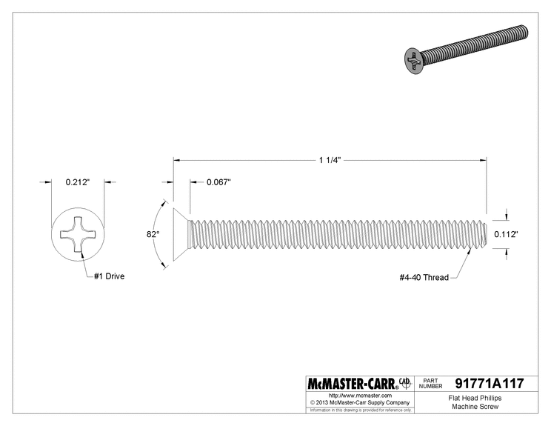

The information in this 3-D model is provided for reference only. [Details](http://www.mcmaster.com/)