**APPENDICES**

**Appendix A.** Classification of Soil

Three kg. of soil will be gathered from the source of the manufacturer. The gathered soil will be sundried for 24 hrs. until dried thoroughly, visible impurities will be handpicked. Sieve analysis and Atterberg Limits Test will be conducted to determine the soil sample according to USCS. After drying the soil will be prepared for Sieve Analysis, Atterberg Limits Test.

The sieve analysis will be done in as specified by ASTM D422. Approximately 500 g of soil shall be obtained, and its mass determined. The weight of each sieve will also be determined, and then the set of sieves will be placed, with the largest opening on top, and with the pan on the bottom. The dried soil will be poured into the top of the sieve. Sieving operation will be conducted by means of a lateral and vertical motion of the sieve with a shaking action that keeps the material moving continuously over the surface of the sieves. The sieving will be continued until no material passes through the sieve. If there are particles stuck in the wires of the sieve, these material will be carefully brushed into the next lower sieve. After sieving, the mass of the soil in each sieved will be obtained. The graph and results shall be produced by an existing MS Excel worksheet intended for sieve analysis.

The determination of Atterberg limits (Liquid Limit and Plastic Limit) will be done as specified by ASTM D4318.

For the determination of Liquid limit, a 200g of soil passing through sieve no.40 will be put in a mixing bowl. A small amount of distilled water will be added and the soil will be thoroughly mixed. Using a spatula, a portion of the prepared soil will be placed into the cup of liquid limit device. Make sure that the cup rests on the base, then squeeze it down and spread it into the cup to form an approximately horizontal surface. The grooving tool will be used to cut a groove through the sample; the bottom of the cup should be seen. At this point, the crank will be turned at a rate of 2 turn per second until the groove closes 1/2 inch. The number of blows required to close the groove will be recorded. Using a spatula, a small portion of the soil will be removed and will be placed in a moisture can with known mass to obtain its moisture content. The soil in the can will be weighed and will be put in the oven at 110 deg. Celsius for 16 hours. The soil remaining in the cup will be transferred to the mixing dish. The cup and grooving tool will then be washed and dried in preparation for the next trial. The soil will be remixed and water will be added to increase the water content of the soil and decrease the number of blows required to close the groove. Repeat the procedure for at least two additional trials.

For the determination of Plastic Limit, 20g of soil from the material from the liquid limit test will be obtained. The water content of the sample will be reduced to a consistency at which it can be rolled without sticking to the hands. A small portion of the soil, about 1.5 to 2 g will be formed into an ellipsoidal mass and will be rolled by hand into the glass plate with just sufficient pressure to roll the mass into a uniform diameter, 80 to 90 strokes per minute. The thread shall be deformed so that its diameter reaches 3.2 mm (1/8 in.), taking no more than two minutes. When the diameter of the thread reaches the correct diameter the thread will be broken into several pieces, will be rubbed and reformed into ellipsoidal masses and re-rolled. This process will be continued until the thread can no longer be rolled into a 3.2 mm diameter. The portions of the crumbled thread with be gathered together and will be placed in a moisture can with known mass. The operations will be repeated until the container has at least 6g of soil. The whole process will be repeated to make another container holding at least 6 g of soil. The water content of the soil contained in the containers will be determined in accordance with ASTM D2216.

The classification of soil shall be done as specified by ASTM D 2487 with the aid of a MS Excel Worksheet.

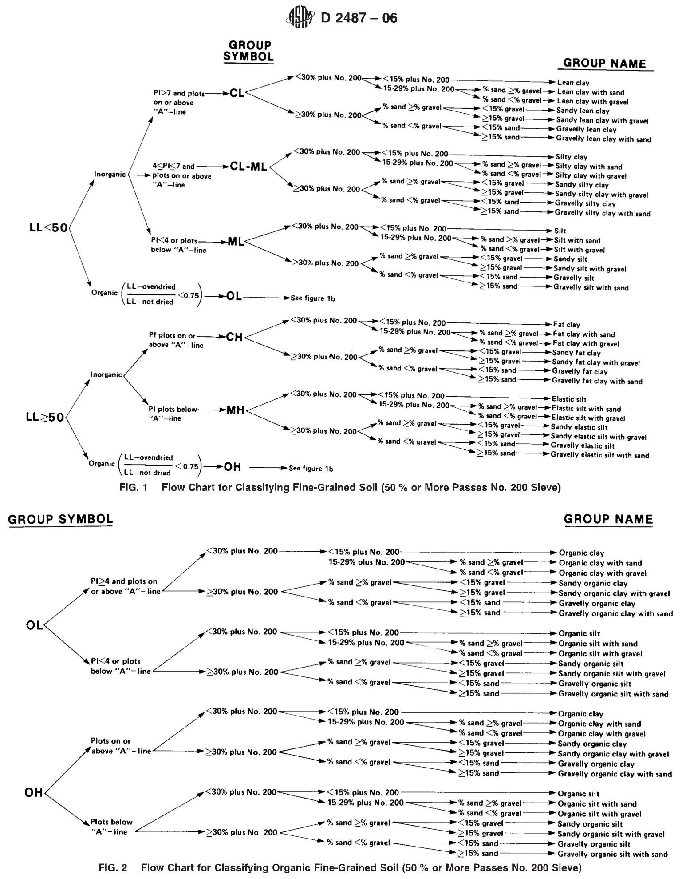**Appendix B.** Excerpts from ASTM D2487

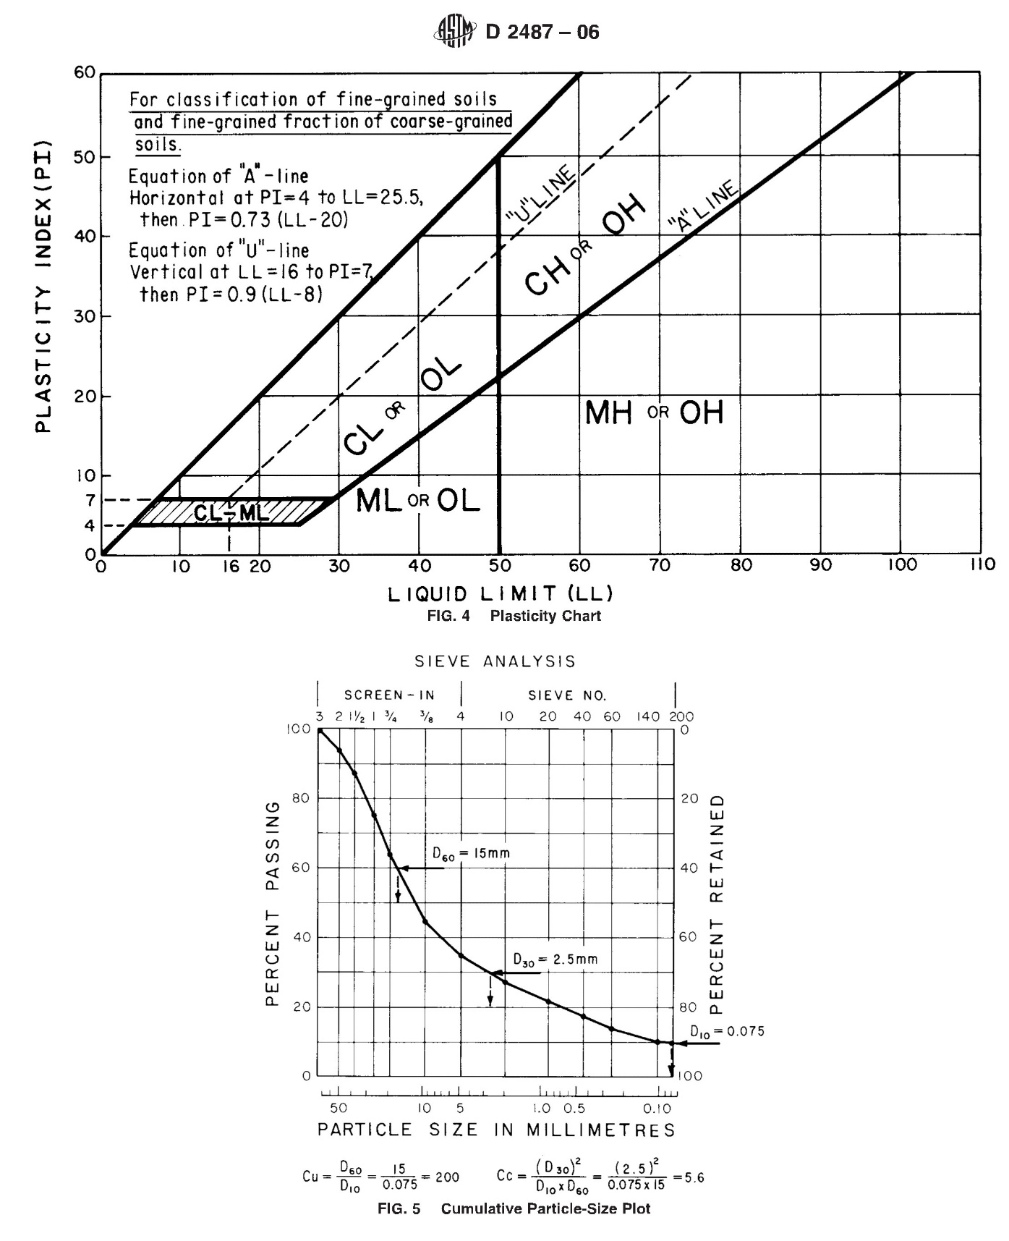

**Appendix C.** Budgetary Requirements of the Study

|  |  |  |
| --- | --- | --- |
| ITEMS | ESTIMATED COST (PhP) | |
| 1. **Maintenance and other Operating Expenses (MOE)** 2. Travel 3. Materials and Supplies 4. Communication 5. Sundry (Binding and Reproduction) 6. Outline   5. Contingency (10% of MOE) | | 3,000.00  1,200.00  200.00  1,200.00  560.00 |
| Sub-total | | 6,160.00 |
| 1. **Testing** 2. Compressive Test 3. Modulus of Rupture | | 4,000.00  4,500.00 |
| 1. **Professional Services** 2. Adviser 3. Department Statistician 4. Department Research Coordinator | | 700.00  250.00  250.00 |
| Sub-total | | 1,200.00 |
| **GRAND TOTAL** | | **15,860.00** |

|  |  |
| --- | --- |
|  | Prepared and submitted by:  **ZAMANODE D. NAWAL**  Researcher |
| RECOMMENDING APPROVAL:  **RONALD A. GARBIN**  Adviser |  |

**Appendix D.** Plan of Course Work

|  |  |  |  |  |  |  |  |  |  |  |  |
| --- | --- | --- | --- | --- | --- | --- | --- | --- | --- | --- | --- |
| **Course No. Description** | |  | **Units** | | | | | **Grades S.Y. Taken** | | | |
| **Required Courses**  Eng 311B Technical Writing and Reporting  Stat 214 Methods of Research and  Statistical Analysis  ES 411 Engineering Economy  **Major Courses**  ES 412 Environmental Engineering  CENG 324 Construction Materials and  Testing  CENG 412 Highway Engineering  CENG 421 Theory of Structures II  CENG 424 Engineering Hydrology  CENG 425 Water Resource Engineering  CENG 426 Geotechnical Engineering 2  (Foundation Engineering) | 3  3  3  3  3  3  4  3  3  4 | | | |  | | 2.25 2012-2013  2.25 2013-2014  2.50 2014-2015  2.50 2013-2014  2.75 2013-2014  3.00 2014-2015  2.25 2014-2015  2.75 2014-2015  2.75 2015-2016  3.00 2014-2015 | | | |
| **10 Subjects, checked by:** |  | | |  | |  | | |  |  | |

Prepared by:

**ZAMANODE D. NAWAL**

Researcher

**RECOMMENDING APPROVAL**

**RONALD A. GARBIN**

Adviser Date

**JEANNALEN P. LUNOD**

Department Research Date

Coordinator

**APPROVED:**

**RONALD A. GARBIN**

Department Chairman Date

**Appendix E.** Certification for Statistical Pool

Office of the President for Research, Development and Extension

**STATISTICAL POOL**

University of Southern Mindanao

Kabacan, Cotabato

Date: _________________

Research Proposal/Outline Research Manuscript

Name: **ZAMANODE D. NAWAL**

Course: **BS CIVIL ENGINEERING** Major:

Thesis Title: **“COCONUT (*Cocos nucifera*) SHELL ASH AS COMPONENT OF BRICKS”**

Research Design: **RANDOMIZED COMPLETE BLOCK DESIGN**

Statistical Analysis: **ANALYSIS OF VARIANCE (ANNOVA) and DMRT TEST**

Requested by: Noted by:

**ZAMANODE D. NAWAL** **RONALD A. GARBIN** Signature over Printed Name Signature over Printed Name

of Researcher of Thesis Adviser

I certify that the statistical treatment to be used/used for this research is appropriate and valid.

Recommended by:

**ALBERTO C. ARELLANO**

Chairman, Statistical Pool

**ALBERTO C. ARELLANO**

Signature over Printed Name

of Statistician

Recorded by:

**JEANNALEN P. LUNOD**

College Research Coordinator