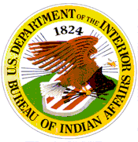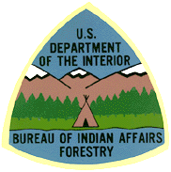**WHAT’S HOT…**

**BIA Natural Resources**

**February 2015**

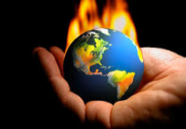**GRANT DUE DATE EXTENSIONS FOR FY 2015**

**FOR THREE BIA FORESTRY PROGRAMS**

Funding has been made available nationally, based on the Administration's commitment to advance science based collaborative efforts and technical assistance, to improve and develop sources of data and associated forest management planning activities in relation to climate change. The funding was made available to the BIA as a general increase to the Forestry Projects line item in FY2014 and **will be recurring annually** until rescinded.

The Pacific Region Branch of Forestry is requesting project proposals for two of the three initiatives associated with this increase:

1. Climate Change, Forest Inventories and Planning;

2. Geospatial Capacity for Forest Management

3. Forestry Youth Initiative

Details for these **Grant Programs** can be found on the Pacific Region’s BIA Programs Disk. The funding for these programs has been significant again this year and additional time has been provided for this year’s request.

**j0239107**

**New California Fire Assistance Agreement (CFAA)**

June 26, 2013, an update was made to the CFAA to insure that Local Fire Departments would be paid by the BIA for wildland fire suppression responses made to protect Indian lands from point of dispatch. In the new CFAA all of the California Interior Agencies have agreed to pay Local Fire Departments, however there are nuances to how and when these payments are made. The BIA encourages Tribal (25 USC 450 et. seq./EO B-10-11) and Local Fire Department involvement in the development of Local Geographic Operation Plans that should include coordination and cooperation with Tribes and Local Fire Departments (for the upcoming 2015 wildland fire season). The Local Geographic Operation Plans are due at the Regional/State offices by **May 15th** of each year in compliance with the California Fire Master Agreement. Please assist the BIA Superintendents (90 IAM 1 § 1.7(E)5) in completing these annual mobilization planning requirement to ensure the protection of Indian lands.

**j0288976Annual Pacific Region Forest Protection and Improvement Meeting –**

The Pacific Regional Office, Branch of Forestry and Wildland Fire Management will be hosting its annual meeting as follows:

March 26-27, 2015 (meeting begins at 9:00 a.m. & Ends at 4:30 p.m.)

Federal Building

2800 Cottage Way Sacramento, California 95825

(The Meeting will be held in the BIA’s Large Conference Room and Participants are required to have State of Federal Picture Identification to get through Security)



The Pacific Region will continue to provide tribes with updated BIA Programs Disk(s) annually. The disk contains BIA grant information, the programs mentioned in this newsletter and much more. Please contact your local BIA forestry technical service provider for an updated disk or **our new Indian Forestry College Interns**: Colton Bearquiver at [colton.bearquiver@bia.gov](mailto:colton.bearquiver@bia.gov) - (916) 978-6075 or

Inessa Bartholomew, [inessa.bartholomew@bia.gov](mailto:inessa.bartholomew@bia.gov) - (916) 978 6117 or

Dustin Brafford, dustin.brafford@bia.gov - (916) 978-6078