# **Tye Wells – EBS Volumes**

This is a two step process

* Create EBS
* Attach volumes to EC2 Instances

**Create new EBS Volumes.**

1. To create Volumes , Go to Console.aws.amazon.com -> Choose the right region as the EC2 Instances -> Choose EC2

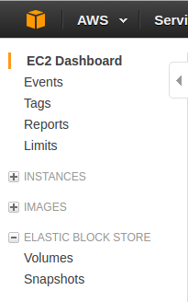

1. On EC2 Dashboard, Choose Elastic Block Store -> volumes -> Create Volume

**Choose**

Volume = SSD GP2 ( As discussed on Friday )  
Size = 1000 GiB (iops will default to 3000 GiB (<http://docs.aws.amazon.com/AWSEC2/latest/UserGuide/EBSVolumeTypes.html>)  
Availability Zone: Select same as EC2 Instances  
Encryption: Your option, you will need to make a key if you do this.   
Click -> Create

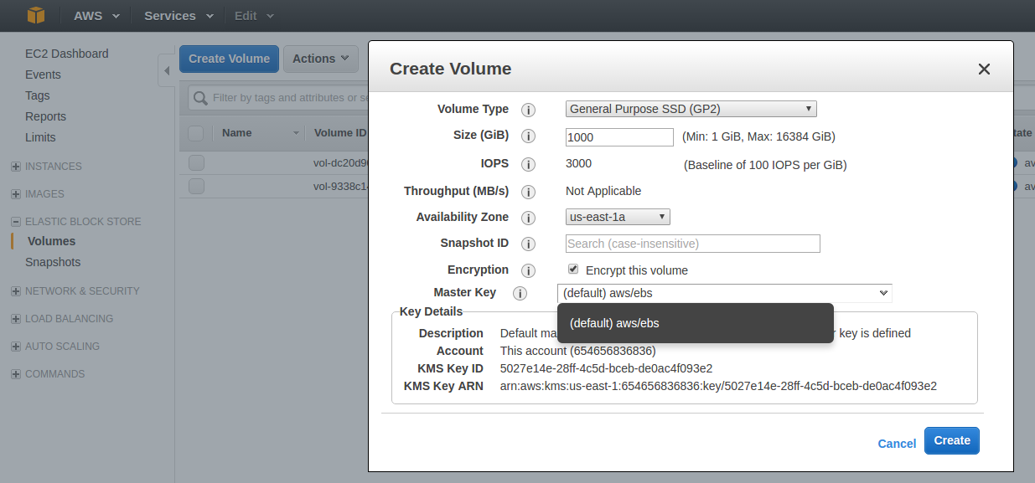

Further Reference : <http://docs.aws.amazon.com/AWSEC2/latest/UserGuide/ebs-creating-volume.html>

You can create a custom name if you prefer

  
 Your would have to do this again to create a second volume and once they are online, we move on to step 2.

**Attach EBS Volumes to EC2 Instance**On the EBS Menu, Go to Actions -> Attach Volume   
On Pop-up window, Double click on Instance ID to choose EC2 Instance

