**SYSTEM DESIGN**

**SYSTEM ARCHITECTURE:**

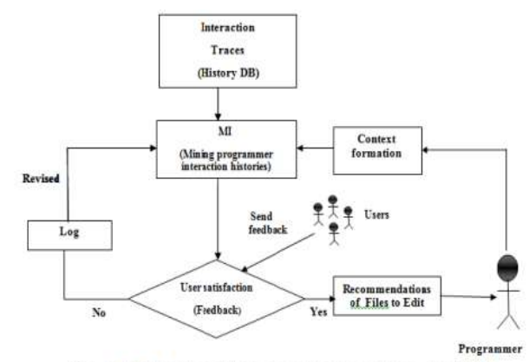

**Data Flow Diagram:**

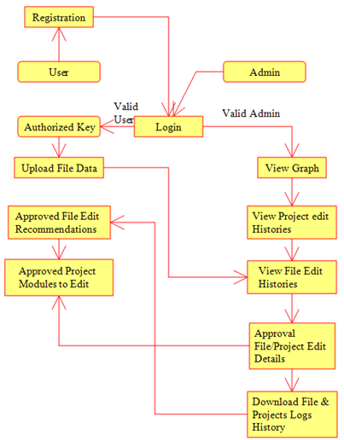

**UseCase Diagram:**

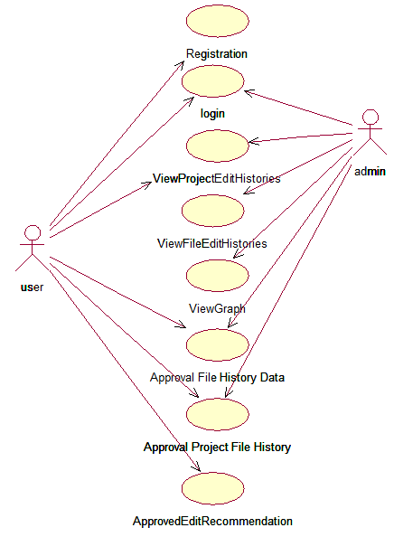

**Class Diagram:**

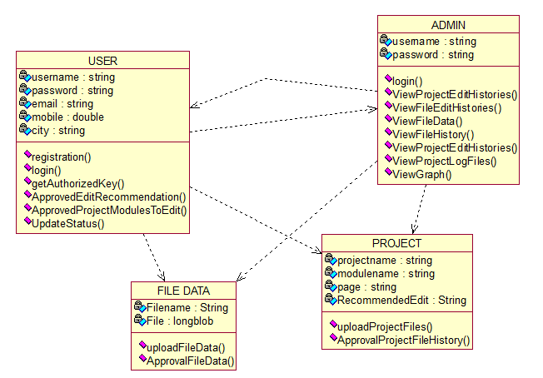

**Sequence Diagram:**

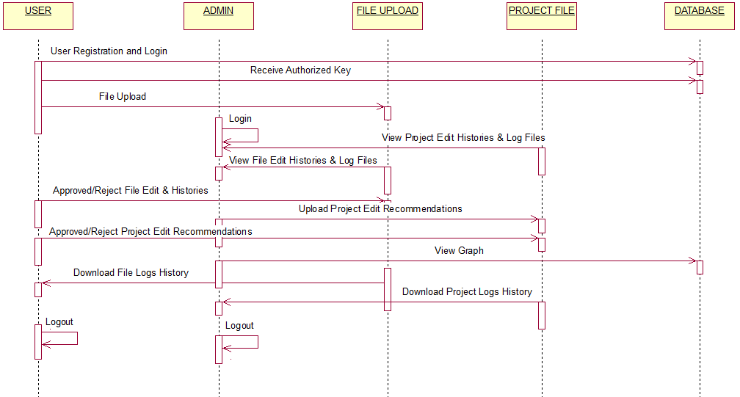

**Activity Diagram:**

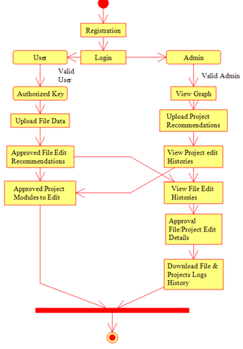

**Collaboration Diagram**

