

Visa & MasterCard ® / Mega-Jackpot  
MasterCard ® Office: 240000. Huntsville, AL 35813,  
                               United States Of American.  
current director, Mr.. Blaine Vandergate  
Phone No: +1940 MasterCard.  
                  (**+1940-238-0512**)

**Visa/MasterCard ® International Mega Jackpot**

Ticket Number: **08 16 20 24 25 40**  
Registration Number: **9027640**  
NO INSURANCE: **MSTC006**  
Tax Debt NO: **28456**  
The Winning Amount: **$ 2,000,000.00.**  
Date: **13/6/2016,**

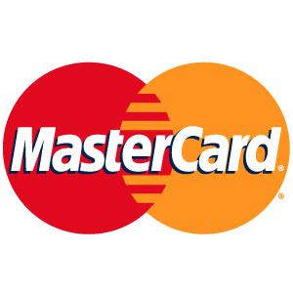.

Dear Winner,

This email address has brought you an unexpected luck, we know this may be a surprise to you because you where not informed about this Promo. Please read through this message. Your e-mail address was selected and confirmed by our co-sponsor Microsoft International Visa/MasterCard® Credit Card Jackpot 2016, through their latest internet software. You are therefore been approved by MasterCard® / Visa Card International to receive $2,000,000.00 in credit card to be delivered to you at your house address.

Equivalent to $480,000,000 US Dollars (Four Hundred And Eight Million US Dollars). In cash, Credited to MasterCard No. 5283 0421 0025 3621 and With Reg. No. MCIMJ: 5148/4178 which have been Verified on the user of this E-mail Address Account. You are the ninth (9th) lucky winner of the total winners of 60 Take Note.

You all won $2,000,000.00USD each. Be informed that your prize (Visa/MasterCard No 5283 0421 0025 3621) has been insured/Debited with the sum won and ready for pay out and **delivery to your house address**. Which you will be withdrawal from any ATM point in your country.

Furthermore your details(e-mail address) falls within our REGIONAL representative office in Africa as indicated in your play coupon and your Credit Card prize of ($2,000,000.00) will be released to you from this regional branch in Africa. Be informed that your winning Credit Card (MasterCard No. 5283 0421 0025 3621) has been insured and ready for delivery to your house address by the regional issuing crediting bank (INTERCONTINENTAL BANK PLC) ready to program in your name .Contact your claims administrator for further instructions and delivery-Visa/MasterCard®.

 ======================================================

**MasterCard® Claims Administrator Region**

Name: **Mrs Grace Campbell**

E-mail: **master.card.verify69@gmail.com**

Telephone: **+233-204-777-278**

 ======================================================

Again for your information, all the 10 participants were selected through the Microsoft computer ballot system (MCBS) drawn from each continent and from each ISP, by the most powerful Microsoft Software Incorporation, as part of our International "E-MAIL" Promotions/Advert Program, to promote the use of MasterCard's and the use of Microsoft Offices all over the World. Furthermore, to promote the use of online payments, for the settlement of debts (taxes) and payment of bills reduce of poverty.

Your funds $2,000,000.00 Two Million Us Dollars has been lodge in this MasterCard No. (5283 0421 0025 3621) on behalf of your E-mail Account, insured and ready for delivery. All you have to do is provide the necessary information to process your Visa/MasterCard Certificate and to upgrade our upcoming WEBSITE. Please note that they are imposter's (Scammers) who pretend to be us, so be careful and report to me any case of double information you receive from someone else.



Do email the above Claims Administrator, at once with all the claims requirements below. To avoid unnecessary delay. They are needed to proceed.

Claims Requirements:

1. Full Name:

2. Nationality:

3. Age:

4. Occupation:

5. Mobile Phone:

6.REGISTRATION NO:9027640

7.MasterCard No.: 5283 0421 0025 3621

**To view out 2013/2014 past lucky winner click:**

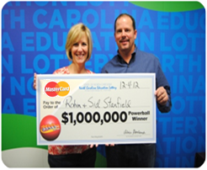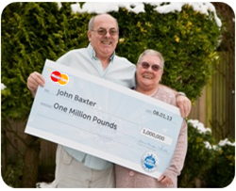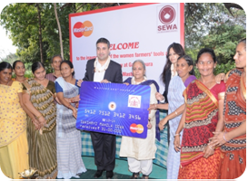

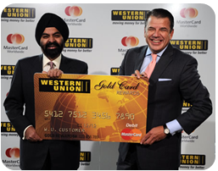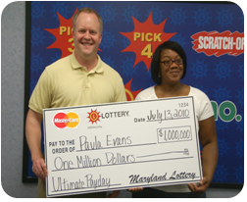

PROCEDURES / RIGHTS AND PRECAUTIONS.

Contact the Claims Administrator with all your claims requirements well filled. Your claims Administrator will give you all the guide lines on how to process your claims. Your claims administrator has the due right to disqualify you for misconduct; you are to keep your winning private until delivery. Any mail received of such should be reported to the claims Administrator above. This will help fight scam.

[](http://www.africatelecomit.com/wp-content/uploads/2013/04/MasterCard-CEO-Ajay-Banga1.j)

Mrs. Ajaypal S. Banga @

(**President and CEO, MasterCard Worldwide**)

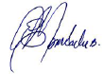

MasterCard® / Microsoft® Mega Jackpot.

===========================  
Sponsored by MasterCard® / Visa Card