***Instructions***

* ***Copy and paste this email (including the banner) into your email template. Add your client and your contact details.***
* ***Details of your clients with online access can be found in the ‘Client listings report’ on the Elevate platform.***

**Email 1: Clients with online access**

TO: clientname@emailaddress.co.uk  
FROM: advisername@ifa.co.uk  
SUBJECT: New iPad app for your investments on Elevate

--------------------------------------------------------------------------------------------------------------------------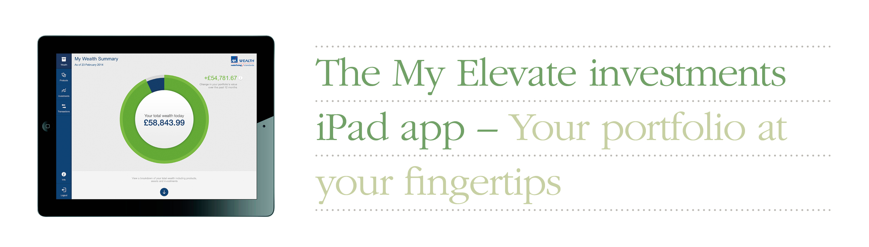

Dear <client name>

To help you better visualise your investments on Elevate, AXA Wealth have created a free app for the iPad. Designed to complement your online access to Elevate, it allows you to view your investments at your leisure.

* Quick and easy to use
* Brings investments to life through dynamic graphics
* Provides a high level summary or a detailed breakdown
* Shows latest transactions and a 12 month portfolio overview

**HOW TO LOG IN**To login to the app you will need to use your Elevate username and password as you use for your online access. If you have forgotten your password please [click here](https://ads.elevateplatform.co.uk/RecoverPassword.aspx). If you have forgotten your username you will need to contact AXA Wealth on 0845 600 2399 Monday to Friday 8.00am to 6.00pm.

**HOW TO DOWNLOAD**Currently only available on a iPad, you can download the My Elevate investments app by clicking on the AppStore link

[](https://itunes.apple.com/gb/app/axa-wealth-my-elevate-investments/id840202345?mt=8)

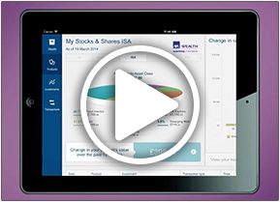

[Watch the ‘How to use’ video](http://www.axawealth.co.uk/our-products/elevate/My-Elevate-app/) to see how you can navigate your way through the app to view your investments.

But remember, if you have opted out of receiving paper from AXA Wealth – you will still need to logon to your Elevate account to view any documents AXA Wealth send you and to check your personal details.

If you have any questions, or I can help you with anything, please call me on [Contact number/email]

Yours sincerely,

[Adviser email signature]