Website Pentesting

1-Target website

<https://www.freshbooks.com>

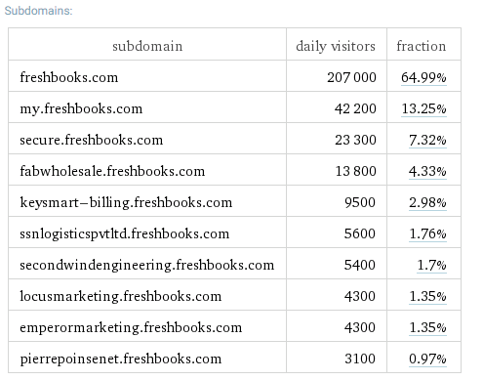2-Subdomains

3-Check this subdomain

(<https://pierrepoinsenet.freshbooks.com>)

4-Test XSS Vulnerability

5- Extract All Links by web Spider tool

6- All Parameters of Each Link by XSSPloit Tool

7- Test Parameter by Malicious Code by My Tool.