

**Chest Surgery Consultation**

**Patient Intake Form**

***Please answer the following questions to the best of your ability. Once the Patient Intake Form is completed please fax it to Nori Reed at (415) 353-2494 along with all other chest surgery new patient consultation documents listed on our website*** [***http://transcare.ucsf.edu/chest-surgery***](http://transcare.ucsf.edu/chest-surgery)***. If you have any questions or concerns when completing this Patient Intake form, please call Nori Reed at (415) 885-7770.***

**Today’s Date:** Click here to enter a date.

**Chosen Name:** Click here to enter text.

**Legal Name, if differs:** Click here to enter text.

**Date of Birth:** Click here to enter a date.

**Gender Identity:** Female ☐Male ☐Transgender Female ☐Transgender Male

☐Genderqueer/Gender Nonconforming/Nonbinary/Neither Male Nor Female

☐Gender Identity Not Listed Here (specify): Click here to enter text.

**Birth Assigned Sex:** ☐Female ☐Male

**Chosen pronoun:** Click here to enter text.

**Sexual Orientation (optional):**  ☐Lesbian/Gay/Homosexual ☐Straight/Heterosexual

☐Bisexual/Pansexual/Queer ☐Sexual Orientation Not Listed Here (specify): Click here to enter text.

☐ Not Sure/Questioning

**Do you require a translator?** Yes ☐ No ☐ If yes, what language? Click here to enter text.

**City where you live?** Click here to enter text.

**Current employment status (check all that apply):**

☐Full time work ☐Part time work ☐Student ☐Unemployed, looking for work

☐Unemployed, not looking for work ☐Currently on disability

**Marital status**

☐Single, never married ☐Married/domestic partner ☐Partnered but not legally married

☐Separated/divorced☐Widowed

**Highest level of education completed:**

☐Some high school ☐High school diploma ☐Some college ☐Vocational degree/technical school

☐Associates degree ☐Bachelor’s degree ☐Masters degree ☐Doctoral Degree

**Place of work / name of school** Click here to enter text.

**Please list any sources of additional financial support** Click here to enter text. **Who lives with you?** Click here to enter text.

**How long have you lived there?** Click here to enter text.

**Do you have a private room?** Click here to enter text.

**Do you have access to a shower?** Click here to enter text.

**Do you have any possible upcoming changes in your housing? If so, describe:**

Click here to enter text.

**Do you have any financial issues which may threaten your housing? If so, please describe:**

Click here to enter text.

**Do you have a car?** Click here to enter text.

**If you do not have a car, how do you get around?** Click here to enter text.

**Who is going to take you to and from your surgery appointment?** Click here to enter text.

**Who is going to stay with you after surgery?** Click here to enter text.

**Who is available to help you with the following possible scenarios after surgery (name person/s for each individual scenario):**

**Need to go to the emergency room** Click here to enter text.

**Need to go back to see my surgeon for a visit** Click here to enter text.

**Need to go to the pharmacy for medications or supplies** Click here to enter text.

**Need to go to the store to buy food, or help me prepare food at home?** Click here to enter text.

**What is the name of the nearest hospital emergency room to where you live?** Click here to enter text.

**Do you have a local primary care provider where you live?** Yes☐ No☐

**If Yes, Primary Provider Name** Click here to enter text. **Phone #** Click here to enter text.

**For each of the following questions, please use the following key and circle or highlight the most appropriate number:**

0 = No Difficulty

1 = Mild Difficulty

2 = Moderate Difficulty

3 = Severe Difficulty

4 = Extreme Difficulty or Cannot Do

**Standing for long periods such as 30 minutes?**

0 1 2 3 4

**Taking care of your household responsibilities?**

0 1 2 3 4

**Learning a new task, for example, learning how to get to a new place?**

0 1 2 3 4

**How much of a problem did you have in joining in community activities (for example, festivities, religious or other activities) in the same way as anyone else can?**

0 1 2 3 4

**How much have you been emotionally affected by your health problems?**

0 1 2 3 4

**Concentrating on doing something for ten minutes?**

0 1 2 3 4

**Walking a long distance such as a ½ mile?**

0 1 2 3 4

**Washing your whole body?**

0 1 2 3 4

**Getting dressed?**

0 1 2 3 4

**Dealing with people you do not know?**

0 1 2 3 4

**Maintaining a friendship?**

0 1 2 3 4

**Your day-to-day work/school?**

0 1 2 3 4

**Overall, in the past 30 days, how many days were these difficulties present?** Click here to enter text.

**In the past 30 days, for how many days were you totally unable to carry out your usual activities or work because of any health condition?** Click here to enter text.

**In the past 30 days, not counting the days that you were totally unable, for how many days did you cut back or reduce your usual activities or work because of any health condition?**

Click here to enter text.

**Please review this label from a container of ice cream, and answer the following questions. How well you answer the questions will not have any impact on your ability to have surgery. This is only to allow us to better understand how to help you read and follow wound care instructions, prescriptions, etc…:**

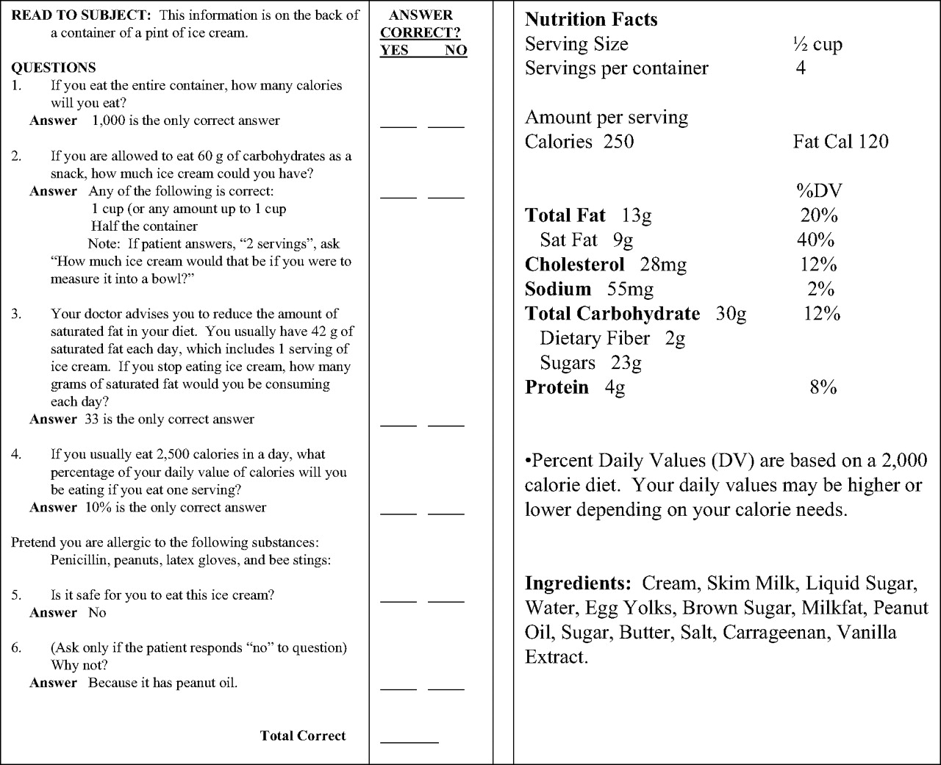

**If you eat the entire container, how many calories will you eat?**

­­­Click here to enter text.

**If you are allowed to eat 60 g of carbohydrates as a snack, how much ice cream could you have?**

Click here to enter text.

**How much ice cream would that be if measured into a bowl?**

Click here to enter text.

**Your doctor advises you to reduce the amount of saturated fat in your diet. You usually have 42 grams of saturated fat each day, which includes 1 serving of ice cream. If you stopped eating ice cream, how many grams of saturated fat would you be consuming each day?** Click here to enter text.

**If you usually eat 2,500 calories in a day, what percentage of your daily value of calories will you be eating if you eat one serving?** Click here to enter text.

**Pretend you are allergic to the following substances: Penicillin, peanuts, latex gloves, and bee stings:**

**Is it safe for you to eat this ice cream?** Click here to enter text.

**Why or why not?** Click here to enter text.