**LITERATURE REVIEW**

**Anatomy of the male external genitalia**

**Penis**

The root of the penis is fixed to the perineum within the superficial pouch. The corpora cavernosa meet beneath the pubis to form the major portion of the body of the penis. They are enclosed by the tunica albuginea. Its outer longitudinal and inner circular fibers form an undulating meshwork when the penis is flaccid and appear tightly stretched with erection.**[14]**

Smooth muscle bundles traverse the erectile bodies to form the cavernous sinuses that are lined by endothelium, erectile tissue has a spongy appearance as seen in **Figure (1)**. Distal to the bulb, the corpus spongiosum become narrower and runs on the ventrum of the corpora cavernosa and then expands to cap them as the glans penis. The spongiosum is traversed throughout its length by the anterior urethra, which begins at the perineal membrane.**[15]**

As seen in **Figure (2),** the common penile artery terminates in three branches. The bulbourethral artery nutrients the urethra, spongiosum, and glans. The cavernosal artery gives off straight and helicine arteries that supply the cavernous sinuses. The dorsal artery of the penis passes between the crus penis and the pubis to reach the dorsal surface of the corporal bodies. The penile skin is supplied by the dorsolateral and ventrolateral branches of the superficial external pudendal arteries of the femoral vessels. Emissary veins in the proximal third of the penis meet on the dorsomedial surface of the cavernous bodies to form two to five cavernous veins before joining the internal pudendal veins. The dorsal nerves provide sensory innervation to the penis.**[16]**

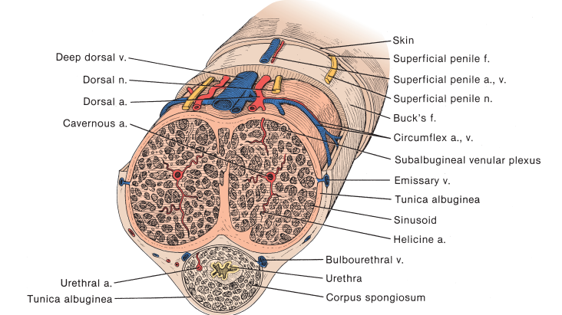

**Figure (1). Cross section of the ponis, demonstrating the relationship between the corporal bodies, penile fascia, vessels. And nerves.[16]**

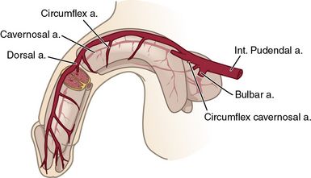

**Figure (2). Arterial supply of the penis.[16]**

**Urethra**

The male urethra is divided into four parts, as illustrated in **Figure (3)**: The prostatic urethra, membranous urethra, bulbar urethra, and penile urethra. The anterior urethra is dilated in its bulbar and glanular segments and narrowest at the external meatus.**[17][18]**

Proximally, it is lined by stratified and pseudostratified columnar epithelium, than turns into stratified squamous epithelium. The mucous secreting glands of Littre look like small outpouchings of the mucosa. The stratified sphincter is supplied by the pudendal nerve and a branch of the sacral plexus that runs on the pelvic aspect of the levator ani muscle.**[19]**

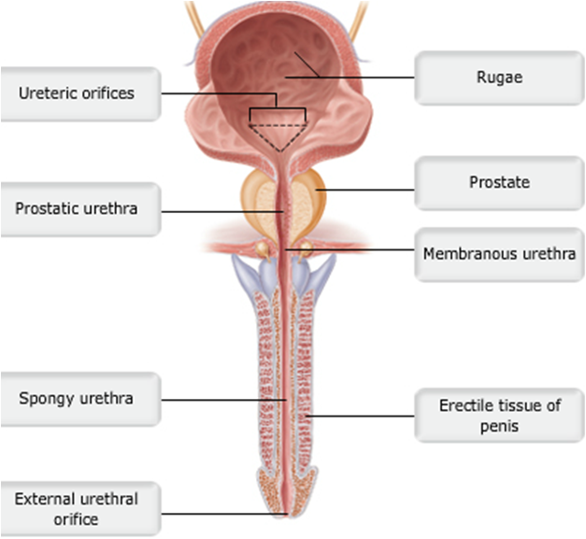

**Figure (3). Posterior wall of the male urethra.[18]**

**Scrotum**

The scrotal skin is pigmented, hair bearing, devoid of fat, and rich in sebaceous and sweat glands**.** The scrotum is separated by a midline raphe. The dartos layer of smooth muscle is continuous with Colles, Scarpa, and the dartos fascia of the penis. As seen in **Figure (4)**, the testes are suspended by their cords in the scrotal compartments. The parietal and visceral tunica vaginalis surround the testis with a mesothelium-lined pouch and are derived from the peritoneum. They are continuous at the posterolateral border of the testis at its mesentery, where it is fixed to the scrotal wall. The testis is also fixed at its lower pole by the gubernaculum. The anterior wall of the scrotum is supplied by the external pudendal vessels and the ilioinguinal and genitofemoral nerves. The back of the scrotum is supplied by the posterior scrotal branches of the perineal vessels and nerves. In addition, the posterior femoral cutaneous nerve (S3) gives a perineal branch to supply the scrotum and perineum.**[20]**

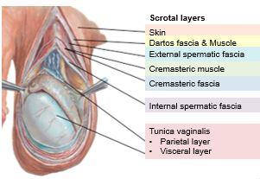

**Figure (4). The scrotum and its layers.[20]**

**Testes**

**Figure (5)** illustrates The anatomy of the testis. The testes are 4 to 5 cm long, 3 cm wide, and 2.5. They are enclosed in a tough capsule comprising (1) the visceral tunica vaginalis; (2) tunica albuginea, with collagenous and smooth muscle elements; and (3) the tunica vasculosa. The epididymis attaches to the posterolateral aspect of the testis. Septa radiate from the mediastinum to attach to the inner surface of the tunica albuginea to form 200 to 300, each of which contains one or more convoluted seminiferous tubules. Interstitial (Leydig) cells lie in the loose tissue surrounding the tubules and are responsible for testosterone production.**[21][22]**

The spermatic cord is composed of the vas deferens, testicular vessels, and spermatic fasciae. The testicular arteries arise from the aorta and travel in the intermediate stratum of the retroperitoneum to reach the internal inguinal ring.**[23]**

The testicular veins form the pampiniform plexus**.** At the level of the inguinal canal, the veins join to form two or three channels and then a single vein that drains into the inferior vena cava on the right and the renal vein on the left.**[24]**

Visceral innervation to the testis and epididymis travels by two routes. A portion arises in the renal and aortic plexuses and travels with the gonadal vessels**.** Additional gonadal afferent and efferent nerves course from the pelvic plexus in association with the vas deferens.**[25]**

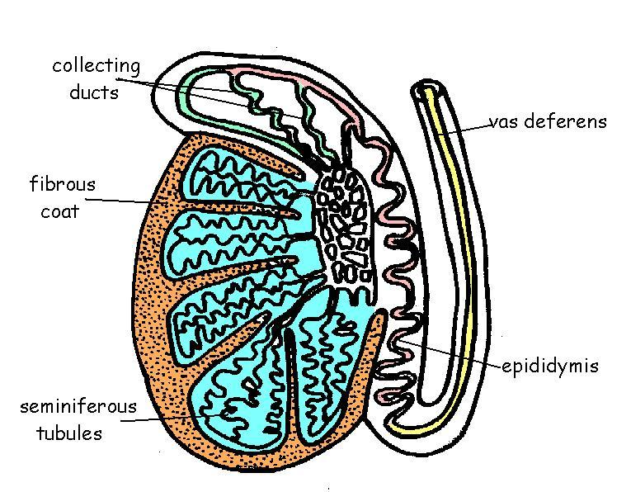

**Figure (5). Drawing of the human testis showing the seminiferous tubules.[22]**

**The inguinal canal**

As illustrated in Figure (6), the anterior boundary of the inguinal canal is the external oblique apponeurosis; the posterior boundary is the transversalis fascia with some contribution from the apponeurosis of the transversus abdominis muscle; the inferior border is formed by the inguinal and lacunar ligaments; and the superior boundary is formed by the arching fibers of the internal oblique muscle. The internal inguinal ring is formed by a normal defect in the transversalis fascia through which the spermatic cord in men and the round ligament in women passes into the abdomen. The external ring is inferior and medial to the inguinal ring, and represents an opening of the apponeurosis of the external oblique. The spermatic cord passes from the peritoneum through the internal ring and then passes into the external ring before entering the scrotum in males.**[26]**

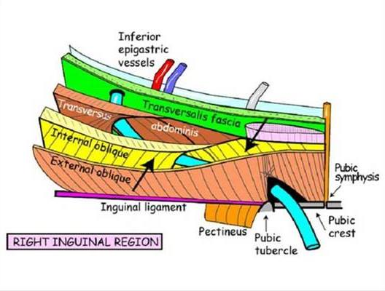

**Figure (6). Anatomy of the inguinal canal.[26]**

**Embryology of the male external genitalia**

Normal embryogenesis of the male genitalia is illustrated in **Figure (7)**.

Understanding factors and sequential steps in normal embryogenesis is essential in the comprehension of the pathogenesis of male genital anomalies. These factors include testosterone synthesis by the fetal testis and its enzymatic conversion into dihydrotestosterone (**DHT**) by 5α-reductase and the presence of androgen receptors able to recognize the androgenic hormones. The influence of **DHT** on the androgen receptors results in the differentiation of the genital tubercle, genital folds, and genital swelling into the glans penis, penile shaft, and scrotum, respectively. As the penis forms from the elongation and enlargement of the phallus, the lateral walls of the urethral groove form from the genital folds. The genital folds then fuse in the midline.**[27]**

The glanular urethra was thought to develop from the ingrowth of surface epithelium, but this theory has been challenged with evidence suggesting that it is due to the fusion of the urethral plate.**[28][29]**

The scrotum forms through the inferomedial migration and midline fusion of the genital folds as marked by the scrotal raphe.**[27]**

Fetal Sertoli cells produce antimüllerian hormone (**AMH**) soon after they differentiate; the human fetal müllerian duct is responsive to **AMH** before week 8 of gestation, and the process of regression occurs between 9 and 10 weeks.**[30]**

The major phases of testicular descent in the human fetus are:

**Phase 1***:* The caudal mesonephros contacts the future gubernaculum at the internal inguinal ring (5 weeks’ gestation).

**Phase 2***:* The genitofemoral nerve accompanies the newly formed gubernaculum (abdominal, interstitial, and subcutaneous portions) and processus vaginalis (7 weeks).

**Phase 2a***:* Growth of the gubernaculum, deepening of the processus vaginalis, and extension of cremaster muscle fibers into the interstitial gubernaculum occurs (8 to 10 weeks).

**Phase 3***:* Growth of the testis and regression of the müllerian ducts and mesonephros occurs; the gubernaculum remains a thin cord in both sexes (10 to 12 weeks).

**Phase 3a***:* The testis overrides the genital ducts and contacts the gubernaculum, which begins its swelling phase in males (12 to 14 weeks).

**Phase 4***:* Swelling of the gubernaculum, development of the cremaster muscle, and migration of the processus vaginalis produce widening of the inguinal canal (14 to 20 weeks).

**Phase 5***:* Release of the distal subcutaneous attachment of the gubernaculum and transinguinal passage of the testis occur (20 to 28 weeks).

**Phase 5a***:* Further caudal movement of the testis into the scrotum is accompanied by regression of the gubernaculum (7th month and beyond).**[31]**

Rodent studies provide strong evidence that testicular **INSL3** and androgen signaling pathways are the primary contributors to gubernacular development and testicular descent.**[32][33]**

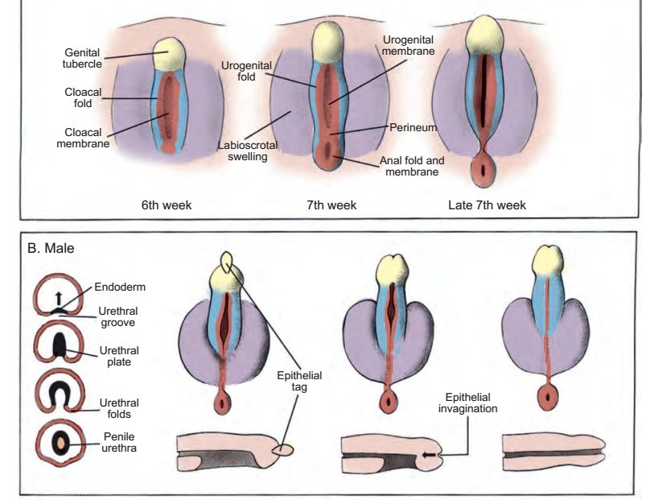

**Figure (7). Timeline and overview of genitourinary system development.[27]**

**Endocrinology of the male reproductive system**

**The hypothalamo-pituitary-gonadal axis**

**Figure (8)** shows a diagram that demonstrates the hypothalamo-pituitary-gonadal axis (**HPG**) which plays a critical role during development and adulthood in four physiological processes:

1. Phenotypic gender development.
2. Sexual maturation at puberty.
3. Testicular endocrine function.
4. Testicular exocrine function.

Two classes of hormones mediate communication in the reproductive axis: peptide hormones (LH), and (FSH) and steroid hormones testosterone and estradiol.**[34][35]**

**Hypothalamus**

The most important hypothalamic hormone for reproduction is gonadotropin-releasing hormone (**GnRH**), secreted from the neuronal cell bodies in the preoptic and arcuate nuclei. **GnRH** stimulates secretion of **LH** and **FSH** from the anterior pituitary. **GnRH** secretion results from stress, exercise, and diet from higher brain centers.**[35]**

**The anterior pituitary**

**FSH** and **LH** are onlyknown to act in the gonads. **LH** stimulates Leydig cells to form and secrete testosterone. **FSH** is the chief stimulator of seminiferous tubule growth during development.**[35]**

Prolactin excess abolishes gonadotropin pulsatility. Adrenocorticotrophic hormone (**ACTH**), growth hormone (**GH**), and thyroid-stimulating hormone (**TSH**) can also have significant effects on male reproductive function.**[35][36]**

**Testis**

Normal male virility and fertility require the cooperation of the exocrine and endocrine testis. The interstitial compartment, composed mainly of Leydig cells, is responsible for steroidogenesis. The seminiferous tubules are lined by Sertoli cells that serve as supporting cells for spermatogenesis. In response to **FSH**, Sertoli cells produce androgen-binding protein (**ABP**), transferrin, lactate, ceruloplasmin, clusterin, plasminogen activator, prostaglandins, and growth factors.**[37]**

Boys with bilateral undescended testes have lower fertility and paternity rates, and increased risk of developing testicular malignancy.**[38]**

**Testosterone**

Testosterone is the principal steroid produced by the testis.**[35]** It is metabolized into two major active metabolites in target tissues: (1) the major androgen **DHT** by the action of 5α-reductase, and (2) the estrogen estradiol through the action of aromatase. The major enzymes participating in its biosynthesis from pregnenolone are: cholesterol side-chain cleavage enzyme, 3β-hydroxysteroid dehydrogenase, cytochrome P450, 17α-hydroxylase/C**17-20**-lyase, and 17β-hydroxysteroid dehydrogenase.**[39]**

Gene mutations in the genes encoding these enzymes cause sexual ambiguity in chromosomally normal males. The most important regulator of testosterone production is **LH**.**[39]**

**Genetics and paternal age**

The paternal age effect appears to increase sex chromosomal aneuploidies. A very significant linear relationship exists between paternal age and the frequency of structural anomalies in sperm. Formal risk estimates exist for the contribution of advanced paternal age to autosomal dominant mutations: In men > 29 years old, the risk of a mutation occurring in offspring is 0.22 per 1000. This risk doubles (0.45 per 1000) at paternal ages 40 to 44, and reaches 3.7 per 1000 at ages < 45.**[40][41]**

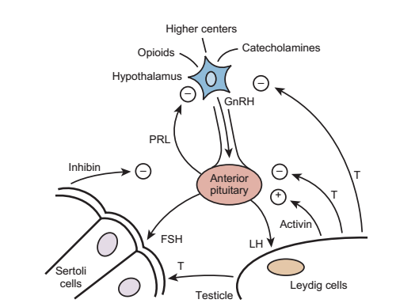

**Figure (8). A diagram of the hypothalamo-pituitary-gonadal axis.[35]**

**Anomalies of the male external genitalia**

**Hypospadias**

It results from arrested penile development, leaving a proximal urethral meatus. It is either glanular, coronal, distal penile, mid penile, proximal penile, penoscrotal, scrotal, or perineal, as shown in **Figure (9)**.

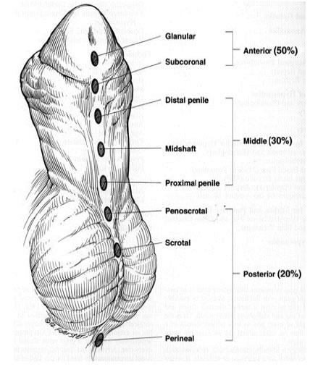

**Figure (9). Classification of hypospadias based on anatomic location of the urethral meatus.[42]**

**Causes**

**1.Genetic Factors:**

Familial aggregation is found in 4% to 10% of hypospadias cases, including first-, second-, and third-degree relatives.**[43][44][45][46]** Hypospadias is equally transmitted through maternal and paternal sides of the family, denoting that familial aggregation is best explained by genetic factors rather than environmental exposure.**[47]**

Several estrogen-responsive genes are upregulated in hypospadias patients.**[48]** Nearly 200 syndromes are associated with hypospadias.**[49]**

**2.Endocrinal factors:**

Leydig cell dysfunction was found in prepubertal boys with hypospadias more than controls.**[50]**

Defects in the testosterone biosynthetic pathway, were reported in proximal hypospadias, but not confirmed in subsequent studies.**[451][52]**

Pregnant animals exposed to various chemicals in pesticides exerting estrogen-like or antiandrogen effects cause urogenital anomalies, including hypospadias.**[53]**

An increased risk for hypospadias has been identified in males after assisted reproduction, possibly due to progesterone administered to mothers. However, although human penis development is potentially vulnerable to endocrine disruption, to date xenobiotics have not been linked to hypospadias.**[54][55]**

**Prevalence**

Its incidence was about 1 of 300 males**,** but data from birth registries indicated an apparent doubling in hypospadias occurrence in the United States, Hungary, and England, with upward trends in Denmark, Norway, and Sweden, reaching an incidence of 1 in 125 newborn males.**[5][6][7][8]**

**Meatal Stenosis**

Meatal stenosis is a condition that occurs in children almost only after circumcision during infancy, however it can be congenital, occurring primarily in neonates with hypospadias. It causes difficult voiding with straining, weak narrow urinary stream, and ballooning of the penile urethra. The normal urethral meatus of an infant below 1 year should accept a 6 French feeding tube.**[9]**

**Aphallia**

Penile agenesis results from failure of development of the genital tubercle.It is rare and has an estimated incidence of 1 in 10 to 30 million births. The karyotype almost always is 46,XY, and the usual appearance is that of a well-developed scrotum with descended testes and an absent penile shaft. The anus is usually displaced anteriorly. The urethra often opens at the anal verge adjacent to a small skin tag, or it can open into the rectum.**[56]**

**Diphallia**

Duplication of the penis is a rare anomaly with an incidence of 1 in 5 million live births, and has a range of appearances from a small accessory penis to complete duplication. In some cases, each phallus has only one corporeal body and urethra, whereas others seem to be a variant of twinning, with each phallus having two corpora cavernosa and a urethra. The penises are usually unequal in size and lie side by side.**[57]**

**Buried Penis**

A buried penis is a form of inconspicuous penis.**[58][59]** The congenital form of buried penis is believed to be due to the inelasticity of the dartos fascia, which normally allows the penile skin to slide freely on the deep layers of the shaft, with restricted extension of the penis because the penile skin is not fixed to the deep fascia.**[60]**

**Micropenis**

The normal penile length in a full-term male newborn is 3.5 ± 0.7 cm in the stretched length.**[61]**

The ratio of the length of the penile shaft to its circumference is usually normal, but occasionally the corpora cavernosa are severely hypoplastic. The testes are usually small and frequently cryptorchid, whereas the scrotum is usually fused and often diminutive. Stretched penile length is used because it correlates more closely with erectile length than does the relaxed penile length. Stretched penile length is determined by measuring the penis from its attachment to the pubic symphysis to the tip of the glans. The most common causes of micropenis are hypogonadotropic hypogonadism, primary testicular failure, and idiopathic.**[61]**

**Penile Curvature**

Curvature of the penis may occur along the vertical or horizontal plane of the penis. Penile curvature may be congenital or acquired from circumcision, other penile surgery, or trauma and has cosmetic significance and future sexual difficulties. Penile curvature is most commonly in the ventral direction, referred to as chordee, and is commonly associated with hypospadias. However, chordee may occur without hypospadias and with or without a dorsal hood of prepuce and is commonly associated with a deficiency of the ventral skin. Lateral penile curvature is usually congenital and caused by overgrowth or hypoplasia of one corporeal body. Lateral penile curvature may be unrecognized until later in childhood because the penis is normal when flaccid and only recognized as being curved with an erection.**[62]**

**Penile Torsion**

It is a rotational deformity of the penile shaft usually in the counterclockwise direction. In most cases, penile size is normal and the condition is unrecognized until circumcision is performed or until the foreskin is retracted. It may also be associated with hypospadias, chordee, and other abnormalities involving the penile skin shaft, such as dorsal hood deformity without a urethral abnormality. In most cases of penile torsion the median raphe spirals obliquely around the shaft and inserts atypically rather than at the base of the glans below the urethral meatus. It may be due to an anomalous arrangement of penile shaft skin. Correction is necessary only if the rotation is at least 60 to 90 degrees from the midline.**[63]**

**Parameatal Urethral Cyst**

The parameatal urethral cyst is another rare anomaly and appears as a small blister in proximity to the urethral meatus. These cysts may result from occlusion of paraurethral ducts or in other cases from faulty preputial separation from the glans along the coronal sulcus.**[64]**

**Cyst of the Median Raphe**

Congenital epidermal cysts tend to form along the median penile raphe on the glans or penile shaft, scrotum, or perineum. These congenital lesions may result from epithelial rests that become buried during the urethral infolding process.**[65][66]**

**Congenital Penile Nevi**

Congenital penile nevi are pigmented lesions that can form on the glans and penile shaft. They tend to be superficial and benign. These lesions can affect the penis or scrotum with as many as 20 % being present at birth. Monitoring is advised to avoid potentially unnecessary ablative genital surgery.**[67][68]**

**Accessory Urethral Openings**

Accessory urethral openings may rarely occur. Congenital urethral fistula is a condition whereby the urethra and meatus are normal and a urethrocutaneous fistula is present, typically located in the coronal or subcoronal position. It is usually an isolated deformity, but it may be associated with imperforate anus or ventral chordee. It is due to a focal defect in theurethral plate that prevents fusion of the urethral folds.**[69][70]**

**Urethral Duplication**

Urethral duplication is another rare congenital anomaly, with about 200 cases reported in the literature. The duplication most commonly occurs in the sagittal plane with one urethra located ventrally and the other dorsally.**[71]**

**Penoscrotal Transposition (Scrotal Engulfment)**

Penoscrotal transposition may be partial or complete, with its less severe forms having been termed bifid scrotum*.* It may result from incomplete or failed inferomedial migration of the labioscrotal swellings. Frequently, the condition occurs in conjunction with perineal, scrotal, or penoscrotal hypospadias with chordee.**[72]**

**Congenital Hemangiomas**

Congenital hemangiomas affect the genitalia in approximately 1% of all hemangiomas.Strawberry hemangiomas are the most common type and result from proliferation of immature capillary vessels. Gradual involution is common, and most lesions require no treatment.**[73]**

**Cryptorchidism (Undescended testis)**

Undescended testisis the absence of one or both testes in normal scrotal position and are either palpable cryptorchid or nonpalpable, which are either cryptorchid or absent. Cryptorchidism occurrs in 1% to 4% of full-term and 1%

to 45% of preterm male neonates.**[74]**

The majority (75% to 80%) of undescended testes are palpable and 60% to 70% are unilateral; involvement of the right side is more common overall but less frequent in case of nonpalpable testes.**[75][76]**

Boys with bilateral undescended testes have lower fertility and paternity rates, and increased risk of developing testicular malignancy.**[38]**

If both testes are nonpalpable, particularly if penile development is abnormal, karyotype and hormonal analyses are performed to rule out congenital adrenal hyperplasia and avoid the potential adverse effects of undiagnosed salt wasting.**[77]** Hypospadias is associated with cryptorchidism in 12% to 24% of cases.**[78]**

**Pediatric hernia and hydrocele**

Simple patency of the processus vavinalis is required but not sufficient alone for the development of a hernia or a communicating hydrocele. The risk of pediatric hernia is highest in neonates, particularly premature boys; in contrast, the prevalence of hydrocele varies with age and etiology. Hydroceles occur in at least 5% in male neonates, they often resolve with time as the processus closes in the perinatal period and reabsorption of tunica vaginalis fluid occurs.**[79]**

The incidence of inguinal hernia in childhood is 1% to 5%, with a male to female ratio of 5 to 10 : 1 and an increased propensity for right-sidedness, unilaterality (75% to 90%), and occurrence in premature infants (up to 30%) as noted for cryptorchidism.**[11][12][80]**