1. **Iruppu falls**.

**“**This place is about 80 kms from Madikeri and the roads are not good. It took more than 2.5 hours to cover the distance. However it was worth the trip. We visited this place on our return to Bangalore.  
The walk from the parking area is less than a km and not tiring. You can see some blue butterflies there that are seen only in this area.  
Dont miss this place and definitely drive through Nagarhole to Bangalore. Its an experience you wont forget.”

“There is a trekking stretch from the car park through the green forest area, which is great and enter the Brahmagiri Sanctuary. The walk itself is very refreshing as u see no commercialization but absolutely clean green environment. It is a no plastic zone (not allowed to enter with any plastics). On reaching the water fall there is a narrow walkway provided to the foot of the waterfall to enjoy a good shower in the cool waters. Though the waterfall wasn't that majestic , at least not in the month of Jan-Feb. The place also houses some beautiful species of butterflies. Overall a nice place to visit.”

“It is really Nice to visit Iruppu Falls in lifetime, Everybody enjoys the water falls, The hanging bridge is Most thrilling experience”

“I liked the trekking stretch to the falls. You have to climb about 1 K.M to see this not yet urbanized/commercialized waterfall and you will get relieved from all your strain once you reach there. The trek is through a jungle sort of area and you feel the fresh air all around you. They have a proper little bridge leading to the falls for tourists who wants to take shower in the falls.”

1. Chelavara water fall- a bit risky tread to the fall. Narrow mud path with leeches and roots to hold onto. Amazing view though.
2. Tala kaveri- 42 kms from madikere. Mainly a pilgrim centre. Have food at Bhagamandala. No food at TalaCauvery.
3. Mandalapatti: 28 km from Madikeri. On the way to Abbey Falls, before 3 km from Abbey Falls take right, from there 25 km.
4. you will need to hire a 4wheel drive to get to this place, the ride itself is thrilling, once you get there you will needto register your name & pay a fee to enter the area, from that point you can go for short treks or longer ones for which you'll need to take a guide. we just climbed to a high point from where you can get a panaromic view of the pushpagiri hill ranges. If you want to trek, it would be better to get an early start, for just a visit it will take atleast 3 hrs from madikeri
5. This is a place to go if you are a true nature lover.!! you can see the entire 360 degree of Western Ghat mountain belts.. you can see nothing but true nature.. best time to visit would be right after the Monsoon ends..  
   Entry fee for bikes: Rs.10  
   and they'll also take Rs.20 per person before going to the view point and they say it's Rs.40 if you want the receipt.!! (so much for corruption)  
   Bumpy roads to the spot.. but once you reach there.. you'll never feel like coming back..

Visited February 2014

1. At crossing of Abbi Falls we have to change vehicle. It is 2.1/2 hour drive to the spot. This place doesn't have habitat. Roads are very rough very stiff . This place got famous after shooting of one south cinema.

Visited January 2014

-Tripadvisor

1. **Raja’s Tomb- Gadhige**. (Aka raja seat). Good panoramic view of madikere. Reach half an hour before sunset. Elevated chairs for getting panoramic view.

Timings: Mon, Tu, We, Thu, Fr- 0800-2100

Its a good location but not properly maintained. Sunset view is fantastic & great for photographers. The toy train is a good attraction for the kids.

The tomb sits at a hilltop overlooking the town of Madikeri. The structures are pretty modest. The gardens are not taken care of neither the structures. Or else, the place could have been more attractive

Must reach half hour before the sun set. A good spot to see the sun set. there is toy train for kids . A fountain with music is also on display but of late it is out of order.

We went there since our auto wala took us to it on the way back from abbey falls. Its a monument built on top of the raja who reigned there. You cant get into monument, but just go there, click pics, see it and return. Mostly isolated..

Raja's tomb aka Gaddige in Madikeri is a protected monument under the archaeological sites Act but as of now is an shambles. The visiting hours for the historical structure are from 9:30 AM - 5:30 PM with a modest entry Fee of Rs 2 per person. The site is not manned at all and the approach to the site is...

-Tripadvisor

1. Madikeri Fort.- nothing great as per reviews. Located near Raja seat.
2. Abbey Falls. Beautiful falls 7-9 km from Madikeri. Cannot get in water. Hanging bridge opposite the falls where the spray of the falls spread.
3. **Buddhist Monastery**. At KushalNagar, locally called "Golden Temple", at Bylakuppe
4. **Kagyudpa monastery**. For some amazing valley view and rest.
5. Then visit **Nisargadhama** which just 3 km from [Kushalnagar](http://www.tripadvisor.in/Tourism-g1486557-Kushalnagar_Kodagu_District_Karnataka-Vacations.html" \t "_blank)- It is a 64-acre (260,000 m2) island, with lush foliage of thick bamboo groves, sandalwood and teak trees. The island is accessible through a hanging rope bridge. There are deer, rabbits, peacocks, and a children's playground as well as an orchidarium. Visitors are allowed to get into water at a few shallow and safe points along the river. Elephant rides and boating are some of the other attractions. It also has a forest department-run guest house and treetop bamboo cottages.  
     
   Timings: 09:00 AM to 05:30 PM.

Entry Fee: 10/- for Adults 05 /- for Children.

1. **Dubare elephant camp**- Mainly an elephant-capturing and training camp of the Forest Department at the edge of Dubare forest; on the bank of the river [Kaveri](http://en.wikipedia.org/wiki/Kaveri" \o "Kaveri) along the [Kushalanagara](http://en.wikipedia.org/wiki/Kushalanagara" \o "Kushalanagara) - [Siddapur](http://en.wikipedia.org/wiki/Siddapura,_Uttara_Kannada" \o "Siddapura, Uttara Kannada) road.
2. **Bhagamandala**-  situated at the confluence of two rivers, the Kaveri and the Kanika. A third river, the Sujyothi, is said to join from underground. Pilgrimage place.

On the way to/ from Talacauvery, have food at Bhagamandala. No restaurants at Talacauvery

1. Mallalli falls. 25 km from Somwarpet, downhill of the Pushpagiri hills. The exact location of Mallali falls is in Bettadahalli Gram Panchayat in Somwarpet taluk. A walk 2 Kms to the right will take you to foothills of Pushpagiri, where you can see the waterfalls.

It is a wonderful experience around here, Water & Greenery covered Scenic beauty and the Stunning view point. The falls is formed from KUMARADHARA River passing by. Falls has a height of about 62m. Experience the breath taking view of the falls from this view point. This falls is in the foot of the Pushpagiri peak a trekking point. An amazing Place for an adventures trip. A full Fledged Panoramic Beauty. Ideal season to visit this place is anywhere between July to December.

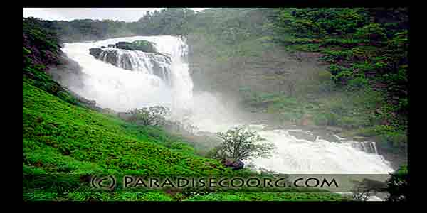 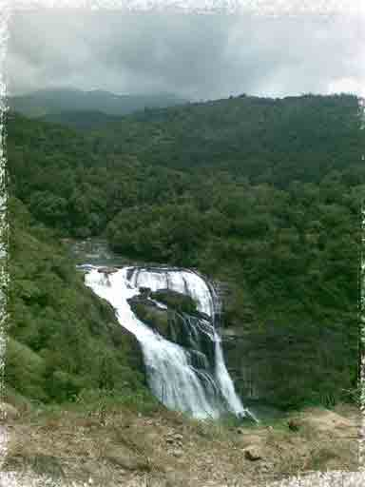

It is a beautiful sight of river Kumaradhara gushing through the valley and falling into a gorge, with lush green mountains around. The river water is white as milk while the surrounding greenery stands out like beautiful emeralds.

1. Suntikoppa. is an ideal escape from the bustling town of Mercara. It is a tiny planter’s town with sprawling estates. It is very nice to take long drives here. There is also a Ayyappa Temple here. Bird watching is also very popular here.  From Madikeri drive towards Kushalnagar, Sunticoppa is about 15 Kms from away.
2. Siddapur. Ideal venue for coffee cultivation and also Mocha County. Optimal rainfall and Rolling Meadows of Siddapur has made the town a tourist’s hub of Coorg. There are not many tourist attractions here. Scenic drives here are far beyond expectation. Angling is the past time sport here at Kummethodu river.

A river rich in all aquatic animals with excellence in carps, snakefish, catfish, katla rohu, etc, Siddapur is 24 Kms drive from Madikeri you need to go through Chettalli to get to Siddapur.

1. Honnama lake. Honnama Lake is a holy and tourist place located in Daddamalthe near Sulimalthe village 6 km away from Somwarpet town. The lake is surrounded by beautiful landscape including Coffee estates and Cliffs.

Special pooja is offered to the Goddess Honnamma on the Gowri festival every year.  Thousands of devotees come to this sacred place on this day and offers pooja to the Goddess Honnamma followed by climbing the cliff.   ‘Bagina’ which consists of sacred belongings of the Goddess is left in the lake.

1. Chettalli. Chettalli is a beautiful small village with plenty of greeneries and marvellous waterfalls. Central Horticultural Experiment Station (CHES) is the major landmark here. It is the largest in Asia and engages in research on tropical horticultural crops.
2. **Pollibetta.** Pollibetta also known as planter’s town, is a very mountainous agricultural region. Along with coffee oranges and pepper is also grown.Best coffee estates are found here. Pollibetta is also tourist’s paradise and also called Scotland of India. pollibetta lies 12 Kms south-east of Siddapur.
3. **Nisargadhama.** Nisargadhama is a breath taking and beautiful island off the state highway, Just 2 km from Kushalnagar town and around 30 kms from Madikeri. An Ecological Park for young and old and a paradise for the nature lovers also it has a small snack house, a deer park, boating and elephant ride.  
    It ïs a 64 acre island with Cauvery river flowing by, can be accessed by walking across a **hanging bridge**. If you feel like having a relaxed time in a quite and peaceful environment, Nisargadhama is the place. It gives immense pleasure to all the Nature loving tourists. Nisargadhama has a forest Department run rest house. It is filled with lush foliage of thick bamboo groves. Elephant rides and boating are some of the other attractions. This place is for one who wants to spend a nice time in the green with family, there are also tree houses boating and other activities conducted around this place.
4. **websites**

<http://www.paradisecoorg.com/Nisargadama.html>

<http://www.paradisecoorg.com/index.html>

<http://www.karnataka.com/coorg/places-near-coorg/>

<http://www.coorgcreek.com/explorecoorg.htm>

