

Migrate Your Data (On Premise Edition)

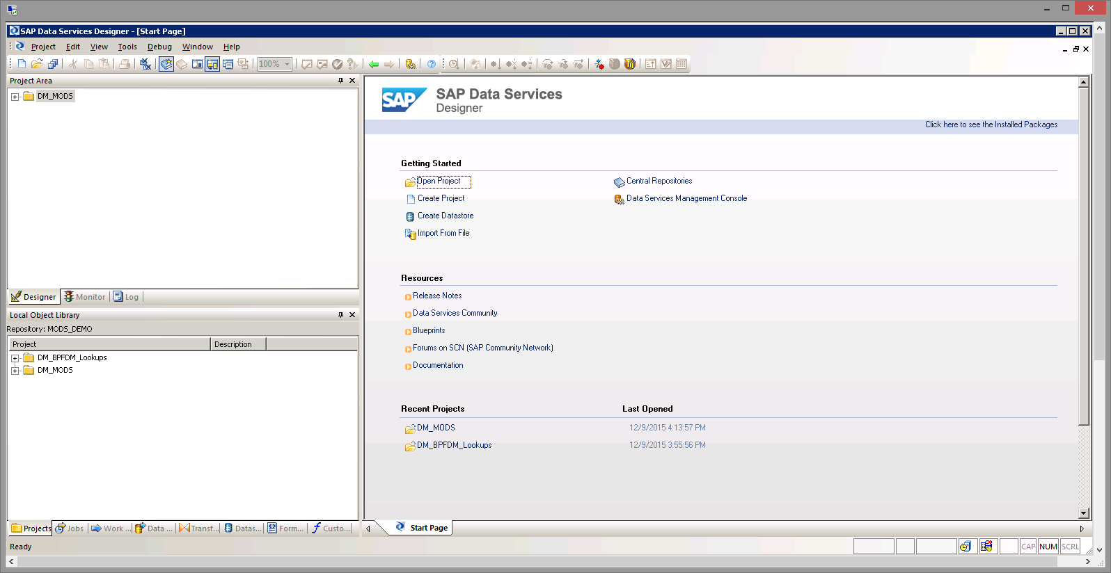

|  | Would you like to know more about how to migrate your data in the SAP S/4HANA On Premise Edition?    If so, follow this interactive demo. |
| --- | --- |

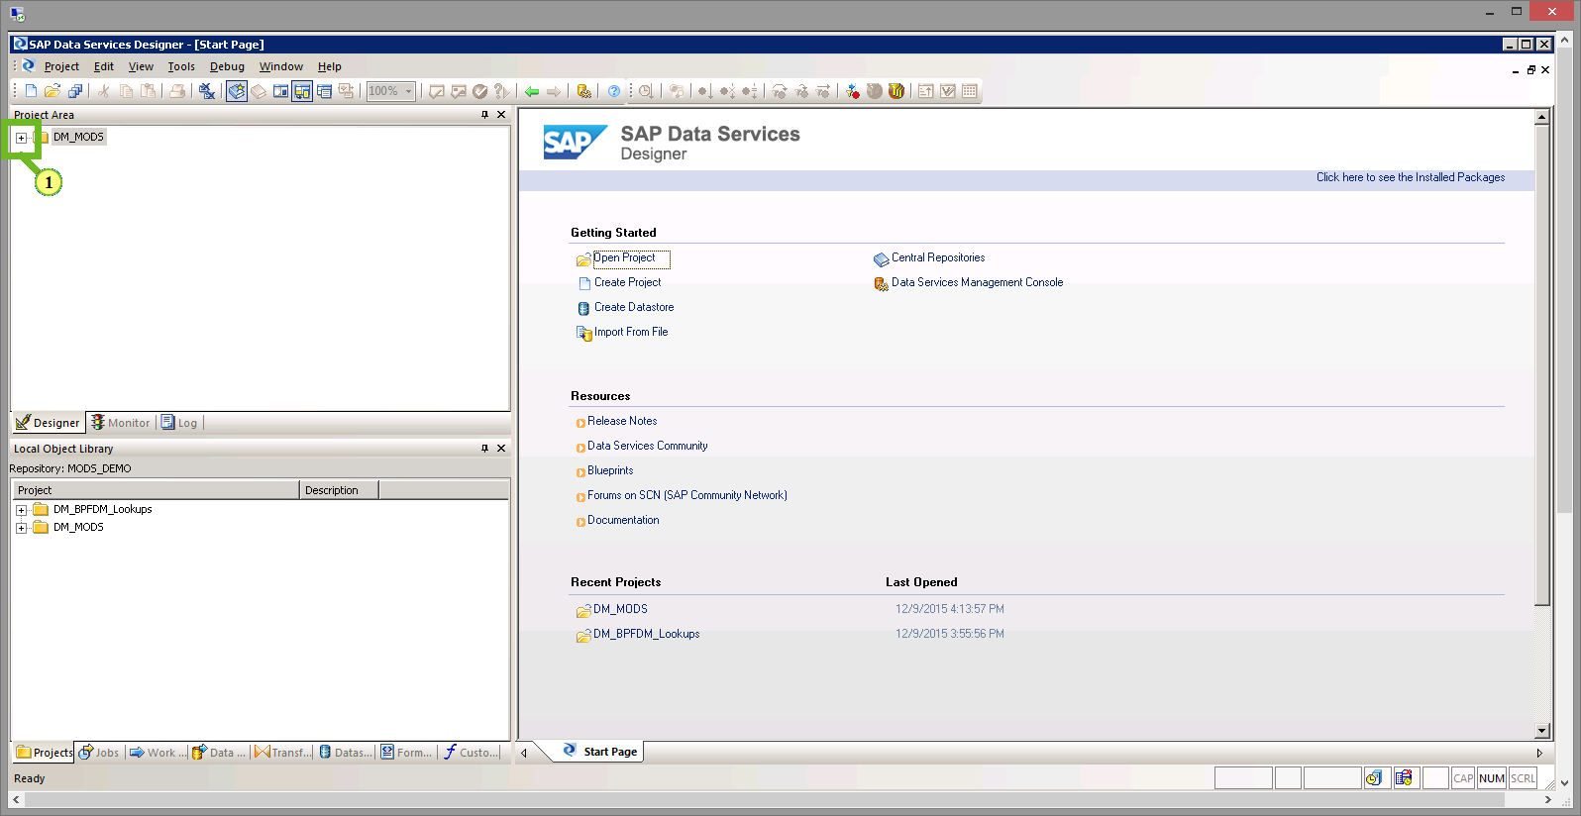

(1) In the SAP Data Services Designer, expand the Project *DM_MODS* to open the data migration project with all its objects.

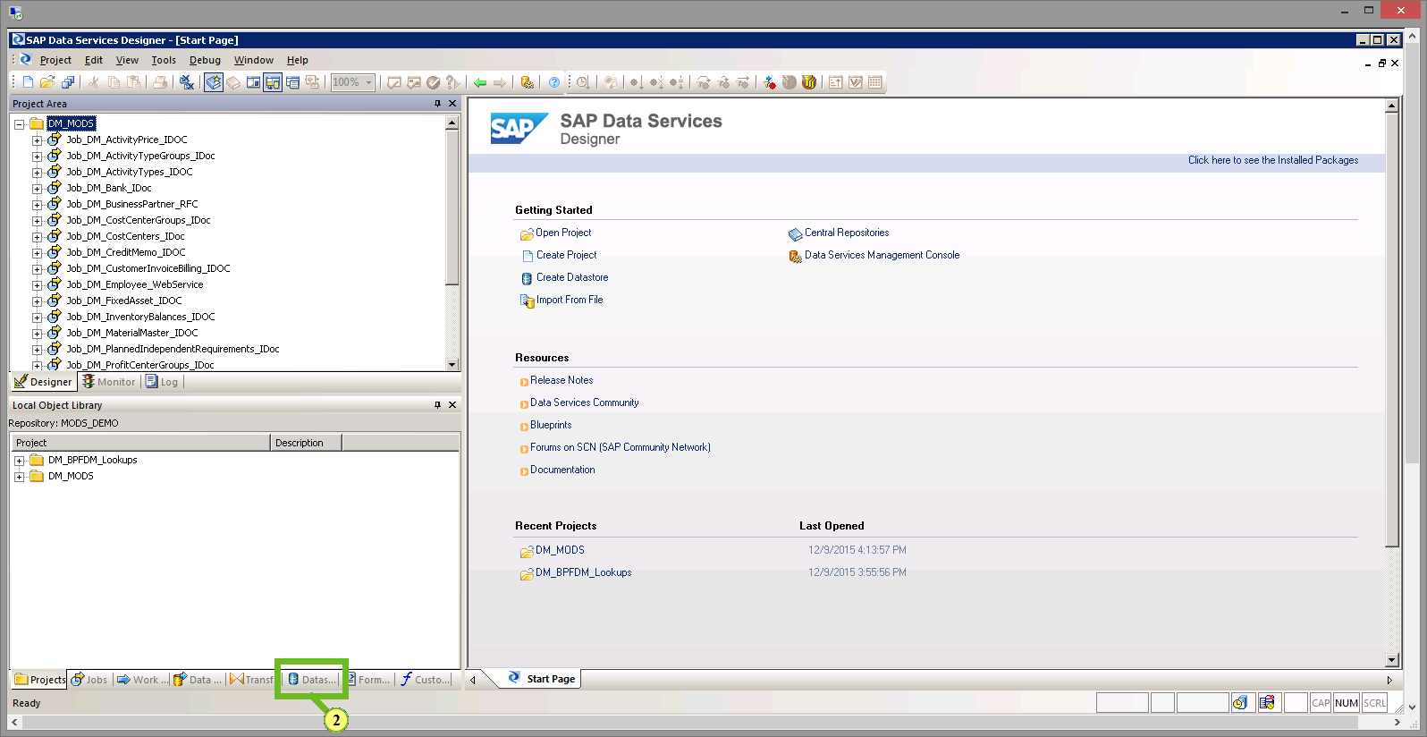

(2) To connect to the target SAP S/4HANA system, choose the *Datastores* tab.

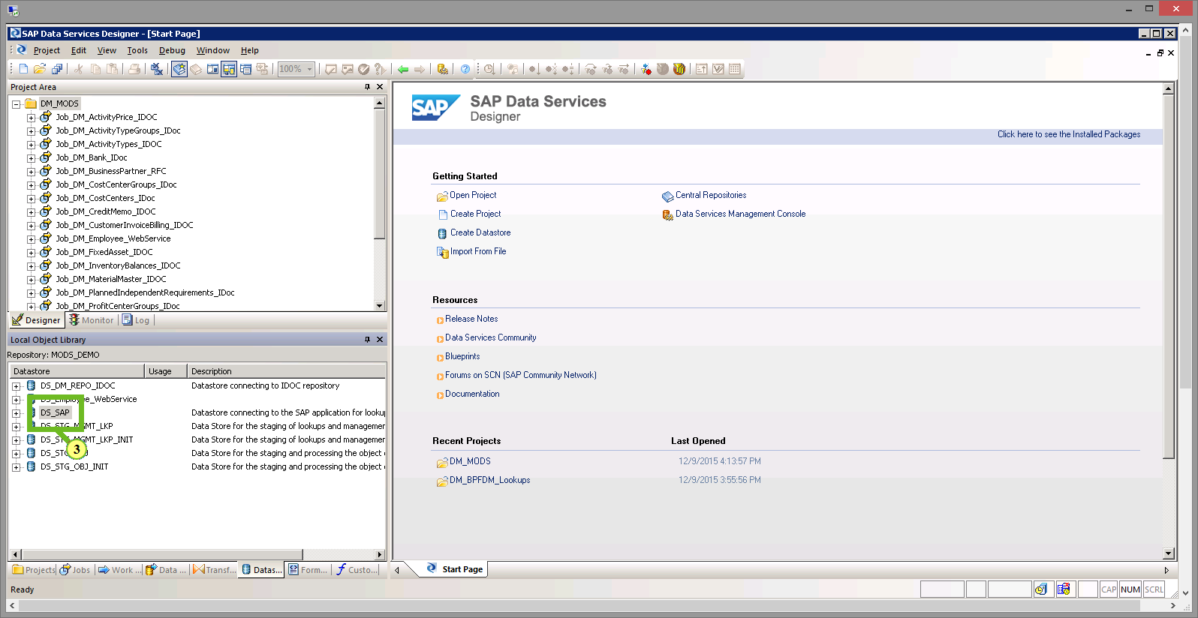

(3) Select the pre-defined target data store *DS_SAP* with a right mouse-click to open the context menu.

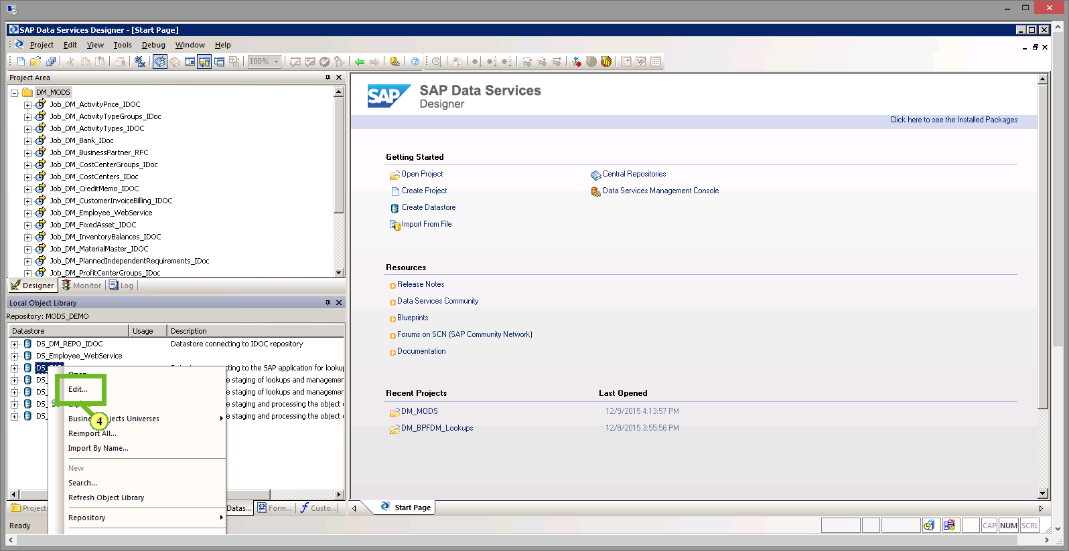

(4) To enter the connection details of the target SAP S/4HANA system, choose *Edit*.

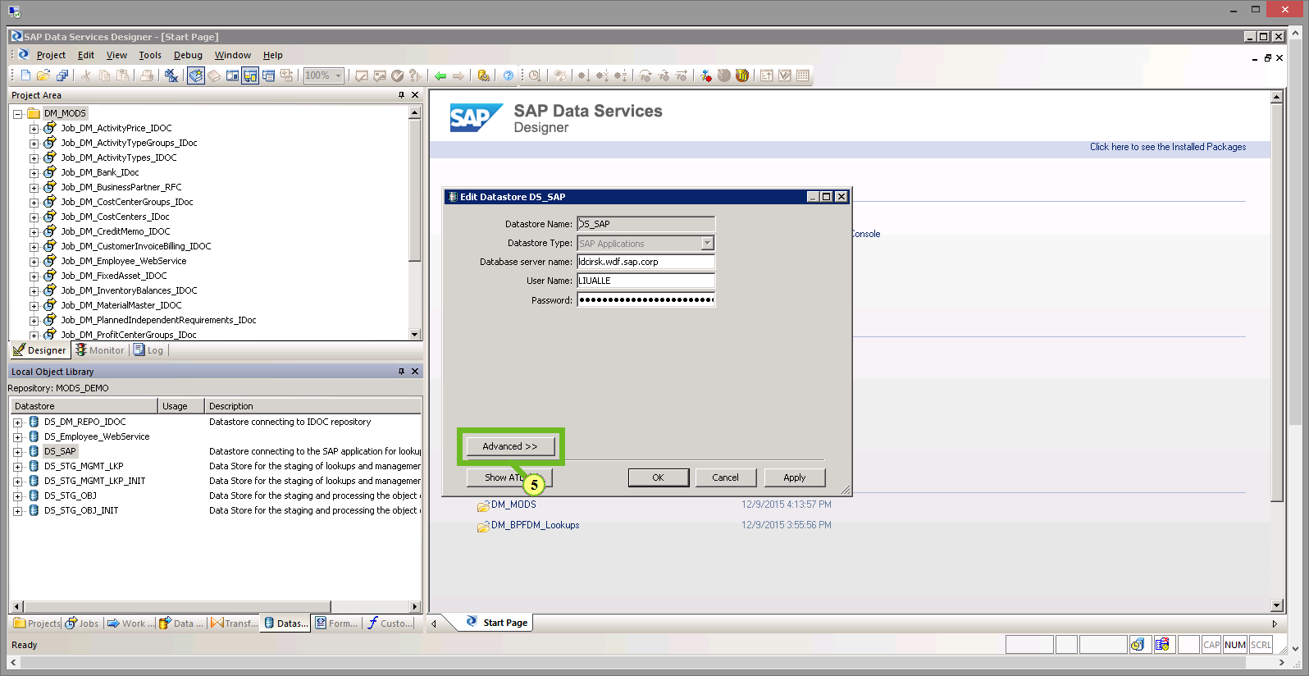

(5) Choose *Advanced*.

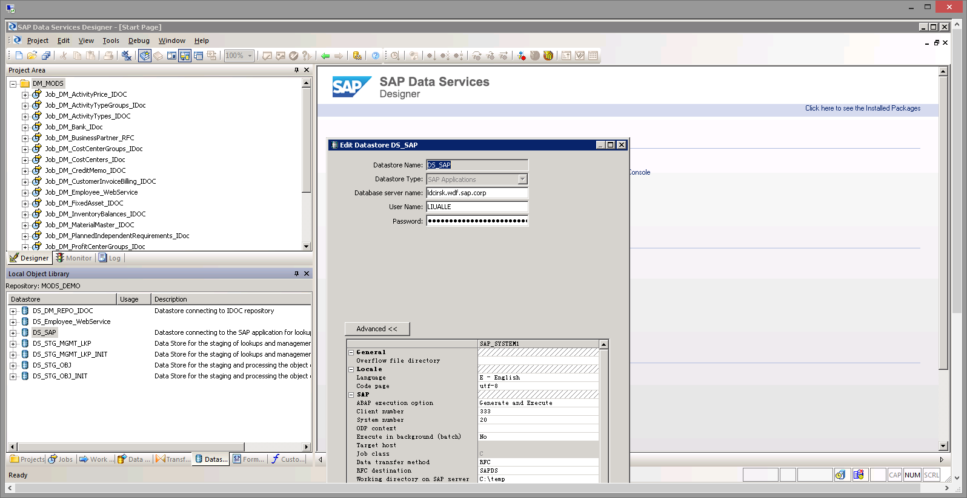

|  | In this popup screen you specify your SAP S/4HANA target system’s connection data, such as server name, instance number, client number and logon user credentials. This connection will be used as a target system to upload the data. For this demo, the necessary system information has been entered already and we don’t need to change anything now. |
| --- | --- |

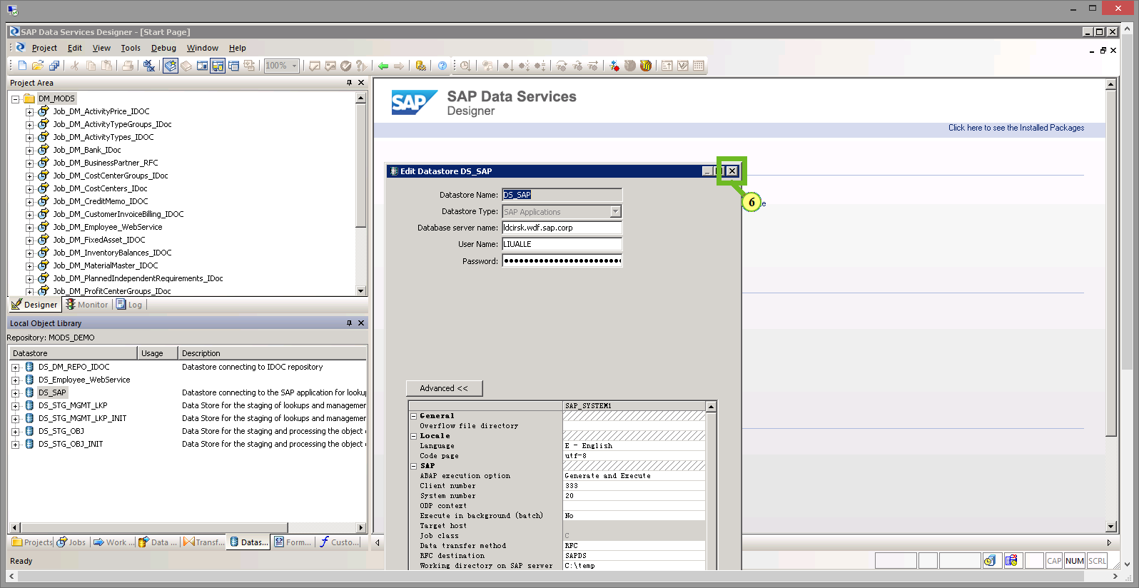

(6) Choose *Close*.

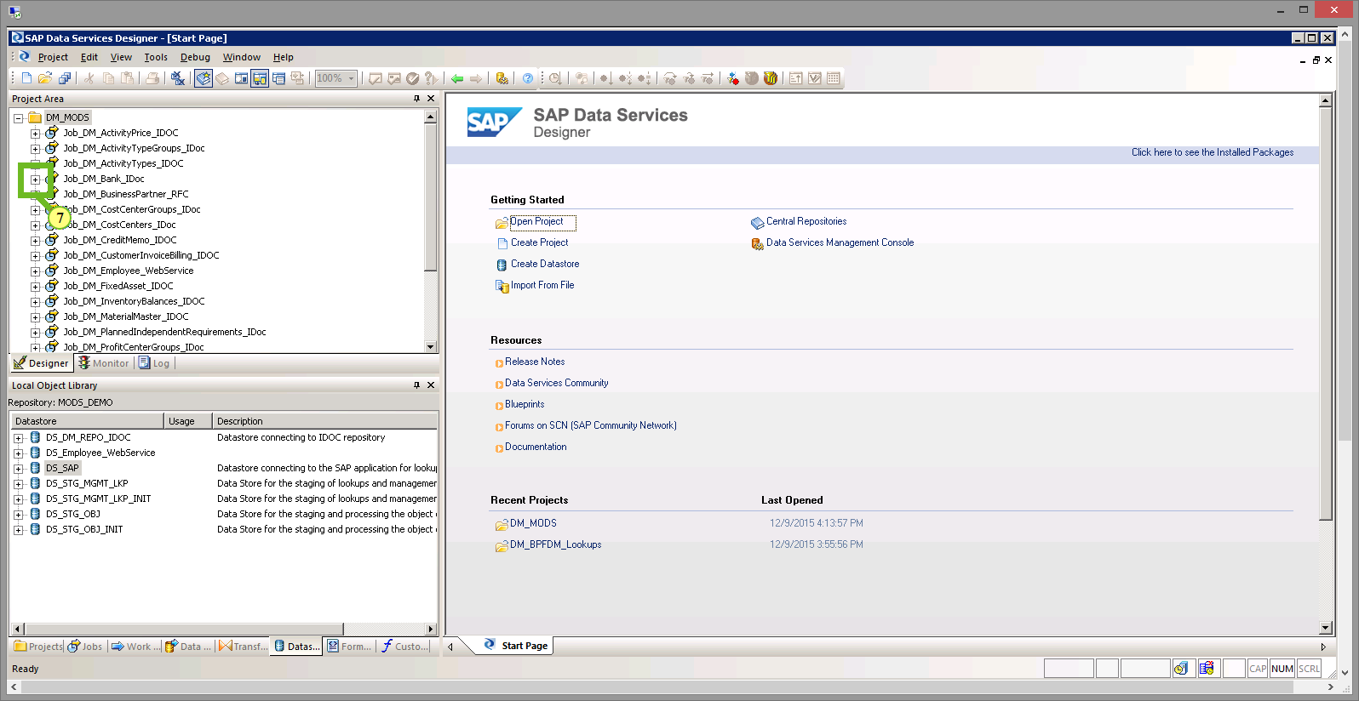

(7) To migrate bank data to the SAP S/4HANA system, expand *Job_DM_Bank_IDoc.*

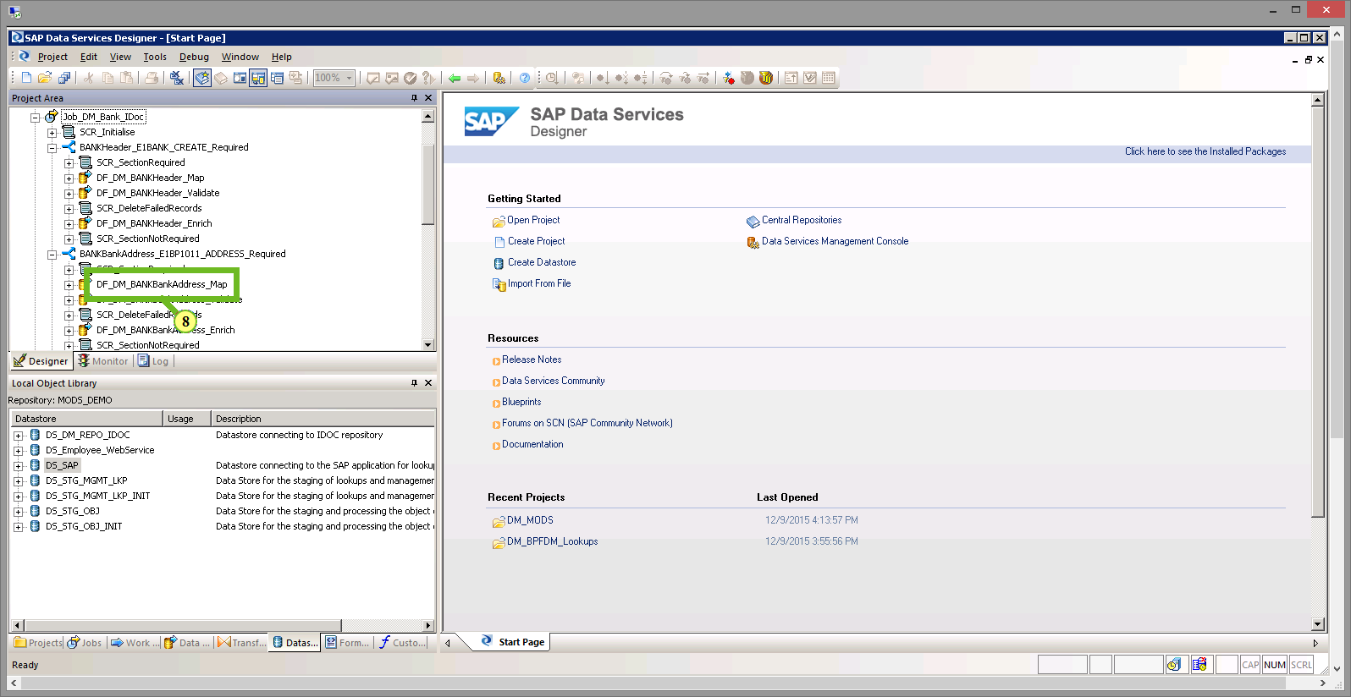

(8) To load the bank address data, select*DF_DM_BANK_BankAddress_Map.*

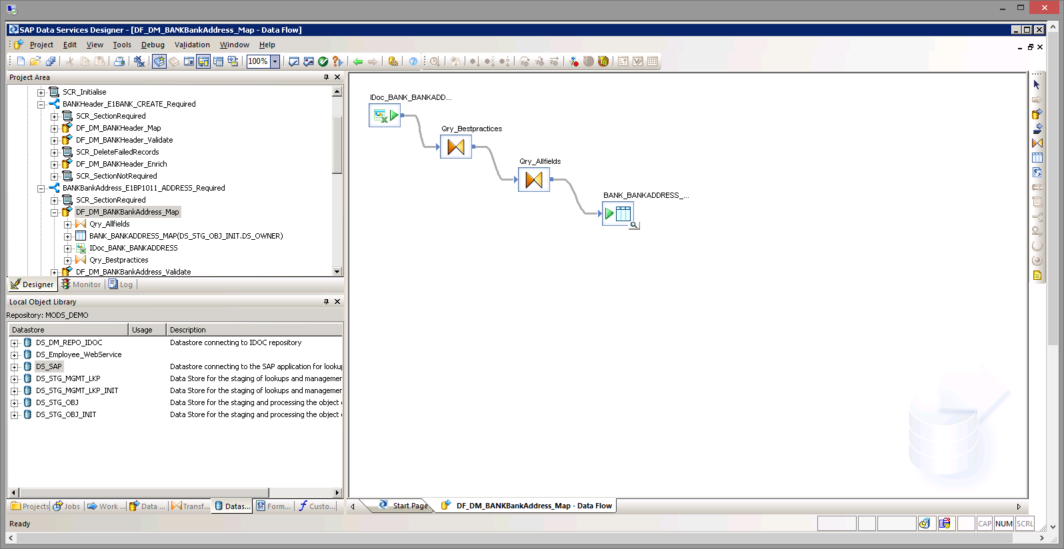

|  | You see the mapping data flow which consist of two queries, one for a limited Best Practices amount of target fields and one that gives you access to the complete field list that contains any field that is part of the bank data, even if not needed for S/4HANA Best Practices scenarios. The mapping is pre-done for Excel mapping sheets that are pre-delivered with the content. You can either fill the Excel sheets with the data or connect via ODBC interfaces to your source system or connect to flat files. For this demo, we are using the Excel template that comes with the SAP S/4HANA data migration content. |
| --- | --- |

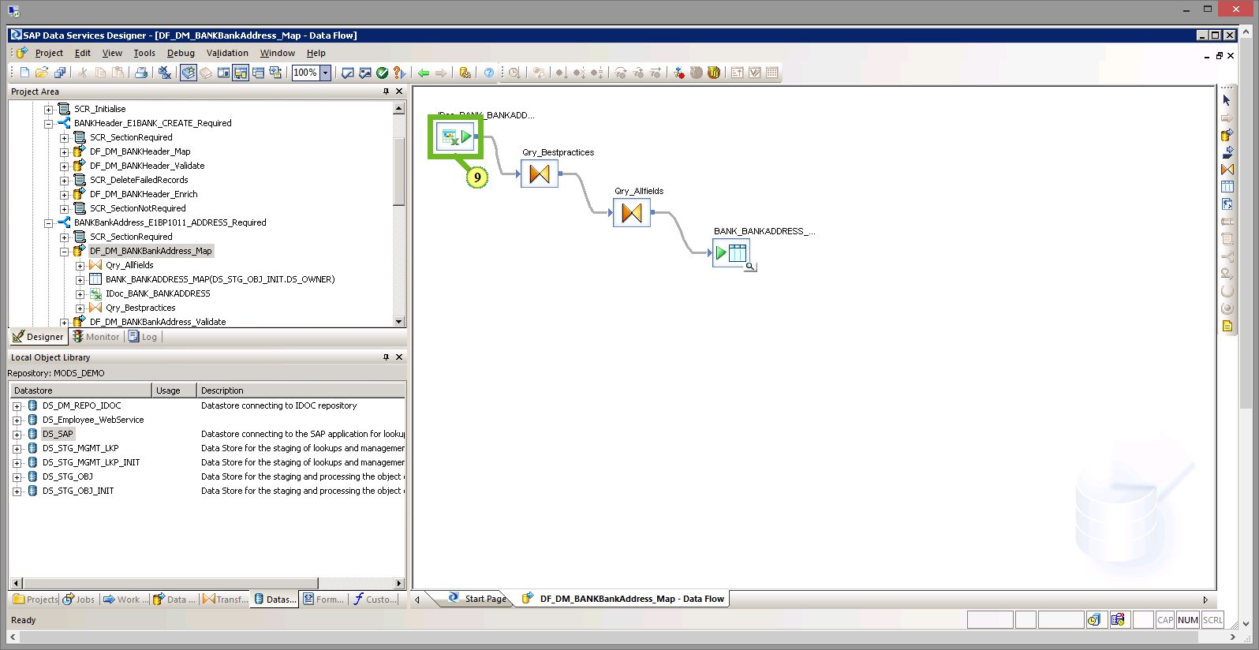

(9) To open the bank source data Excel template, select *IDoc_Bank_BANKADDRESS*.

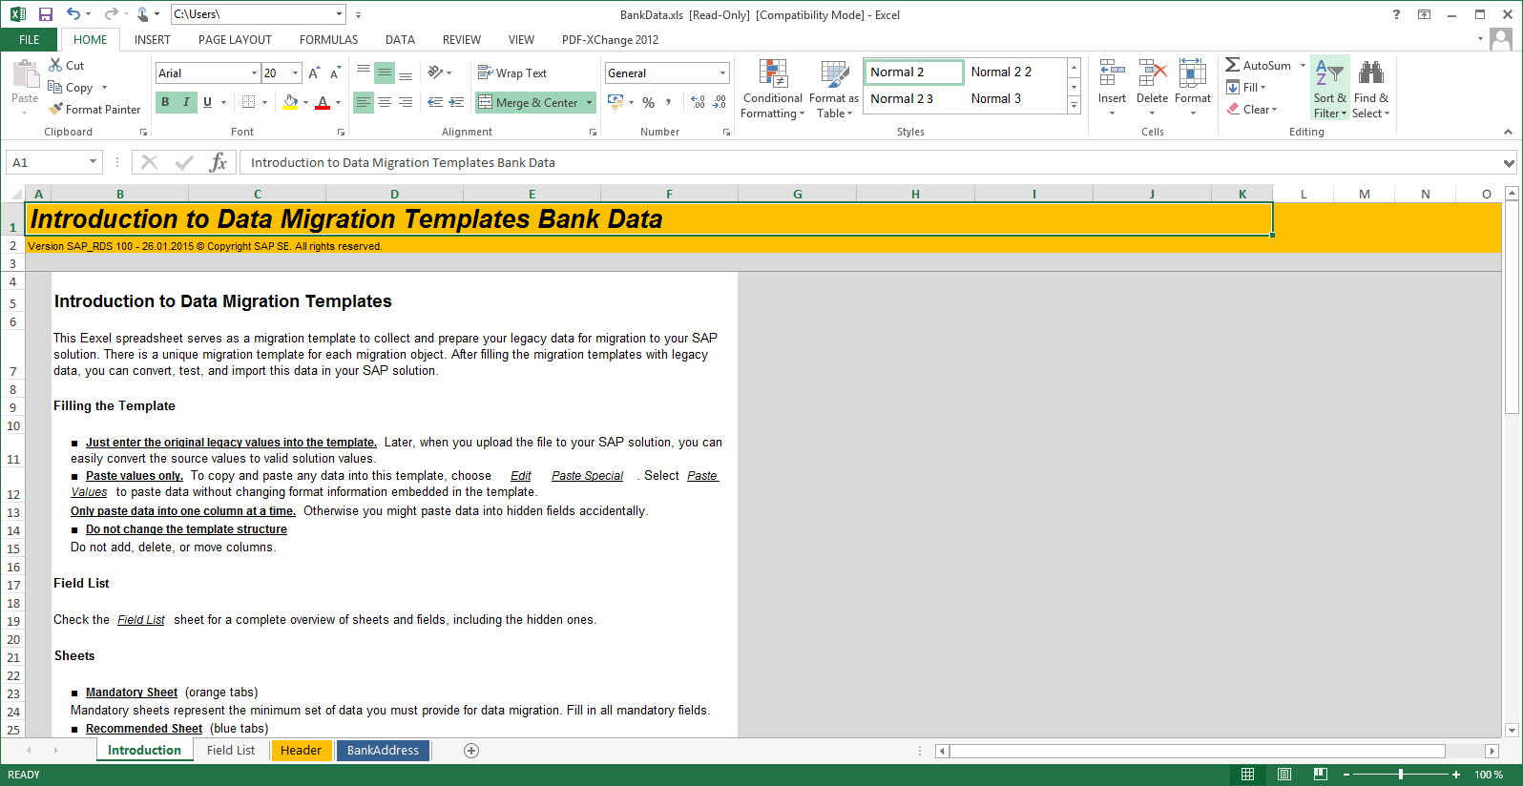

|  | The source data Excel template can be used to collect the legacy data in a predefined way that allows you easily to run jobs in SAP Data Services without the need for complex mapping tasks within the tool. The templates come with introductions in an overview on how to fill the template. |
| --- | --- |

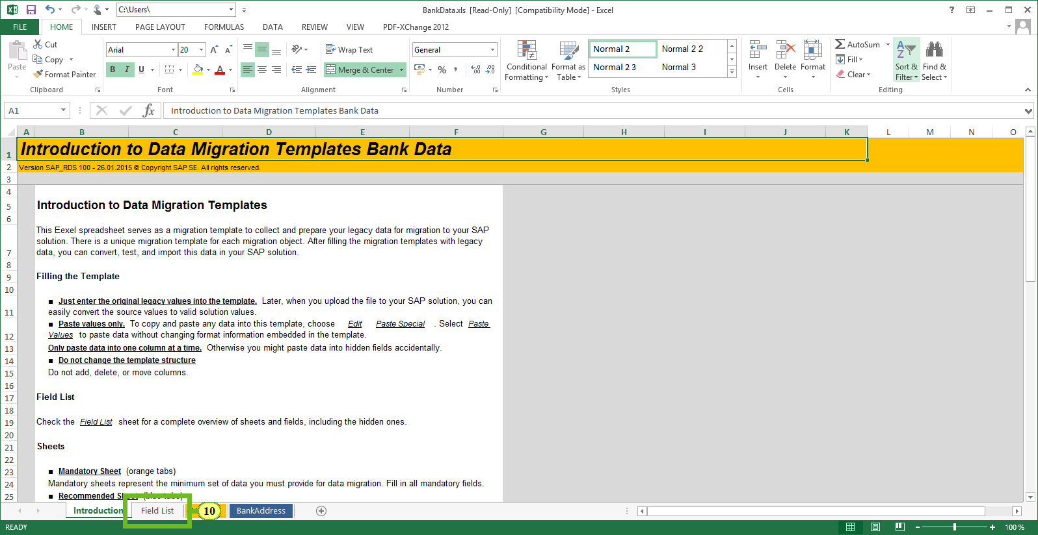

(10) To get more information about the available fields, select the *Field List* tab.

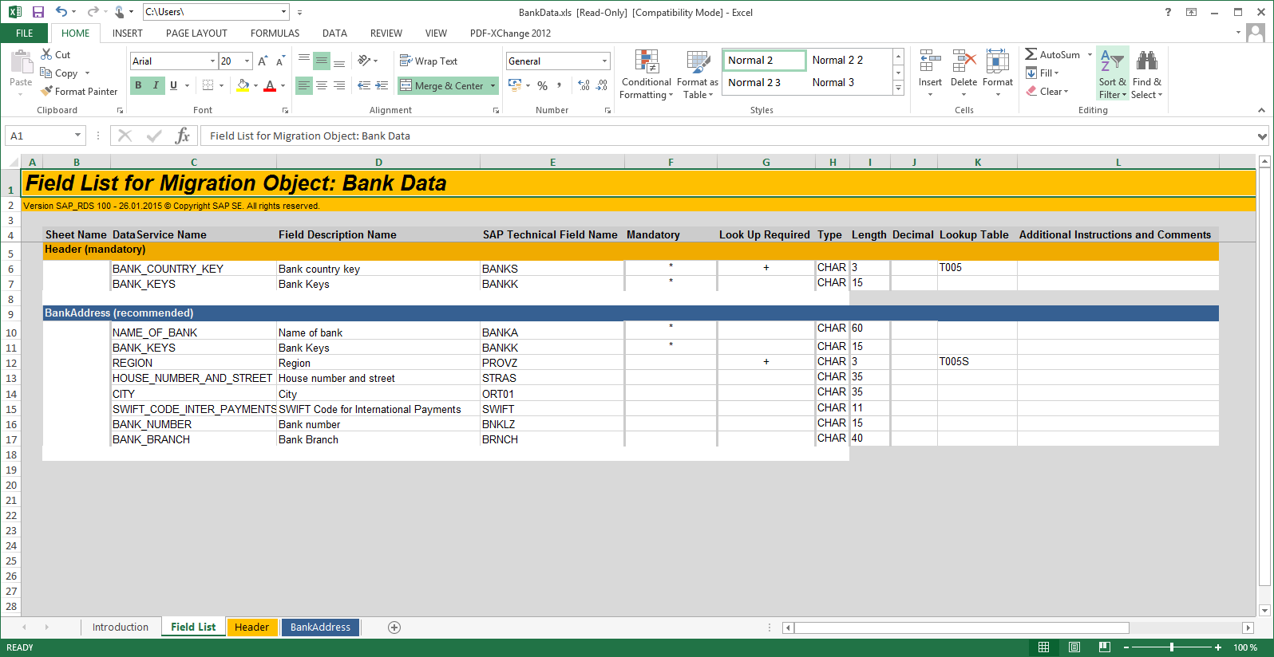

|  | The Field List shows all available fields for both the Header and Address data as well as data format, mandatory fields and whether the fields have dropdown values selected via check tables (for example, Country Key US for the USA and DE for Germany). |
| --- | --- |

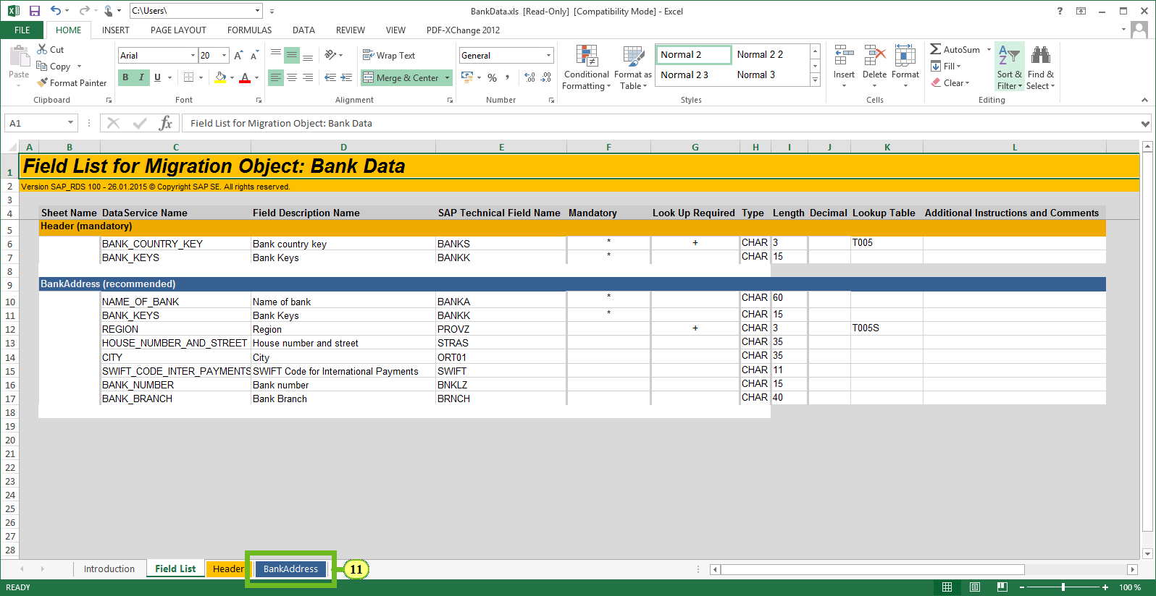

(11) To access the source data area, select the *BankAddress* tab.

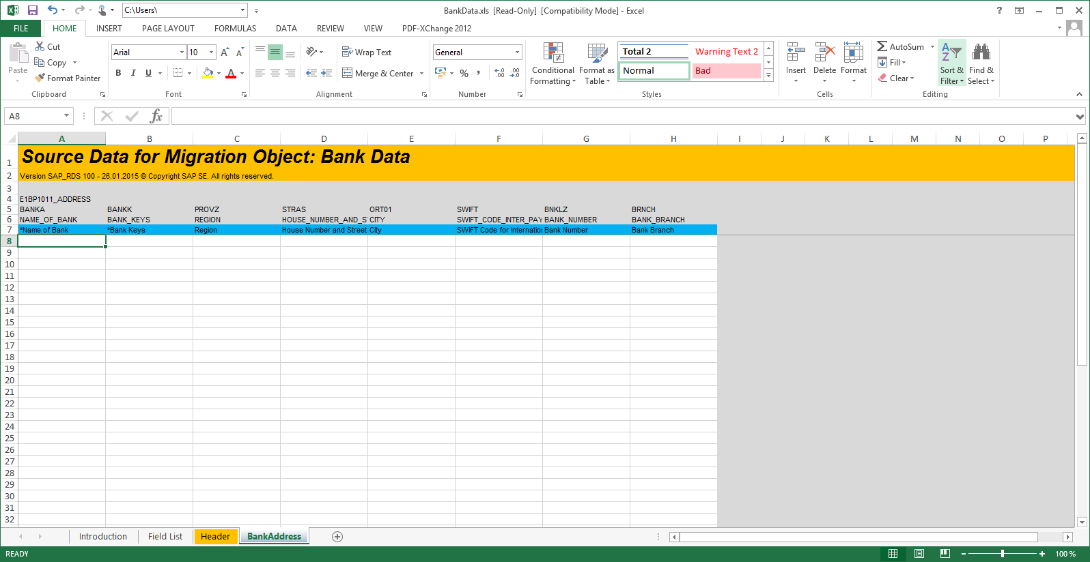

|  | When using the template, this is the space where the source data has to be inserted. You can either fill the Excel templates with an ETL process, manually or using copy and paste form another source (like flat file or Excel table). For this demo, we are using some sample data and populate it via copy and paste. Just choose the Forward button, the data will be entered. |
| --- | --- |

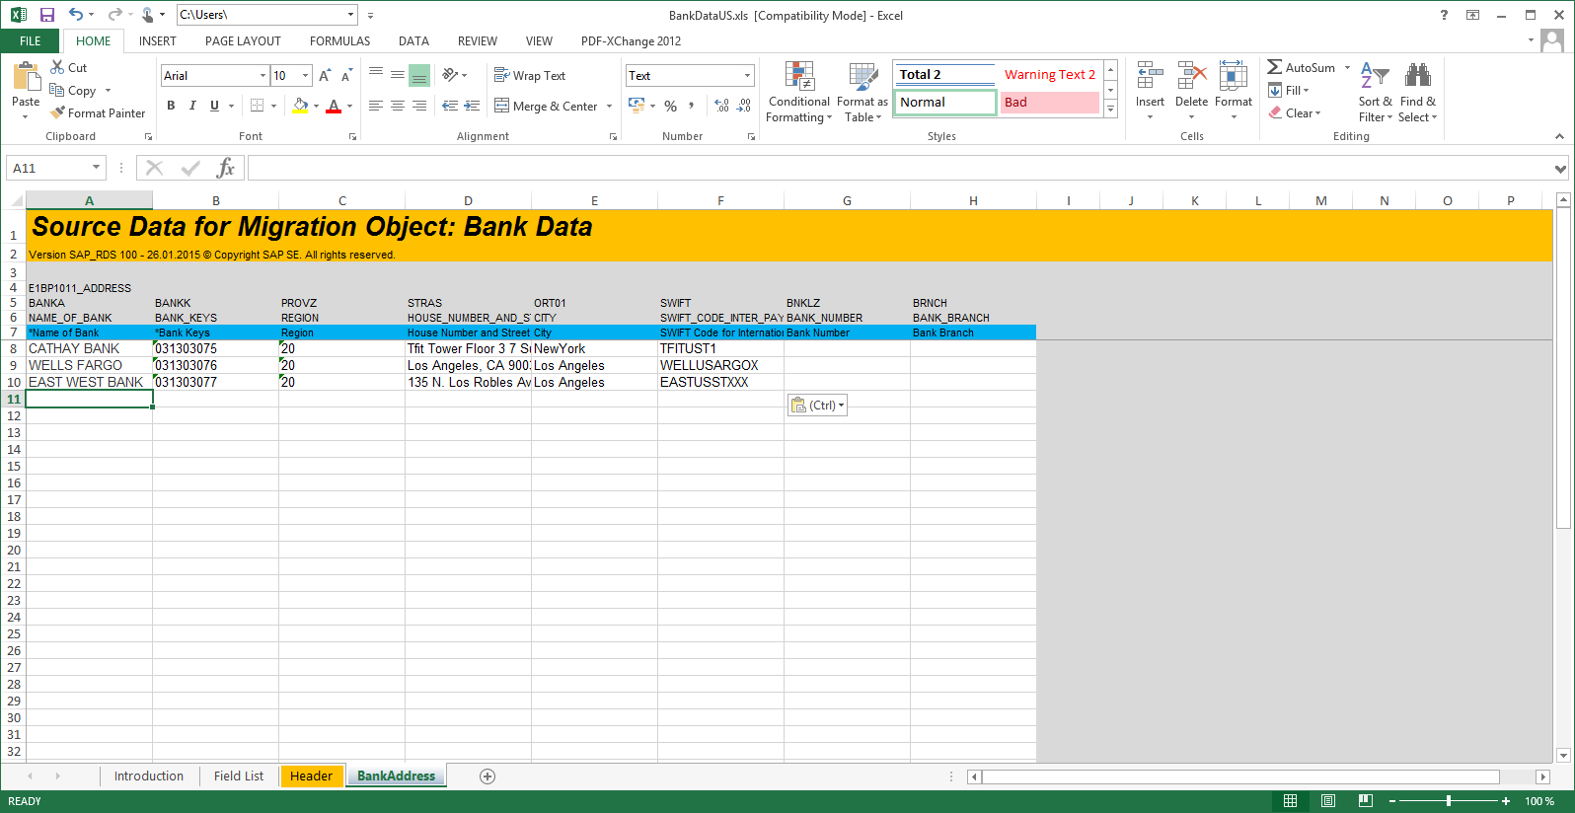

|  | The data has been entered. |
| --- | --- |

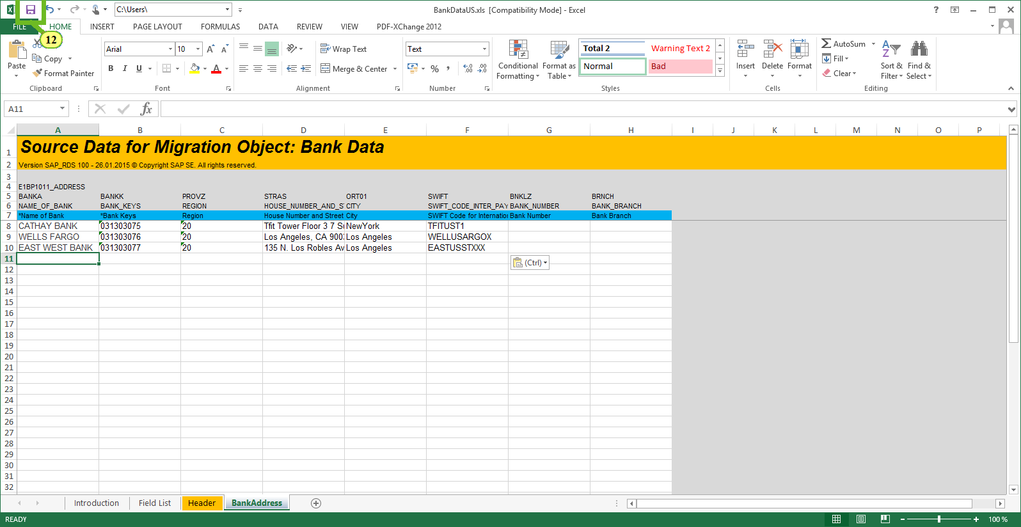

(12) To save the data, choose **Save**.

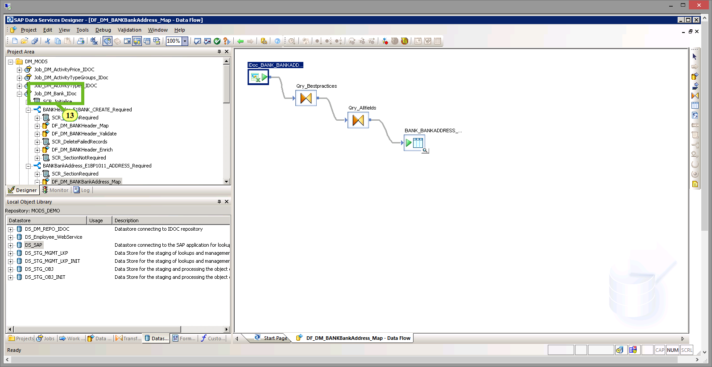

(13) Back in the SAP Data Services Designer, select the job *Job_DM_Bank_Idoc* with a right mouse-click to start the job run.

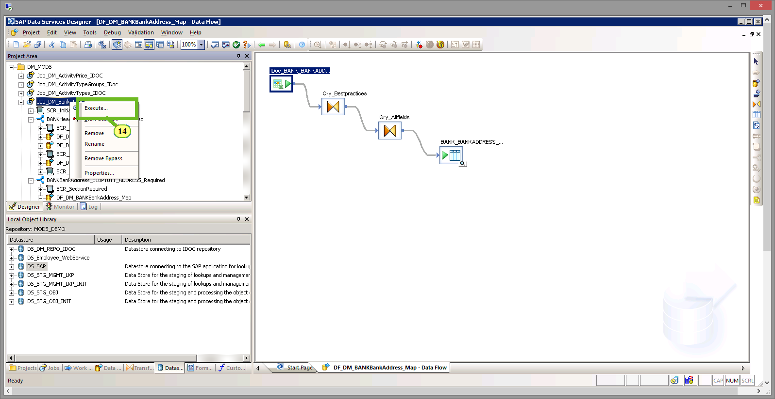

(14) To start the job run, choose *Execute*.

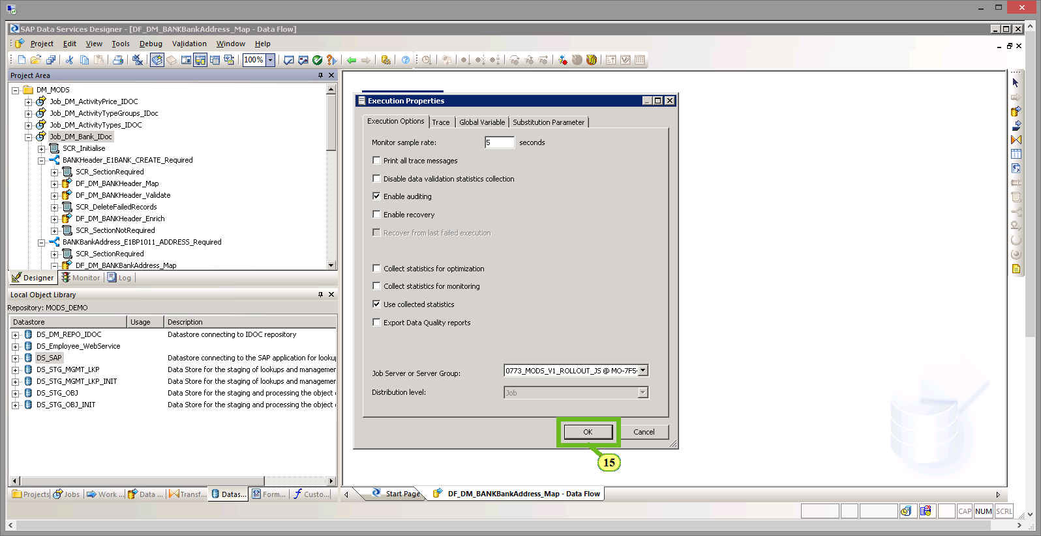

(15) To confirm the default job execution properties, choose *OK*.

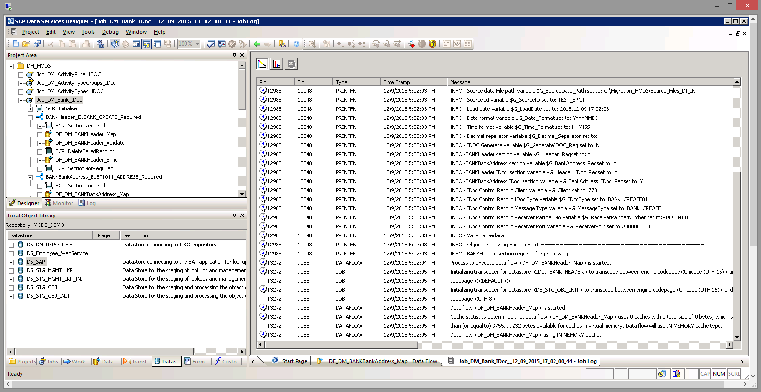

|  | The job is running and a log is shown . |
| --- | --- |

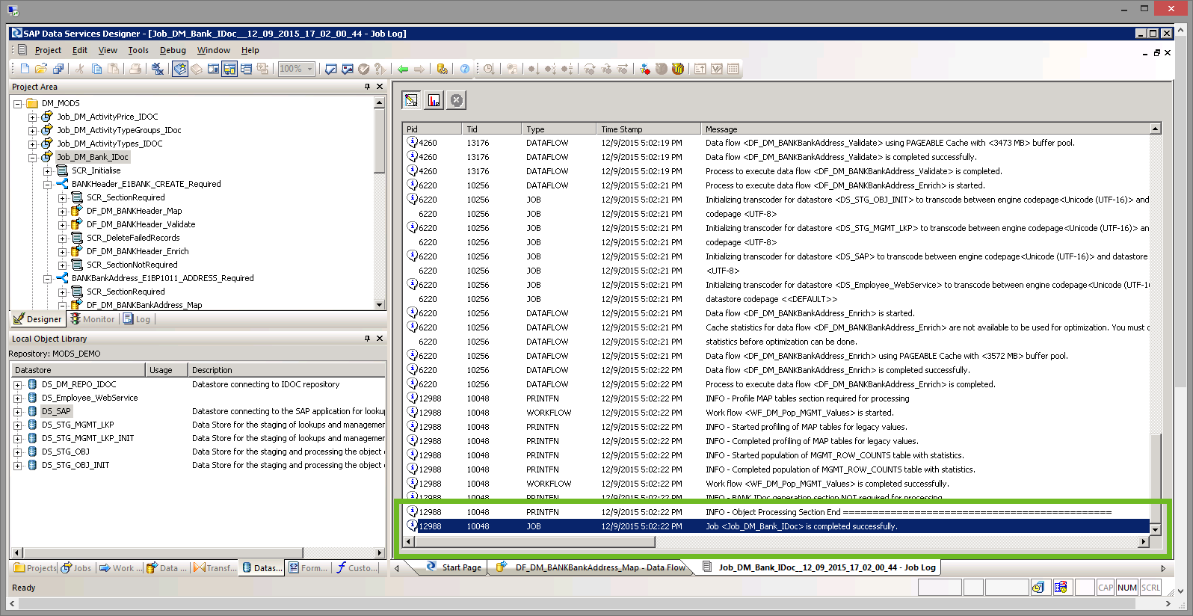

|  | The job is completed successfully. |
| --- | --- |

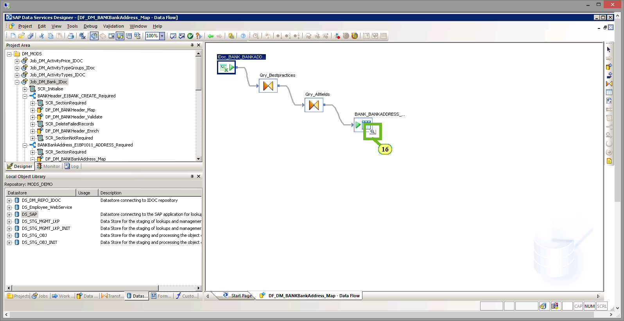

(16) To verify the data, choose *Bank_Bankaddress*.

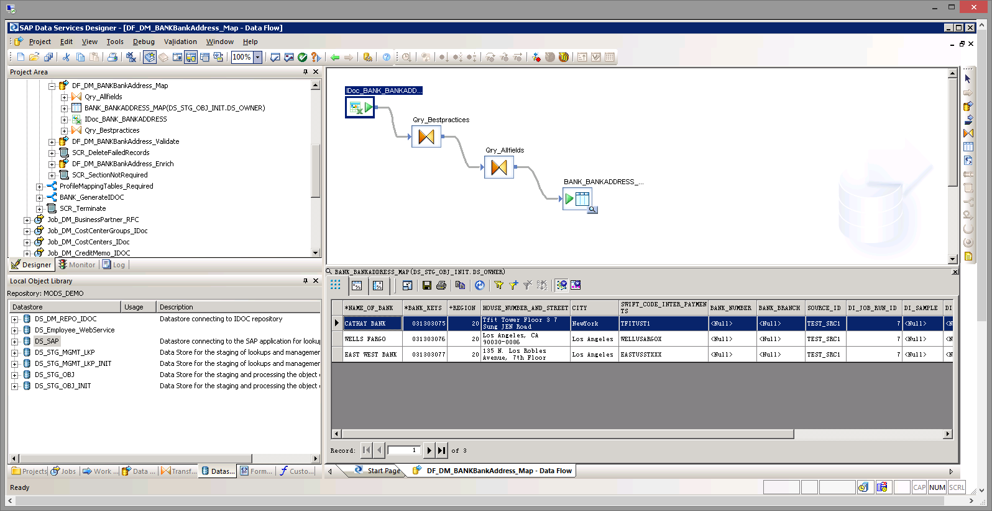

|  | The source data is shown as it has been read from the Excel template. |
| --- | --- |

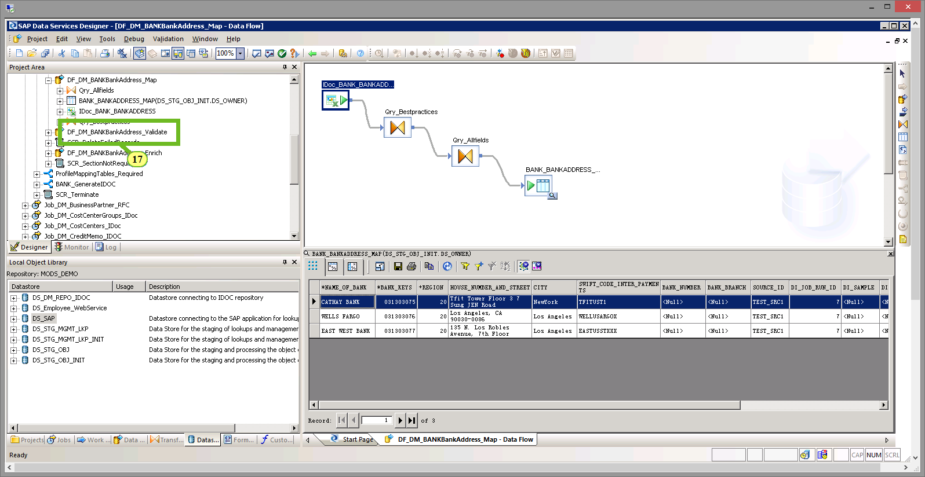

(17) To check whether the data records are valid, select*DF_DM_BANK_BankAddress_Validate.*

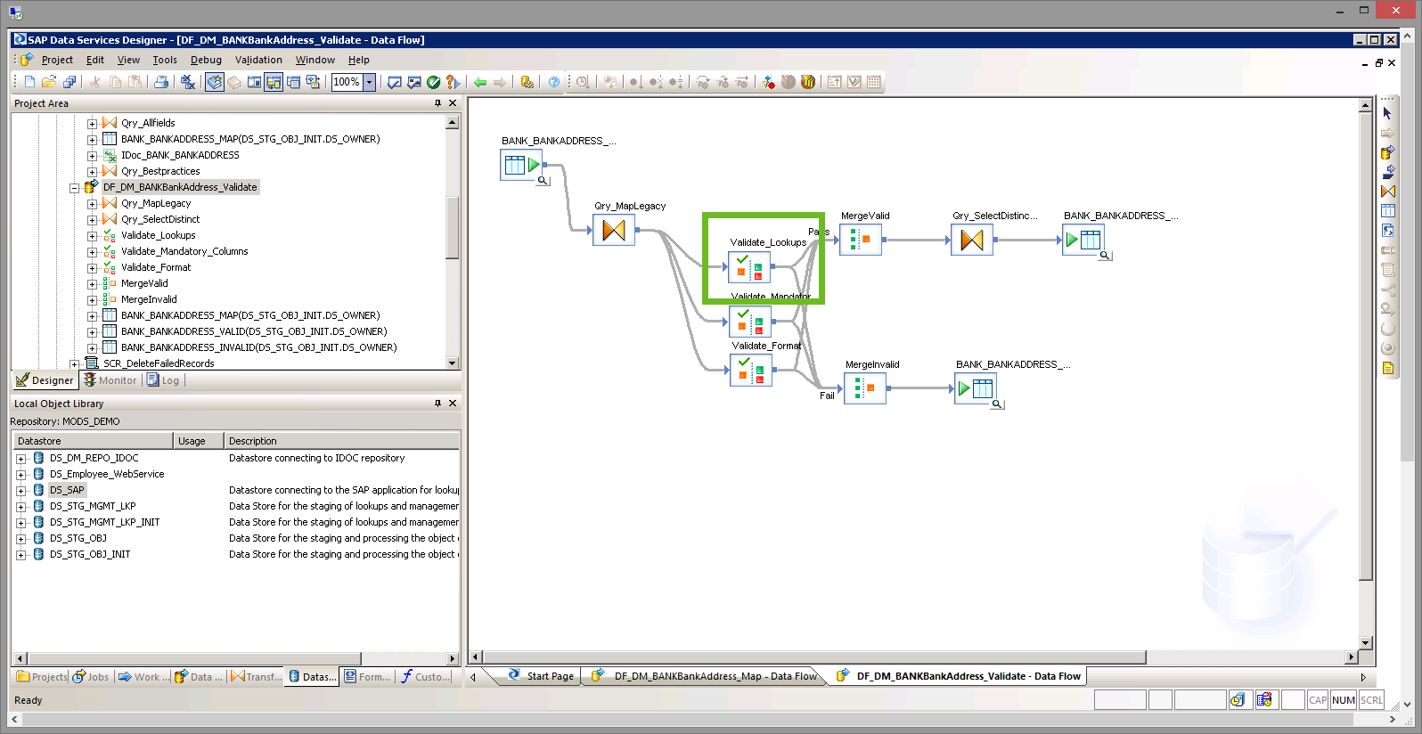

|  | The *Validate_Lookups* validates the values against the SAP check tables, making sure that the data is correct and that performing value mapping is necessary (for example, USA > US or Germany > DE). |
| --- | --- |

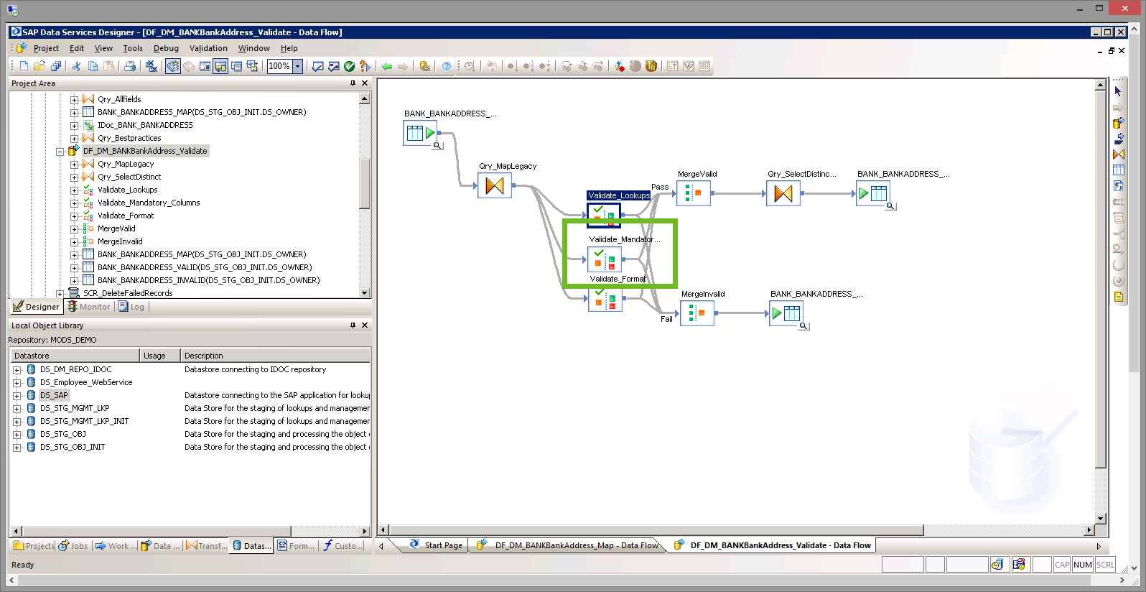

|  | The validation *Validate_Mandatory* checks whether all the mandatory fields are populated and will raise an error message if any required fields are missing. |
| --- | --- |

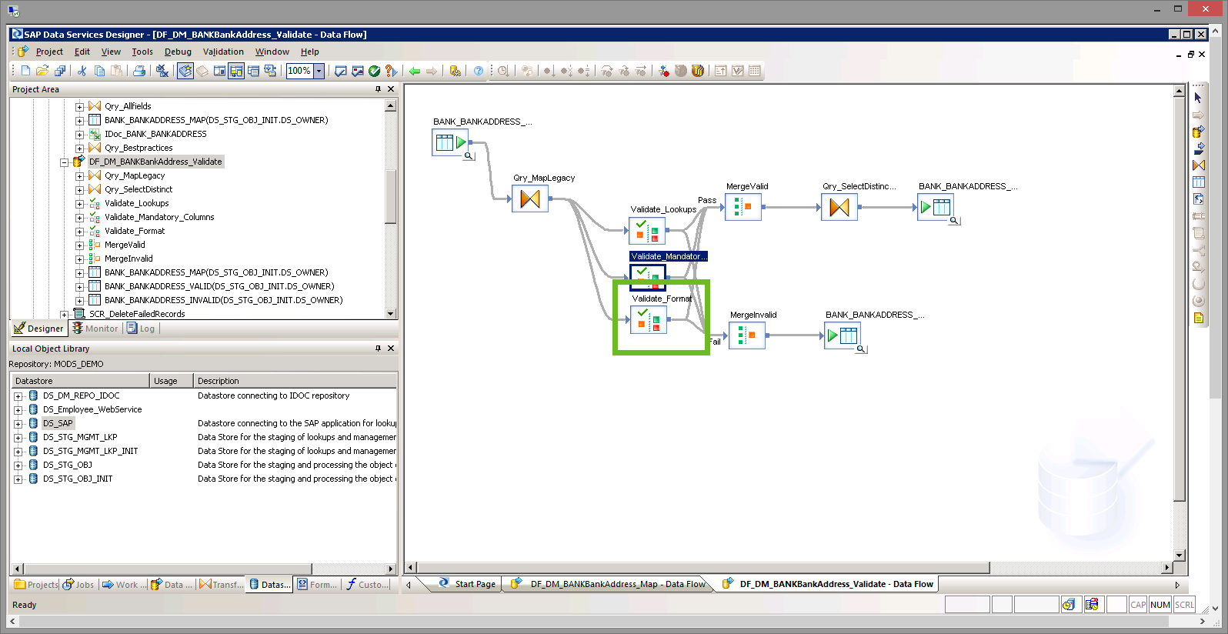

|  | The validation *Validate_Format* verifies the format, such as data type and length, making sure that the data can be loaded by the SAP S/4HANA target system. |
| --- | --- |

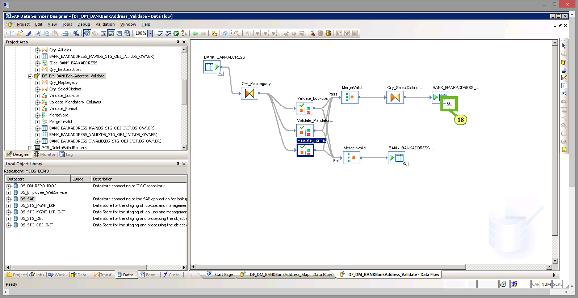

(18) Choose the upper *BANK_BANKADDRESS_* icon which represents the passed data records.

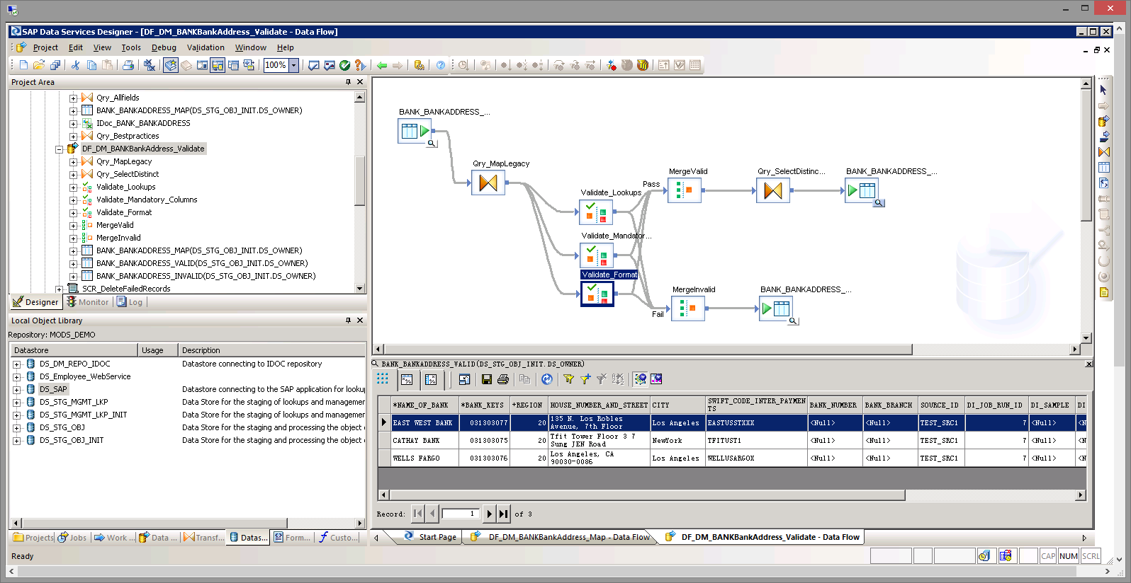

|  | All the three sample data records are valid and therefore have been successfully loaded into the SAP S/4 HANA On Premise system.  In case of invalid legacy data, the SAP Data Services job would have prompted for the invalid data records. You can always run the job in test mode prior to the actual load to check for any invalid data.    This concludes the interactive demo. |
| --- | --- |