SEEYOUALL GROUP REPORT

**Composed by: Joana Rita Paulo Freitas,** [**Precilia Tecassala**](https://www.facebook.com/precilia.tecassala)**,** [**Julie Véronnet**](https://www.facebook.com/julie.veronnet)**,** [**Tibor Paulovics**](https://www.facebook.com/paulovics) **and** [**Roberto Acosta**](https://www.facebook.com/otrebor.acosta)

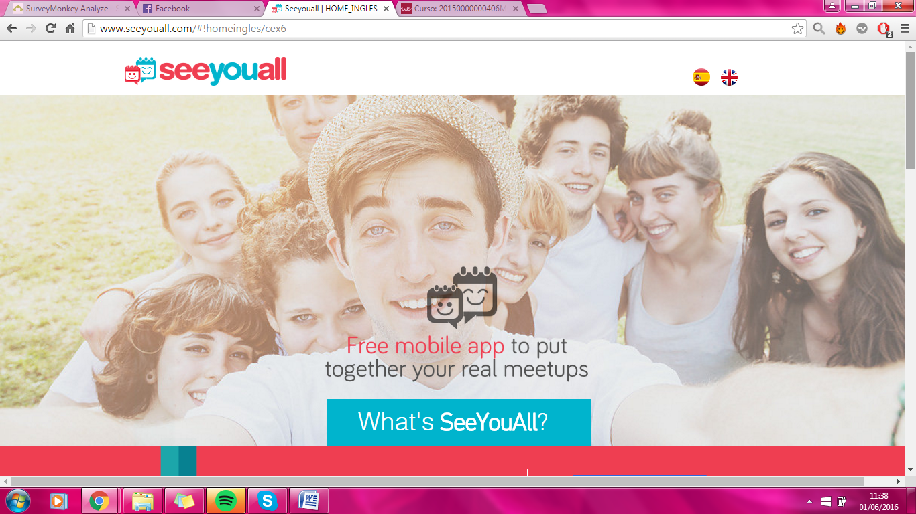

Content

## Introduction Page 3

## Country 1 Finland: Page 3-4

## Country 2 France: Page 4-5

## Country 3 Portugal: include the competitors

## Survey analysis

## Table of comparison

## Conclusion

## Bibliography

## Annex (the survey)

## Introduction

SeeYouAll is a **FREE** Smartphone application that allows that makes you organize get together’s and events in a comprehensive, simple and user friendly way. You can organize our real meet ups, set a date, the place or confirm guests and collect the money for these events which could become our worst nightmare at times. SeeYouAll will let you in a very easy, enjoyful and convenient way to organize, plan and participate in more "real life" events.

We have been given the task to analyse three countries in or around Europe and help the company decide which country they should internationalise to with the correct and justified data.

## Country 1 Finland:

Finland has an A2 level of country risk rating, which indicated that it is a highly recommended country to start a business. The A2 rating comes from the strengths of high living standards. The GDP of Finland is 256.9USB$, it is because Finland has a well structured economy. By its economic system Finland attracts a lot of companies and individuals to invest into Finland due to its prudent economic policy, from these points Finland seems to be a strong and independent Economy but on the other hand the Finnish banking sector highly depends on the Swedish and the Danish financial sectors although these two have a strong economy as well.

Finland has a total population of 5,471,753. Almost half of the people are a using Smartphone due to the statistics (45,5%) by this we can associate that more or less 90% of the Smartphone users are belongs to a social media community where they speaking with their friends, sharing their personal interest and organizing events. The main sites people are using is Facebook and Instagram, with these two the users are able to do all the things mentioned above. The population of Finland’s ratio is 50-50 by gender. By this information it is an advantage that if a social application would like to enter the market, because they will have to take the gender differences too serious in fact of the gender ratio. The probability of users would be equally divided.

People are basically not willing to change frequently, so to enter a market might be really difficult with an application that is new and the others already have more or less the same features.

But still the new application with a good marketing and a great introduction it can be a massive competitor for the current applications. Due to the high Smartphone usage, people would definitely try it out but there must be something that makes sure they will not delete it after the first day.

## Country 2 France:

## Country 3 Portugal:

## Survey Analysis

For our survey analysis we created a quick questionnaire with 10 questions on surveymonkey.com with the following questions:

1. **Are you male or female?**
2. **How old are you?**
3. **What country are you from?**
4. **If you could use only one of the following social networking services, which would you use?**
5. **How long would you say that you spend on social media/internet in a day?**
6. **Do you use social media to meet with your friends?**
7. **Do you know and/or use Doodle?**
8. **When you look at the SeeYouAll App, do you know similar apps/tools in your countries?**
9. **Do you think SeeYouAll could be an interesting app for your country?**
10. **Following question 9, please give your reason for your answer.**

## Table of Comparison

## Conclusion

## Bibliography

[www.surveymonkey.com](http://www.surveymonkey.com)

## Annex (the survey)



 

