INSTRUCTIONS

for

Downloading & Installing

*Medicare Remit Easy Print* Software

onto a Local PC

*(You are not planning on sharing the application*

*with other users on a network)*



This software was developed by the Centers for Medicare & Medicaid Services (CMS) for use by Medicare providers/suppliers to view and print a Health Insurance Portability and Accountability Act (HIPAA) compliant Medicare 835. Medicare has no liability and takes no responsibility for any other use of this software.

|  |
| --- |
| PC Requirements |

Recommended speed: 2.0 GHZ or faster

Compatible speed: 1.0 GHZ

Please note: the processing time for importing and accessing the SPR files within the *Medicare Remit Easy Print* application will be dependent upon on the processing capability of the PC and the size of the files being imported viewed.

|  |
| --- |
| Operating System Requirements |

Recommended: Windows XP

Other compatible versions: Windows 2000, Windows Vista, Windows 7

.NET Framework: 2.0 SP2

This application uses Visual Basic.Net, a Microsoft compatible language and, like many applications that require an MS Windows platform, MREP requires a .NET framework. More than likely one or more.NET frameworks were pre-installed on your Windows operating system or Windows Update downloaded a newer version on your PC. You must have .NET framework version 2.0 SP2 on each PC using the MREP Application.

**Note:** .NET frameworks 3.0, 3.5, and 4.0 include the 2.0 SP2 framework so if one of these frameworks is present, .NET 2.0 SP2 does not need to be installed separately. Windows 8 users may need to install or enable the .NET 3.5 framework 3.5 on each PC that uses MREP.

If you do not have the necessary framework installed, you may receive a message stating that this version of the framework is required during the installation process and prompting you to install it.is required during the installation process and prompting you to install it.

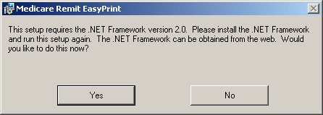

By clicking Yes—and if you have access to the Internet—you are redirected to the Microsoft web site to download the .NET framework 2.0 SP. Download NetFx20SP2_x86.exe for 32-bit systems or NetFx20SP2_64.exe for 64-bit systems. We do not recommend that you download a beta version of the .NET framework if you are presented with this option on the Microsoft web site.

Outside of the application installation process, you may also visit the link to [Microsoft .NET Framework Version 2.0 Service Pack 2](http://www.microsoft.com/en-us/download/details.aspx?id=1639) at the Microsoft website to transport directly to the location on the Microsoft web site to download the 2.0 SP2 .NET framework version.

If you want to learn more about the 2.0 SP2 .NET Framework version and/or determine if you need to install this version, you may visit

.[Net Framework Developer Center](http://msdn.microsoft.com/en-us/netframework/default.aspx) at the Microsoft website.

Please follow the directions within the web site when using this link.

If you do not have access to the Internet and you receive a message to update your .NET framework, you have to obtain a copy of the .NET framework from Microsoft. The Medicare Remit Easy Print application does not work without the appropriate .NET framework installed on each machine accessing the application.

|  |
| --- |
| Download Instructions - ZIP file or MSI file options |

**Step 1.** From the CMS website select **‘*Medicare Remit Easy Print – Version x.x [Zip]*.** (x.x is the latest version number available on the web site.) Depending on your browser settings, you may encounter a pop-up blocker requiring that you allow the download.

**Step 2.** Click on the zip file. Depending on your browser settings, you may encounter a pop-up blocker requiring that you allow the download. A message similar to the following will appear:

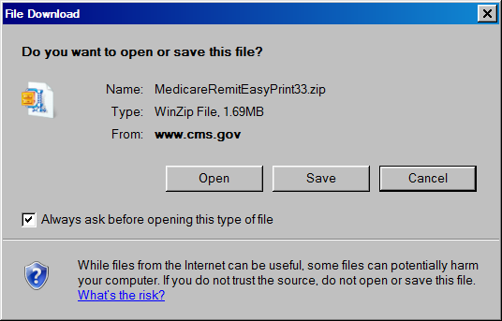

**Step 3.** Click on ‘Open’ and a screen similar to the following will appear.

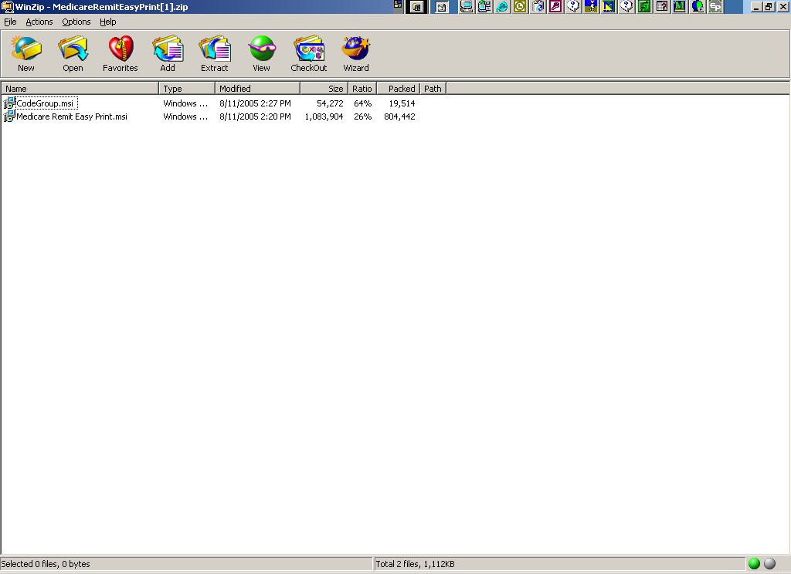

**Step 4.** Highlight the MedicareRemitEasyPrint.msi file and select ‘Extract’. A screen similar to the following will appear (note: the folders displayed will be dependent upon the folders set up by the user – the below is just an example).

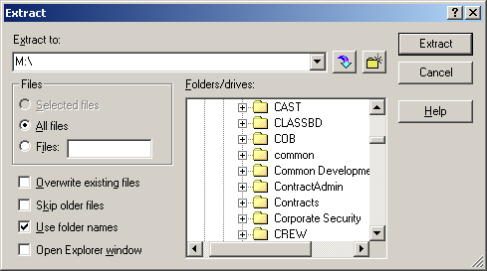

**Step 5.** Select the directory on your PC where you wish to store the CodeGroup.msi, and click on the ‘Extract’ button.

**Step 6.** Record the location of the MedicareRemitEasyPrint.msi file:

_______________________________________________________

**Step 7.** You will return to the WinZip window.

**Step 8.** Since you are not installing the software on a network to be shared by other users, you do not need to copy the CodeGroup.msi file.

Please note: If you have errors that prevent you from downloading the software, please make screen prints of your errors and contact your Medicare carrier. Screen prints can be made by pressing ‘ALT’ and ‘Print Screen’ buttons on your keyboard at the same time while you have the error message screen displayed, and copying them to a word document.

|  |
| --- |
| Installation Instructions |



Installing Easy Print on a Local PC

**Step 1.** Make sure you know the location of the MedicareRemitEasyPrint.msi file (refer to your download instructions where you recorded the location where you saved the file).

**Step 2.** Create a directory on the PC for the Medicare Remit Easy Print installation, where the application and all the associated files will be stored. This directory must have adequate security for PHI. Record the location:

________________________________________________

**Step 3.** Open Microsoft Windows Explorer and find the MedicareRemitEasyPrint.msi file.

**Step 4.** Double-click the MedicareRemitEasyPrint.msi file:

Installation icon and filename

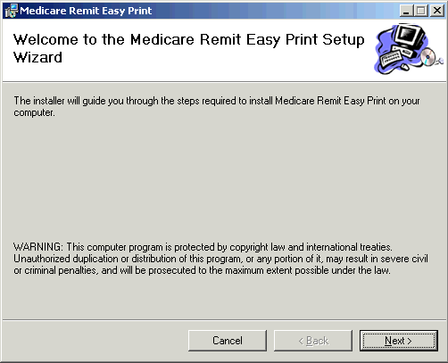The *Medicare Remit Easy Print* Setup Wizard opens:

**Step 5.** Click the ‘Next’ button.

The Select Installation Folder window opens.

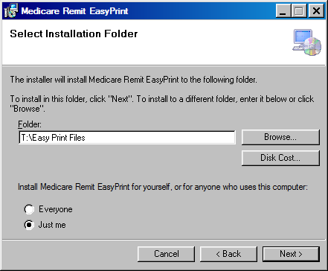

**Step 6.** Browse for the PC directory (noted in Installation step 2) where you want the application and all the associated files to be stored).

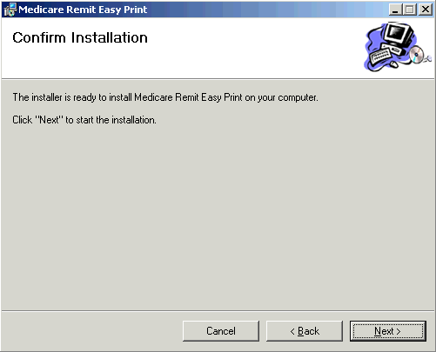**Step 7.** Select ‘Just me’, and click the ‘Next’ button.

The Confirm Installation window opens:

**Step 8.** Click the ‘Next’ button

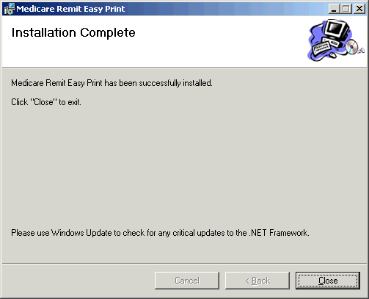When the installation is finished, the Installation Complete window opens:

**Step 9.** Click the Close button.

The Easy Print shortcut is available in the directory you recorded during Installation **Step 2,** and it has also been copied to your desktop.

**The Installation Process is Complete!**

**Thank you for using**

***Medicare Remit Easy Print.***