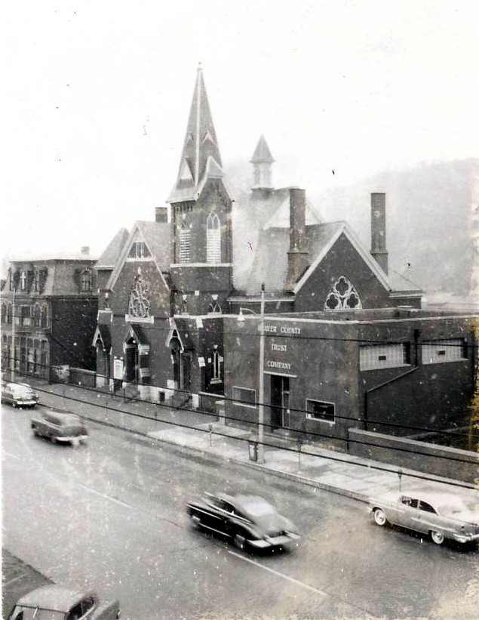The History of Westminster United Presbyterian Church

Compiled by Jordan Rimmer to Celebrate 50 Years on Oak Hill.

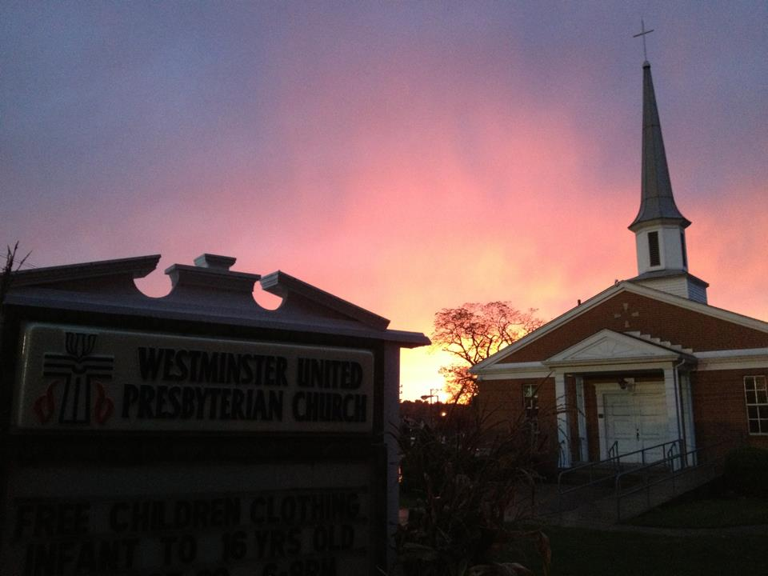

**Introduction**

When we look at the history of Westminster United Presbyterian Church we find a rich history. This church has gone through many changes and adaptations. Our earliest records show that Bible studies that would become our church began as early as 1801. We have worshipped under 7 names and in as many locations. We have had 25 pastors not included supplies that came and went during several periods. We have burned to the ground and we have come up from the ashes. We have impacted our community and one another. And Christ has received glory in our work.

This telling of our history grew out of several events. First, 2014 marks the 50 year anniversary of our location on Oak Hill. In celebrating that event I though it was important to collect some of the history that has been lot or is being lost with our saintly members. This study was propelled forward as I found a combination to a safe that our church had but no one remembered how to open. While we hoped to find money or stock, we found treasure in its own right in the form of lost historical documents. Later, in reading old session minutes, I discovered that in the late 1960’s the session of Westminster sent its old records to the Presbyterian Historical Society in Philadelphia for safe keeping. These records dating all the way back to 1860 were assumed lost in the fire.

The world seems to be changing very quickly as we celebrate our 50 year anniversary on Oak Hill. We have a tendency to want to cling to the way things have always been. But what we find in our history is that times have always been changing and so has our church.

Perhaps you are new to Westminster. Many who are part of this church today do not have the same last name as someone in these pages of history. While this may not be your family heritage, please understand that this is your *spiritual heritage*. God has brought you to this community and you are part of God’s work in our church so this is also your history.

I would also like to say a word of thanks to those who have captured this history at key points in time such as several of our church anniversaries. Especially valuable was the document prepared for the 125th anniversary, the handwritten history read by Miss Jessie Cuthbertson at the 100th anniversary, and the handwritten letter by Mr. Thomas Kennedy that was written for the 100th anniversary when he could not attend in person. This history would have been lost had those people not captured their memories and stories. Most of their testimony can be read in the Historical Documents section at the back of this history. Also included after the history of the church is a section of Historical Fact that includes a detailed Timeline. Finally, there is a section of memories of current and past church members.

As your read this history, I would encourage you to read it as 2 stories. One is the story of a church that changed and adapted, rose to challenges, and persevered to have an impact on its member and on the community. On another level this is also God’s story. It is a story of God’s action to protect, lead, and work through a group of people. It is our church’s history, but it is also His-story.

As we begin, it is important to note that the church now known as Westminster United Presbyterian Church of New Brighton was formed from two different churches—the Associate Church and the Associate Reformed Church. These two denominations merged in 1858. Until that point these churches had different histories. While a great deal of history is preserved about our church, some of the details are collected from memories and stories passed down. Some dates and details are recorded with slight differences at different times.

**The Associate Church**

The Chartiers Presbytery of the Associate Presbyterian Church received a petition asking for supply preaching for this area. Records show that The Associate Church first met on the fourth Sunday in November of 1801. In 1803 some of those who were part of that community began meeting in the home of James Kennedy. That congregation met informally and with various supply pastors until a congregation was officially formed about 1825.

The Associate Church is also sometimes called the “seceder” church. One might assume this to be related to the Civil War until noticing that this term predates the Civil War. It is actually related to the denomination’s connections to its Scottish heritage. In 1732 a fight broke out in the Church of Scotland about nominating pastors. When a minister named Ebenzer Eskine wanted to have his dissent recorded it was not allowed based on a ruling in 1730. When he preached against this action in October of 1733, he was censured. Other pastors came to support him, but the assembly held their ground. In 1733 these pastors and their churches formed a new presbytery later called the Associate Presbytery later called the Associate Synod. The Associate Church in New Brighton was known to be of this tradition and regularly referred to as the “seceder” church.

Records recount the earliest pastor of the Associate Church in New Brighton. David Imrie is described in this way in the history read at the 100th Anniversary of 1925:

It is said that Mr. Imbrie was a very large man, weighing over 300 pound; and when going any distance always took two horses. He would ride up to a house and get the inmates to assist him in changing horses, for if not careful, he would fall off on the other side.

In 1830 a house of worship was built near the brickyard between Grove Cemetery and the New Castle Road. The location is also described as being at the end of Fourth Street overlooking Grove Cemetery. This was the first church of any denomination to be built in New Brighton though the town of New Brighton was not officially formed until 1838. At this time, the church’s name changed to New Bethel Church, though the name “seceder church” was also commonly used. This church location later became a home. The building is also referred to as “The Church in the Wildwood.”

Thomas Kennedy in his letter for the 100th anniversary leaves the best description we have of that worship space:

To return to the old meeting house, the furnishings of the interior were of a very primitive character, to be sure there was quite a respectable pulpit at the end opposite the entrance, this was rather high and entered by steps on one side, but as to pews there were none, instead there were rough benches made of plank with holes bored at either end for the insertion of legs, a back made of a couple of slats running lengthwise, fastened to supports and rudely constructed ends. This seating served the purpose all the time that the congregation occupied the old church and was subsequently brought in to the new church on the hill at Tenth St. and was used there until a modern system of pews was installed. The only other furniture was a few chairs in front of the pulpit and the Communion tables and seating which later were stored in the left of the building through a small door above the entrance.

Thomas Kennedy also recalls vividly his impressions of Reverend Benjamin Sawyer who pastored 1944-1958:

Rev. Sawyer was in many ways a rather odd character, he must have been over six feet in height with strong features, a large frame spare and angular, his movements were somewhat awkward. He was of an exceedingly nervous temperament of a genial disposition with a vein of humor in his composition which some of his older more serious minded parishioners were rather inclined to criticize.

In the pulpit, he possessed a good command of language, was a fluent speaker, but not an orator. He made no gestures but with his nervous temperament he seemed to crave some employment for his hands while speaking. I have seen him deliver a long sermon with a little pocket bible grasped in both hands twisting it and turning it over and over until I wondered what it held together, all the while speaking in a straight forward way to his audience. Rev. Sawyer was singular in many ways, but he was a man of no mean attainments. As a boy I only took note of the length of his sermons, but in later years there came into my possession one of his sermons that had been printed for circulation. The text was taken from the 47 chapter of Ezekiel, the swelling waters, etc. and I was surprised beyond measure at the excellence of this exposition of our unusual text, it was far above the ordinary in literary style and originality of thought. I only regret that I had not preserved this copy or that one could not have obtained for the anniversary.

A second church was built by the Seceders north of Tenth Street at the top of the hill by 1859. At the time it was the corner of Tenth Street and Cherry Alley but it is now the corner of Tenth Street and Eighth Avenue. This church was known as “The White Tower Church” because it had a square white tower on the point of its roof. Started in 1854 and finished in 1858. It was a red brick structure.

**The Associate Reformed Church**

Preaching for the Associate Reformed Church began at the falls of the Beaver under a famous old elm tree that stood until 1880. This was at the foot of Ross Hill close to where the old Patterson Heights incline was located. At first they met in a tent in the summers for Bible study. In the winter they would move to James Patterson’s woolen mill that was located nearby. The church later met in in a school house in New Brighton where the Church of God stood in 1975

In 1838 the church built a building on what is now Seventh Avenue and across from what was the Third Ward school house. Today it would be the block of Seventh Avenue between Sixth and Seventh Streets. It was brick and had a round roof so it was often called the “bake oven” church. It was later sold to the Roman Catholic Parish and later burned to the ground.

The term “reformed” refers specifically to a tradition of theology (study of God) and ecclesiology (study of the church) that began at the reformation. In 1517 Martin Luther, a Catholic monk, posted his 95 Theses on the door to the church in Wittenberg, Germany. These comment were meant for academic debate, but ended up being a match that began a fire that changed Christianity for every. Luther and the growing group of people that wanted to change the church ended up being forced to begin their own church. There were a great number of reformation churches that would generally be labeled as “protestant.” There was a core group led by Luther and later by John Calvin in Geneva that were theologically called “reformered.” The Reformed tradition is marked by 2 distinctives. First, we would emphasize the sovereignty of God and His choice in our salvation over any concept of free-will or personal choice. Second and related to it, we have a strong emphasis on the sacraments as the church’s way of affirming God’s work in a person’s life. We call baptism and communion each a “sign” or a “seal” of what we believe God is doing in the life of a believer. This also means we tent to like regular communion as a focal point of the worship service and we emphasize infant baptism.

The Associate Reformed Church also has its ties back to Scotland as well. Some of them were “seceders” while most were called “covenanters.” In response to conflict in the Church of Scotland, the British House of Commons called for the church to settle their differences. Ministers met at Westminster Abbey and over time created what would be the Westminster Confession of Faith and its accompanying catechisms. After the Westminster Confession was signed in 1643 a number of churches left the Church of Scotland for the New World because they did not want to be forced to swear an oath to the monarch. Since the Associate Church was specifically called the “seceder” church it is quite possible that the Associate Reformed Church was of the covenanter tradition, though there is not record of this designation. If it is true, however, it is quite ironic that a church that was started by people who left Europe to avoid an oath regarding the Westminster Confession of Faith was later renamed Westminster.

The Sabbath School was started in 1848. When the modern ear hears this, they immediately associate the term with was would alter be called Sunday School. The memory that most have of Sunday School is not as intense or organized as Sabbath School was. It was meant to be a school complete with a superintendent, committed teacher, and a developed curriculum. Pastor McClean was the first superintendent. Sabbath School would be a very important part of our church well into the 1900’s, with the officers prominently listed in the 125th anniversary history in 1950.

**Churches Join**

In 1858, at a meeting in Old City Hall in Pittburgh, PA, the North branch of the Associate Reformed Presbyterian Church and the Associate Presbyterian Church joined to form the United Presbyterian Church in North America. The churches had already begun to meet together sometime in the 2 years prior to denominational merger and they themselves merged in that same year. A group from the Associate Congregation rejected the merger and kept up their own gathering. In 1898 they purchased Grace Chapel on 13th Avenue.

It may seem to be an abrupt change to suddenly become “Presbyterian,” but in reality both these denomination belonged to the Presbyterian tradition. A man named John Calvin did much in the 1500’s to lead the reformation after Martin Luther. Calvin’s idea for leadership was for it to be led be elders elected from the people. This form of government was called Presbyterian based on the Greek word *presbuteros* meaning elder. This idea fit within the reformation call for “the priesthood of all believers.” Since all are saved by Christ, all are called to ministry. Therefore the church should not be controlled by the priests or pastors but the leadership should be shared by all. This form of representative government would later be used in the New World by Presbyterians who helped establish the United States of America.

A man named John Knox was forced to flee from his native Scotland and ended up spending time at Geneva and studying with John Calvin. He later returned to Scotland to establish a protestant church there called the Church of Scotland. This Scottish protestant church was run using Presbyterian government and reformed theology. As members of the Church of Scotland moved to the New World, they established churches under the term Presbyterian more than the term had been used in Europe.

The Presbyterian tradition has sometimes been defined by the 3 C’s of Confessional, Constitutional, and Connectional. Our constitution represents these well. Part I of the Presbyterian Church (USA) constitution is the Book of Confessions. It includes great statements of church history to which we adhere and on which our decisions are to be made. They are considered good interpretation and expressions of the truths of Scripture. Part II of our constitution is the Book of Order. It represents the Constitutional nature of Presbyterians where we are guided by order and discipline. Churches and pastors are to be accountable to one another and to the tradition. Finally, this structure of government is Connection. This means that we are not congregational where each church is independent. It also means that we are not hierarchical where we are controlled by higher governing bodies or a series of bishops or popes. We are intentionally connected to one another for the purpose of serving God’s Kingdom on a larger scale and for strengthening the individual congregations.

**Worship in the 1800’s**

Worship looked and sounded very different in the early days of the church

Because communication and travel were so difficult and because church was usually the center of social life, church was an all day affair with morning worship, a lunch break, and more worship in the afternoon. Thomas Kennedy recounts the Sabbath schedule:

With a congregation whose members were so widely scattered, and the means of communication so few, it may well be imagined that the Sabbath was an eventful day, not alone as the day for rest and worship but also as a time for social intercourse. The religious exercises consisted of two services each of generous length one in the morning and the other in the afternoon with an intermission of a half or three quarters of an hour between, affording time for a lunch and a season of social intercourse. In times of pleasant weather especially there was always a full turn out and it was truly the best day of the week anticipated and enjoyed by all.

Singing was a major part of worship, but functioned very differently. Not only were there no powerpoint slides, there were no hymnals. There were no bulletins and no instruments either. Songs were mainly Psalms with some hymns mixed in as well. A leader would have to stand in front of the congregation to share the lines and lead the tune. Thomas Sawyer remembers how the practice went and the outrageous day that the congregation moved to continuous singing:

The congregational singing was conducted by a presenter who took his place before the pulpit when the psalm had been given out. He read out the first two lines immediately starting into the tune the congregation followed with him singing the two lines read. He doled out two lines more and so on until the entire selection had been sung. Of course this custom originated at an early day when there was a scarcity of book but it had a strong hold on the older members and they strenuously opposed any change. The custom of lining out was discontinued in the Associate Presbyterian Church before the union, in Rev. Sawyer’s time, as I recall the event it was a rather unexpected move and created quite a bitter feeling in the congregation.

I well remember the Sabbath when the session of the church having held a meeting during the time of intermission decided to abandon the practice of lining out, and to inaugurate the change at the afternoon service that day. Without any notice to the congregation the presenter proceeded to carry the first psalm right through, the effect was almost electrical, one and another of the elderly men of the congregation grabbed their hats and hurried out of the house to return when the singing was concluded. They respected this procedure for some time afterward, but finally became in a measure mollified but some were never fully reconciled to the change. I recall a visit to our home made by a distant relative of my father about this time or perhaps earlier, the sole object of a trip on horseback from Mount Jackson to New Brighton being to consult father in regard to a serious innovation in choir church as they had discontinued lining out the psalm one line at a time and were lining out two.

The first organ for our church was placed early in the pastorate of Rev. Robert L. Hay between 1892 and 1911. In those days, organs had to be manually pumped with air while being played. The history from the 125th anniversary recounts the process to run the early organ:

As it was necessary in the early days of the instrument to pump compressed air from the bellows, young men in the congregation were engaged as official “pumpers…” As the se assistants usually had a chair in back of the organ out of the view of both minister and congregation, on more than one occasion when the time came for the singing of the closing Psalm at the evening service, there would be no response from the bellow and the operator would be found to be safe in the arms of Morpheus. (aka asleep).

The sacrament of communion has always been important to Presbyterians. Many churches, including our own, took part in the practice of communion tokens. This practice was suggested in 1560 by John Calvin and Pierre Viret in Geneva under the thought that Christian should be prepared for communion. The fear was that people would profane the table if they partook without being worthy. Therefore, the practice became for elders to meet with congregants in the days leading up to communion. If you were found to be in good standing with regards to your faith and conduct, you would be issued a metal token. When you came forward for communion you had to bring your token and give it to an elder. The history from our 125th Anniversary recounts the practice:

Preparatory services for Communion were held Thursday, Friday and Saturday afternoons and on the last named day the tokens, small pieces of metal, were given to those who were considered worthy to come to the Communion table. On Sabbath the members of the congregation, singing a psalm, filed to the tables, made of long boards and placed in front of the church and sometimes down the aisles, handing to the elders the tokens which had been given to them the day before.

The practice of communion tokens was discontinued during the pastorate of Rev. A.G. Wallace 1868-1884. During his time a new version of the Psalms was used for the first time. It was not until 1890 that the communion elements were brought to people in the pews. Until that point communion was always served up front. During prayer, at least in the Sabbath School if not the church services, you remained standing. You would only be allowed to sit in case of illness

**Moving to Third Avenue**

Buildt 1886

History of the Church a given in the New Brighton News July 21, 1886

The corner tone was laid today, July 21, 1886. The building is to be completed December 15, 1886 at a cost of 13,000. All the contractors are from New Brighton except Robert McClain, of Rochester.

The Building will be one of the handsomest and most convenient in the county, a great ornament to Broadway, the fine street on which it is being built. The work being done I first class, and the gentlemen and firms having the contract for the several parts of the work, are a sure guarantee of the bet work throughout. The Society is in a very flourishing condition, the best of feeling exiting, and every one doing hi best to hold up his hands and aid their efficient pastor in hi work. The increase of the past year shows the faithful work that is being done by pastor and congregation.

The laying of the cornerstone was accomplished quietly, under the most favorable auspices, and every condition exists for a future of prosperity for this church. We trust that its growth may be a continuous one, and that tit may be the means of great blessing to our town and community.

During the pastorate of Dr. William Barr the church moved

Plans began to 1870 to consider moving, but it would be

The plot of ground was between what is now Under the Gun Tatoo Parlor (and McNutt’s) and ____________ This ground was given by Matthew and Samuel Kennedy and deeded to the church by the Harmonie Society in Ambridge.

Total cost of the building was $18,000 which was all pledged in February of 1887. When it built, was considered one of the most modern and best equipped churches in the entire United Presbyterian denomination.

Describe the space

The building

Digging out the basement

Things we did there

Missionary school- Fallston chapel

Depression and World Wars

1958 in Pittsburgh PA the United Presbyterian Church of North America joined with the Presbyterian Church in the United States of America to form the United Presbyterian Church in the United States of America- generally known as the Northern Church though that is not completely accurate

One of the most important functions of the church was doing funerals and providing care to families who have had a loss. The death records for our church include some very interesting and sad notations. They tell of a darker time when many people died of accident and fires. Some illnesses such as Diphtheria which killed so many in our church are no longer around today. In the United States, there have only been 2 diagnoses of Diphtheria since 2000. Here is a sampling:

January 29-February 2 1872 Elizabeth, Alice, Celicia and Miranda Freed- Children of Wilson and Mary Freed, all burned at one time

February 25 1873 John Knoll=Buckle age 34 Shot through the head at cross roads supposed suicide.

January 22 1879 Geraldine Reed Killed by a fall from a sled, when horses were running away

December 16 1882 Thomas Sloan aged 47 killed in an elevator

May 30, 1883 Inarece B. Orr age 46 Paralysis from lead poisoning

January 6 1884 Mrs. Elleanor Hindman age 68 Died of Pneumonia

January 6 1884 Samuel McGowan age 70 died suddenly

Note: Mr. McGowan was the brother of Mr. Hidman. He was in usual health; had jut finished sending notice of her death, when suddenly he died in his chair. They were buried at the same time- January 8, 1884. Mr. Hindman died at 2 am and Mr. McGowan at 4 pm.

November 27 1890 Miss Eliza Buchanan Age 61 Typhoid Fever

July 8, 1906 William Magee age 4 Diphtheria

January 4, 1912 Samuel D. Kennedy Killed in mill

February 20, 1912 Mrs. Jennie McCally Smith Killed of blood poison after operation

Wanted to move away from the downtown area and away from the railroad and the main street. People can recall Sundays when a train would pass in the middle of the sermon and the pastor could not be heard.

Actually purchased the property where Christian Assembly is now but, before building began, the property where we are currently located came up for sale. Mr. Donald Schwartzel purchased the land and then sold it to the church

**A Church Burns**

October 20, 1963 was supposed to be an exciting Sunday. A committee had been visiting church members to secure pledges for the new church location and were prepared to share their results. Services were not held that morning. Around 5 am a fire began that soon engulfed Westminster. A Bible study that met on Saturday night worried that they had started the fire, but the fire began in Christner’s Bible Bookstore next door to the church.

John and Don Hickey ran in before the flames got too high and grabbed several items including the pulpit Bible, a Bible holder, and the offering plates that we still use to this day. Don Hickey recounts that due to the heat the paint was pealing off the walls and it almost looked like it was snowing inside as it fell to the floor off the ceiling.

The session met on the corner opposite the flaming church and voted to hold worship at the New Brighton High School Auditorium that morning. One of the session members was on the school board and had access to the facility. After the service much of the church joined the rest of the community as much of New Brighton turned out to watch the fire. The fire was announced in all of the churches. Most members who were alive and in town that day can give you a firsthand account of the fire.

It took a lot of effort to get the fire put out. Essentially it burned from the top of the building down. This left rubble in the church to catch fire again. The gas

Later that day the fire was restarted

gas company was checking

Window stood- and a fire place that people were worried was not safe in case of a fire

Sign melted

The safe survived, and was removed from the rubble by a crane.

Perhaps those most harmed by the fire were the pigeons. The newspaper reported this in a section titled “Pigeons Stay on Hot Roost”:

Pigeons living in the steeple of the Westminster United Presbyterian Church, Which was destroyed by fire early Sunday in New Brighton, were determined not to give up their roost in spite of the fire. Firemen reported seeing some of the birds flying with their wing and tail feathers flaming, and another perched on a TV antenna on the burning Gospel Tabernacle gave up his hot perch at the last minute, only to fly to the church steeple. After the fire was out pigeons were flying back to the steeple, but soon were evicted by the wrecker’s crane, which knocked down their condemned home.

Cornerstone of the old building was exposed- got out newspaper articles

The church was well insured for up to $46,000. Unfortunately, the organ which was valued at $20,000 was not under the insurance. Yet the church almost got no insurance money from the fire. A contract was drawn up to sell the 3rd Avenue building to Wayman Chapel African Methodist Episcopal Church for the cot of $10,000. The document was never signed and the negotiations were never completed. Had the deal been done, it would have been Wayman Chapel collect the insurance claim and Westminster would have been in a difficult spot.

Fire started in the building next door

Bible study group felt guilty that they had started the fire

Running in to get stuff- offering plate still used

Burning birds

People recount coming down to watch the fire- announced in other churches- lined with people

Session met

Safe lifted out of the tower

Contract never signed

First church kind enough to invite us to worship at their church

Immediately after the fire both Calvary United Presbyterian Church in Beaver Falls and First Presbyterian Church of New Brighton offered there church buildings as a home for Westminster until the building could be completed.

**A Church on Oak Hill**

Plans were already begun for the new building- proper already purchased???

Began

Dates it happened, how that all worked out

Broke ground- 4-4

Laying Corner stone 7-26- what is in it

What is in the cornerstone:

* List of members and officers
* Newspaper clippings of the groundbreaking
* Newspaper picture and story from the fire
* Picture of the old church on 3rd Avenue
* Picture of the Old Church on 10th Street
* Program from the 100th Anniversary
* Program and history from the 125th Anniversary
* Building fund brochure from October 13, 1963
* Bulletins showing reference to the new building
* Program of the Corner Stone Laying Service

October 16- Steeple put on the Oak Hill Church

Raising the Steeple 10-16- almost a year from the date of the removal of the steeple on 3rd Avenue- Great article in the paper showing the taking down of the steeple

12-6 held first communion

**Recent History**

The United Presbyterian Church in the United States of America joined with the Presbyterian Church in the United State (called the Southern Presbyterians) in 1983 in Atlanta, Georgia.

PC USA is formed- show the United symbol and the new symbol

Pittsburgh Seminary

**Conclusion- The Future of the Church**

Child Baptisms

1868-1896- 301

1896-1917- 176

1918-1948- 244

1948- 1968- 194

1969- Date- 164

1,079 recorded child baptisms since 1868

Change and adapt

Build Community and support one another

Care about learning

Care about missions

Perhaps you have not gone to this church your whole life. Perhaps your family is not found in this history. This is your spiritual history