**Supplementary Data**

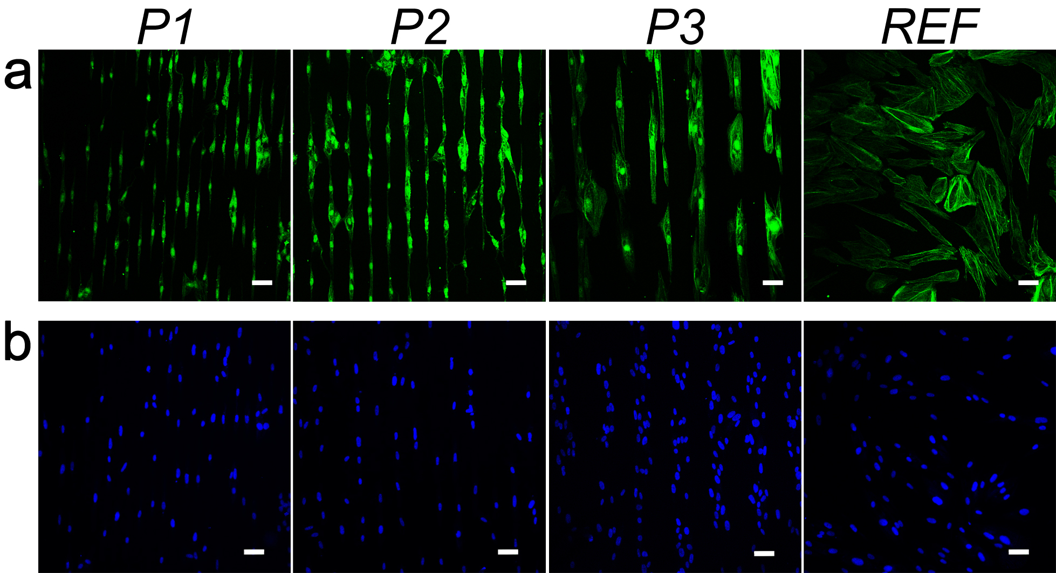

**Figure S1**

**Fig. S1** Fluorescent labeled actin filaments (a) and nuclei (b) of ARPCs cultured for 10 days on micropatterned (*P1*, *P2*, *P3*) and unpatterned (*REF*) surfaces. Scale bars = 50 μm.

**Figure S2**

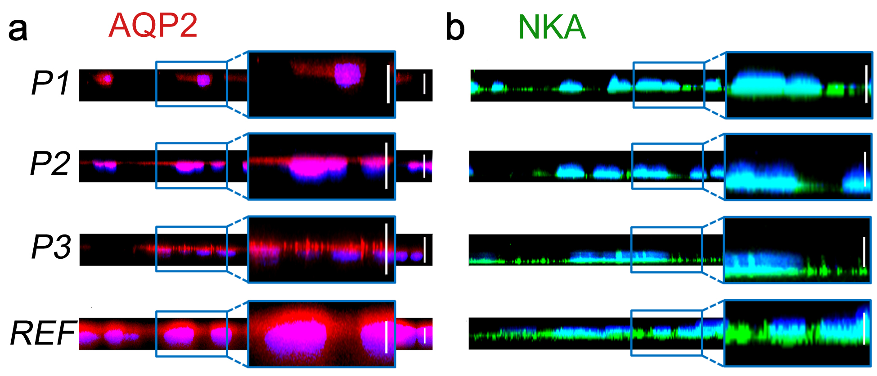

**Fig. S2** *x*-*z* confocal images of ARPCs grown for 10 days on micropatterned (*P1*, *P2*, *P3*) and unpatterned (*REF*) surfaces, under BM conditions. The apical marker AQP2 (red, a) and the basolateral protein NKA (green, b) and are shown against nuclei (blue). Scale bars = 5 μm.