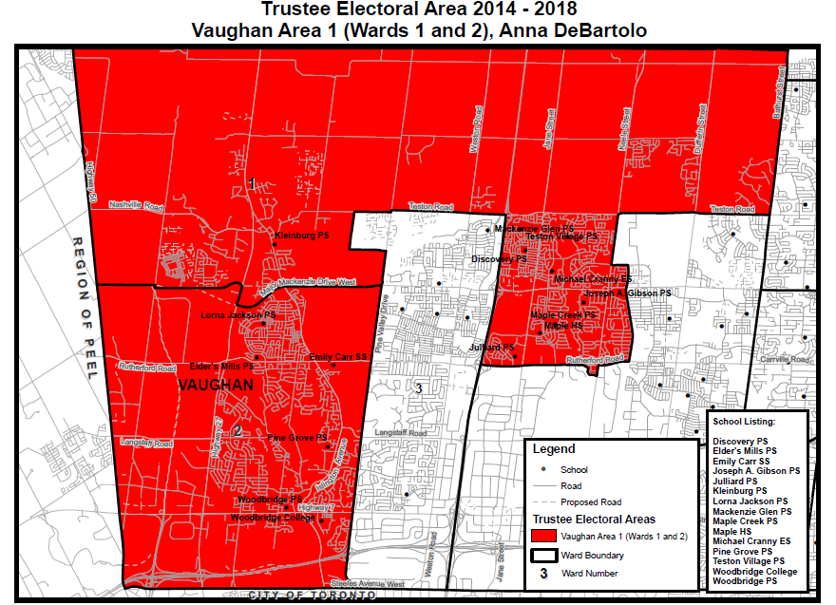

To: [anna.debartolo@yrdsb.ca](mailto:anna.debartolo@yrdsb.ca)

Cc: [allan.tam@yrdsb.ca](mailto:allan.tam@yrdsb.ca) ; [billy.pang@yrdsb.ca](mailto:billy.pang@yrdsb.ca) ; [Juanita.nathan@yrdsb.ca](mailto:Juanita.nathan@yrdsb.ca) ; [peter.adams-luchowski@yrdsb.ca](mailto:peter.adams-luchowski@yrdsb.ca) ; [nancy.elgie@yrdsb.ca](mailto:nancy.elgie@yrdsb.ca) ; [susan.geller@yrdsb.ca](mailto:susan.geller@yrdsb.ca) ; [martin.vanbeek@yrdsb.ca](mailto:martin.vanbeek@yrdsb.ca) ; [corrie.mcbain@yrdsb.ca](mailto:corrie.mcbain@yrdsb.ca) ; [carol.chan@yrdsb.ca](mailto:carol.chan@yrdsb.ca) ; [linda.aversa@yrdsb.ca](mailto:linda.aversa@yrdsb.ca); [director@yrdsb.ca](mailto:director@yrdsb.ca); [lsandals.mpp.co@liberal.ola.org](mailto:lsandals.mpp.co@liberal.ola.org); [Premier@ontario.ca](mailto:Premier@ontario.ca); [mchan.mpp.co@liberal.ola.org](mailto:mchan.mpp.co@liberal.ola.org); [hjaczek.mpp.co@liberal.ola.org](mailto:hjaczek.mpp.co@liberal.ola.org); [gila.martowco@pc.ola.org](mailto:gila.martowco@pc.ola.org); [rmoridi.mpp.co@liberal.ola.org](mailto:rmoridi.mpp.co@liberal.ola.org); [sdelduca.mpp.co@liberal.ola.org](mailto:sdelduca.mpp.co@liberal.ola.org); [cballard.mpp.co@liberal.ola.org](mailto:cballard.mpp.co@liberal.ola.org); [julia.munroco@pc.ola.org](mailto:julia.munroco@pc.ola.org); [Yorkregionparents@gmail.com](mailto:Yorkregionparents@gmail.com)

SAMPLE #1

Subject: Re: L4L *(replace with the first 3 digit of your postal code)* New Sex Ed is not scientific proven

Dear Anna, (or ***insert name of your Trustee***)

I am writing this email to express my deep concern regarding the new sex ed curriculum. The curriculum manipulates and eases the consequence of HIV/AIDS. It does not mention that anal sex dramatically increases the risks of HIV infection and people could die of HIV/AIDS!

a) Grade 7 (pg. 197, C1.5), “HIV treatment can reduce the amount of HIV in someone’s body to the point where it is much less likely that HIV will be transmitted”. → The above teaching could cause potential HIV spreads among young children. According to eMedicineHealth, “Drugs used to treat HIV and AIDS does not eliminate the infection. It is important to remember that he or she is still contagious even receiving effective treatment” (http://www.emedicinehealth.com/hivaids/page9_em.htm#hiv/aids_prognosis)

b) Grade 7 (pg. 197, C1.5), “When people get tested for HIV early and access to HIV treatment, they have the opportunity to live a near-to-normal lifespan” → According to WHO, 1.5 million people die of HIV/AIDS in 2013. And Health Canada states: “The median time for HIV infection to AIDS is now exceeding 10 years” (http://www.hc-sc.gc.ca/hc-ps/dc-ma/aids-sida-eng.php)

c) Grade 7 (pg. 197, C1.5), “One of the best things you can do to stop HIV is to stop the stigma that is associated with having the infection”. There is no scientific evidence to support that “HIV can be stopped by stopping any stigma”.

Therefore, I hope the curriculum could be reviewed again by medical professionals before the rollout.

Sincerely,

*Your name*

*Your full address with postal code (very important)*

SAMPLE #2

Subject: Re: L4L *(replace with the first 3 digit of your postal code)* The new sex ed will cause STIs to spread in Ontario

Dear Anna, (or ***insert name of your Trustee***)

I would like to give out some arguments regarding the new Sex Ed curriculum that will potential cause the spread of the STIs and HIV. Just look at pg. 196, C1.5 “People who think they will be having sex sometime soon should keep a condom with them … because condoms help to protect you against STIs, HIV and pregnancy” It misleads Gr-7 students that sex is safe as long as they use condom. However, according to World Health Organization, evidence shows condoms have only 85% protective effect against HIV and other STIs. In addition, condoms cannot prevent the spread of HPV infection, which is closely associated with cervical cancer. If 7th graders (13 yrs old) are not careful, that will be a mass spread of STI and HIV among our teenagers.

Other studies conducted south the border that embraces similar curriculum - Comprehensive Sex Education (CSE), also shows stunning results. New Jersey and Oregon have implemented CSE the longest (1980 and 1984). Between 2007 and 2011 teen STI rates increased 25.3% and 38% respectively. I don’t think we would like to see the future of Ontario be like this.

Could you help to stop the implementation of the new Sex Ed until full consultation of medical professionals and parents are conducted?

Sincerely,

*Your name*

*Your full address with postal code (very important)*

SAMPLE #3

Subject: Re: L4L *(replace with the first 3 digit of your postal code)* Why does new Sex Ed teach 1st grader this?

Dear Anna, (or ***insert name of your Trustee***)

Thank you for taking time to read through my email. I am stunned after reading how the new sex ed curriculum plans to teach our Grade 1 kids – On Page 93, C1.3, it expects Gr-1 students to identify body parts including detailed genitalia (pg.93, C1.3), but it fails to warn kids nobody shall touch their genitalia. I also heard that Minister of Education Liz Sandals has promised that teaching of “sexual consent" will begin in Gr-1. What if a naive young kid gives consent to anyone to touch his/her genitalia? Will this teaching expose our young kids to sex predators?

Please delay the implementation of the new sex ed until full consultation of parents have been conducted.

Sincerely,

*Your name*

*Your full address with postal code (very important)*

SAMPLE #4

Subject: Re: L4L *(replace with the first 3 digit of your postal code)* Concern about new Sex Ed

Dear Anna, (or ***insert name of your Trustee***)

I am like many parents fully recognize the need for school curriculums to be regularly updated. The new Sex-Ed Curriculum does not, despite claims by the Ministry of Education, reflect a factual and science-based approach in many of its key subject areas. The curriculum offers too much explicit information to children too early, and then incorrectly presents this information as if it was founded on the latest scientific and medical research. I am therefore requesting a delay in the implementation of the curriculum. As it stands, it is not inclusive, nor does it respect the diversity of all Ontarians.

Sincerely,

*Your name*

*Your full address with postal code (very important)*

SAMPLE #5

Subject: Re: L4L *(replace with the first 3 digit of your postal code)* Please delay the implementation of Sex Ed

Dear Anna, (or ***insert name of your Trustee***)

I am writing you to request a delay in the implementation of the new Sex-Ed Curriculum. This curriculum teaches advanced material to students before they are psychologically ready to absorb it. The danger is that this leads directly to pre-mature sexualizing of our children. The truth is that children can be made aware of dangers in ways that are not graphic, and they can be taught to respect diversity in less explicit ways.

Sincerely,

*Your name*

*Your full address with postal code (very important)*

SAMPLE #6

Subject: Re: L4L *(replace with the first 3 digit of your postal code)* May we know who design the new Sex Ed ?

Dear Anna, (or ***insert name of your Trustee***)

I am very concerned regarding the role that Ben Levin, the past Deputy Minister of Education, had in the development of the 2010 and 2015 Sex-Ed Curricula. The Ministry of Education has said that the 2015 Sex Ed Curriculum is an updated version of the 2010 curriculum. I have taken a cursory review of both curricula and noticed that there are no meaningful differences between the two documents. The very issues that parents and Ontario stakeholders found so objectionable in 2010 remain unchanged, and if anything, have been expanded in the 2015 version in even more explicit detail. I cannot believe that Ben Levin’s personal lifestyle would not in some way be reflected in this curriculum. For this reason, I am requesting a delay in its implementation.

Sincerely,

*Your name*

*Your full address with postal code (very important)*

SAMPLE #7

Subject: Re: L4L *(replace with the first 3 digit of your postal code)* New sex ed does not have meaningful parent consultation

Dear Anna

The introduction of the Sex-Ed Curriculum was based on the promise that a comprehensive consultation process would be undertaken with parents as a vital part of the curriculum development. This has not happened. The previously conducted survey with 4,000 chairs of Parent Councils was vague, with leading questions that were not relevant or specific enough to provide meaningful feedback for the development of the curriculum. I have seen a list of the stakeholder organizations that were consulted by the Ministry of Education in the development of the curriculum. I noticed however that there were no conservative groups in the list that could have better represented the diverse views of all Ontarians. I am requesting a delay in the implementation of the new curriculum.

Sincerely,

*Your name*

*Your full address with postal code (very important)*

SAMPLE #8

Subject: Re: L4L *(replace with the first 3 digit of your postal code)* New sex ed miss out love and responsibility

Dear Anna, (or ***insert name of your Trustee***)

I am very concerned regarding the implementation of the new Sex-Ed Curriculum. I have noticed that not one time will you find the word "marriage" in the curriculum. The word "love" is only mentioned in the context of enjoying an activity such as sports and reading. The curriculum treats sex as a pleasurable activity only, unrelated in any way to intimacy or a meaningful relationship - which is particularly important for the healthy development of girls' self-esteem. The curriculum also discourages the use of the words “husband” and “wife”. Instead, students are told to use the word “partner” which is deemed to be more “inclusive and welcoming”. I believe this is a direct attempt to deconstruct the family unit, despite all the current research that proves its importance in the healthy development of children. I am therefore requesting a delay in the implementation of this curriculum.

Sincerely,

*Your name*

*Your full address with postal code (very important)*

SAMPLE #9

Subject: Re: L4L *(replace with the first 3 digit of your postal code)* Anti sex ed

Dear Anna, (or ***insert name of your Trustee***)

I am writing you to request a delay in the implementation of the new Sex-Ed Curriculum. The curriculum directly states that “…masturbating is something that many people do and find pleasurable. It is common and is not harmful…” This is just one example where the curriculum does not reflect a factual and science-based approach. When coupled with the directly correlated viewing of pornography (especially by males), there is more and more research that shows that such activity is directly connected with higher rates of depression, sexual dysfunction, failure to develop healthy relationships etc. And perhaps the most glaring omission in the curriculum is that it makes no mention of pornography, despite its acknowledged impact on every aspect of our lives.

Sincerely,

*Your name*

*Your full address with postal code (very important)*