Donor Series Setup

|  |
| --- |
| **Stationery**  **Stationary Template: donor_series_stationery** |

1. Create a new stationery using the name convention, “Donor Series”.

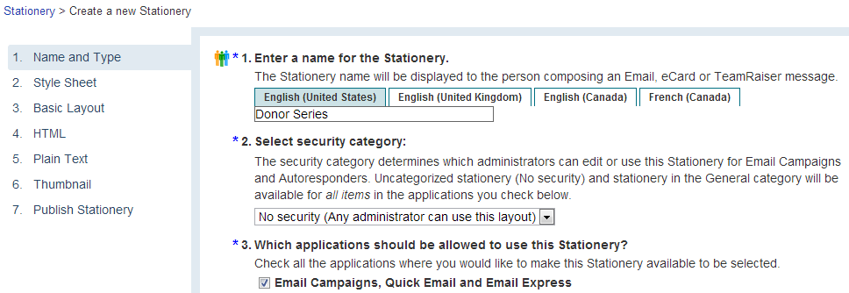

1. Depending on the stationary option you choose, upload items like your logo and email banner to the image library

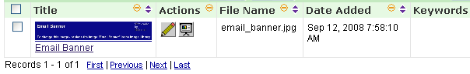

1. Adjust address, colors, and other elements in the stationery footer.

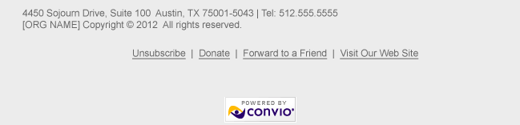

Here is a sample of your stationary:

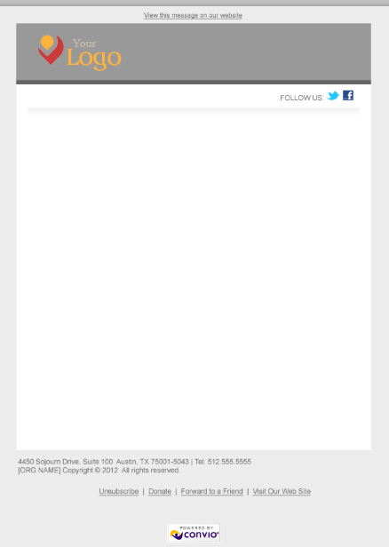

|  |
| --- |
| **Campaign**  **Content Template: donor_series_content (two messages)** |

1. Create a new email campaign, “Donor Series”. Be sure to enable web viewing.

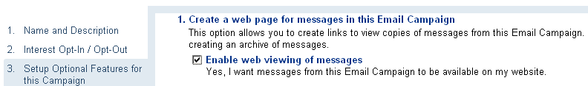

1. Upload the appropriately colored and sized “Become A Monthly Donor” button. If none are available, create new ones from the templates. When uploading, use keywords “DS”
2. Create “thank you again” message and call it “Donor Series #1”.
3. Create “become a sustaining donor” message and call it “Donor Series #2”.

|  |
| --- |
| **Queries Setup** |

1. Go to Groups and create a new group and title it “No Donor Series (Suppression Group)”. This group could be used in the future to suppress new online donor constituents who are uploaded or who you do not want to receive this email donor series message. To suppress a constituent from the donor series simply add them to this group.
2. Go to Queries and create a new query named Donor Series #1 with the following parameters (Creation Time falls under System in the first dropdown of queries). Make sure you add a “Sustaining Donor” status filter. This will suppress first-time online donors whose first gift was joining a sustaining gift program:  
   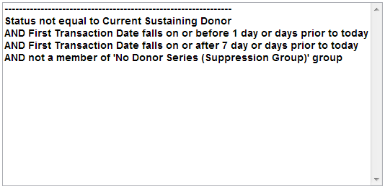
3. ***IMPORTANT!*** You need to consider any other donor type that you do not want to receive this email series. An example would be a TeamRaiser donor. To suppress these types of donors, simply add go to Field Type and choose “Transaction Information” and in the Field drop-down choose “First Transaction Campaign”. In the configuration choose the TeamRaiser campaigns that should be suppressed from the query. Repeat this step for any campaign you want to suppress a first-time donor’s gift from adding them to this query-built group. See below for an example:

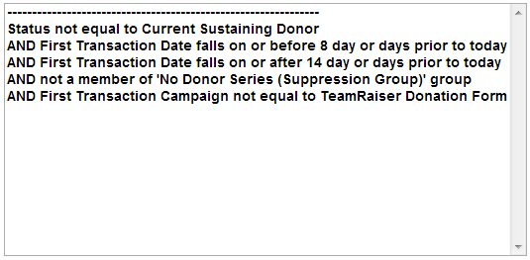

1. Hit Save, then Run Query. On the next page click Use Query and create a group named Donor Series #1 and associate it with this query.
2. Set the group to rebuild once a week.
3. Repeat steps 2, 3 and 4 with a new query named Donor Series #2 for both the query and group name. Use this logic *(don’t forget to add additional First Transaction Campaign and other filters like you did for Donor Series #1)*:   
   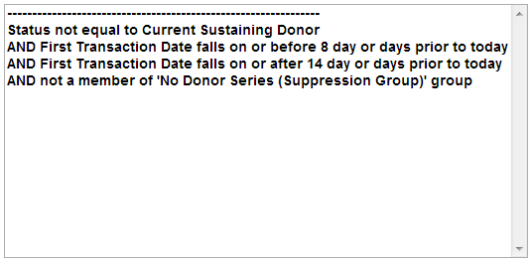

|  |
| --- |
| **Reccurring Email Setup** |

1. Go to personal greeting message and set it up for reccurring delivery.
2. Set the email to send once a week, Tuesday morning, 9 am, and set the expiration to be year 2015 because we want this to keep going as far in the future as possible.
3. Set the target audience for Donor Series #1 to be the group called Donor Series #1 and don’t set up the suppression group because we already took care of that in the query logic.
4. Repeat step 3 for Donor Series #2 message.
5. Enable both messages and you are done!

|  |
| --- |
| **Optional New Sustaining Donor Message Series** |

1. Repeat all of the steps for the Donor Series but label everything with “Sustaining” to indicate what that element is being used in
2. The query is the primary project item you will need to change. We have provided some sample query filter samples below:  
     
   Message 1 Query:  
   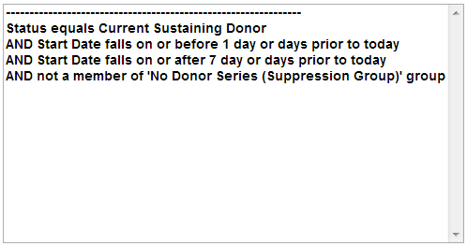

Message 2 Query:  
