**PRESS RELEASE**

**Philips ‘izzy**™**’ multiroom speaker range**

**provides theeasiest way to enjoy music in and around your home**

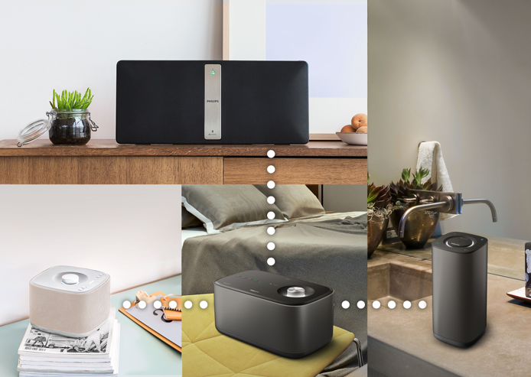

**Berlin – September 1, 2016** – Listening to the same music throughout your home was never easier than with Philips’ izzy wireless multiroom speakers. While other systems require consumers to install apps and struggle with their routers, izzy lets you connect via Bluetooth and share your music throughout your home and garden with the tap of just one button. Using ‘izzylink’ wireless technology, you create a wireless network instantly. Simply play music on one izzy speaker and press the ‘Group’ button to play the same music on other in-range izzy speakers.

**Enjoy music from any source**

Offering an extended range of playback possibilities, it doesn’t matter if you love your FM radio or still prefer your beloved CD collection. Izzy can stream all sorts of audio to your speaker system. And if you do not want to share your coveted music, don’t worry. Just as easy as you’ve set up the network, you can disconnect from it. Simply press the ‘Group’ button again and you will leave the network. Philips izzy speakers work with all music apps, so users can stream music wirelessly from any Bluetooth®-enabled smartphone or tablet. The speakers support multiple sources including FM radio, CD, USB and Audio-in music.

**Wide range of speakers**

Izzy product offerings include models spanning different form factors, sound solutions and features, to allow enjoyment throughout the home and even outdoor. Since going to market in September 2015 the izzy range has developed into a speaker ecosystem spanning six different types of speakers.

“These new additions to the Philips izzy range are a real breakthrough for people who want an easy-to-use multiroom music system in their home”, said Jerome Alfonsi, Business Leader Audio, Video and Home Cinema, Gibson Innovations. “This is the first range to offer a multi-room plug-and-play solution with many different forms of playback without the need for a wireless router or app.”

**Product Specifics**

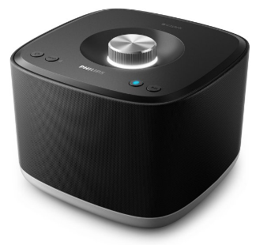

**Philips izzy BM5** - A compact multiroom speaker with a minimalist appearance and simple interface. It connects easily to any Bluetooth equipped device including tablets and smartphones. Equipped with two 2.5” drivers and a bass port for a deeper low end, it delivers room-filling sound wherever it’s placed. Recommended retail price: €129.

* Two 2.5” full range drivers with a bass port

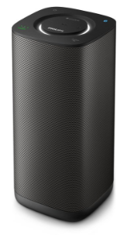

**Philips izzy BM6 –** Includes Multipair, making it easy to swap music between two smart devices. Equipped with two 2” full-range drivers twinned with two opposing passive radiators, the Philips izzy BM6 delivers balanced sound with clarity. A built-in rechargeable battery and splash-proof (IPX4) design allows multi-room music to extend to the pool area, garden, kitchen and bathroom. It is also compact enough to take it outdoors as a portable Bluetooth speaker. Recommended retail price: €179.

* Two 2” Full range drivers with two passive radiators
* Splash proof with IPX4 protection rating
* Built-in rechargeable battery
* Multipair for easy swapping of music source

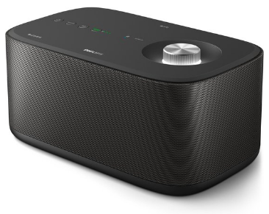

**Philips izzy BM7 –** The solution for larger rooms with greater sound requirements, the izzy BM7 is an even more powerful two-way all-in-one speaker. It comes equipped with two 3.5” woofers and two 1” tweeters with two passive radiators. Delivering high quality, wide, and rich stereo large room-filling sound with deep bass. It also comes with the Bluetooth Multipair feature, making it easy to swap music between two devices, anytime. Recommended retail price: €229.

* Two 3.5” woofer, 2 x 1” Tweeter, 2 x passive radiators
* Multipair for easy swapping of music source
* NFC for easy Bluetooth pairing and connection

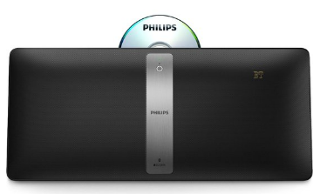

**Philips izzy BM50 -** A multi-room music system solution with a large range of playback options. This means a prized CD collection can be played not only on the music system, but also through the connected izzy speakers. The izzy BM50 also includes radio and USB playback as well as Bluetooth wireless streaming from smartphones and tablets. A larger selection of playback options gives users even greater flexibility in enjoying their music. Recommended retail price: €279.

* 40W amplification with two 2.5” full range speaker with bass reflex system
* CD, radio, USB playback
* Slim form factor to fit any space
* Wall Mounting Option

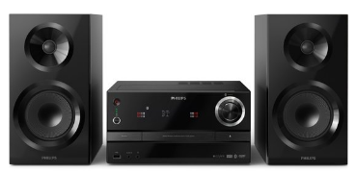**Philips izzy BM60 -** An easy to use and intuitive home audio solution that allows consumers to enjoy music from CD, FM radio, Bluetooth or USB. Coming in a recognizable design that will charm most avid music listeners, this stereo set lets you connect to up to five other izzy speakers to create a home network of beloved music. Recommended retail price: €299.

* 130W RMS music power
* 2 x 0.8” dome tweeter with 2 x 4” woofer
* CD, radio, USB and Bluetooth playback

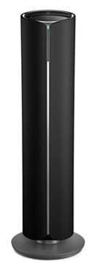

**Philips izzy BM90 -** An easy on the eye home audio solution that allows consumers to enjoy music from different playback possibilities. Not only does this tower fit in even the smallest space, the sound it produces will blow you away. Working as a 3.1 speaker system the tower can handle up to 200W music power. Recommended retail price: €599.

* 200W music power
* 3.1 speaker system with a built-in subwoofer
* CD, radio, USB and Bluetooth playback

**The ENTIRE Philips izzy Range Features:**

* Wireless music streaming from smart devices via Bluetooth
* No passwords, routers or apps required for setup
* Link up to five izzy speakers for multiroom music
* izzylink technology supports up to 100m open range with wireless connection
* One-touch operation for switching between single mode and group mode

**Philips at IFA**

For further information on the latest Philips innovations at IFA 2016 please visit [www.ifa.philips.com](http://www.ifa.philips.com), follow Philips at IFA on twitter @PhilipsLiveFrom, or visit our additional social media channels on YouTube and LinkedIn.

**About Gibson Brands**

Gibson Brands, a global leader in musical instruments, consumer electronics and professional audio, is dedicated to improving the quality of life and music for its customers. Founded in 1894 and headquartered in Nashville, Tennessee, Gibson Brands has manufacturing, marketing and research and development centers throughout the world. For more information, go to [www.gibson.com](http://www.gibson.com)

Gibson Innovations, a subsidiary of Gibson Brands, is a global powerhouse committed to innovation in sound and entertainment. As a leading player in key categories including headphones, audio systems, soundbars and connected audio with world-recognized brands including Philips and Onkyo, Gibson Innovations brings the finest audio products and experiences to consumers. For more information, go to [www.gibsoninnovations.com](http://www.gibsoninnovations.com)

**# # #**

**For More Information:**

**Gibson Innovations**

Marc de Kloet, Marketing Director, [marc.de.kloet@gibson.com](mailto:marc.de.kloet@gibson.com), 0031 627 625 417

Ilona de Bok, PR Manager, [Ilona.de.bok@gibson.com](mailto:Ilona.de.bok@gibson.com), 0031 627 625 542