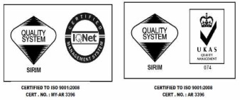

 Product Information

**DECCO-MELT 9326**

# Introduction

DECCO-MELT 9326 is a synthetic polymer hot melt adhesive specially formulated for edge banding application.

# Properties

Base : Ethylene Vinyl Acetate Copolymer

Appearance : Solids in beads form

Colour : Transparent yellow

Melt Viscosity (Brookfield Thermosel) : 25 000 – 35 000 cPs (34/1.5/140 oC) Softening Point (R&B) : 85 – 95 o C

Suggested Operating Temperature : 130 - 150 o C

# Characteristic

It exhibits excellent tackiness and setting time for edge banding application.

# Application

It is suitable for bonding thin PVC edging to particles board, MDF board and wood panel.

# Storage

It should be stored in dry and cool conditions. Keep bag closed when not in use. It has indefinite storage life.

# Toxicity

This product does not contain any toxic or hazardous substances.

*This hotmelt is free from contamination of silicone emulsion.*

***TDS/R1C1/JUN15***

**WILRON PRODUCTS SDN. BHD. (52720- X)** No 5, Jalan Pelabur 23/1, 40300 Shah Alam, Selangor Darul Ehsan, Malaysia. Tel: 03-55410612 Fax: 03-55410132

The above data are the results of carefully executed investigated. We do not guarantee the applicability or the accuracy of this information or suitability of our products in any given situation, because we cannot control the wide range of possibility. The products discussed are sold without warranty, either express or implied. We do not accept responsibility for damage of any kind.