

|  |
| --- |
| **Activity 6.2a Visual Analysis ALTERNATE** |

Introduction

What is it about an object that captures a person’s attention? Is it the color of an object that emphasizes its presence? That might explain why a kindergarten classroom is full of reds, yellows, and blues. Is it the organic curves of an object’s form, like the body of a sports car? Could it be a repeating series of shapes, such as a tile pattern in a bathroom? Is it the visual rhythm of the wood grain that makes a person purchase a fine piece of furniture? Perhaps it is a matter of symmetry, or a lack of it. Sometimes the sheer scale of an object or a space within it demands attention. Could that be another reason why people are attracted to cities? With some insight into these and other visual design principles and elements, students will develop their abilities to create designs that not only work, but also look good.

Equipment

* Engineering notebook
* Pencil
* Digital camera
* Optional: Collection of products or objects to be used for reverse engineering

Procedure

In this activity, working in a team of two or three, you will use a digital camera to aid you in your visual analysis of the object. Finally, you will describe the object using the language of visual design principles and elements.

Teacher will provide the object for your study.

Perform a visual analysis of the object using the following procedure:

1. In your engineering notebook, identify the product of your study, for example: Hose Nozzle.
2. Using a digital camera, take **at least two pictures** of the product from different angles.
3. Print out the images on a color or laser printer, and neatly secure them in your engineering notebook.
4. Create a caption under each image that identifies the particular object view.
5. Next to each image, write a description of the visual design principles and elements that are evident from that particular view.

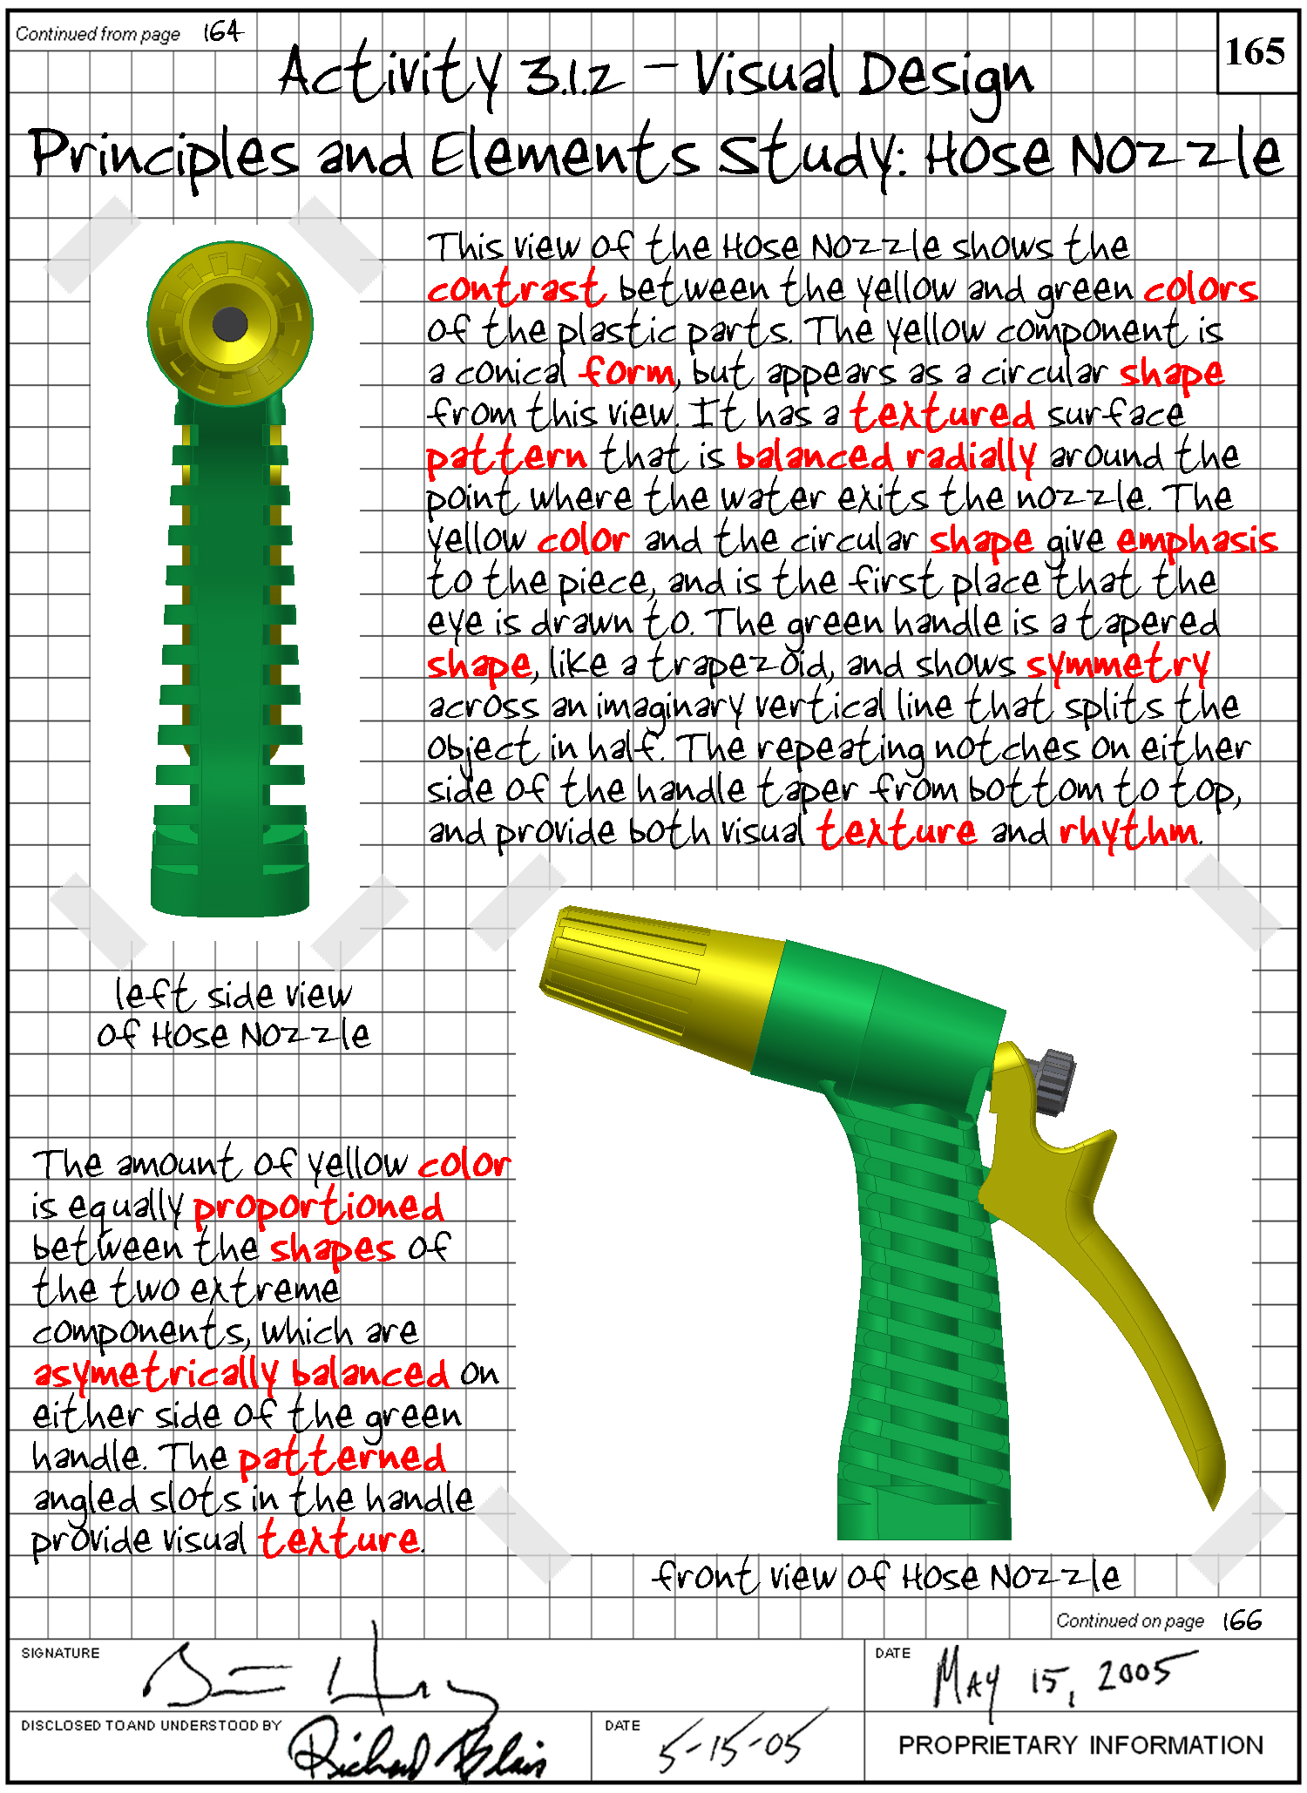

1. **Submit your engineering notebook to your instructor for evaluation.**

**Conclusion**

1. How will you look at products differently from now on, based on your understanding of visual design principles and elements?
2. How do visual design principles and elements impact the commercial appeal of a product?

5. Is the product you analyzed visually appealing? Do you think it appeals to the target market?

6. How would you improve the visual appeal of the product? Use terminology related to visual elements and principles of design to respond.