**1. Externalities - Definition and examples**

Dismiss All

**Please Wait . . .**

**Please Wait...**

An externality arises when a firm or person engages in an activity that affects the well-being of a third party, yet neither pays nor receives any compensation for that effect. If the impact on the third party is beneficial, it is called a selector 1**positive**

* negative
* positive

externality.

Points:

1 / 1

Close Explanation

Explanation:

A negative externality is a cost that a third party incurs from someone else's economic activity, while a positive externality is a benefit that a third party receives from someone else's economic activity. When the third party experiences a beneficial effect, it is called a positive externality.

The following graph shows the demand and supply curves for a good with this type of externality. The dashed drop lines on the graph reflect the market equilibrium price and quantity for this good.

*Shift one or both of the curves to reflect the presence of the externality. If the social cost of producing the good is not equal to the private cost, then you should shift the supply curve to reflect the social costs of producing the good; similarly, if the social value of producing the good is not equal to the private value, then you should shift the demand curve to reflect the social value of consuming the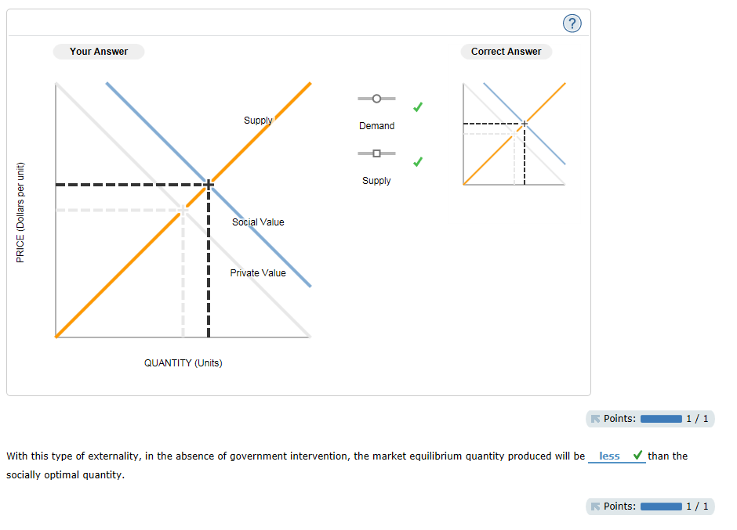 good.*

With this type of externality, in the absence of government intervention, the market equilibrium quantity produced will be selector 1 **less**

* greater
* less

than the socially optimal quantity.

Points:

1 / 1

Close Explanation

Explanation:

A positive externality is a benefit that a third party receives from someone else's economic activity. Graphically, a positive externality places the social value curve above the private value curve. In the presence of a positive externality, the market equilibrium quantity produced is less than the socially optimal quantity. The reason for this inefficiency is that the market equilibrium reflects only the private value to each consumer. It doesn’t take into account the fact that some benefits spill over, making other members of society better off.

Which of the following generate the type of externality previously described? Check all that apply.

A microbiology lab has published its breakthrough in swine flu research.

The local airport has doubled the number of runways, causing additional noise pollution for the surrounding residents.

Your roommate, Becky, has bought a puppy that barks all day while you are trying to study economics.

Raphael has planted several trees in his backyard that increase the beauty of the neighborhood, especially during the fall foliage season.

Points:

1 / 1

Close Explanation

Explanation:

A positive externality is a benefit that a third party receives from someone else's economic activity. The aesthetic benefit to Raphael's neighbors and the additional research that will be sparked by the medical breakthrough are examples of positive externalities.

In contrast, the extra noise from additional planes flying in and out of the terminals and the extra noise caused by your roommate's puppy are examples of negative externalities.

**2. Efficiency in the presence of externalities**

Dismiss All

**Please Wait . . .**

**Please Wait...**

Air horns impose many external costs on society: the risk of being deafened, the annoyance of being awoken in the middle of the night, and so on. Therefore, the market equilibrium quantity of air horns is not equal to the socially optimal quantity. The following graph shows the demand for air horns (their private value), the supply of air horns (the private cost of producing them), and the social cost of air horns, including both the private cost and external costs.

*Use the black point (plus symbol) to indicate the market equilibrium quantity. Next, use the purple point (diamond symbol) to indicate the socially optimal quantity.*

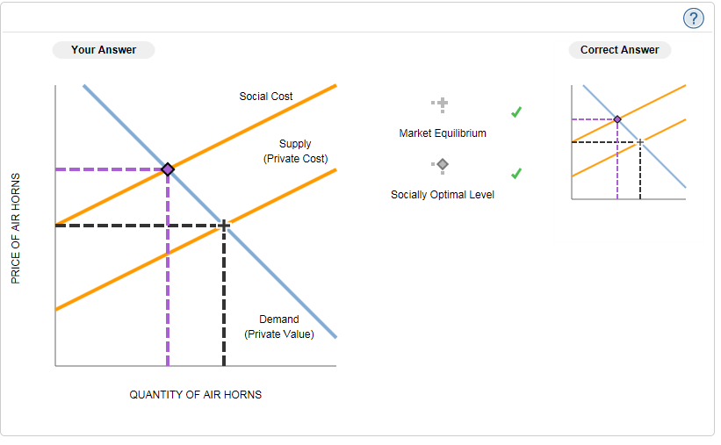

Points:

1 / 1

Close Explanation

Explanation:

The market equilibrium quantity occurs at the intersection of the private cost curve and the private value curve. The socially optimal quantity occurs at the intersection of the social cost curve and the social value curve. In this case, because there are no positive externalities, the social value equals the private value. However, the social cost is the vertical sum of the private cost and the external costs.

**3. The effect of negative externalities on the optimal quantityof consumption**

Dismiss All

**Please Wait . . .**

**Please Wait...**

Consider the market for paper. Suppose that a paper factory dumps toxic waste into a nearby river, creating a negative externality for those living downstream from the factory. Producing an additional ton of paper imposes a constant external cost of $245 per ton. The following graph shows the demand (private value) curve and the supply (private cost) curve for paper.

*Use the purple points (diamond symbol) to plot the social cost curve when the external cost is $245 per ton.*

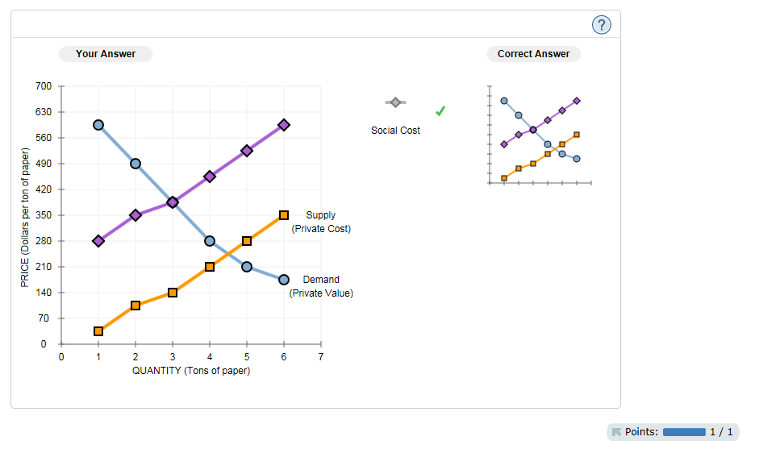

Points:

1 / 1

Close Explanation

Explanation:

The difference between the social cost and the private cost is the external cost of $245 per ton of paper. When the paper factory increases output from zero to one ton of paper, the social cost equals the private cost plus the external cost associated with one ton of paper, or   . Therefore, (1, 280) is a point on the social cost curve. Similarly, when the paper factory increases output from one to two tons, the social cost equals   , so (2, 350) is another point on the social cost curve. Use similar calculations to plot the rest of the points on the social cost curve.

The following table summarizes the private cost and social cost at different levels of output.

| **Quantity of Paper** | **Private Cost** | **+** | **External Cost** | **=** | **Social Cost** |
| --- | --- | --- | --- | --- | --- |
| **(Tons)** | **(Dollars)** | **(Dollars)** | **(Dollars)** |
| 1.0 | 35 |  | 245 |  | 280 |
| 2.0 | 105 |  | 245 |  | 350 |
| 3.0 | 140 |  | 245 |  | 385 |
| 4.0 | 210 |  | 245 |  | 455 |
| 5.0 | 280 |  | 245 |  | 525 |
| 6.0 | 350 |  | 245 |  | 595 |

The market equilibrium quantity is selector 1**4.5**

* 1.5
* 2
* 2.5
* 3
* 3.5
* 4
* 4.5
* 5
* 5.5

tons of paper, but the socially optimal quantity of paper production is selector 2**3**

* 1.5
* 2
* 2.5
* 3
* 3.5
* 4
* 4.5
* 5
* 5.5

tons.

Points:

1 / 1

Explanation:

If the paper factory is unregulated, it will produce paper until the private cost curve intersects the demand curve. For the paper factory, this occurs at 4.5 tons of paper.

The paper factory's private optimal level of production is 4.5 tons of paper. However, at this output level, the social cost of $490 exceeds the social value of $245. The socially optimal quantity of output occurs at the quantity where the social value is equal to the social cost. For quantities less than 3 tons of paper, the social value exceeds the social cost; and for quantities greater than 3 tons of paper, the social cost exceeds the social value. Therefore, it would be socially efficient for the paper factory to produce 3 tons of paper.

To create an incentive for the firm to produce the socially optimal quantity of paper, the government could impose a selector 1**tax**

* tax
* subsidy

of $245 per ton of paper.

Points:

1 / 1

Close Explanation

Explanation:

A subsidy to producers of paper creates an incentive to produce more paper, while a tax creates an incentive to produce less. The previous analysis shows that the market overproduces paper; therefore, the correct government response is to impose a tax on the production of paper.

A tax equal to the external cost ($245) would cause the socially optimal quantity of paper to be produced. This is called a Pigovian tax, and it causes the factory to internalize the negative externality so that the private cost now exactly equals the social cost.

If the tax were below $245, the paper factory would be internalizing only a portion of the negative externality. Thus, its output of paper would still be greater than the socially optimal quantity. On the other hand, if the tax were above $245, the costs facing the paper factory (the private cost plus the tax) would be greater than the social cost, leading the factory to produce less than the socially optimal quantity of paper.

**4. Understanding different policy options to correct for negativeexternalities**

Dismiss All

**Please Wait . . .**

**Please Wait...**

Carbon dioxide emissions have been linked to increased air pollution. The following table lists some possible public policies aimed at reducing the amount of carbon dioxide in the air.

*For each policy listed, identify whether it is a command-and-control policy (regulation), tradable permit system, corrective subsidy, or corrective tax.*

| **Public Policy** | **Command-and-Control Policy** | **Tradable Permit System** | **Corrective Subsidy** | **Corrective Tax** |
| --- | --- | --- | --- | --- |
| The government agrees to reimburse all factories that purchase new, emissions-reducing technology in order to provide cleaner air. |  |  |  |  |  |
| The government charges factories $480 for every ton of carbon dioxide they emit. |  |  |  |  |  |
| The government orders every factory to adopt a new technology, which reduces carbon-dioxide emissions into the atmosphere. |  |  |  |  |  |
| The government limits total carbon-dioxide emissions by all factories to 130,000 tons per decade. Each individual factory is given the right to emit 170 tons of carbon dioxide, and factories may buy and sell these rights in a marketplace. |  |  |  |  |  |

Points:

1 / 1

Close Explanation

Explanation:

A command-and-control policy, or regulation, remedies an externality by legally limiting a specific behavior by a specific entity. Some examples of command-and-control policies are directly limiting the emissions of carbon dioxide by each factory or mandating that firms adopt emissions-reducing technology.

A tradable permit system remedies an externality by regulating general behavior—in this case, total emissions of carbon dioxide—but also by allowing market forces to determine individual outcomes—in this case, the amount that each individual factory pollutes.

A corrective subsidy encourages behavior that has positive external effects. Since subsidizing firms with emissions-reducing technology will allow firms to decrease pollution without incurring any costs from doing so, a corrective subsidy will help reduce the amount of emissions to the efficient level.

A corrective tax, also known as a Pigovian tax, discourages behavior that has negative external effects. For example, since carbon-dioxide pollution generates a social cost beyond the private costs to the factory owner, a corrective tax can help achieve the socially optimal quantity of pollution.

**5. Correcting for negative externalities - Regulation versus tradablepermits**

Dismiss All

**Please Wait . . .**

**Please Wait...**

Suppose the government wants to reduce the total pollution emitted by three local firms. Currently, each firm is creating 4 units of pollution in the area, for a total of 12 pollution units. If the government wants to reduce total pollution in the area to 6 units, it can choose between the following two methods:

|  | **Available Methods to Reduce Pollution** |
| --- | --- |
| 1. | The government sets pollution standards using regulation. |
| 2. | The government allocates tradable pollution permits. |

Each firm faces different costs, so reducing pollution is more difficult for some firms than others. The following table shows the cost each firm faces to eliminate each unit of pollution. For each firm, assume that the cost of reducing pollution to zero (that is, eliminating all 4 units of pollution) is prohibitively expensive.

| **Firm** | **Cost of Eliminating the...** | | |
| --- | --- | --- | --- |
| **First Unit of Pollution** | **Second Unit of Pollution** | **Third Unit of Pollution** |
| **(Dollars)** | **(Dollars)** | **(Dollars)** |
| Firm X | 90 | 125 | 180 |
| Firm Y | 55 | 70 | 110 |
| Firm Z | 650 | 800 | 1,500 |

Now, imagine that two government employees proposed alternative plans for reducing pollution by 6 units.

**Method 1: Regulation**

The first government employee suggests to limit pollution through regulation. To meet the pollution goal, the government requires each firm to reduce its pollution by 2 units.

*Complete the following table with the total cost to each firm of reducing its pollution by 2 units.*

| **Firm** | **Total Cost of Eliminating Two Units of Pollution** |
| --- | --- |
| **(Dollars)** |
| Firm X | 215 |
| Firm Y | 125 |
| Firm Z | 1,450 |

Points:

1 / 1

Close Explanation

Explanation:

In order to compute the total cost of eliminating two units of pollution for each firm, add the cost of eliminating the first unit and the cost of eliminating the second unit for each firm. The following table summarizes these calculations:

| **Firm** | **Cost of Eliminating the...** | | **Total Cost of Eliminating Two Units of Pollution** |
| --- | --- | --- | --- |
| **First Unit of Pollution** | **Second Unit of Pollution** | **(Dollars)** |
| **(Dollars)** | **(Dollars)** |
| Firm X | 90 | 125 | 215 |
| Firm Y | 55 | 70 | 125 |
| Firm Z | 650 | 800 | 1,450 |

Method 2: Tradable Permits

Meanwhile, the other employee proposes using a different strategy to achieve the government’s goal of reducing pollution in the area from 12 units to 6 units. He suggests that the government issues two pollution permits to each firm. For each permit a firm has in its possession, it can emit 1 unit of pollution. Firms are free to trade pollution permits with one another (that is, buy and sell them) as long as both firms can agree on a price. For example, if firm X agrees to sell a permit to firm Y at an agreed-upon price, then firm Y would end up with three permits and would need to reduce its pollution by only 1 unit while firm X would end up with only one permit and would have to reduce its pollution by 3 units. Assume the negotiation and exchange of permits are costless.

Because firm Z has high pollution-reduction costs, it thinks it might be better off buying a permit from firm Y and a permit from firm X so that it doesn't have to reduce its own pollution emissions. At which of the following prices are both firm Y and firm X willing to sell one of their permits to firm Z ? Check all that apply.

$103

$135

$146

$290

$553

Points:

0.8 / 1

Explanation:

In order for a firm to be willing to sell one of its permits, the price it receives for the permit must be larger than the cost of eliminating the unit of pollution the permit represents: Each firm can use its initial allocation of two permits to avoid eliminating the third and fourth units of pollution, which are the mostly costly units to eliminate. This leaves each firm, before buying or selling permits, with just having to eliminate the first two least costly units of pollution. If a firm wants to sell one of its permits, it will then have to eliminate three units of pollution. Given that the cost of eliminating the third unit of pollution is $110 for firm Y and $180 for firm X, both firms will be willing to sell one of their permits at any price above $180.

Suppose the the government has set the trading price of a permit at $136 per permit.

*Complete the following table with the action each firm will take at this permit price, the amount of pollution each firm will eliminate, and the amount it costs each firm to reduce pollution to the necessary level. If a firm is willing to buy two permits, assume that it buys one permit from each of the other firms. (Hint: Do not include the prices paid for permits in the cost of reducing pollution.)*

| **Firm** | **Initial Pollution Permit Allocation** | **Action** | **Final Amount of Pollution Eliminated** | **Cost of Pollution Reduction** |
| --- | --- | --- | --- | --- |
| **(Units of pollution)** | **(Units of pollution)** | **(Dollars)** |
| Firm X | 2 | selector 1**Don’t buy/sell**   * Buy one permit * Buy two permits * Don’t buy/sell * Sell one permit * Sell two permits | 2 | 215 |
| Firm Y | 2 | selector 2**Sell one permit**   * Buy one permit * Buy two permits * Don’t buy/sell * Sell one permit * Sell two permits | 3 | 235 |
| Firm Z | 2 | selector 3**Buy one permit**   * Buy one permit * Buy two permits * Don’t buy/sell * Sell one permit * Sell two permits | 1 | 650 |

Points:

1 / 1

Close Explanation

Explanation:

Because the permit price ($136) is above firm Y's cost of removing its third unit of pollution ($110), firm Y will agree to sell one permit to firm Z. Firm Z will be willing to buy that permit, because $136 is less than its cost of eliminating its second unit of pollution, 800. Therefore, firm Y will end up with one pollution permit and will have to reduce its pollution by 3 units, which costs $235. Meanwhile, firm Z will end up with three pollution permits, so it will have to reduce pollution by only 1 unit at a cost of $650. Firm X will retain both of its initial permits because $136 is less than its cost of eliminating its third unit of pollution. As a result, it will need to reduce pollution by 2 units, which costs $215. (Note: The $136 exchanged when firm Z buys 1 of the permits is not a cost to society of eliminating pollution. It is simply a transfer from firm Z to firm Y.)

Regulation Versus Tradable Permits

*Determine the total cost of eliminating six units of pollution using both methods, and enter the amounts in the following table. (Hint: You might need to get information from previous tasks to complete this table.)*

| **Proposed Method** | **Total Cost of Eliminating Six Units of Pollution** |
| --- | --- |
| **(Dollars)** |
| Regulation | 1,790 |
| Tradable Permits | 1,100 |

Points:

1 / 1

Close Explanation

Explanation:

Recall the total cost of eliminating two units of pollution for each firm under standard regulation:

| **Firm** | **Cost of Eliminating the...** | | **Total Cost of Eliminating Two Units of Pollution** |
| --- | --- | --- | --- |
| **First Unit of Pollution** | **Second Unit of Pollution** | **(Dollars)** |
| **(Dollars)** | **(Dollars)** |
| Firm X | 90 | 125 | 215 |
| Firm Y | 55 | 70 | 125 |
| Firm Z | 650 | 800 | 1,450 |
| Total |  |  | 1,790 |

Therefore, the total cost of each firm reducing pollution by 2 units through regulation is   .

Under tradable permits, firm Y eliminates 3 units of pollution at a cost of $235, firm X eliminates 2 units of pollution at a cost of $215, and firm Z eliminates 1 unit of pollution at a cost of $650. Therefore, the total cost of reducing pollution by 6 units under tradable permits is   .

In this case, you can conclude that eliminating pollution is selector 1**less**

* less
* more

costly to society when the government distributes tradable permits than when it regulates each firm to eliminate a certain amount of pollution.

Points:

1 / 1

Close Explanation

Explanation:

The societal cost of reducing pollution by 6 units when the government regulates each firm to eliminate a certain number of units of pollution is $1,790. However, the cost of reducing pollution by 6 units under tradable permits is only $1,100. Therefore, in this case, it is less costly for firms to eliminate pollution when the government distributes tradable permits than when it regulates each firm to eliminate a certain amount of pollution.

**6. Achieving lower pollution**

Dismiss All

**Please Wait . . .**

**Please Wait...**

Suppose the Environmental Protection Agency (EPA) wants to mandate that all methane emissions must be reduced to zero in order to alleviate global warming in the United States.

Which of the following describes why most economists would disagree with this policy?

 Reducing methane emissions is desirable, but whatever levels of pollution firms decide to emit privately are already efficient.

 The environment isn’t worth protecting.

 Society would not benefit from lower air pollution.

 The opportunity cost of zero pollution is much higher than its benefit.

Points:

1 / 1

Close Explanation

Explanation:

While it is clearly desirable to breathe clean air, fully reducing emissions comes with a high cost. The question economists ask is whether or not this cost is worth it. Therefore, they believe you must compare the costs of zero pollution with the benefits from clean air. Specifically, eliminating all pollution is very costly and would likely cause more harm than good by restricting output, technology, and growth. Thus, zero pollution is likely not an economically efficient outcome because the social costs outweigh the benefits.

**7. Correcting for negative externalities - Taxes versus tradablepermits**

Dismiss All

**Please Wait . . .**

**Please Wait...**

Paper factories emit chemicals as a waste product. This generates a cost to society that is not paid for by the firm; therefore, pollution is a negative externality of paper production. Suppose the U.S. government wants to correct this market failure by getting firms to internalize the cost of pollution. To do this, the government can charge firms for pollution rights (the right to emit a given quantity of chemicals). The following graph shows the daily demand for pollution rights.

*Use the graph input tool to help you answer the following questions. You will not be graded on any changes you make to this graph.*

Note: Once you enter a value in a white field, the graph and any corresponding amounts in each grey field will change accordingly.

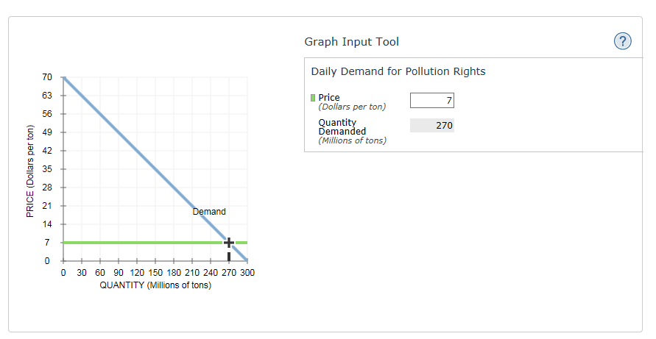

Suppose the government has determined that the socially optimal quantity of chemical pollution is 150 million tons per day.

One way governments can charge firms for pollution rights is by imposing a per-unit tax on emissions. A tax (or price in this case) of

$35

per ton of chemicals emitted will achieve the desired level of pollution.

Points:

1 / 1

Close Explanation

Explanation:

When the price of emitting a ton of chemicals is $35, paper factories will demand a quantity of 150 million tons of chemicals. You can see this change by entering $35 in the Price field of the graph input tool.Therefore, if the U.S. government wants to reduce chemical pollution to 150 million tons per day, it should impose a tax of $35 per ton.

If the government imposed a tax less than $35, then paper factories would choose to emit more than 150 million tons of chemicals per day. Similarly, if the government imposed a tax greater than $35, then chemical pollution would be reduced by more than is socially optimal. You can see examples of this on the following graphs:

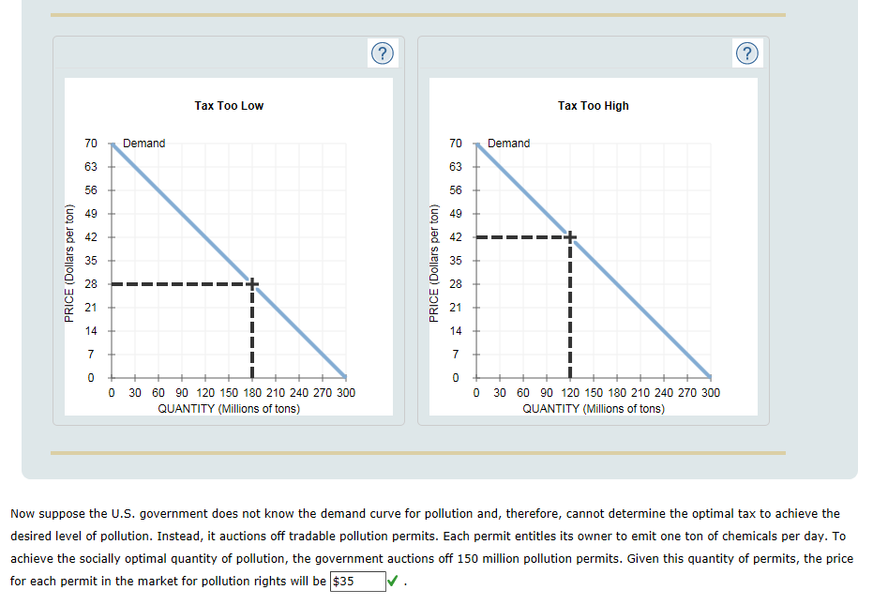

Explanation:

It turns out that the government can achieve the same level of pollution using either tradable pollution permits or a tax. In both cases, emitting one ton of chemicals will cost a firm $35.

Selling 150 million pollution permits that each allow a firm to emit one ton of chemicals means that the supply of pollution will be 150 million tons per day. At a quantity of 150 million tons, the market for pollution rights will clear at a price of $35. That is, each pollution permit will have a value of $35 because, at this price, all 150 million pollution permits will be demanded.

If the price for a permit were less than $35, firms would demand more than 150 million permits, which would not achieve the desired pollution level. If the price for a pollution permit were more than $35, then the quantity of permits demanded would be less than the 150 million permits the government put on the market. This excess quantity would put downward pressure on the price for permits, until the price falls to $35 per permit. You can see examples of this in the following graphs:

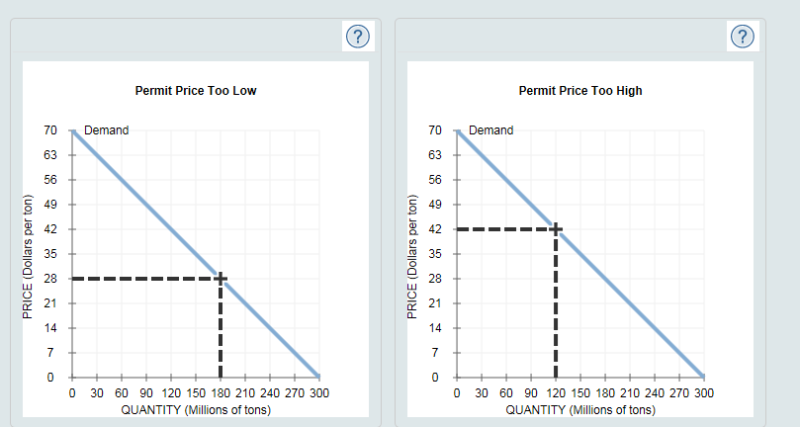

The previous analysis hinges on the government having good information regarding either the demand for pollution permits or the optimal level of pollution (or both). Given that the appropriate policy (tradable permits or corrective taxes) can depend on the available information and the policy goal, consider the following scenario.

Suppose the government knows the optimal quantity of pollution as well as how much it costs a particular polluting firm to reduce pollution at each quantity.

If this is all the information the government has, which solution to reduce pollution is appropriate? Check all that apply.

Tradable permits

Corrective taxes

Points:

1 / 1

Close Explanation

Explanation:

Although, under some circumstances, corrective taxes and tradable permits can be equally effective at reducing pollution, the government may prefer one over the other due to the information it has.

If the government knows how much it costs a particular polluting firm to reduce pollution at each quantity, this means they also know a firm's demand for pollution rights. Therefore, the government can achieve the socially optimal quantity of pollution by setting a corrective tax equal to the price the firm is willing to pay to pollute at the optimal quantity. This causes producers to internalize the cost so that they will generate pollution only up to the point where their marginal benefit is equal to their marginal private cost plus the marginal cost to society. This quantity will be lower than that in the absence of the tax, since without the tax they would continue to produce units that generated private benefits equal to private marginal costs but lower than the total marginal costs.

Because the government also knows the optimal quantity of pollution, they can also use tradable permits, which are a direct means of controlling the total quantity of pollution emitted.

The following graphs show the theoretical equivalence of corrective taxes and pollution permits if the government knew that the desired pollution level is 150 million tons.

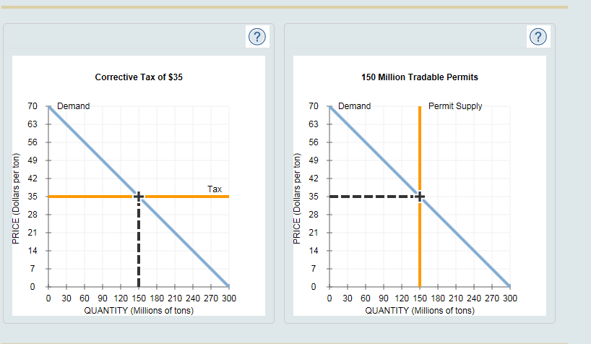

**8. The effects of property rights on achieving efficiency**

Dismiss All

**Please Wait . . .**

**Please Wait...**

Consider a lake found in the village of Sturbridge, and then answer the questions that follow. 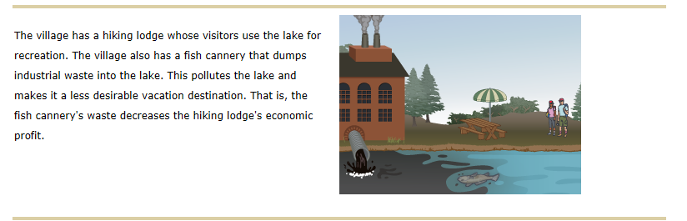

Suppose that the fish cannery could use a different production method that involves recycling water. This would reduce the pollution in the lake to levels safe for recreation, and the hiking lodge would no longer be affected. If the fish cannery uses the recycling method, then the fish cannery's economic profit is $1,500 per week, and the hiking lodge's economic profit is $1,800 per week. If the fish cannery does not use the recycling method, then the fish cannery's economic profit is $2,000 per week, and the hiking lodge's economic profit is $1,000 per week. These figures are summarized in the following table.

*Complete the following table by computing the total profit (the fish cannery's economic profit and the hiking lodge's economic profit combined) with and without recycling.*

| **Action** | **Profit** | | |
| --- | --- | --- | --- |
| **Fish Cannery** | **Hiking Lodge** | **Total** |
| **(Dollars)** | **(Dollars)** | **(Dollars)** |
| No Recycling | 2,000 | 1,000 | 3,000 |
| Recycling | 1,500 | 1,800 | 3,300 |

Points:

1 / 1

Total economic profit is highest when the recycling production method is selector 1**used**

* not used
* used

.

Points:

1 / 1

Close Explanation

Explanation:

When the recycling method is not used, total economic profit is   . When the recycling method is used, total economic profit is   . This is $300 more than without recycling.

When the fish cannery uses the recycling method, the hiking lodge earns    more per week than it does with no recycling. Therefore, the hiking lodge should be willing to pay up to $800 per week for the fish cannery to recycle water. However, the recycling method decreases the fish cannery's economic profit by    per week. Therefore, the fish cannery should be willing to use the recycling method if it is compensated with at least $500 per week.

Suppose the hiking lodge has the property rights to the lake. That is, the hiking lodge has the right to a clean (unpolluted) lake. In this case, assuming the two firms can bargain at no cost, the fish cannery will selector 1**use**

* not use
* use

the recycling method and will pay the hiking lodge selector 2**$0**

* $0
* between $0 and $300
* between $300 and $500
* between $500 and $800

per week.

Points:

1 / 1

Close Explanation

Explanation:

The recycling method decreases the fish cannery's economic profit by $500 per week. Therefore, the fish cannery is willing to pay the hiking lodge up to $500 per week to avoid using the recycling method. But when the fish cannery doesn't use the recycling method, the hiking lodge earns $800 less each week. Therefore, the hiking lodge will require at least $800 per week to allow the fish cannery to pollute the lake by not recycling.

Even if the fish cannery offered to pay the hiking lodge $500 per week, the hiking lodge would not consider allowing the pollution, because a clean lake is worth $800 per week to the hiking lodge. Because the hiking lodge owns the rights to a clean lake, the fish cannery's only choice is to use the recycling production method. Because it uses the recycling method, the water remains clean, so the fish cannery does not need to pay the hiking lodge any money.

Now, suppose the fish cannery has the property rights to the lake, including the right to pollute it. In this case, assuming the two firms can bargain at no cost, the fish cannery will selector 1**use**

* not use
* use

the recycling method, and the hiking lodge will pay the fish cannery selector 2**between $500 and $800**

* $0
* between $0 and $300
* between $300 and $500
* between $500 and $800

per week.

Points:

1 / 1

Close Explanation

Explanation:

The recycling method increases the hiking lodge's economic profit by $800 per week. Therefore, the hiking lodge is willing to pay the fish cannery up to $800 per week to use the recycling method. But when the fish cannery uses the recycling method, it earns $500 less each week. Therefore, the fish cannery will require at least $500 per week to use the recycling method.

Because using the recycling method is worth more to the hiking lodge than it costs the fish cannery, the fish cannery and the hiking lodge can bargain to reduce pollution. That is, they can decide on a sum between $500 and $800 that the hiking lodge can pay the fish cannery each week to use the recycling production method. This will make both firms better off.

Notice that the fish cannery will use the recycling method of production no matter who has the property rights to the lake. That is, the socially efficient outcome will be reached, regardless of who has the property rights. This is an example of the Coase theorem.

The fish cannery will make the most economic profit when selector 1**it has property rights to pollute the lake**

* the hiking lodge has property rights to a clean lake
* it has property rights to pollute the lake

.

Points:

1 / 1

Close Explanation

Explanation:

When the hiking lodge has property rights to the lake, the fish cannery will use the recycling method, and no payment will be exchanged. Therefore, the hiking lodge will earn a profit of $1,800 per week, and the fish cannery will earn a profit of $1,500 per week.

When the fish cannery has property rights to the lake, the hiking lodge will pay the fish cannery to use the recycling method (to avoid pollution). Although the amount of the payment is determined by bargaining, you know it will be between $500 and $800. Therefore, the hiking lodge will make less than    per week, and the fish cannery will make more than    per week.

Therefore, the hiking lodge will make the most economic profit when it has the property rights to a clean lake, and the fish cannery will make the most economic profit when it has the rights to pollute the lake.

True or False: The fish cannery will use the recycling method, regardless of who has the property rights.

True

False

Points:

1 / 1

Close Explanation

Explanation:

No matter who has property rights to the lake, the social outcome is the same: The fish cannery will use the recycling method of production, and the total economic profit made by both companies will be $3,300. However, the distribution of that economic profit depends on who has the property rights. This is an example of the Coase theorem, which asserts that as long as bargaining costs are low enough (they were assumed to be zero in this case), assigning property rights to one party will efficiently solve the problem of externalities (regardless of which party is initially awarded the rights).

**9. Private solutions to correct for externalities**

Dismiss All

**Please Wait . . .**

**Please Wait...**

Consider the following scenario:

Suppose that a chicken farm uses a nearby stream to dispose of the wastes released by its chickens. These wastes flow downstream into a lake that has become thick with algae and polluted due to the minerals in the waste matter. The local office of a nonprofit environmental organization successfully lobbies state regulators to stop the farm's pollution.

Which of the following types of private solutions to the externality of pollution has occurred in this case?

Contracts

Moral codes and social sanctions

Charities

Integration of different types of businesses

Points:

1 / 1

Close Explanation

Explanation:

In this case, the negative pollution externality is addressed by the nonprofit environmental organization, which is a charity. Private donations allow the nonprofit environmental organization to fund operations that get government regulators to limit the chicken farm's pollution. The government can encourage a private solution to the externality by providing a tax incentive, like making charitable donations tax deductible.

It’s important to note that sometimes private solutions to externalities do not work. For example, this occurs when the number of parties involved is so large that it makes selector 1**coordinating negotiations among all of the parties too costly**

* coordinating negotiations among all of the parties too costly
* the market failure from the externality unimportant
* government action the only viable solution

.

Points:

1 / 1

Close Explanation

Explanation:

When there are many people either impacted by or contributing to an externality, it can be too difficult and costly to coordinate them and get them to come to an agreement. The government may be able to help in this situation by making this coordination easier to achieve or by leading the charge to correct for the externality.