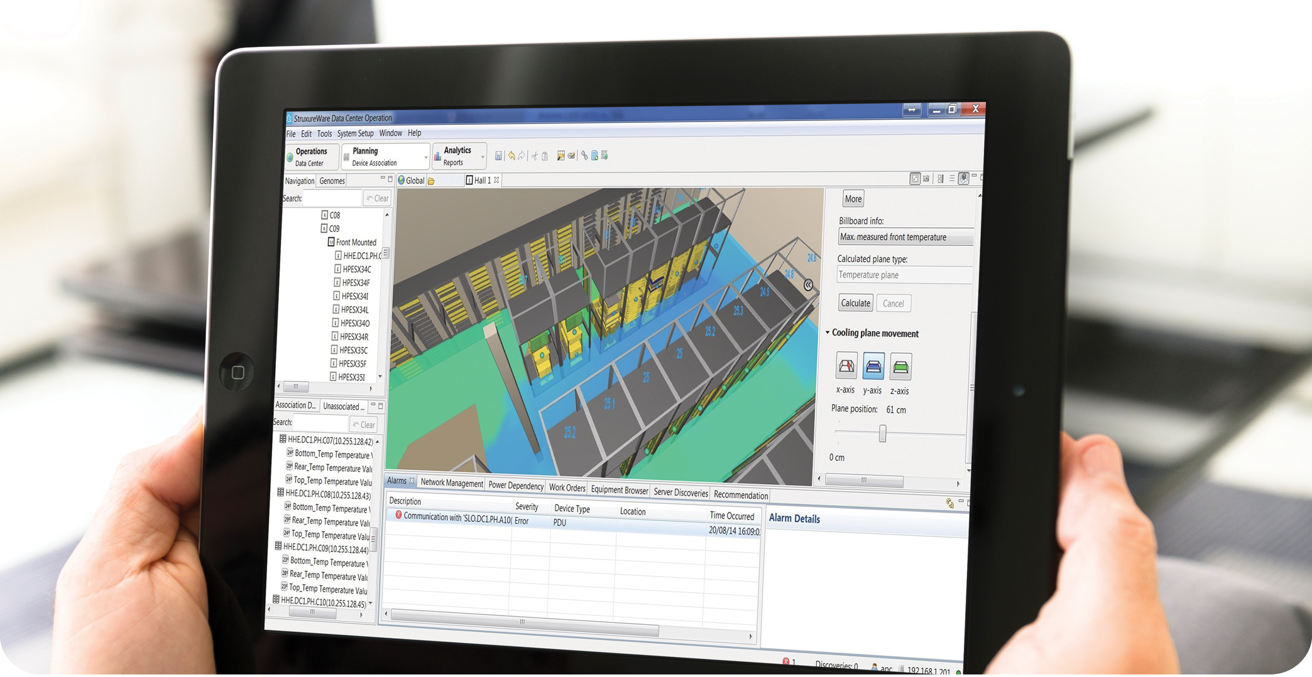

**Sky picks Keysource and Schneider Electric to manage the UK Data Centers Infrastructure***Sky has rolled out a new Data Center Infrastructure Management (DCIM) solution across its UK data center estate. The project was awarded to and led by leading data center specialists Keysource, who were chosen in partnership with Schneider Electric. StruxureWare for Data Centers DCIM platform was chosen to deliver a range of operational, performance, cost and efficiency benefits across Sky’s business.*

**CUSTOMER CASE STUDY**



“Data Center Operations is the foundation of IT at Sky and it needs to enable our business to grow”.

998-1284-01-21-14AR0

Sky operates the most comprehensive multi-channel and multi-platform television services in the UK, Ireland, Italy, Germany and Austria covering 20 million households, and extending from TV to mobile devices, on linear and On Demand. It also offers a range of broadband and telephone services.

Operating data centers throughout the UK, technology is at the heart of ensuring Sky can meet the demands of its business and customers both now and in the future. Sky’s IT estate includes over 1,000 server racks located in a combination of Sky owned and operated facilities along with some colocated facilities. The range of challenges the operations team faces include: delivering service availability with the highest levels of performance, improving resource and operational efficiency and lowering costs.

Riccardo Degli Effetti, Head of Data Center Operations at Sky said, “Data Center Operations is the foundation of IT at Sky and it needs to enable our business to grow. Uptime is the primary goal and responsibility of the operations team, but maximizing capacity and efficiency while minimizing our carbon footprint is high on the agenda too: As a company, Sky has set bold environment targets to reach by 2020.”

With the existing asset management solution approaching end of life, Riccardo and his data center operations team sought a new solution which would help Sky understand how its servers could be better utilized, whether idle equipment could be safely turned off, and what impact that could have on available capacity throughout the data center estate, as well as the energy consumption of the system.

“Capacity costs money,” Riccardo said. “The most efficient data center is the one you don’t have to build. At Sky, we want to be able to measure what capacity we have as a resource, and understand how long it will be before we need additional infrastructure. We want to know which of our servers are working efficiently and which ones are not and therefore are candidates for decommissioning or further virtualization. In a sense, PUE is not that useful to us – our key metrics are CPU utilization and power consumption.”

Building a business case for the DCIM project was greatly enhanced because all the stakeholders are invested in the same corporate aim; to reduce energy use and increase efficiency. In fact, funding was granted precisely because Riccardo and his team were able to demonstrate, to a cross-discipline panel, how the project would improve utilization of IT assets and deliver associated energy savings throughout the infrastructure.

The exciting and ambitious aim of the project is to raise awareness of IT usage across the whole of the Sky business. It is also one which Riccardo Degli Effetti believes will enable DCIM to show its full potential “The objective is to be at the forefront of innovation – not to follow but to lead – and this project will achieve that”.

* By developing the requirements further to encompass a range of other desired and required functionality, Sky produced a performance specification and went to the market in a competitive tender. The process involved eight potential suppliers, but Keysource saw the opportunity to focus not only on the software but on the project outcome as a whole and the need for ongoing collaboration with the rollout of further functionality. The partnership between Keysource and Schneider Electric provided Sky with the benefit of a leading data center specialist working together with an industry-leading DCIM solution provider.

The Approach

With such a transformational project it was crucial to get all relevant people engaged and on board with the overall project objectives and timelines. So, once appointed, Keysource’s initial focus was to identify the key stakeholders across all businesses and establish the respective roles.

Keysource organized a number of workshops where the proposed approach to the project was modeled, the core functionality of the toolset was explained and demonstrations of its impact on current systems and ways of working could be discussed.

Customer

* Sky provides multi-channel and multi-platform television services in the UK, Ireland, Italy, Germany and Austria.
* Covers approximately 20 million households.

Challenges

* Delivering service availability with the highest levels of performance.
* Improving resource and operational efficiency.
* Lowering costs.

Results

* Replace multiple tools with a single integrated system.
* Centralize asset management with data center infrastructure.
* Improve efficiency by optimizing power utilization.
* Improve service by matching IT demand with data center capacity and performance.
* Establish an approach and supplier engagement for longevity and continuous improvement.

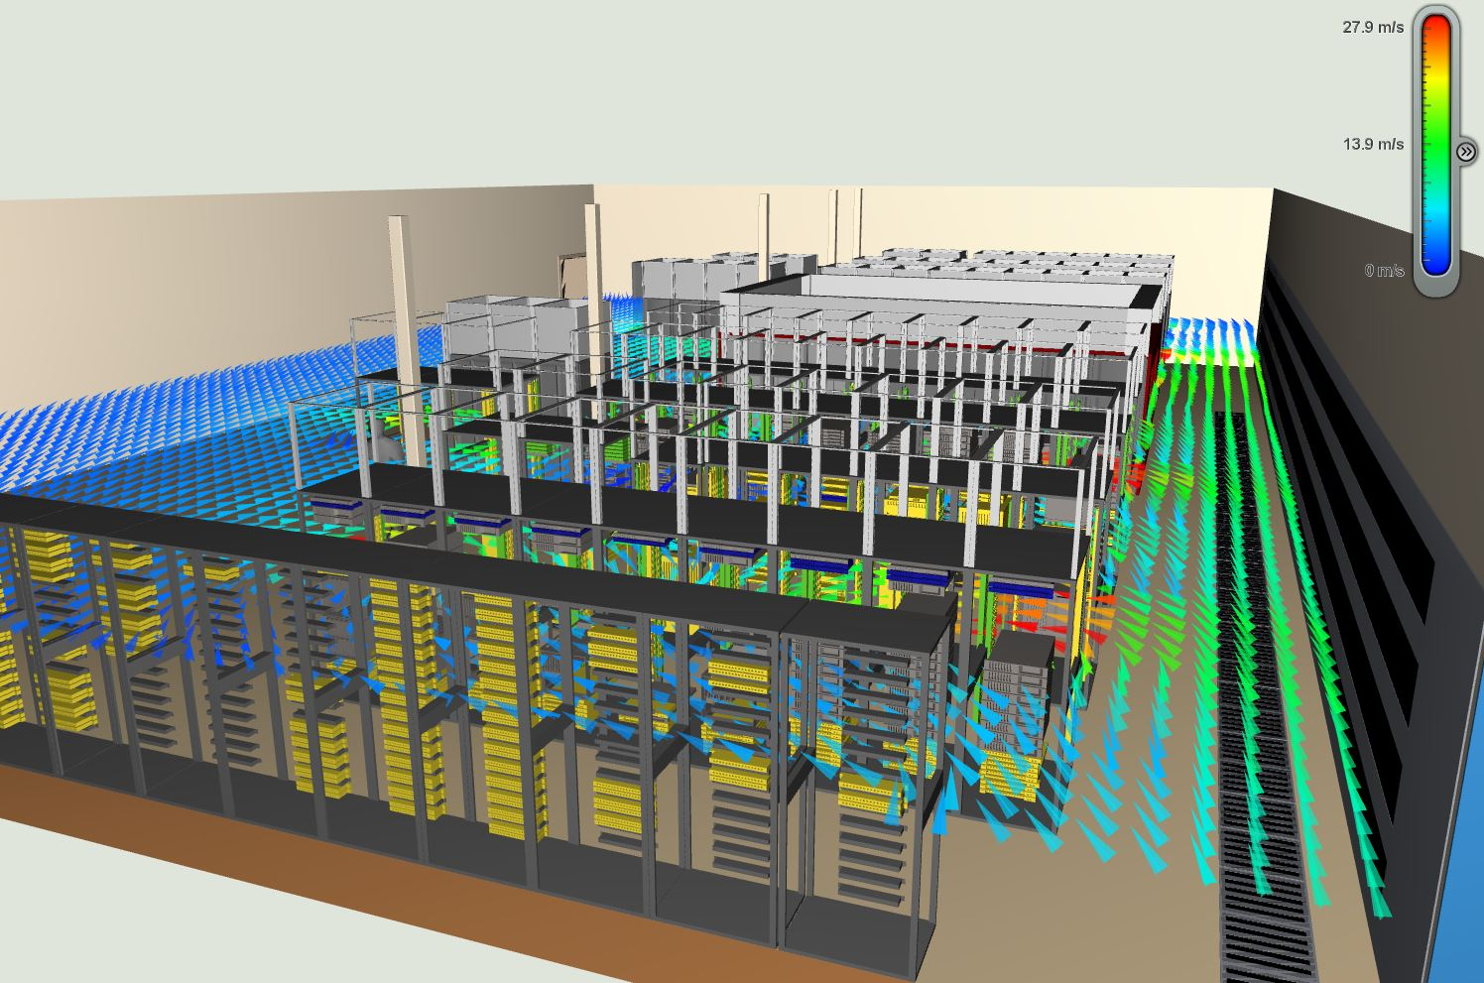[](http://www.twitter.com/SchneiderElec)[](http://www.linkedin.com/groups/Schneider-%20Electric-Intelligent-Energy-56843)[](http://tv.schneider-electric.com/)[](http://www.facebook.com/SchneiderElectric)



*“The most efficient data center is the one you don’t have to build. At Sky, we want to be able to measure what capacity we have as a resource, and understand how long it will be before we need additional infrastructure”.*

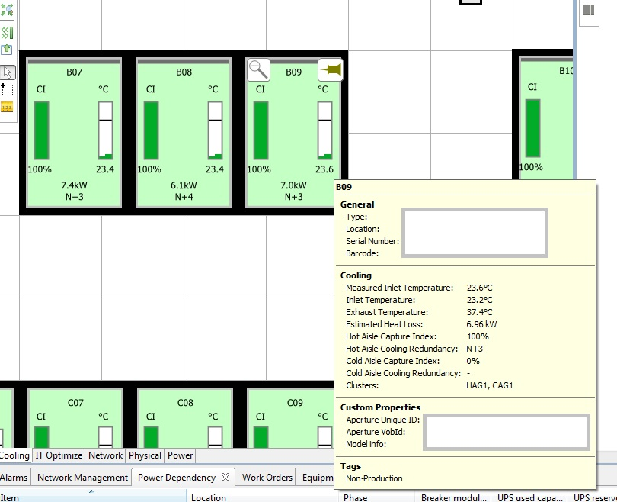

The workshops incorporated demonstrations and virtual examples of real infrastructure to help visualize the overall end goal. By getting early buy-in, Riccardo’s team and Keysource were able to ensure that stakeholders were fully on board with the plan, shared ownership of what was being proposed and were positive about the future potential. Rob Elder, Director at Keysource said, “With any roll out of DCIM, the success will be derived by what is achieved as a result of the data from the tool, not by deploying the tool itself.”

The next step was to ensure the relevant technical, security, network and operational resource was available from all sides to plan the implementation and scope of integration. Spanning multiple systems and teams, more than 30 subject matter experts were required at various stages to ensure a successful and ultimately workable outcome.

Phase one commenced in June 2014 and was delivered in early October 2014 for the pilot facility. Within this time all aspects of the planning, engineering and development, as well as deployment and validation testing, were conducted.

The second phase, currently being implemented, involves integrating the DCIM solution with the BMS across all sites. This will unlock further benefits and functionality, and will require further collaboration and interfacing with a range of service and solution providers.

**The Solution**

Prior to the implementation, Sky had been using a number of different tools, which were not integrated; therefore rendering the capacity and performance management of the data centre estate very time consuming. Furthermore, the incumbent asset management tool did not have some of the required functionalities; it was apparent that a new approach was needed.

The Schneider Electric StruxureWare for Data Centers software suite includes all

key components of a truly comprehensive DCIM toolset combined with the integration and functionality to make it central to Sky’s data center operations.

**Out of the box components included:**

1. Asset Management
2. Change Management
3. Capacity Planning
4. IT Optimization
5. BMS Integration

Through flawless integration, Keysource were able to ensure StruxureWare was populated from existing data and interfaced with other business tools for Service Delivery and Ticketing. The aim was not to alter the way Sky ran their operations to fit in with the new tool, but rather to develop an approach which optimized and streamlined the whole process. This resulted in a single dashboard in which assets, racks and BMS data can be viewed through a single screen.

One of the key aspects of the project, covered by the functionality of the IT Optimize software module, was to give Sky the ability to identify assets through CPU utilization which could be candidates for virtualizing, re-provisioning or retiring. Armed with this insight the operations team could go back to the different parts of the business, who were responsible for the

Impact failure analysis through linking the BMS to the IT assets enables real time changes in status or availability to be flagged via alarms through the tool. Either due to a planned or unplanned event, workloads can be deployed or managed based on suitable data centre capacity and availability on current conditions.

Combined with real time data the operations team out in the field can access the DCIM data and tools through mobile devices. Providing a dashboard and the ability to drill down into different areas improves service delivery by allowing for better more informed decisions and reduces the need for duplication.



*The aim was not to alter the way Sky ran their operations to fit in with the new tool, but rather to develop an approach which optimized and streamlined the whole process*



Head of Data Center Operation at Sky,  
Riccardo Degli Effetti

* Reduced human error and improved workflow through integrated change management.
* Provided full visibility of server hardware utilization correlated with power consumption for long term planning.
* Provided business intelligence through reports showing utilization, performance and capacity planning.
* Improved service availability and operational performance through impact alerts and mobile apps.
* Achieved compliance and reduced time with a full audit trail.
* Lower carbon footprint can be achieved via automatic notification of server under-usage.
* Engaged users and informed them of potential improvements in terms of performance / usage, budget and carbon savings from better provisioned resources.

specific platforms or applications, and engage with them about how their IT was put to use.

Impact failure analysis through linking the BMS to the IT assets enables real time changes in status or availability to be flagged via alarms through the tool. Either due to a planned or unplanned event, workloads can be deployed or managed based on suitable data center capacity and availability on current conditions.

Combined with real time data the operations team out in the field can access the DCIM data and tools through mobile devices. Providing a dashboard and the ability to drill down into different areas improves service delivery by allowing for better more informed decisions and reduces the need for duplication.

**The Benefits**

Despite the range of operational and technical benefits the real driver comes back to efficiency and reducing cost.

Riccardo Degli Effetti believes that the industry-standard measurement of data center performance PUE (Power Usage Effectiveness) has limitations when it comes to actually showing how usefully a data center is performing, relative to its specific IT workload. “PUE has changed the industry, but it is not a final indication. It doesn’t tell you whether a data center is doing something useful or not. To do that, you need to go very granular on the IT, and previously where we had the capacity to do that, we didn’t have the intelligence in the tools to enable it” he says.

* Maximized efficiency of the existing data center estate, avoiding building new data center facilities.
* Enabled centralized holistic monitoring of the whole data center estate via a single dashboard, saving time.



*The Schneider Electric StruxureWare for Data Centers software suite includes all key components of a truly comprehensive DCIM toolset*