**Come one, come all to Vancouver Homecoming’s FUNdraising night!**

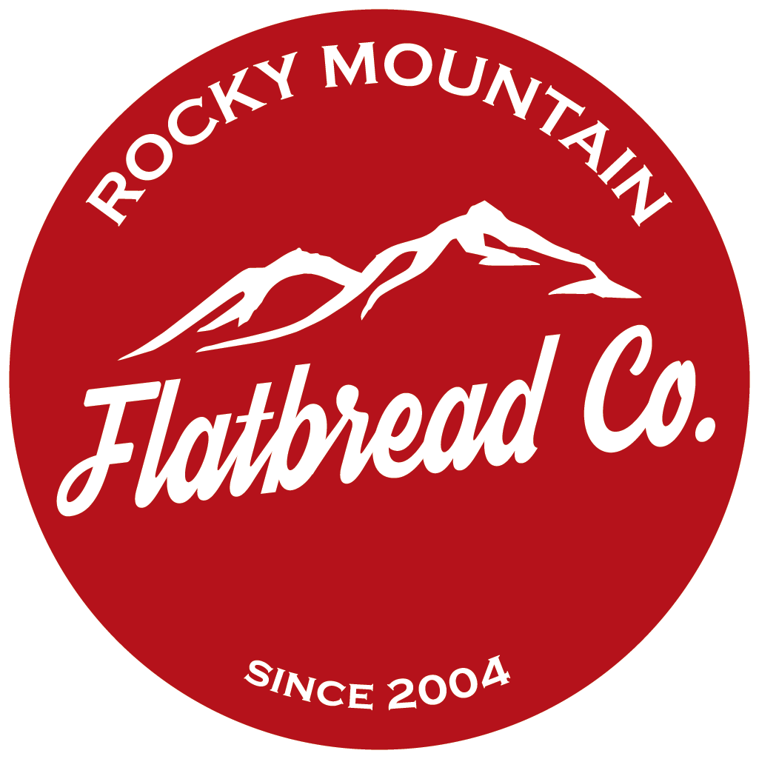

When: June 22nd (World Refugee Day), 5pm-9pm

*we recommend you make a reservation, as there is limited seating. Click on this link to make reserve a table:

<https://www.seatme.yelp.com/r/rocky-mountain-flatbread-co-vancouver/?date=2016-04-13&time=1100&covers=2>

What: FUNdraising night for our sponsorship funds and in honour of World Refugee Day

Where: Rocky Mountain Pizza Company, 4186 Main Street, (604) 566-9779

More details:

Please join us for dinner at the Rocky Mountain Pizza Company for a fun and tasty night of community building, raising awareness about the Syrian refugee crisis and refugees around the world and FUNdraising!

The restaurant gives our group 10% of sales from the evening. This money will go towards sponsoring the Syrian family that we have been connected with through MOSAIC.

We’re planning the following for the event, and would love your help with these things:

* a silent auction and/or things for sale, so if you have anything to contribute (beer, honey, jewelry, notecards, skills/talents) or you know businesses you can contact for silent auction items, please let Surya know (vancouverhomecoming@gmail.com)
* raffle or 50/50 draw
* live music - musician or connected to a musician, please let us know
* a trivia game/mixer

Other ideas are welcome! Please contact Terra (tkaethler@gmail.com) with your input or if you are able to help with any of the things listed above.

**Come one, come all to Vancouver Homecoming’s FUNdraising night!**

When: June 22nd (World Refugee Day), 5pm-9pm

*we recommend you make a reservation, as there is limited seating. Click on this link to make reserve a table:

<https://www.seatme.yelp.com/r/rocky-mountain-flatbread-co-vancouver/?date=2016-04-13&time=1100&covers=2>

What: FUNdraising night for our refugee sponsorship funds and in honour of World Refugee Day

Where: Rocky Mountain Pizza Company, 4186 Main Street, (604) 566-9779

More details:

Please join us for dinner at the Rocky Mountain Pizza Company for a fun and tasty night of community building, raising awareness about the Syrian refugee crisis and refugees around the world and FUNdraising!

**The restaurant gives our group 10% of sales from the evening.** In addition, we plan to have an auction/sale table, and a raffle draw at the event to raise funds. All proceeds will go towards sponsoring the Syrian family that we have been connected with through MOSAIC.

We hope you will join us for a wonderful community event.

If you have any questions, please contact us at vancouverhomecoming@gmail.com