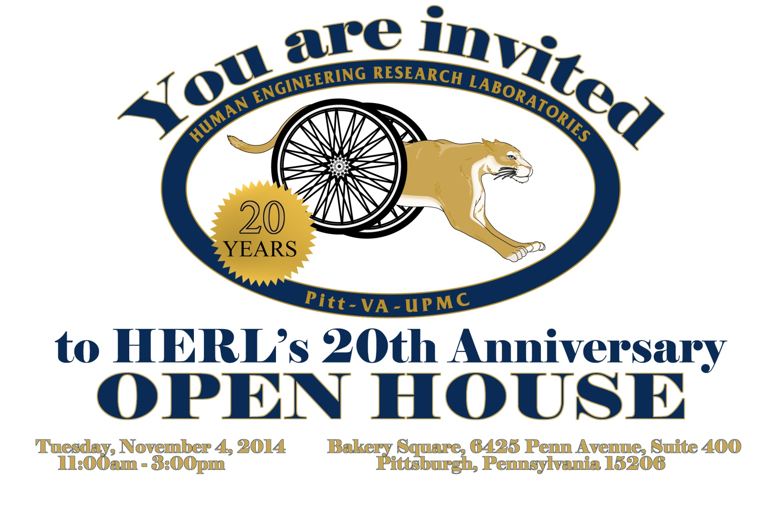

Please join us in celebration!

***1100hrs: Remarks***  
***1200hrs: Light Lunch***

No RSVP necessary  
Free 3-hour parking in Bakery Square garage

Map and directions:  
*http://www.herl.pitt.edu/maps-directions*