AR – CASH COLLECTION REVIEW

Purpose: To provide instructions for reviewing progress of cash collections

1. ACCOUNTING band > ACCOUNTS RECEIVABLE > TRANSACTION > GENERATE CASH COLLECTION CALL LIST

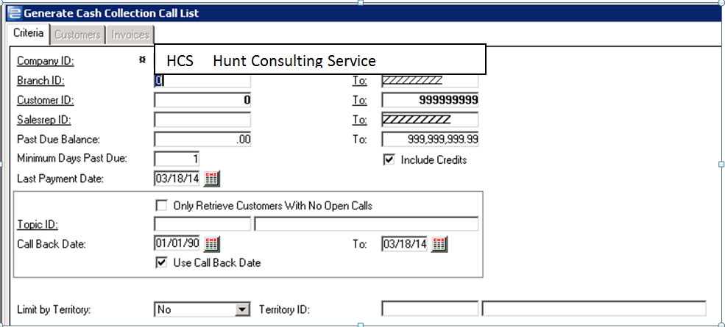

1. To check on overdue accounts with call back dates:
   1. Set beginning PAST DUE BALANCE to $1
   2. Leave ending PAST DUE BALANCE as 999,999,999.99
   3. Set MINIMUM DAYS PAST DUE to 15
   4. Leave USE CALL BACK DATE checkbox checked
   5. Leave CALL BACK starting date as 01/01/90
   6. Change CALL BACK ending date to yesterday
   7. Click RETRIEVE

Customers that display are ones that should have had a follow up call no later than “yesterday”. This gives you an idea of the credit/collection staff are keeping up to date with follow ups.

1. To review accounts with past due amounts but no collection calls:
   1. Set beginning PAST DUE BALANCE to $1
   2. Leave ending PAST DUE BALANCE as 999,999,999.99
   3. Set MINIMUM DAYS PAST DUE to 15 or 30 (depending on your preference)
   4. UNCHECK the checkbox USE CALL BACK DATE
   5. CHECK the checkbox ONLY RETRIEVE CUSTOMERS WITH NO OPEN CALLS
   6. Click RETRIEVE

This will show customers that are past due where credit/collections has not yet made the first contact. This gives you an idea of whether they are keeping up with routine collection processes.

1. Once data has been retrieved, you can press F8 to review customer invoices, payment status, etc. in Customer Master Inquiry. When reviewing open calls, you can see the cash collection calls already entered against the account. If you are reviewing open calls, you can click right mouse button, select GOTO>CASH COLLECTION CALL MAINTENANCE and add any additional information you may have regarding the past due invoices.