Druze’s SnapChat Growing

So I’ll just jump right into it. If you have a jailbroken iPhone or rooted Android it will make this method much easier, if not it will still work great.

So what you’re going to want to do is go to the App Store and search for an app called yellow. The picture is just Yellow and nothing else.

Once you download it all you have to do is go to discover and begin swiping.

If it says looking for people or out of people to add or anything like that, just press on the profile tab and go back and it will have more people to add.

Here is some of my adds in the last couple of days:

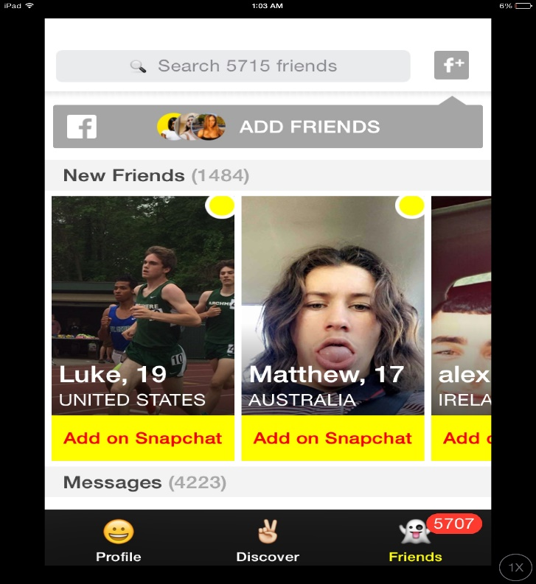

Now if you have a jailbroken device, you’ll want to go download AutoTouch.

First go to Cydia and add this source: <http://repo.insanelyi.com>

Then search for AutoTouch and download the cracked version from insanelyi

This is the script I use for Yellow: pastebin.com/cW5uScpi

If that does not work here is what you have to record:

1. Go to Yellow and start recording
2. Swipe a few people
3. Press in the area of the person’s name (nothing will happen)
4. Swipe a few more people
5. Go to your profile and wait a couple of seconds
6. Go back to discover and swipe a couple more people

That’s it! I set the speed to 1.5x but you can set it to 1.9x, I recommend setting the interval to 2 or 3 and loop it as many times as you want!

This can also be emulated on an android emulator such as memu or nox which both have their own macro recorders.

Method 2:

So for this we will be using MeetMe, Tinder, and Badoo

Make sure to have a few appropriate pictures of the girls you’re using and choose a highly populated city

For this it will be easier if you use autotouch or use an emulator such as nox or memu to automate it

Basically just record a macro of you liking profiles and let that run

Then record another macro of you messaging every person to add you on snapchat

Say something like “Hey I wanted to talk but I’m not on here very often. You should add me on snapchat: (snapchat here) ;)”

Method 3:

So this one is very simple

Sign up for a new facebook account using a couple appropriate pictures of the girl you’re using.

Go to the search bar and under groups search the word “Snapchat”

This will bring up a lot of groups with people looking for others on snapchat.

Join about 10 a day (more than that and you risk being banned)

Once you are in the groups use a photo collage app to make a photo with your snapcode on one side and a picture of the girl (with clothes on) on the other side.

Then go into whatever groups you’re in and post the picture with something like this: “Hey I’m pretty bored anyone wanna talk on Snap? Add me: (name here) ☺”

Do this every 8-12 hours and change up the message