# Microsoft Word 2007 – Formatting Characters and Paragraphs

A Word document is based on a template that applies default formatting. Some of the default formats include **11-point Calibri**, line spacing of **1.15**, **10 points of spacing after** each paragraph, and **left-aligned** text. The appearance of a document in the document screen and how it looks when printed is called the format. Character formatting can include such elements as changing the typeface, type size and typestyle as well as applying font effects such as bolding and italicizing. The *Paragraph* group in the *Home* tab includes buttons for applying formatting to paragraphs of text. In Word, a paragraph is any amount of text followed by the press of the *Enter* key.

## Changing Fonts

The *Font* group contains a number of buttons you can use to apply character formatting to text in a document. The top row contains buttons for changing the font and font size as well as buttons for increasing and decreasing the size of the font. The bottom row contains buttons for applying typestyles such as bold, italics, underlining, superscript and subscript. You can remove character formatting (as well as paragraph formatting) applied to text by clicking the *Clear Formatting* button in the *Font* group. Remove only character formatting from selected text by pressing the keyboard shortcut, **Ctrl + spacebar**.

A Word document is based on a template that formats text in 11-point Calibri. You may want to change this default to some other font for such reasons as changing the mood of the document, enhancing the visual appeal, and increasing the readability of the text. A font consists of three elements—typeface, type size, and type style.

A typeface is a set of characters with a common design and shape and can be decorative or plain and either monospaced or proportional. Word refers to typeface as ***font***. A monospaced typeface allots the same amount of horizontal space for each character while a proportional typeface allots a varying amount of space for each character. Proportional typefaces are divided into two main categories: ***serif*** and ***sans serif***. A serif is a small line at the end of a character stroke. Consider using a serif typeface for text-intensive documents because the serifs help move the reader’s eyes across the page. Use a sans serif typeface for headings, headlines, and advertisements.

Microsoft Word 2007 includes six new typefaces designed for extended on-screen reading. These typefaces include the default, Calibri, as well as Cambria, Candara, Consolas, Constantia, and Corbel. Calibri, Candara and Corel are sans serif typefaces; Cambria and Constantia are serif typefaces; and Consolas is monospaced.

Type size is generally set in proportional size. The size of proportional type is measured vertically in units called ***points***. A point is approximately 1/72 of an inch—the higher the point size, the larger the characters. Within a typeface, characters may have a varying style. Type styles are divided into four main categories: regular, bold, italic, and bold italic.

You can use the *Font* button in the Font group to change the font and the *Font Size* button to change the size. When you select text and then click the *Font* button arrow, a drop-down gallery displays of font options. Hover your mouse pointer over a font option and the selected text in the document displays with the font applied. You can continue hovering your mouse pointer over different font options to see how the selected text displays in the specified font. The *Font* button drop-down gallery is an example of the ***live preview*** feature, which allows you to see how the font formatting affects your text without having to return to the document. The live preview feature is also available when you click the *Font Size* button arrow.

## Choosing a Typestyle

Apply a particular typestyle to text with the **Bold**, *Italic* or Underline buttons in the bottom row in the *Font* group. You can apply more than one style to text.

Each of the three styles has traditional uses that you may find appropriate in your documents. **Bold** is often used to draw the reader’s attention to important words to remember. *Italics* typically are used to emphasize certain words or phrases within a sentence. In biology texts, they are used for genus and species names. Underlining also serves to emphasize and set apart words or phrases, although most style manuals recommend using italics instead of underlines.

## Choosing a Font Effect

Apply font effects with some of the buttons in the bottom row in the Font group. Use the *Strikethrough* button to draw a line through selected text. This has a practical application in some legal documents in which deleted text must be retained in the document. Use the *Subscript* button to create text that is lowered slightly below the line such as the chemical formula H2O). Use the *Superscript* button to create text that is raised slightly above the text line such as the mathematical equation four to the third power (written as 43).

Change the case of text with the *Change Case* button drop-down list. Click the *Change Case* button and a drop-down list displays with the options *Sentence case*, *lowercase*, *UPPERCASE*, *Capitalize Each Word*, and *Toggle Case*. You can also change the case of selected text with the keyboard shortcut, **Shift + F3**. Each time you press Shift + F3, selected text cycles through the case options.

The bottom row in the Font group contains two additional buttons—the Text Highlight Color button and the Font Color button. Use the Text Highlight Color button to highlight specific text in a document and use the Font Color button to change the color of text.

## Using Keyboard Shortcuts

Several of the buttons in the Font group have keyboard shortcuts. Position the mouse pointer on a button and an enhanced *ScreenTip* displays with the name of the button; the keyboard shortcut, if any; a description of the action performed by the button; and sometimes access to the *Word Help* window.

***Font Group Button Keyboard Shortcut:***

Bold *Ctrl + B*  
Italic *Ctrl + I*  
Underline *Ctrl + U*  
Change Case *Shift + F3*

## Formatting with the Mini Toolbar

When you select text, the *Mini toolbar* displays in a dimmed fashion above the selected text. Hover the mouse pointer over the *Mini toolbar* and it becomes active. Click a button on the *Mini toolbar* to apply formatting to selected text.

## Changing Fonts at the Font Dialog Box

In addition to buttons in the Font group, you can use options at the *Font* dialog box to change the typeface, type size, and typestyle of text as well as apply font effects. Display the *Font* dialog box by clicking the *Font group dialog box launcher*. The dialog box launcher is a small square containing a diagonal-pointing arrow that displays in the lower right corner of the *Font* group.

## Applying Styles from a Quick Styles Set

A Word document contains a number of predesigned formats grouped into style sets called *Quick Styles*. Four of the styles in the default *Quick Styles* set display in the *Styles* group in the *Home* tab. Display additional styles by clicking the *More* button that displays at the right side of the four styles. This displays a drop-down gallery of style choices. To apply a style, position the insertion point in the paragraph of text to which you want the style applied, click the *More* button at the right side of the styles in the *Styles* group, and then click the desired style at the drop-down gallery.

A Word document contains some default formatting including 10 points of spacing after paragraphs and a line spacing of 1.15. You can remove this default formatting as well as any character formatting applied to text in your document by applying the *No Spacing* style to your text. This style is located in the *Styles* group.

## Changing the Quick Styles Set

Word contains a number of *Quick Styles* sets containing styles you can use to apply formatting to a document. To change to a different *Quick Styles* set, click the Change *Styles* button in the *Styles* group in the *Home* tab and then point to *Style Set*. This displays a side menu with *Quick Styles* sets. Click the desired set and the style formatting changes for the styles in the set.

## Applying a Theme

Word provides a number of themes you can use to format text in your document. A theme is a set of formatting choices that include a color theme (a set of colors), a font theme (a set of lines and fill effects). To apply a theme, click the *Page Layout* tab and then click the *Themes* button in the *Themes* group. At the drop-down gallery that displays, click the desired theme. You can hover the mouse pointer over a theme and the live preview feature will display your document with the theme formatting applied. With the live preview feature you can see how the theme formatting affects your document before you make your final choice. Applying a theme is an easy way to give your document a professional look.

## Changing Themes

You can change a theme with the three buttons that display at the right side of the *Themes* button. A theme contains specific color formatting, which you can change with options from the *Theme Colors* button in the *Themes* group. Click this button and a drop-down gallery displays with named color schemes. The names of the color schemes correspond to the names of the themes. Each theme applies specific fonts, which you can change with options from the *Theme Fonts* button in the *Themes* group. Click this button and a drop-down gallery displays with font choices. Each font group in the drop-down gallery contains two choices. The first choice is the font that is applied to body text in the document. If you are formatting a document containing graphics with lines and fills, you can apply a specific theme effect with options at the *Theme Effects* drop-down gallery.

## Changing Paragraph Alignment

By default, paragraphs in a Word document are aligned at the left margin and ragged at the right margin. Change this default alignment with buttons in the *Paragraph* group in the *Home* tab or with keyboard shortcuts.

***To align text Keyboard Shortcut:***

Align Left *Ctrl + L*  
Align Center *Ctrl + E*  
Align Right *Ctrl + R*

You can change the alignment of text in paragraphs before you type the text or you can change the alignment of existing text. If you change the alignment before typing text, the alignment formatting is inserted in the paragraph mark. As you type text and press *Enter*, the paragraph formatting is continued. To display the paragraph symbols in a document, click the *Show/Hide ¶* button in the *Paragraph* group. With the *Show/Hide ¶* button active (displays with an orange background), nonprinting formatting symbols display such as the paragraph symbol *¶* indicating a press of the *Enter* key, an arrow indicating a tab has been inserted or a dot indicating a press of the spacebar.

To return paragraph alignment to the default (left-aligned), click the *Align Text Left* button in the *Paragraph* group. You can also return all paragraph formatting to the default with the keyboard shortcut, **Ctrl + Q**. this keyboard shortcut removes paragraph formatting from selected text. If you want to remove all formatting from selected text including character and paragraph formatting, click the *Clear Formatting* button in the Font group.

To change the alignment of existing text in a paragraph, position the insertion point anywhere within the paragraph. You do not need to select the entire paragraph. To change the alignment of several adjacent paragraphs in a document, select a portion of the first paragraph through a portion of the last paragraph. You do not need to select all the text in the paragraphs.

## Changing Alignment at the Paragraph Dialog Box

Along with buttons in the *Paragraph* group and keyboard shortcuts, you can also change paragraph alignment with the *Alignment* option at the *Paragraph* dialog box. Display this dialog box by clicking the *Paragraph* group dialog box launcher. At the *Paragraph* dialog box, click the down-pointing arrow at the right side of the *Alignment* option box. At the drop-down list that displays, click the desired alignment option and then click OK to close the dialog box.

## Indenting Text in Paragraphs

The word wrap feature in Word ends lines and wraps the insertion point to the next line. To indent text from the left margin, the right margin, or both, use indent buttons in the Paragraph group, in the *Page Layout* tab, keyboard shortcuts, options from the *Paragraph* dialog box, markers on the Ruler, or use the *Alignment* button on the Ruler. To display the Ruler, click the *View Ruler* button located at the top of the vertical scroll bar.

Rather than using quotation marks to set off a lengthy passage of quoted material, indent from both margins. This option creates a block of text that the reader recognizes instantly as being separate from the body of the report and therefore “new” or “different.”

Another type of indent is a negative indent, which is referred to as an “outdent” because it moves the text out into the left margin. A negative indent is an additional option for highlighting, or calling special attention to, a section of writing.

Alignment Button

First Line Indent Marker

Right Indent Marker

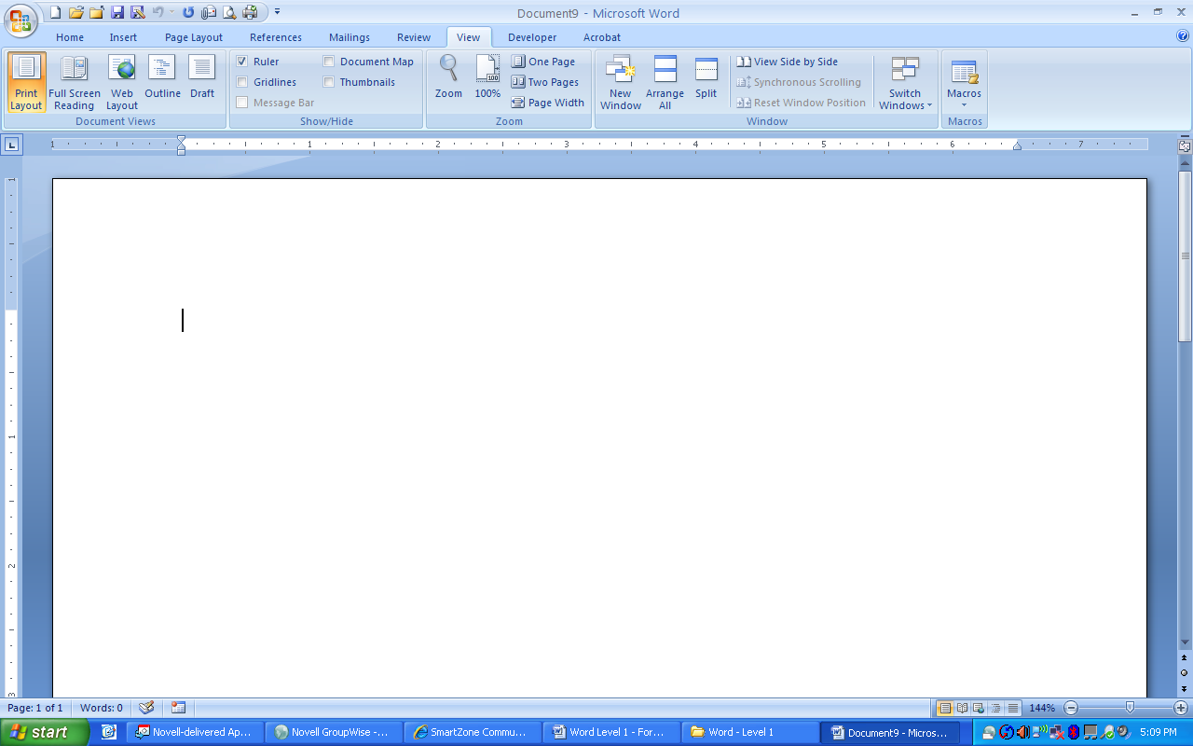

Left Line Indent Marker

Hanging Indent Marker

|  |  |
| --- | --- |
| ***Indent*** | ***Methods for Indenting*** |
| **First Line Indent**  (First line of paragraph) | * Press the *Tab* key * Display *Paragraph* dialog box, click the down-pointing arrow to the right of the *Special* list box, click First line, and then click *OK*. * Drag the *First Line Indent* marker on the Ruler. * Click the *Alignment* button located at the left side of the Ruler until the *First Line Indent* button displays and then click on the Ruler at the desired location. |
| **Left Indent**  (Text from left margin) | * Click the *Increase Indent* button in the *Paragraph* group in the *Home* tab to increase the indent or click the *Decrease Indent* button to decrease the indent. * Insert a measurement in the *Indent Left* measurement button in the *Paragraph* group in the *Page Layout* tab. * Press Ctrl + M to increase the indent or press Ctrl + Shift + M to decrease the indent. * Display the *Paragraph* dialog box, type the desired indent measurement in the *Left* measurement box, and then click *OK*. * Drag the *left* indent marker on the Ruler. |
| **Right Indent**  (Text from right margin) | * Insert a measurement in the *Indent Right* measurement button in the *Paragraph* group in the Page Layout tab. * Display the *Paragraph* dialog box, type the desired indent measurement in the *Right* measurement box, and then click *OK*. * Drag the *right* indent marker on the Ruler. |
| **HHanging Indent**  (all lines of text except the first line are indented) | * Press Ctrl + T * Display the *Paragraph* dialog box, click the down-pointing arrow to the right of the *Special:* list box, click *Hanging*, and then click *OK*. * Click the *Alignment* button located at the left side of the Ruler until the *Hanging Indent* button displays and then click on the Ruler at the desired location. |

|  |  |
| --- | --- |
| (Text from both left and right margins) | * Display the *Paragraph* dialog box, type the desired indent measurement in the *Left* measurement box, type the desired indent measurement in the *Right* measurement box and then click *OK*. * Click the *Decrease Indent* button and the *Increase Indent* button in the *Paragraph* group in the *Home* tab. * Insert a measurement in the *Indent Right* and *Indent Left* measurement buttons in the *Paragraph* group in the *Page Layout* tab. * Drag the left indent marker on the Ruler; then drag the right indent marker on the Ruler. |

## Spacing Before and After Paragraphs

Line spacing determines the amount of vertical space between lines while paragraph spacing determines the amount of space above or below paragraphs of text.

By default, Word applies 10 points of spacing after a paragraph. You can remove this spacing, increase or decrease the spacing, and insert spacing above the paragraph. To change spacing before or after a paragraph, use the *Spacing Before* and *Spacing After* measurement boxes located in the *Paragraph* group in the *Page Layout* tab, or the *Before and/or After* options at the *Paragraph* dialog box with the *Indents and Spacing* tab selected.

Spacing before or after a paragraph is part of the paragraph and will be moved, copied, deleted with the paragraph. If paragraph, such as a heading, contains spacing before it, and the paragraph falls at the top of a page, Word ignores the spacing.

Spacing before or after paragraphs is added in points and a vertical inch contains approximately **72** points. To add spacing before or after a paragraph, you would click the *Page Layout* tab, select the current measurement in the *Spacing Before* or the *Spacing After* measurement box, and then type the desired number of points. You can also click the up- or down-pointing arrows at the right side of the *Spacing Before* and *Spacing After* measurement boxes to increase or decrease the amount of spacing.

## Repeating the Last Action

If you apply formatting to text and then want to apply the same formatting to other text in the document, consider using the *Repeat* command. To use this command, apply the desired formatting, move the insertion point to the next location where you want the formatting applied, and press the **F4** function key or press **Ctrl + Y**.

## Formatting with Format Painter

The *Clipboard* group in the *Home* tab contains a button for copying formatting and displays in the *Clipboard* group as a paintbrush. To use the *Format Painter* button, position the insertion point on a character containing the desired formatting, click the *Format Painter* button, and then select text to which you want the formatting applied. When you click the *Format Painter* button, the mouse I-beam pointer displays with a paintbrush attached. If you want to apply the formatting in more than one location, double-click the *Format Painter* button and then select text to which you want formatting applied. When you are finished, click the *Format Painter* button to turn it off. You can also turn off *Format Painter* by pressing the *Esc* key.

## Changing Line Spacing

The default line spacing for a document is **1.15**. In certain situations, Word automatically adjusts the line spacing. For example, if you insert a large character or object such as a graphic, Word increases the line spacing of that specific line. But you also may sometimes encounter a writing situation in which you decide to change the line spacing for a section or the entire document.

Change line spacing using the *Line Spacing* button in the *Paragraph* group in the *Home* tab, with keyboard shortcuts, or with options from the Paragraph dialog box.

***Press To change line spacing:***

Ctrl + 1 Single spacing  
Ctrl + 2 Double spacing   
Ctrl + 5 1.5 line spacing

You can also change line spacing at the *Paragraph* dialog box with the *Line spacing* option or the *At* option. If you click the down-pointing arrow at the right side of the *Line spacing* option, a drop down list displays with a variety of spacing options. For example, to change the line spacing to double you would click *Double* at the drop-down list. You can type a specific line spacing measurement in the *At* text box. For example, to change the line spacing to 1.75, type *1.75* in the *At* text box.

## Revealing Formatting

Display formatting applied to specific text in a document at the *Reveal Formatting* task pane. The *Reveal Formatting* task pane displays font, paragraph, and section formatting applied to text where the insertion point is positioned or to selected text. Display the *Reveal Formatting* task pane with the keyboard shortcut **Shift + F1**.

Generally, a minus symbol precedes *Font* and *Paragraph* and a plus symbol precedes *Section* in the *Formatting of selected text* section of the *Reveal Formatting* task pane. Click the minus symbol to hide any items below a heading and click the plus symbol to reveal items. Some of the items below headings in the *Formatting of selected text* section are hyperlinks. Click a hyperlink and a dialog box displays with the specific option.

## Comparing Formatting

Along with displaying formatting applied to text, you can use the *Reveal Formatting* task pane to compare formatting of two text selections to determine what formatting is different. To compare formatting, select the first instance of formatting to be compared, click the *Compare to another selection* check box, and then select the second instance of formatting to compare. Any differences between the two selections display in the *Formatting differences* list box.