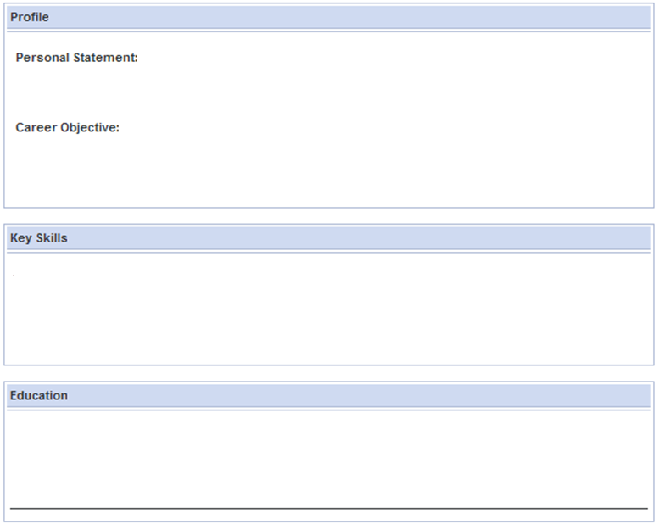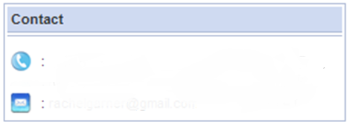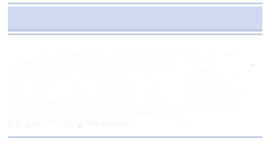

**MOB**

**TEL**

**07957 435234**

**07493516613**

I have experience in working in a retail type of clothing charity store as well as being a self employed makeup artist, where I gained costumer service skills, communication skills and I also developed skills which work with beauty clients such as advising what's suitable for them and how to apply products on themselves.

I am a dedicated and good team worker, with a great attitude to work and an highly successful background in the achievement. I have excellent interpersonal, communication and negotiation skills, I thrive to work in highly pressurized and challenging working environments. I have a passion for fashion and have a good stylish and dress sense.  In the future I am aiming to establish a career in Architecture/Fashion, I believe myself to be hard working, intuitive and friendly however most importantly passionate about Fashion and art.

I am always willing to experiment with new ideas and ways of working. I am also naturally creative which is reflected in my approach to work, I am a very organized person, enough to have a plan and therefore a goal in place and will employ past experience and learning when grappling with new ideas and challenges. Most importantly I remain flexible and adaptive when experimenting and combining skills and concepts until I can find an approach that works.

**Pringle Brandon -** 15-07-2013 to - 26-07-2013 **La Senza Retail**

*10 Bonhill St,   
London*

*EC2A 4QJ  
020 7466 1000*

**Chadwell Dental Care -** 28-07-2013 to 08-08-2013

*Chadwell Heath,*

*RM6 4AL*

*Call : 020 8590 3284*

*info@chadwelldentalcare.co.uk*

**Work / Work Experience**

**Grades are as follows ;GCSEs A levels**

* **Additional Science (Double)(B) Maths(C) Art As (B)**
* **Media (B) English (C) AS Design and technology (D)**
* **Art (B) Core Science (C) AS Photography (C)**
* **Business (B) ICT (C)**

* Art
* Textiles/fashion/makeup
* Fashion photography/photography
* Business
* Information, communication and technology

**SAMIRAH AHMED**

**0208 257 2128**

**0**

**samirah_15@hotmail.com**

**Address:**

**101 Belgrave Road Wanstead London E113QR**

*Westfeild Stratford -*

04-2014-22-07-2014

**Self Employed makeup artist -** 10/2014- 09/2015

*I work with a variety of costumers providing makeup for occasions 07957 435 294*

**AAB Legal National Accident Advice Bureau**

*Telecom sales*

*0ct 2015 - Jan 2016*

**Domino's Pizza**

*Woodford*

*Feb 2016-April 2016*