Press Information

September 1, 2016

**Switching from a jug to share, to a cup just for you. It’s so easy with the new SENSEO® Switch!**

***The first SENSEO® 2-in-1 coffee maker with filter and pads***

**Berlin, Germany** – At this year’s Internationale Funkausstellung ([IFA](http://www.ifa.philips.com)) in Berlin, Germany, [Royal Philips](http://www.philips.com/) (NYSE: PHG, AEX: PHIA) today announced a range of new products that empower consumers to stay healthy, live well and enjoy life.

Every moment in your day deserves a special coffee, prepared the way you like it. Well now that’s possible thanks to our SENSEO® Switch! The first SENSEO® 2-in1 coffee maker that, at the touch of a button, allows you to brew a big pot of filter coffee to share or one cup of pad coffee just for you to enjoy. Chosen from the wide variety of quality blends offered by SENSEO®, Europe’s no.1 coffee machine brand[1].

Enjoying a long breakfast with your family on a Sunday? Have friends visiting that are desperate for a cup of coffee? You’ve just come back from work and want to unwind? Simply deserve a pleasureable treat for yourself? This new coffee maker gives you the freedom to choose your coffee, your way, by easily switching between making a pot for everyone to a cup of SENSEO® just for you – selected from the range of over 13 unique SENSEO® blends available. No matter what you prefer, its innovative DualBrew technology ensures that your coffee is prepared to perfection, with the right pressure and amount of water.

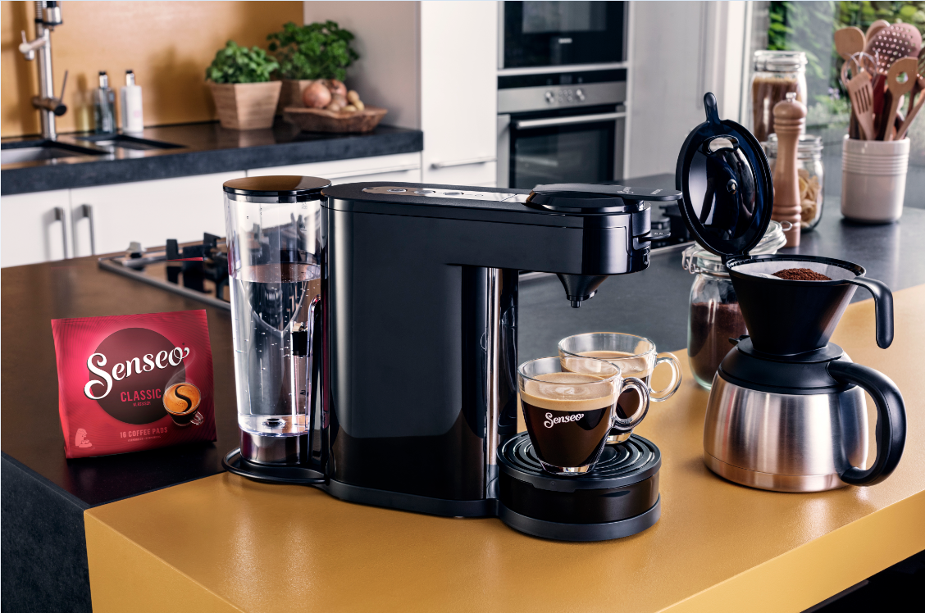

**SENSEO® Switch lets you easily switch coffee moments, from a jug to share to a cup just for you**

For when you want to fill your home with the delicious smells and sounds of filter coffee being prepared, the SENSEO® Switch pulses water through your filter paper to extract the best aromas into your drink – providing that wonderful, authentic filter taste. The one liter water tank means you can brew up to seven cups of coffee at a time without refilling, and the stainless steel thermal jug keeps your coffee hot for longer once it has been brewed.

There’s always something amazing to discover, so when you want to explore a world of different coffee flavors, you will be surprised to see how simple it is to brew your SENSEO® pad coffee. At the touch of a button, you can choose between one or two cups of coffee at a time, all brewed in less than a minute and topped with the delicious crema layer that is a proof of SENSEO® quality. Whether you’re looking for a classic coffee, something with milk or want to be surprised by a new taste, get set for a little adventure inspired by the aromatic richness of 50 roasted and finely ground beans in every SENSEO® pad.

Super convenient to operate, the SENSEO® Switch makes it easy to cater for every moment – whether you’re socializing with family and friends, or want to take time out for an individual treat. Light indicators will remind you when it’s time to descale the coffee maker, and its removable drip tray means you can use your favorite cups. For added comfort, the drip tray is also dishwasher safe. No less important, the auto shut-off function turns the appliance off after brewing to save you energy.

Leopold Stratenus, Business Leader Roast & Ground Coffee said, “Since its launch in 2001, our SENSEO® system has been a game changer in coffee making at home, with over 28,000,000 SENSEO® coffee machines sold globally to-date[2]. Building on this, and our long heritage in filter coffee, we wanted to give coffee lovers the ultimate flexibility. By combining two ways to enjoy your coffee in just one machine, the new SENSEO® Switch really does let you easily choose between a jug to share and a cup of coffee just for you.”

**Philips at IFA**

The Philips Press Conference takes place on September 1 at 12.15pm in Hall 22, Messe Berlin. The live stream of the event can be seen at [www.ifa.philips.com](http://www.ifa.philips.com). Pieter Nota, CEO Personal Health Businesses and Chief Marketing Officer at Philips, will be joined on stage by Chris Worp, Head of Business Group Home from Philips Lighting and Kostas Vouzas, Senior Director Business EMEA at TP Vision.

For further information on the latest Philips innovations at IFA 2016 please visit [www.ifa.philips.com](http://www.ifa.philips.com), follow Philips at IFA on twitter @PhilipsLiveFrom, or visit our additional social media channels on YouTube and LinkedIn.

**For further information, please contact:**

**Lian Verhoeven**

Communications Business Partner Philips Coffee

[Lian.verhoeven@philips.com](mailto:Lian.verhoeven@philips.com)

Tel: +31 (0)6 10 56 45 13

**About Royal Philips**

Royal Philips (NYSE: PHG, AEX: PHIA) is a leading health technology company focused on improving people’s health and enabling better outcomes across the health continuum from healthy living and prevention, to diagnosis, treatment and home care. Philips leverages advanced technology and deep clinical and consumer insights to deliver integrated solutions. The company, headquartered in the Netherlands, is a leader in diagnostic imaging, image-guided therapy, patient monitoring and health informatics, as well as in consumer health and home care. Philips’ health technology portfolio generated 2015 sales of EUR 16.8 billion and employs approximately 69,000 employees with sales and services in more than 100 countries. News about Philips can be found at [www.philips.com/newscenter](http://www.philips.com/newscenter).

**About JACOBS DOUWE EGBERTS (JDE)**

A global coffee & tea company, serving consumers in more than 100 countries through iconic brands including: Jacobs, Tassimo, Moccona, Senseo, L’OR, Douwe Egberts, Kenco, Pilao & Gevalia. For more information visit: [www.jacobsdouweegberts.com](http://www.jacobsdouweegberts.com)

Product Specifications

SENSEO® Switch in Black

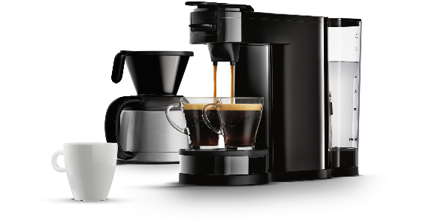

SENSEO® Switch Pod and filter coffee machine

**HD7892/60, HD7892/80, HD7892/00**

**Accessories**

* Included: Pod holder, Jug

**Design**

* Color: Deep Black

**Country of origin**

* Made in: Romania

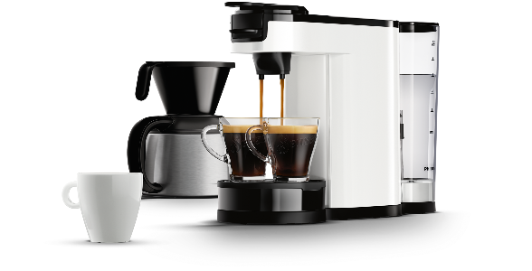

SENSEO® Switch in White

**General specifications**

* Cups at the same time: 2 to 7
* Ease of cleaning & maintenance: Calc indicator, Removable filter holder
* Ease of use and comfort: Removable drip-tray, Removable water tank, Water level indication

**Sustainability**

* Packaging: > 90% recycled materials
* Power consumption brewing: 1450 W
* User manual: 100% recycled paper

**Service**

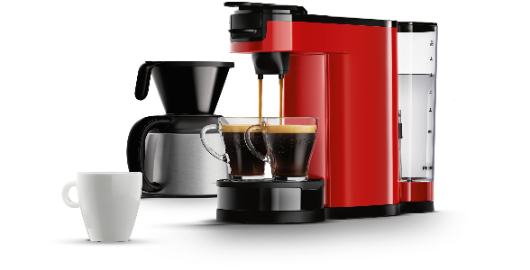

SENSEO® Switch in Red

* 2-year guarantee

**Technical specifications**

* Brewing time one cup: 30 sec
* Capacity water tank: 1 l
* Capacity water tank: 7 cups
* Cord length: 0.8 m
* Frequency: 50 Hz
* Max. cup height: 130 mm
* Pump pressure: 1 bar
* Brewing time for a jug: 8.5 min

**Weight and dimensions**

* Dimensions of packaging (WxDxH: 466 x 242 x 322 mm
* Dimensions of product (WxDxH): 150 x 400 x 270 mm
* Weight incl. packaging: 2.4 kg
* Weight of product: 1.75 kg

1. Based on retail sales volumes
2. According to Philips internal sales and market intelligence sales data