# 

**The Higher Education Academy (HEA)/JISC Final Report**

|  |  |  |  |
| --- | --- | --- | --- |
| **Project Information** | | | |
| **Project Identifier** | *To be completed by HEA/JISC* | | |
| **Project Title** | Digital Futures in Teacher Education | | |
| **Project Hashtag** | #deftoer3 | | |
| **Start Date** | 17 October 2011 | **End Date** | 19 October 2012 |
| **Lead Institution** | Sheffield Hallam University | | |
| **Project Director** | Richard Pountney | | |
| **Project Manager** | Anna Gruszczynska | | |
| **Contact email** | [a.gruszczynska@shu.ac.uk](mailto:a.gruszczynska@shu.ac.uk) | | |
| **Partner Institutions** | University of Sheffield; Sheffield Children's Festival, realsmart, Yorkshire and Humber Grid for Learning, Learning Connections; 5 primary and 5 secondary schools in South Yorkshire (see body of text) | | |
| **Project Web URL** | [www.digitalfutures.org](http://www.digitalfutures.org) | | |
| **Programme Name** | UKOER | | |
| **Programme Manager** | David Kernohan | | |

|  |  |  |  |
| --- | --- | --- | --- |
| **Document Information** | | | |
| **Author(s)** | Anna Gruszczynska | | |
| **Project Role(s)** | Project manager | | |
| **Date** | 19 October 2012 | **Filename** |  |
| **URL** |  | | |
| **Access** | This report is for general dissemination | | |

|  |  |  |
| --- | --- | --- |
| **Document History** | | |
| **Version** | **Date** | **Comments** |
| 1.0 | 15 October 2012 | First draft created by Anna Gruszczynska |
| 1.1 | 18 October 2012 | Second draft with comments from Richard Pountney |
| 1.2 | 19 October 2012 | Final version of report |

**Table of Contents**

 1

Acknowledgements 6

Project Summary 6

Main Body of Report 7

Project Outputs and Outcomes 7

How did you go about achieving your outputs / outcomes? 12

Aims and objectives 12

Project methodology 12

Reflexive aspects of project methodology 13

Communication strategy 13

**Table 1. DeFT project blog: Number of views** 14

Key project outputs 14

Open textbook 14

Open textbook: Development 14

Open textbook: principles and content 15

Case studies of digital practice: School-based 16

Case studies of digital practice: PGCE-based 18

Digital Bloom 19

Digital Bloom installation 19

Digital Bloom online 22

Evaluation activities 23

Formative and summative evaluation 23

Peer evaluation 24

Stakeholder engagement 24

Dissemination: Regional conference, 2nd October 2012 25

Project findings and lessons learnt 26

Issues related to digital literacy 26

Issues related to Open Educational Resources 28

Issues related to re-use of OERs 28

Issues related to sharing of resources 28

Copyright concerns 29

OERs and professional practice 29

Exploring the use of open source tools 31

Learner-produced OERs 33

Immediate Impact 33

Future Impact 35

Future impact within the institutions 36

Conclusions 37

General conclusions 37

Conclusions relevant to the wider community 37

Conclusions relevant to the HEA/JISC 37

Recommendations 38

General recommendations 38

Recommendations for the wider community 38

Recommendations for the HEA/JISC 38

Implications for the future 39

Appendices 40

# Acknowledgements

The Digital Futures in Teacher Education (DeFT) project was undertaken as part of the third phase of the HEA/JISC-funded UK OER programme. The DeFT project team would like to thank a number of individuals and groups who have contributed to the project, including:

* All project partners
* Julia Gillen (project evaluator)
* Julia Bishop at University of Sheffield
* The e-learning team at the Faculty of Development and Society – Sue Bamford, Clare Young and Richard McCarter
* PGCE students at Sheffield Hallam University and University of Sheffield
* Technical developers at realsmart
* Our "evaluation buddy" - the ORBIT project at Cambridge University
* Other projects participating in the third phase of the UKOER programme, who contributed their insights and kindly offered feedback at various programme meetings

# Project Summary

The aim of the project was to release OERs which address the opportunities and challenges of creative and innovative uses of digital literacy in the context of the school and teacher education sectors as well as explore cross-sector partnerships in the context of OER (re)use. The key output of the project consists of the Open Textbook (available from www.digitalfutures.org) in the form of an interactive website where users are able to engage with OERs released in the context of the project through a customisable "thinking space". This way, they will be able to create their own personalised version of the open textbook which is relevant to their context and level of engagement with digital literacy and openness. One of the key elements of the open textbooks are the case studies of practice with digital literacies and open educational resources produced by participating school teachers and PGCE tutors. These are intended to provide examples of practice grounded in teachers’ practice and to stimulate critical debate around the nature of digital literacy and possibilities for increased use of digital media within educational contexts. The case studies cover a variety of themes including an exploration of open tools and approaches for the purposes of professional development and building communities of practice; embedding of OERs within teacher training and the use of Web2.0 applications to support student-produced OERs. The case studies and any supporting materials have been released as part of open textbook, an interactive website which is being developed in close collaboration with project technical partners. The project also explored the intersections of digital literacy and creativity and in collaboration with project partner, Sheffield Children's Festival the team have developed a the Digital Bloom installation which offered a space for pupils from participating schools to reflect on the process of digital production through creative activities. An online version of the Digital Bloom was also made available for schools and youth groups to share their understandings of digital literacy. Our work was underpinned by a reflexive project methodology, where the team strive to create opportunities for project participants to explore their understandings of digital literacies and attitudes towards sharing and releasing teaching resources openly.

# Main Body of Report

## Project Outputs and Outcomes

|  |  |  |
| --- | --- | --- |
| **Output / Outcome Type** | **Brief Description and URLs (where applicable)** | |
| **Key project outputs** | | |
| Open textbook | | **Open textbook**  [www.digitalfutures.org](http://www.digitalfutures.org)  The open textbook pulls together resources produced in the context of the project in the form of an interactive website where users will be able to engage with OERs released in the context of the project. The final version of the open textbook will be available on 1 November. |
| Case studies of digital practice | | **Case studies**  www.deft-project.org  The team worked collaboratively with teachers and PGCE tutors to produce 13 case studies (10 school-based and 3 PGCE-based) focusing on challenges of practice with digital literacies and issues related to OERs and open practices within the school sector. The case studies are available from the open textbook and have also been deposited into JorumOpen (tagged with "deftoer3"). |
| Digital Bloom installation | | **Digital Bloom installation**  <http://deftoer3.wordpress.com/category/digital-bloom-2/>  The "Digital Bloom" installation celebrating the work of the pupils from schools participating in the DeFT project took place in Sheffield Winter Gardens between 9-13 July as part of Sheffield Children's Festival and attracted over 400 visitors. The mini report on Digital Bloom strand of the project is available from the case studies website www.deft-project.org |
| Digital Bloom online | | **Digital Bloom online**  [www.digitalbloom.org](http://www.digitalbloom.org)  Digital Bloom online is an interactive website where school teachers, youth groups and members of general public can submit their stories which explore understandings of digital literacy. Users can also explore stories submitted by others and create their own collections. Please note that at the moment the online space has been designed with Google Chrome in mind.  **Digital Bloom It's the Learning Futures project "meadow"**  <http://www.digitalbloom.org/index.html?meadow=ilfdays>  This meadow contains stories developed in the context of "It's the Learning Future Project" which arose from collaboration between Sheffield Hallam and The University of Sheffield in 2010 It involved the children from Campsmount High School Doncaster, Winterhill School Rotherham and Beck Primary and Callow Primary schools Sheffield Children were set a number of digital challenges and explored the notion of being a digital leader. |
| Project wiki | | **DeFT project wiki**  <http://bit.ly/DeFT-wiki>  During the lifetime of the project, the wiki was a closed, password protected working space for the project team to share ideas, offer their responses to the reflexive tasks and share early versions of the resources being developed. The wiki was opened up at the end of October and now functions as a resource reflecting the process of developing the DeFT open textbook and accompanying resources. |
| Project blog | | **DeFT project blog**  <http://deftoer3.wordpress.com/>  The project team used the blog as a space to inform the wider OER community of work-in-progress and to aid dissemination. |
| Twitter account | | **Project Twitter account (@deftoer3)**  <https://twitter.com/#!DeFTOER3project>  The project team has used the Twitter account to interact with the wider OER community and to publicise information about resources produced in the context of the project. Altogether, the project shared 169 Tweets and had 94 followers. |
| Slideshare account | | **Project Slideshare account**  [www.slideshare.net/deftoer3](http://www.slideshare.net/deftoer3)  Project team used the Slideshare account to upload all project-related documents, including promotional leaflets, materials produced in the context of case studies as well as conference presentations. |
| Second Life | | Second Life  http//bit.ly/DeFT-SL  The project has a presence on Second Life, maintained by the University of Sheffield project members. |
| Regional conference | | **Project dissemination event**  <http://deftoer3.wordpress.com/2012/10/04/deft-regional-conference/>  The key project dissemination event took place on 2 October 2012, Sheffield United Football Ground Stadium and attracted over 80 participants from the Yorkshire and Humber education sector. The conference was a chance for the teachers and tutors to showcase their involvement with the project. |
| Film | | **The DeFT project movie**  <https://vimeo.com/43191700>  Animated film about the project produced in collaboration with children from Mundella Primary School. |
| **Conference presentations and workshops delivered by team members** | | |
| Presentation | | **Digital Futures in Teacher Education: Open Educational Resources**  <http://www.slideshare.net/DEFToer3/digital-futures-in-teacher-education-open-educational-resources-10964571>  Presentation delivered at the faculty Forum event at Sheffield Hallam University, 11 January 2012 |
| Presentation | | **Presentation at Regional Education Expertise Forum**  <http://www.slideshare.net/DEFToer3/presentation-at-regional-education-expertise-forum>  Presentation delivered at the Regional Education Expertise Forum, 29 February 2012, Sheffield |
| Presentation | | **DeFT workshop**  <http://www.slideshare.net/DEFToer3/khlim-workshop>  Workshop delivered during Erasmus visit to Limburg Catholic University College in Hasselt, Belgium; 21 March 2012 |
| Presentation | | **Exploring the opportunities and challenges of creative uses of digital literacy in schools**  <http://www.slideshare.net/DEFToer3/oer2012-conference-presentation>  Presentation delivered at the OER 2012 conference, 17 April 2012, Cambridge University |
| Presentation | | **Exploring Open Educational Resources and digital literacy in the context of professional education**  <http://www.slideshare.net/DEFToer3/telic-conference-digital-futures-in-teacher-education>  Presentation delivered at the annual MSc TELIC conference, 8 June 2012, Rotterdam University |
| Presentation | | **Digital literacy frameworks in the context of embedding Open Educational Resources within teacher education**  <http://www.slideshare.net/DEFToer3/dl-frameworks-hergs-presentation>  Presentation delivered at the Higher Education Research Group Conference, 22 June 2012 at Sheffield Hallam University |
| Workshop | | **Digital Futures in Teacher Education workshop**  <http://www.slideshare.net/DEFToer3/digital-futures-in-teacher-education-workshop>  Delivered as part of the HEA-funded workshop "Promoting Digital Literacy through OER: the release, use and reuse of open educational resources", 5 July 2012, Oxford University |
| Presentation | | **Digital Futures in Teacher Education- the DeFT Project** <http://www.slideshare.net/DEFToer3/def-tukla>  Presentation delivered at United Kingdom Literacy Association Conference, 6-8 July 2012, University of Leicester. |
| Presentation | | **Filling in the Blanks: signature pedagogies and their impact on understanding and sharing practice in the form of OERs in the Social Science Curriculum**  <http://www.slideshare.net/DEFToer3/seda-presentation-pountney-gruszczynska-1>  Presentation delivered at HEA/SEDA conference on 20 July 2012, Aston University, Birmingham |
| Conference paper | | **"Digital Futures in Teacher Education" Project: Exploring Open Approaches towards Digital Literacy**  <http://www.slideshare.net/DEFToer3/gruszczynskapountneyexploring-open-approaches-towards-digital-literacyecel-paper>  Paper delivered at the 11th European Conference on E-learning (ECEL), 26-27 October, Groningen, The Netherlands |
| **Materials from the 2nd October dissemination event** | | |
| Conference booklet | | <http://www.slideshare.net/DEFToer3/conference-booklet27-sep2012> – outline of conference programme, information about the case studies etc. |
| Presentation | | **OERs to promote good practice in school**  Michael Payton-Greene  <http://www.slideshare.net/DEFToer3/michael-payton-greene-deftconference2oct2012> |
| Presentation | | **Using handheld devices to develop literacy skills**  Rob Hobson  <http://www.slideshare.net/DEFToer3/using-handheld-devices-to-develop-literacy-skills2> |
| Presentation | | **Digital Participation, apprenticeship and learning – overview of project themes**  Cathy Burnett, Julia Davies  [http://www.slideshare.net/DEFToer3/themes-of-digital-literacies-arising-from-d](http://www.slideshare.net/DEFToer3/themes-of-digital-literacies-arising-from-deft-case-studies)  [eft-case-studies](http://www.slideshare.net/DEFToer3/themes-of-digital-literacies-arising-from-deft-case-studies) |
| Presentation | | **Reflections on digital literacies and openness in professional practice**  Sarah Butler  <http://www.slideshare.net/DEFToer3/pgce-students-engaging-with-digital-technologies> |
| Presentation | | **Magna QR project**  Jim Hildyard  <http://www.slideshare.net/DEFToer3/conference-presentation-about-mobile-technologies-taking-the-class-outside> |
| Presentation | | **Teaching Sheffield – dissemination**  Mick Connell  <http://www.slideshare.net/DEFToer3/teaching-sheffield-dissemination-event-october-2012-pptx> |
| Presentation | | **Digital reporters at Camp Cardboard**  Chris Bailey  <http://www.slideshare.net/DEFToer3/camp-cardboard-deft> |
| Presentation | | **Developing digital literacies in Early Years**  Zubida Khatoon  <http://www.slideshare.net/DEFToer3/developing-digital-literacies-in-early-years-presentation-final> |
| Presentation | | **Bigger Bloom**  Kate Cosgrove  <http://www.slideshare.net/DEFToer3/bigger-bloom-ppt> |
| Presentation | | **21st Century Show and tell: Making instructional videos**  Chris Welch  <http://www.slideshare.net/DEFToer3/chris-welchs-presentation-on-making-instructional-videos-for-deft-conference> |
| **Conference video** | | **Conference video**  <http://www.youtube.com/watch?v=JlbHFbgCvOk&feature=player_embedded>  Short recording of the event produced by Jack Todhunter, focusing on interactions between conference participants and technologies used on the day. |
| **Other** | | |
| Summary of focus group findings | | **Findings of PGCE student focus group**  <http://www.slideshare.net/DEFToer3/findings-of-pgce-student-focus-groups-12173561>  Summary of findings from PGCE student focus group undertaken at Sheffield Hallam University and University of Sheffield in January 2012 |
| Presentation | | **Involvement of DeFT project team with the UK Open Educational Resources JISC/HEA -funded programme**  <http://www.slideshare.net/DEFToer3/involvement-of-de-ft-with-ukoer>  Overview of background to the DeFT project and previous involvement of the DeFT team with the UKOER programme |
| Leaflet | | **Project leaflet**  <http://www.slideshare.net/DEFToer3/digital-futures-in-teacher-education-second-leaflet>  Information about the project and contact details. |
| **Contribution to other JISC UKOER3 projects** | | |
| Resources | | **Contribution to "Digital Literacy and Creativity" project (University of Bedfordshire)**  [**http://digitalfuturesoer3.pbworks.com/w/file/53710521/PG%20Cert%20DL%20Collection.docx**](http://digitalfuturesoer3.pbworks.com/w/file/53710521/PG%20Cert%20DL%20Collection.docx)  Development of a set of resources for the project; consultation on the design of the module. |
| Peer evaluation | | **Peer evaluation undertaken with the ORBIT project**  <http://deftoer3.wordpress.com/2012/05/18/buddying-up-with-orbit/>  Active involvement with "evaluation buddy" (for more information, see evaluation section in the main body of the report). |

## How did you go about achieving your outputs / outcomes?

## Aims and objectives

The aim of the project is to develop guidance on digital literacy practice and involvement with Open Educational Resources in teaching and learning in the school sector, with an emphasis on raising the status and quality of teaching and the level of digital literacies and the (re)use of OERs in the teaching workforce and within educational provision. In order to achieve the key aims and objectives, the project team worked collaboratively with participating schools, trainee teachers and tutors to develop an online-based open textbook, which incorporates resources addressing the opportunities and challenges of embedding digital literacies within teacher education at all levels. Throughout that process, we also relied on a network of partners connected to the education sector, i.e. regional support networks, technical/creative partners and local non-profit organisations.

## Project methodology

In terms of methodology, the project worked with a team which included teachers from 10 primary (including early years) and secondary schools in South Yorkshire (see appendix A for list of schools and teachers); PGCE tutors and students at two universities in Sheffield (Sheffield Hallam University and University of Sheffield); supported by partners from public and commercial sector - Yorkshire and Humber Grid for Learning (YHGfL www.yhgfl.net); Sheffield Children's Festival (www.sheffieldchildrensfestival.org), and creative industry SMEs (small-medium enterprises) Learning Connections (www.learning-connections.co.uk/) and realsmart (www.realsmart.co.uk).

Overall, project activities, which will be described in more detail in the following sections, were centred on producing the key output of the project, i.e. the open textbook and its central elements - the case studies of digital practices and resources to support effective practice with digital literacy for teachers at all stages of their careers. The case studies served as a mechanism for project partners through which they had a chance to explore new methods of engagement with digital literacy, as well as focus on barriers and enablers in the uptake of digital tools for teaching and learning, with an emphasis on issues involved in sharing resources and good practice between peers. Importantly, the case studies were UK-focussed and culturally bound as indicative of the reality of actual practice rather than examples of best practice. The project also explored the intersections of digital literacy and creativity, and as a result of our collaboration with Sheffield Children's Festival and realsmart the team developed the Digital Bloom strand of the project - the Digital Bloom installation and Digital Bloom online (www.digitalbloom.org), both of which offer a space to showcase the individual understandings of digital literacy made by learners in participating schools involved with the project.

### Reflexive aspects of project methodology

Building on previous involvement of the core team members with the UKOER programme, we have developed a collaborative method of working with our partners, with an emphasis on reflection in the process of exploring digital literacy practice and open practices within teacher education contexts. A guiding principle was that through structured reflection, teaching practices can be critically reviewed and hence better understood. This helped in articulating approaches to digital literacies which mapped onto the experiences of project participants. In terms of practical realisation of that approach, all project participants (core team, teachers, course tutors and students) contributed to a series of reflexive tasks in which they responded to prompts provided by the project team at five points in the project lifecycle. These prompts[1] varied slightly for each of the groups in acknowledgement of their particular working context. Participants were encouraged to offer their responses in a variety of formats such as text, audio or video, depending on personal preferences. The responses were then collated to identify emerging themes and to gain a sense of developing understandings of DL. A digest of these reflections was shared amongst participants shortly after each stage, thus contributing to a cumulative sense of meanings generated by the group. These outputs were also incorporated into project case studies and informed the development of the open textbook. The reflexive approach was also extended to the evaluation strand of the project - as will be discussed later in the report, the contribution of the evaluator was both formative and summative and the involvement of the project team with our "evaluation buddy" (a sister OER project) offered a chance for reflection at macro level.

## Communication strategy

The project communication strategy was based on a combination of face-to-face meetings and email/phone support. Communication within the core team was facilitated by engagement with password protected wiki, where all relevant project documents were stored. A revised version of the wiki, available from [www.bit.ly/DeFT-wiki](http://www.bit.ly/DeFT-wiki), was released at the end of the project to showcase the process of developing project key outputs, including the open textbook.

External communication was built on the principle of open sharing and was based around purposeful engagement with Web2.0 tools, where the team used project blog (<http://deftoer3.wordpress.com/>) to communicate project progress and raise issues of concern or interest to the OER community. See table 1 below for an information about blog site stats.

**Table 1. DeFT project blog: Number of views**

|  |  |  |  |  |  |  |  |  |  |  |  |  |  |
| --- | --- | --- | --- | --- | --- | --- | --- | --- | --- | --- | --- | --- | --- |
|  | **Jan** | **Feb** | **Mar** | **Apr** | **May** | **Jun** | **Jul** | **Aug** | **Sep** | **Oct** | **Nov** | **Dec** | **Total** |
| **2011** |  |  |  |  |  |  |  |  |  |  | 68 | 188 | 256 |
| **2012** | 227 | 266 | 322 | 365 | 438 | 481 | 782 | 268 | 705 | 1,414 |  |  | 5,268 |

The team also relied on Slideshare (<https://www.slideshare.net/DEFToer3/>) for uploading all project-related documents; flickr for sharing images and photographs of relevance to the project and Twitter (@deftoer3) for amplifying information about the project and also reaching out to a broader OER network.

The team also made an effort to communicate any research outputs emerging from the project by presenting at a number of local, national and international events; all presentations have been uploaded to slideshare and have been included in the project outputs section.

## Key project outputs

### Open textbook

The open textbook is the key output of the project in the form of an interactive website where users will be able to engage with OERs released in the context of the project through a customisable "thinking space". This way, they will be able to create their own personalised version of the open textbook which is relevant to their context and level of engagement with digital literacy and openness. This aspect of the textbook will add interactivity to the resource, allowing the user to add their tags, share and comment on the material. Our decision to engage with the format of the open textbook is informed by our attempt to make reading a collective experience by enabling rich interactions, and tools for personalisation, social, device independence. Through the Open Textbook, we want to offer users access to customised content, and also give them the opportunity to select, store and re-use content.

### Open textbook: Development

The development of the open textbook took place in two phases - phase 1 (April-August 2012) was undertaken in collaboration with the Learning Connections partner and led to the development of a flat website based on a concrete5[2] Content Management System which served as a repository for material emerging from the case studies – see screenshot of Phase 1 website below.

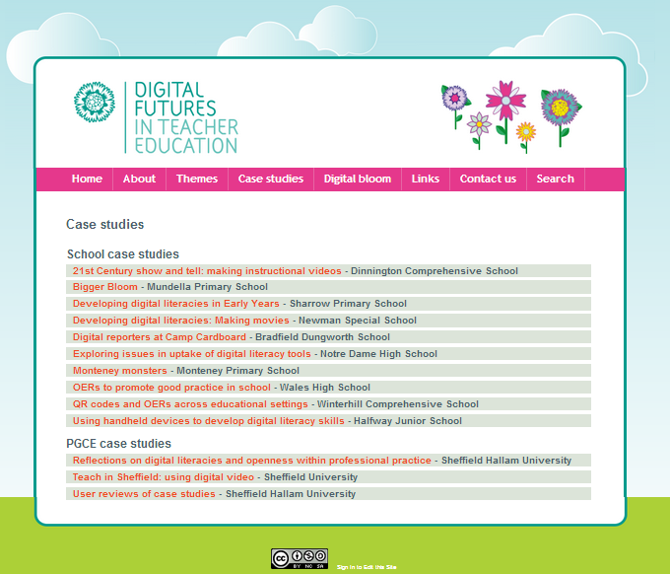

Figure 1: Phase 1 website - case studies page

After completion of phase 1 (now available from www.deft-project.org), the team developed a specification for the interactive, Wordpress-based phase 2 website in consultation with developer from realsmart who had relevant technical expertise in undertaking similar projects (see appendix C). Specifications for both phases were shared via project wiki and were available for feedback from the project team. The development of phase 2 website was finalised mid-October, with the Open Textbook available from [www.digitalfutures.org](http://www.digitalfutures.org).

### Open textbook: principles and content

The open textbook is hosted on a Wordpress platform and constructed in a way which allows for its parts to be disaggregated, reused and repurposed (subject to Creative Commons license conditions). The target audience, in order of priority is as follows:

1. School teachers and teacher educators (i.e. teacher trainers in HEIs)
2. Trainee teachers
3. Tutors in Higher Education (especially new lecturers)

The content of the open textbook is divided broadly into five “chapters”, these are further broken down into sections, then topics and finally individual paragraphs. Users are able to work at each of these four levels, and to annotate and comment on “chunks” of content which then can be added these to their own personal “thinking space”. Any content in thinking space can be exported and/or shared with others. The breakdown of the chapters is as follows (the full structure/table of contents can be accessed from the website:)

1. **Introduction** – information about the resource, scenarios for use, accessibility statement, acknowledgments and contacts
2. **Digital literacy** – a review of literature and current digital literacy frameworks; DL-related themes which emerged in the context of the project (cross-referenced to relevant links/research), including values and identities as well as an exploration of open Education practices in classroom/teacher education context.
3. **Practice with Digital Literacy (in schools)** – this is where DL issues specific to the school context are discussed (barriers and enablers, relationships, creativity) and where school-based case studies are introduced
4. **Teacher Education and Digital Literacy** – focusing on PGCE-based case studies and issues related to professional development of both trainee teachers and their tutors and the space for open education practices within teacher training.
5. **The Story of DeFT** – an overview of project methodology and its reflexive aspects; outline of project dissemination strategy and steps undertaken to ensure sustainability of the open textbook

## Case studies of digital practice: School-based

One of the key elements of the open textbook is a set of case studies of digital practice undertaken by project school teachers and tutors. In terms of participating schools, overall, twelve schools were approached in October-November, eight joined the project in December and further two were recruited in January 2012. In general, the teachers were known to the project team and part of existing networks, allowing the project to get up and running quickly. Most teachers did not identify themselves as possessing specific technical expertise or knowledge; however all had a strong interest and concern for digital practices around literacy.

Teachers and project partners attended a meeting on 8 December 2011 to discuss principles for collaboration and start planning out the case studies which would focus on digital literacy and openness in the context of their own teaching practice. The plans for case studies were then further developed and finalised through individual visits of team members to participating schools and subsequent teacher meetings during which participants had the opportunity to network and share ideas. Teacher meetings took place on 9 February, 29 June and 18 September with all teachers actively contributing to the dissemination event on 2 October at Sheffield United Football Ground Stadium. The aim of school visits was to provide support to the teachers, negotiate the scope of the case study and the extent of learner involvement to ensure that it meets the key aims and objectives of the project. The conversations with the teachers also focused on their resource needs, both in terms of specialist support from the project team as well as equipment as the team purchased a set of mobile devices which were offered to schools on a loan basis (see appendix D for an overview). Finally, the conversations allowed the team members to introduce the reflexive principles of project methodology and gather background information about the space of digital literacy/open practices within individual teachers' curriculum and their institutions.

The teachers began trialling their ideas for the case studies between February-April, with the bulk of the work taking place in May-July (see appendix B for an outline of case studies). Most case studies focused on providing meaningful contexts in which pupils were able to experiment with digital media and a number revolved around a classroom-based event whose aim was to enhance digital literacy skills of the pupils. All events, and any preparatory work, were documented by school key contacts with the support of the project assistant and project manager. The documentation included notes from school visits, audio and video recordings from the events where appropriate, interviews with members of staff and/or learners involved in the case study. These supporting materials informed the process of writing up the case studies, which took place in July and August. The drafts were then shared with the teachers and team members who provided feedback, with finalised versions of the case studies incorporated into the open textbook. Selected images and audio-visual material collected as part of the case studies will be released through the project website, subject to relevant permissions from teachers and learners. All case studies are now available from project website and users can choose to either download them as a single Word/pdf document or to interact with the case study online which allows for access to rich media produced in the process of developing the case studies. Each case study is accompanied by a gallery which collates key images and video/audio recordings from case study-related events; voices of learners and teachers involved with the project etc.; these can be accessed both from the case studies website ([www.deft-project.org](http://www.deft-project.org)) and the Open Textbook.

Overall, the pedagogical outcomes of the school-based case studies were as follows:

* Development of a pedagogical framework for using short video with pupils
* Offering the pupils a chance to improve their communication skills as well as support skills in writing/recording for a target audience
* Evaluation of the possibilities and limitations of using hand-held devices in out-of-school contexts
* Imaginative use of digital technologies to encourage children’s participation in reading and writing activities
* Enhancement of children's ability to use a range of digital tools for the purposes of creativity and self-expression in a range of subject areas e.g. literacy, music, art.
* Exploration of the use OERs to provide an enriched experience of literacy within the classroom

## Case studies of digital practice: PGCE-based

The project team adopted a similar case-study based approach to engagement with PGCE tutors from two participating universities. Overall, two tutors from each institution were involved - Julia Myers (PGCE Primary/Early Years) and Sarah Butler (PGCE English Secondary) from Sheffield Hallam University and Andrey Rosowsky and Mick Connell (both PGCE English Secondary) from University of Sheffield. The initial meetings with tutors to develop an outline of their case studies and discuss the extent of involvement of PGCE students took place in January, with regular follow-up email/phone conversations. The tutors were involved in the process of reflecting critically on their involvement in the project and responded at regular intervals to reflexive prompts. They also assisted the project team in organising focus groups with their student cohorts, aimed at eliciting student views on issues of relevance to digital literacy and OERs, with the focus groups taking place in January and June 2012.[3] The tutors also facilitated student-led presentation sessions in June during which PGCE students explored issues of digital literacy in the context of professional development.

The themes addressed by the PGCE-based case studies were as follows:

* Engaging with case studies focusing on digital literacy to support teaching practice
* Reflections on digital literacy in professional practice
* "Teaching Sheffield" project: Exploring professional development via the use of digital video

The project team created further opportunities for PGCE students to be actively involved with the project and so, students from both institutions participated in the regional dissemination event on 2nd October. Selected students also offered their critical readership of the case studies and commented on the presentation, value and accessibility of the case studies and ways in which these could be useful to support early career teachers in developing digital literacy skills.

### Digital Bloom

The term “Digital Bloom” refers to a combination of online and offline activities whose aim was to explore the intersections of digital literacy and creativity as well as reflect on the ways in which creativity informs learners’ digital literacy practice, both within and outside of formal education institutions. Importantly, the Digital Bloom strand was related to the efforts of the team to explore the concept of the Open Textbook and its aims. The concept of "Digital Bloom" functioned as a metaphor of meanings made with digital literacy by learners and teachers where a field of flowers was used to express individualised and diverse understandings of digital literacy (represented by individual flowers) all of which existed against a backdrop of socioeconomic context (meadow). "Digital Bloom" strand of the project was realised through a showcase of the creative art of children involved with the project (Digital Bloom installation) exhibited at Sheffield Children's Festival in July 2012 and through creation of an online space (Digital Bloom) where users can contribute by adding their own stories exploring meanings of digital literacy and each of the stories is represented by a flower.

### Digital Bloom installation

Within this strand of the project, the team collaborated with Richard Johnson from Sheffield Children's Festival to design a showcase of the work created by learners from participating schools. The working title of the showcase was "Project voices" and the following principles were adopted in its design:

* the showcase should be digital given the nature of the project
* the showcase should be interactive and allow for contributions from members of the public (online and/or offline)
* the showcase would incorporate rich media material (images, audio and video recordings) collected by the project team in the course of undertaking the case studies
* the showcase should celebrate the involvement of the learners from participating schools in the project
* the showcase should be a space for both contributors and participants to explore their understandings of digital literacy

The inspiration for the final shape and form of the installation came from the work undertaken by the pupils at Mundella Primary School who as part of their case study explored the use of Brushes app on iPads and the affordances of Web.2.0 tools such as blogs and Twitter to communicate about their experience of involvement with the DeFT project. 80 children took part in artist-led workshops where they had a chance to use iPads to create individual digital flowers which were then pulled into a digital mural by a graphic artist. The workshops were inspired by art of David Hockney, an artist well-known for his murals depicting the Yorkshire landscape as well as his iPad based digital paintings.

Thus the work of the children at Mundella inspired the team to conceive of an installation based around a central concept of a field of flowers where the artefacts produced by learners involved with the DeFT project would be displayed on a digital meadow and each individual piece of work would be represented by a flower; visitors could then access these stories (in the form of an image, video or audio recording) by clicking on a stylised flower – see below for image of visitors interacting with the installation:

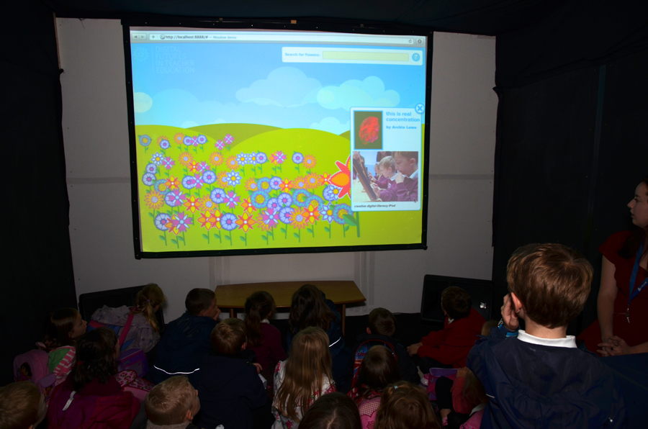

Figure 2: Visitors exploring the Digital Bloom installation

The installation was exhibited between 9 and 13 July 2012 in Winter Gardens which is a public space in central area in Sheffield. It was hosted within "The Cube" - a flatpack, portable installation space provided by Art in the Park (<http://www.artinthepark.org.uk/>), a charity supporting community arts. The pod was open to the public between 10:00 and 17:00 each day when it was staffed by Sheffield Hallam PGCE students. Around the pod, the project team placed a display of the work of children from different schools (see figure 3 below) interspersed with quotes from project team members and teachers talking about their understanding of the project and ways in which they interpreted digital literacy.

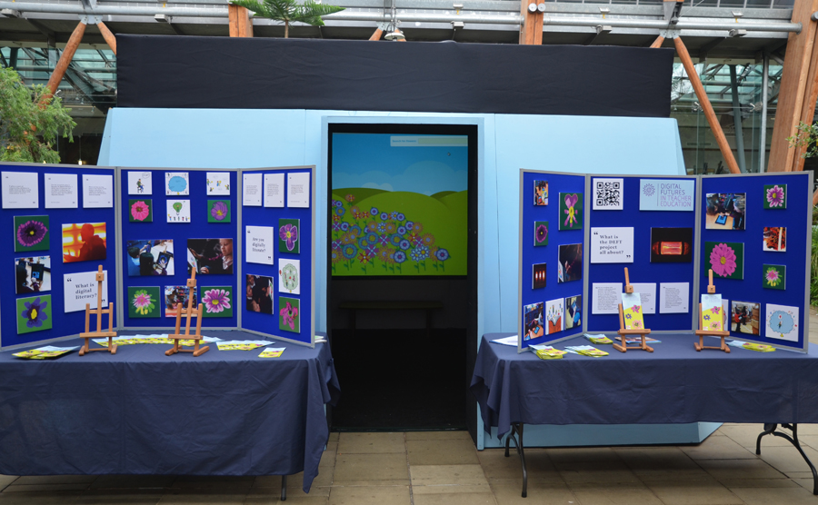

Figure 3: Digital Bloom installation and display in Winter Gardens

A key event taking place during the week was a drop-in workshop on 10 July led by Richard Johnson from Sheffield Children’s Festival during which members of the public could use iPads to use the Brushes app and create their own paintings. Five iPads were placed on the table outside of the pod and members of the public were invited to join and create their own paintings (see figure 4 below). Where permission was granted, the paintings were then uploaded to a dedicated flickr account (available from <http://www.flickr.com/photos/82322448@N02/>).

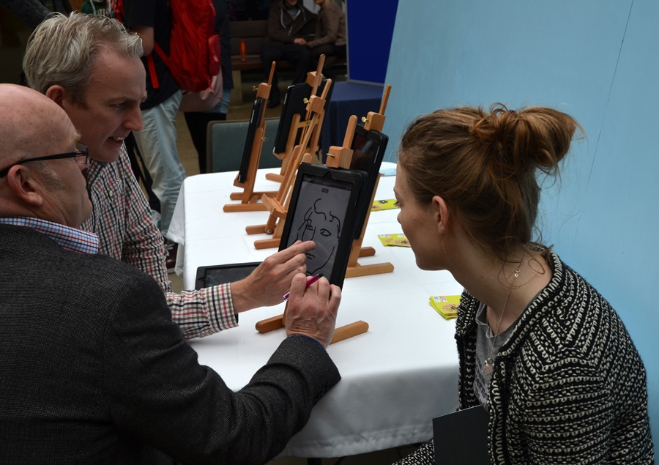

Figure 4: Richard Johnson facilitating a drop-in workshop

Overall, the event attracted four hundred visitors and gave the project a chance to reach out to members of the public who would otherwise probably never consider getting involved with a project focused on digital literacy in the context of teacher education and as one of the students staffing the pod commented:

It's just been a really worthwhile experience; we have had so many people comment on having the pod in a public place, to make people aware of it who might be just passing through. .. We have had people from the council and Children's Services come through, and make connections with the project. Hopefully it will lead to all sorts of possibilities, it’s so important that you have reached out to the public, and given them this opportunity

At its core, the installation reflected the commitment of the project team to values of open access; importantly, the installation itself is customisable and repurposeable and so the concept could be taken up by others wishing to offer dissemination events which maximise creative engagement with the public.

### Digital Bloom online

The concept of sharing accounts and stories surrounding digital literacy became an extended metaphor of the Digital Bloom online, in which the team explored ‘collections’ and assemblages as a means of exploring and provoking meanings to do with technical tools and how we live and learn with them. The second strand of Digital Bloom built on collaboration with realsmart and its aim was to develop an online space where project participants and members of general public could submit their stories exploring their understandings of digital literacies. Users can visit the website [www.digitalbloom.org](http://www.digitalbloom.org) to share a digital story in the form of text, images or rich media which then will be added to the public meadow (see screenshot of the submission form below) and can be viewed by others.

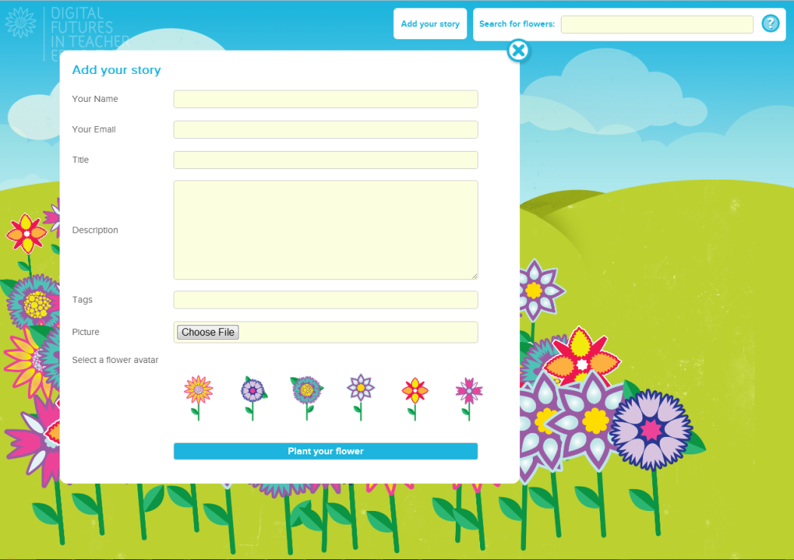

Figure 5: Digital Bloom online submission form

Individuals can also contact the Digital Bloom administrators for permission to create their own meadows; we envisage that school teachers might be interested in using the website to create a meadow collating stories from their pupils to post, share and develop digital meanings. The resource would be of value to community groups; in particular, we are also keen of capturing the stories of young people who have been excluded from the curriculum and focus on digital practices which happen outside of school environment.

## Evaluation activities

### Formative and summative evaluation

Evaluation was on-going throughout the project, with the project evaluator (Dr Julia Gillen from University of Lancaster) combining formative and summative elements. During the lifetime of the project, Julia's role was to act as a critical friend, offering feedback to the team on any issues emerging in the context of the project. Accordingly, Julia attended project team meetings via Skype and offered valuable feedback to the team afterwards on methodological approach and emerging case studies. For instance, she provided very helpful advice with regard to addressing privacy issues in the context of the case studies. Importantly, the formative element offered the team a chance to implement the evaluator’s suggestions within the lifetime of the project. At the end of the project, Julia also produced a summative report (see appendix F) assessing the progress and success of the projects against their aims and objectives as well as the achievement of anticipated outcomes as outlined in the project plan. The report was underpinned by the UKOER evaluation and synthesis framework and drew on an overview of project documentation (project wiki, blog and website), a focus group with the teachers involved in the project and e-mail consultations with project team.

### Peer evaluation

The team also benefitted from the support of Evaluation and Synthesis team who facilitated peer evaluation based on involvement with the ORBIT (The Open Resource Bank for Interactive Teaching at Cambridge University) project. Through that arrangement, we were able to take advantage of synergies between projects both of which focused on OER issues within the school sector. The teams met in Sheffield on 16 May and also took part in a series of Skype conversations (23 April, 8 and 29 August). These interactions led to numerous collaborative outputs

•A deeper understanding of the synergies between the two projects and exchange of ideas for collaboration beyond the lifetime of the project

•An exchange of ideas for further collaborative development and involvement of DeFT project participants in ORBIT initiatives such as a survey for teachers

• A joint ORBIT-DeFT Kanban (visual process management tool) for sharing evaluation outputs and exchange approaches to evaluation

•The creation of a DeFT “family” page within ORBIT wiki listing all DeFT case studies (see http://orbit.educ.cam.ac.uk/wiki/DEFT). The ORBIT team have re-purposed the DeFT case studies into interactive lesson plans. On top of being an excellent example of content reuse, sharing the case studies via ORBIT wiki increases exposure and aids dissemination efforts.

## Stakeholder engagement

Examples of stakeholder engagement are provided below:

* In the process of developing case studies, teachers in participating schools involved learners and support personnel (predominantly media technicians and teaching assistants).
* Each of the schools organised a dissemination event (for more information see appendix E) which offered opportunities for reaching out to parents and staff members within the participating schools
* Across the case studies, it is possible to see ways in which the pupils engage with parents and the community using digital technologies. For example, the children at Mundella Primary School produced innovative artwork using iPads. Following this, the teacher, Kate Cosgrove, organised a number of open days during which the children taught their parents, grandparents and siblings how to use the iPads.
* The project blog was a powerful tool for engaging with stakeholders with an interest in teacher education and digital literacy, with almost 6,000 overall views.
* A number of teachers incorporated involvement with local community sector in their case studies; this will be discussed in more detail in section outlining immediate impact of the project
* As part of project dissemination strategy, the team was actively involved with Collaboration Sheffield (partnership between University of Sheffield and Sheffield Hallam University), thus tapping into well-established regional education sector networks
* Thanks to the Digital Bloom event, the team reached out to over 400 members of general public who visited the installation; furthermore, as the event was part of Sheffield Children's Festival (attracting an audience of over 30,000), information about the installation and the DeFT project was disseminated through festival materials. This interaction with the public was be captured in a mini-case study report (available from project website) outlining what people said about the project and their own stories about digital literacy

## Dissemination: Regional conference, 2nd October 2012

The dissemination conference took place on 2nd October 2012 in Sheffield (Sheffield United Football Ground Stadium) and was organised in collaboration with Yorkshire and Humber Grid for Learning who offered support with the logistics of the event. Over 80 participants from the Yorkshire and Humber region gathered together to engage with ideas, discuss, share and to provoke new understandings of each other's digital practice. The delegates comprised school teachers, representatives of Local Authorities and City Learning Centres, PGCE tutors and students from both Sheffield Universities and education developers from local private and public sector.

The programme included keynote talks from Doug Belshaw I(Mozilla Foundation) and Bob Harrison (Support for Education and Training) on the key themes of openness, digital literacy and professional development, teachers' and PGCE tutors' work and account of classroom practice in the form of case studies and an opportunity for participants to explore resources produced by the project, including the website and beta version of Digital Bloom Online.

In terms of feedback obtained through an evaluation questionnaire, the majority of participants thought that the event as a whole, including planning, delivery and relevance of the content, was excellent; as evidenced by comments below:

* Better than I expected
* A very valuable experience overall….introduced to many new ideas and issues to think about, which I plan to share with my fellow PGCE primary students
* Excellent opportunity to learn from others and contribute to that learning ... privilege to meet so many creative and daring people who are making a difference
* Events like this help to provide the most valuable CPD - learning from each other, sharing innovative work, how social media is a forum for sharing

In particular, the input from the teachers and tutors was rated very highly, as can be gleaned from comments below:

* Very thought provoking; positive promotion of using digital technology in the classroom by inspirational teachers
* Constant frustrations with tech. but seen huge passion and enthusiasm with great examples of innovation in learning and teaching
* Great to get EYFS [Early Years Foundation Stage], primary and secondary perspectives in the mobile technologies

The consistent effort of the project team to maintain a strong Web2.0 presence yielded particularly positive results during the event when participants contributed to the conference back-channel with over 70 Tweets posted with the #deft1 hashtag (a recording of this was captured on storify and can be accessed from http://storify.com/deftoer3/deft-conference) which enriched the discussions taking place on the day. The Twitter backchannel attracted a number of new readers to the project blog, where the posts capturing the conference attracted almost 800 views after the conference (add links). Finally, both the programme and individual presentations can be accessed from slideshare (available from <http://www.slideshare.net/DEFToer3/tag/deft_conference>; see also table of project outputs).

# Project findings and lessons learnt

Overall, in the context of the project, the team have gained access to rich accounts of pedagogical practice with digital literacies in schools as well as a deeper insight into OER-related issues within that context. Our work with teachers brings into sharp focus issues which may not have been as prominent in the HEI context but are of key relevance to the school context, such as for instance issues related to e-safety, e-security; the ethical and pedagogical aspects of student-produced resources as well as a number of technological barriers in terms of access to web-based resources.

## Issues related to digital literacy

In the context of the project, the emphasis was on digital literacy understood as a practice which exists ‘in the relations between people, within groups and communities, rather than as a set of properties residing in individuals’, where the focus is on ‘what people do with literacy’ (Barton and Hamilton 1998, 7–8). This approach seems to be more empowering for the teachers when compared with conceptualisations of digital literacy which focus solely on technical competency and often leave teachers feeling inadequate in comparison with their pupils, as evidenced by the following two quotes.

*In terms of understandings of digital literacy which underpin my work, I believe that being digitally literate and proficient at communicating in digital spaces enables participants to think and collaborate more effectively, reflectively and creatively; this in turn enhances the sharing of good practice, develops a greater understanding of its value, and consequently enables teachers to gain a greater understanding of the processes involved in new literacies, thus positioning teachers as learners. Furthermore, communicating and engaging in digital practices encourages different ways of thinking and makes new, and potentially powerful, dialogues possible (quote from teacher participating in the project).*

*Digital literary in my classroom looked like children who were competent and confident to access and use a range of technology in order to communicate with peers, teachers and a wider global audience through blogging. I felt that we as a class were forging a path of modelling high end technology, in a world which was restricted by the high costs of hardware, making the most of what we had (quote from teacher participating in the project).*

When reflecting on their involvement with the DeFT project, the teachers acknowledged that the projects took up a lot of classroom time, did not always map neatly onto the prescribed curriculum areas and at times were quite disruptive to existing classroom practices. Teachers also mentioned that sometimes they would have to fight for recognition of their time as meaningful in terms of curriculum as projects focusing on digital literacy would not be given the same priority as more traditional projects leading to print-based, more tangible outputs. They argued it was often difficult to justify taking up two to three weeks of pupils' time where the end result would seem disproportionate to the time and effort invested in producing for instance a one-minute video. While the teachers involved with the project were experienced professionals and did not seem daunted by these challenges, they nevertheless have to be acknowledged.

Overall, the case studies illustrate both exciting possibilities and on-going problems associated with digital literacy in school settings. The curriculum in UK schools is characterised by an emphasis on coverage of content coupled with the strong arm of accountability, with an emphasis on print literacy within the curriculum. One of the effects of this is a reduced opportunity to embed digital literacy practices or to accommodate them within the on-going routines of the classroom. At the same time, in a relatively short length of time, ways of thinking about digital technologies in schools seem to have shifted in the UK and during the lifetime of the project, there has been a significant recent change at the school level in the emphasis given to digital literacy in the context of the ICT curriculum.

## Issues related to Open Educational Resources

### Issues related to re-use of OERs

Overall, responses from project participants indicated high levels of re-use, especially with regard to online teaching materials from teaching resource banks such as TeachFind and Teachernet; at the same time, only a small minority indicated any familiarity with the concept of Open Educational Resources. A number of participants mentioned their frustration with the teaching resource banks arguing that resources were often not described in a way that met their needs - for instance, they mentioned they would like to be able to search for resources in a specific curriculum area. They also mentioned they would like to be able to filter the search results according to assessment objectives, levels (i.e. primary/secondary) and provenance (UK vs non-UK); they also wanted to have an indication of whether the resource was visual/auditory/kinaesthetic so that they could best adapt it to their teaching needs. Given that lack of description is one of the key barriers to reuse of Open Educational Resources (Conole and Adams, 2010), these issues should be addressed as a matter of priority to improve the uptake of OERs within the school sector.

### Issues related to sharing of resources

One of the aims of the project was to collect evidence on barriers and enablers to embedding OERs within the school sector and so this section draws on material from teachers' and PGCE students reflections on the topic collected throughout school visits, focus groups (with PGCE students) and reflexive activities. Overall, their responses described to a widespread culture of sharing, especially within the immediate network of peers:

*I have shared my resources with my course mates in a Facebook group. I have also shared them with the department at my placement school. I did this because I use others' resources so I think it is fair to share myself (quote from a focus group with PGCE students).*

*I think sharing good practice is a good part of developing professionally and using tried and tested resources- adapting them, differentiating them, reinventing them - saves time and often improves the quality of learning for students when I have run out of creative ideas! (quote from a focus group with PGCE students).*

*I have contributed resources a couple of times…to TES because it is sharing with other teachers. That is something I would like to do more of. It is such a big help, not having to reinvent the wheel (quote from a teacher involved with the project).*

Thus sharing was seen as an essential element of professional identity (as one of the respondents indicated, "you are sharing with kids anyway all the time) and a crucial part of continuous professional development - an impulse to enhance/improve good teaching. At the same time, while both teachers and PGCE students were happy to share resources within their immediate network (i.e. peers on the course; teachers on placements), they had a number of reservations when it came to releasing their resources openly online and sharing them with a potentially unknown audience:

*I am always willing to share my resources with other members of staff in school and have done this on a regular basis at my current placement. I have shied away from sharing materials online contexts, however, as I always feel a little protective of the things I produce because I invest a lot of time in making resources, and don’t feel entirely comfortable at present to make it freely available for anyone to download. I like knowing who is using it! (quote from a focus group with PGCE students).*

Others mentioned that if the resource they released attracted negative comments they would feel judged and hurt by criticism; argued that in the context of sharing with an unknown audience criticism was more likely as people would be unfamiliar with the context of the resource. Others mentioned concerns about the time investment needed to upload resources online. A small minority were also concerned about pedagogical issues and the potential risk of stifling creativity through excessive reliance on resources "off the shelf":

*While I think this is a good idea in some respects, such as sharing outstanding practice, taking the pressure off teachers' time (planning and so forth) it may have the less positive effects of stifling creativity and causing teachers to put less effort into preparing lessons for the specific classes they teach, instead just teaching another person's lesson wholesale (quote from a focus group with PGCE students).*

### Copyright concerns

Other disincentives for sharing were related to copyright, with some project participants openly admitting that they wanted to "avoid the hassle of figuring out copyright stuff" and assumed that sharing within the network of their peers bypassed the need to address these issues. Some believed that copyright was irrelevant if resources were shared for educational purposes and reasoned that "nobody would bring it up… they are not going to go back to someone". Others went as far as to argue that if resources are available online then by default they can be reused without regard for copyright as evidenced in the following quote:

*That’s the one thing that I have not really thought about, I mean the images that I use, I think if they are freely available to get on line, and if you can to listen to it on line - that might sound really bad, but that's my impression, then surely they are free to use (quote from a focus group with PGCE students).*

The above exchange illustrates a number of misconceptions related to copyright and sharing open resources - such as for instance that copyright is irrelevant if resources are intended for private and/or educational use. These misconceptions need to be addressed so that teachers can model good practice and take full advantage of benefits offered by Open Educational Resources.

### OERs and professional practice

One of the key motifs for engagement with OERs was to support professional practice. This is probably best exemplified by the case study undertaken at Wales High School, where Michael Payton-Greene created a school blog whose aim was to encourage the open sharing of resources and enhanced reflection on pedagogic practice:

This blog is an online space designed to at Wales High School.  The space will enable participants to access a range of discussions focussed on a variety of teaching and learning strategies, lesson ideas and pedagogic approaches.  Participants can consider, trial, disseminate and then reflect upon any resources or ideas they find on the site and then reflect on how their practice, but more importantly students’ learning, has been enhanced.[4]

This way, Open Educational Resources functioned as a tool to improve communication between and within departments, share best practices and support professional development. The teachers who contributed to the blog were quite enthusiastic about its potential:

*there is lots of potential there that I know I could use… so I am determined to get myself much more proficient with technology.(…) I am very much looking forward to sharing things on the blog. Within this department we do share resources, but I think we might be missing out on good practice in other parts of the school… there is scope to share things wider throughout the school, country wide…*

Importantly, the blog offered a space for sharing accounts of both best practice and exemplary resources as well as authentic practice where teachers could acknowledge some of the challenges of embracing more innovative ways of working with the pupils; for instance, one of the teachers commenting on the use of mobile devices within PE classes mentioned problems with pupils using mobile devices to access Facebook instead of concentrating on the task at hand. At the same time, the Wales case study pointed to some tensions inherent in open practices as evidenced by conversation with a representative of senior management at the school:

*Anna: How do you feel about the open nature of the blog?*

*Andrew: There is an issue here about professional dialogue, and where professional dialogue becomes personal dialogue, and how open that is - particularly when you have a parent or a student audience, how that works in terms of -- do you limit the professional dialogue that is taking place because people become aware of the public nature of what they are doing? There is a tension there, and managing that tension is important. Quite how we are going to do that I don’t know this is something that we are trying to work out. It’s a trial, because everything is new to us, as education, institutions, you can't avoid the use of technology as a medium. We've got to manage it effectively so that it works for us.*

At the same time, it has to be noted that Andrew was very supportive of Michael's involvement with the project and was keen for the blog to continue into the new school year. This comment also expresses some concerns about revealing accounts of "unpolished" practice and even worse, incompetence with regard to technology. One of the key themes emerging from our conversations with the teachers was that a lot of them argued that their students were much more digitally competent than themselves and that accordingly, they (i.e. the teachers) needed to work really hard to be able to keep up with their students - to be able to respond to the knowledge and skills that the students were bringing into the classroom. In terms of professional development, a number of project participants expressed their concerns about being able to keep up with the rapid changes in technology to keep their teaching interesting - The open textbook has the potential to signpost teachers to ways in which they could enhance their practice and so OERs could be helpful in terms of helping them 'catch up'.

While most teachers argued they preferred accounts of pedagogical practice that were imperfect but which showcased challenges and problems encountered by other practitioners, they also were very reluctant to produce accounts which revealed their own struggles with technology that could potentially put their professional skills in a poor light. Similarly, as pointed out earlier, the PGCE students were keen to stress that they saw the process of sharing resources as an essential requirement of their chosen profession. On the other hand, when contemplating the possibility of releasing their own resources online so that they could be shared openly with others, the students said they would be very careful and would only consider sharing materials that were of sufficiently high quality. For instance, a number of students were quite adamant they would not want to share their lesson plans so as not to reveal that they ‘had no clue what they were doing’. Arguably, the tension between the wish to showcase ‘polished performance’ and the need to engage with accounts of ‘real-life’ practice has implications for sharing resources and their open release.

### Exploring the use of open source tools

A number of the case studies explored the affordances of open tools. Perhaps the most prominent e is that of Peter Winter at Monteney Primary School whose case study introduced a set of activities linked by the theme of "Monsters at Monteney" and aimed to develop children’s abilities to use a range of open source online tools for digital arts, storytelling and poetry. Peter was very clear that he wanted to develop a set of resources that would enable children to undertake a series of activities independently and which they could access both from home and school. He felt that it was important that these resources should be open source and able to access across any platform:

*I really wanted this project to be about accessibility. Not just for the pupils. But for any teachers or parents who wish to try out some of the activities with their children. Too often the opportunity to try out new and exciting learning opportunities can be stymied by a reliance on one particular operating system, a piece of kit they do not possess (or cannot afford) or a level of technical expertise Mr Zuckerberg would quake at.*

Accordingly, the tools he used for the case studies activities were as follows:

* ‘Scratch’ ([http://scratch.mit.edu](http://scratch.mit.edu/)) as a simple programming tool
* ‘Screenr’ (<http://www.screenr.com/> ) to create screencasts
* ‘Spore’ game (<http://eu.spore.com/home.cfm> ) for creating ecosystems
* ‘Fotobabble’ presentation tool (<http://www.fotobabble.com/>) which allows to add users a commentary to photographs/video
* ‘Aviary’s suite (<http://advanced.aviary.com/tools/music-creator>) for editing rich media; including a music creator
* ‘Voki’ tool (<http://www.voki.com/>) for creating customised avatars
* ‘Sumo Paint’ (<http://www.sumopaint.com/app/>) and ‘Pixlr’ (<http://pixlr.com/>) online image editors
* ‘Linio’ annotating tool (<http://en.linoit.com/>) for creating "sticky notes"

The case study illustrates further benefits of open approaches to teaching practice - using open source tools meant that pupils could continue working on project tasks outside of the school environment and continue their learning.[5] Similarly, the open nature of the tools and resources would allow teachers to undertake tasks across the curriculum without being restricted by cost of software licences or specialised equipment.

At the same time, both teachers and PGCE students mentioned numerous barriers they experienced in the school setting in terms of their access to equipment and software as well as Web2.0 applications. A number of teachers commented on very strong filters on social networking services in schools which they felt limited their options in terms of offering their pupils a more interactive learning experience. Here a preoccupation with e-safety has led to top-down mechanisms involving firewalls and content filters that compromise the autonomy and creativity as well as professional integrity of the teachers. These barriers also have a negative impact on embracing of open practices within their teaching. For instance, most teachers were keen to explore the potential of open tools both for the purposes of the case studies and their teaching more in general and accordingly, the case studies incorporate the use of Wordpress platform; free mobile apps and open source tools for programming. While these tools are open in principle, it did not mean that they could be used openly within the school - for instance, one of the teachers mentioned that it was possible to use the Wordpress platform on school computers, however some plug-ins would be blocked by the school software and so elements of the blogging platform were inaccessible in the classroom. [the use of mobile devices – schools blocked access to internet and had to use mifis

### Learner-produced OERs

The project has raised a number of both logistic and ethical issues involved when it comes to pupil involvement with OERs; for instance, issues of copyright become even more complex in the school context where issues related to e-safety and e-safeguarding are of key importance and parent permission has to be secured.

Furthermore, the open release of resources produced by learners involves securing permission from parents/guardians who may have little understanding of issues involved in open licensing and sharing of online teaching materials; this may raise complex ethical issues. The issue of attribution can be problematic with regard to learner-produced work - as a safety precaution, school pupils are cautioned not to release personal details online. These concerns surfaced during the discussions taking place at the teachers' meetings, with teachers pointing out that each of them has to make their own ethical and moral judgements on how open their practice could/should be as there is no official guidance on these issues because they are so new to this sector. The following quote illustrates the range of issues that had to be considered by project participants:

*I guess what I am saying is once you put an image or a voice or something out there when its in a public space, now it might be private, in the future that might be open to manipulation , and those images and things can be used in a way that can be manipulated*

Overall, the teachers decided to be pragmatic in their approach and to recognise that it was impossible to "futureproof" their own or their learners' contributions to the project. Decisions were taken on a case-by-case basis and where images or recordings of pupils are being used, permission has been explicitly granted. Wherever possible, the project team talked to the pupils in the schools explaining the purpose of the case studies; in a number of schools, the teachers have organised dissemination events in the form of open evenings for parents/carers to create space for discussing potential concerns as and when they arose.

## Immediate Impact

A number of the case studies incorporated elements of collaboration between the schools and the local community organisations, highlighting the potential of OERs and open practices for the public sector. For instance, two of the case studies - at Halfway Junior School and Winterhill High School explored the use of QR (Quick Response) codes to enhance digital literacy skills of pupils. The Halfway case study was based around a treasure hunt where the children used mobile devices to find QR codes in Heathlands Park, and follow clues to find a story. The pupils at Winterhill created open resources to accompany exhibits in the Fire Pavilion at Magna Science Adventure Centre; the visitors will be able to access the resources via QR codes attached next to exhibits. Through these collaborations, the schools cascaded and modelled open practices, and also created a more long-term foundation for future involvement - in both cases, the collaborative work will continue beyond the lifetime of the project as Magna are planning to roll out the use of QR codes across all of the pavilions and Friends of Heathlands park are planning to display QR codes throughout the park to help visitors learn more about the venue. The Chair of the 'Friends of Heathlands Community Park' commented that "We would never have thought of it if Rob had not introduced us to the concept [of QR codes]". Another spin-off from the case study is that the organisation would like to become further involved with the school in terms of planning future joint activities in the park.

The work undertaken within the schools also seems to have a positive impact on parents - the feedback from dissemination events held at participating schools indicated that parents expressed an interest in learning more about digital technologies and ways in which these could support both their children's learning but also their professional and personal life.

#### What kind of difference has your project made in your institution?

Throughout the lifetime of the project, we offered advice to colleagues interested in developing their own OER-based projects or looking at embedding OERs within existing projects. For instance, we provided guidance to a colleague who was working a project whose aim was to develop a portal pulling together resources to support student skills and signposted her to existing OERs in that area.

The resources produced for the Post Graduate Certificate in Learning and Teaching in Higher Education include a set of OERS mapped to the UK Professional Standards Framework. These have been incorporated in a sister project Digital Literacy and Creativity for university teachers undertaken at University of Bedfordshire whose aim was to design a module for teachers in HE addressing digital literacy. Elements of this have been incorporated in the PGCertHE at the lead institution, Sheffield Hallam University and dissemination of approaches to OER have resulted in the identification of OER as a focus for a funded pilot for OERs in the curriculum within the faculty of Development and Society.

#### Impact on practice of teachers involved with the project

Further quotes illustrating impact on teachers' practice will be added once the teachers offer their final reflections. The quotes below represent the impact participation in the project had on teachers' individual practice:

*The DeFT project has given me the opportunity to develop skills in ICT.  I have been able to get help and suggestions for embedding my ideas into my practice by asking questions of peers who are doing similar work.  It has been so valuable to be able to be part of a network of like-minded practitioners and for us to learn together.  Access to the project partners (in my case Richard Johnson from the Sheffield Children's Festival) has also enabled me to put ideas into school which we may not have been able to afford to do on our own.  It was the coming together of all stakeholders that allowed the work to be so successful.*

*There has definitely been impact on my teaching practice due to the project. I am currently doing a Masters in education and because of this project I chose to do my current module enhancing learning and teaching across educational contexts based around use of digital technologies in the early years and whether they can help extend speaking and listening. I was able to implement the use of iPads and digital cameras within nursery and saw the benefits of these on the children's learning and created a blog that works in partnership with parents. I found the children were highly motivated and engaged when using these technologies as were other practitioners within our setting. […] as a result of this fantastic project we will be purchasing iPads and digital cameras for the children to use. We hope the use of these can soon be embedded within our practice.*

*Participation in the project has made me increasingly aware of the importance of developing students' and teachers' digital literacy, but probably more significantly, the responsibility educators have to enhance students' digital literacy skills and to encourage responsible digital citizenship. It also have given me the opportunity to work with a range wide of colleagues, both in and out of school, and enabled me to have a reflective and professional dialogue that I would not ordinarily have had. The opportunity to use a range of resources and participate in various INSET and teaching & learning conversations has also encouraged me to think more carefully about learning processes and thus had an impact on my teaching.*

*My headteacher saw the value of our use of iPads from the project and has recently allocated resources to buy a set of 10 iPads. New technologies have been written into the school improvement plan. So through performance management it's expected that all teachers and students engage in use of new technologies including iPads, Twitter, blogs, CLC, netbooks, actibooks, visualisers and various other things. We're just a little primary school in Sheffield and we're engaging quite heavily in new technology and new teaching opportunities thought through at a reflective academic level. Our headteacher sees us as digital leaders, experts in this field. The findings from the MA enquiry I'm now going to undertake will be disseminated into the school population. We have got our own sustainability from the initial project that we were given but all this came from the project. There is no other way we could have done that - if we hadn't been given 3 days of [Project leader's] time and loaned 12 iPads from the CLC and Sheffield Hallam we wouldn't have been able to move in this direction. The project has had an impact and the impact will be ongoing and changing as well.*

## Future Impact

The following steps will ensure the sustainability of the project past the end of October 2012:

* All web-based project outputs will remain openly available from project website as well as project wiki, blog and Slideshare account
* Some teachers have indicated that they have support from senior management to engage in projects building on their involvement with DeFT - for instance, Michael Payton-Greene in Wales High School will be rolling out the OER-based blog across the school from September onwards; Rob Hobson at Halfway Junior School is planning to undertake QR-based treasure hunts with pupils in the new school year and Jim Hildyard from Winterhill High School will continue collaboration with Magna to produce further resources for the centre.
* The online version of Digital Bloom was released at the beginning of October and will remain open so that teachers and learners can share their stories and understandings of digital literacy. We will monitor the website and use Sheffield Hallam University networks to encourage schools and youth groups to populate the platform with content and use it to support their work in both formal and informal contexts
* We will pilot resources developed in the context of the project through our involvement with HEA-OER internationalisation project (taking place between September 2012-January 2013) where we are working with partners from Poland (University of Science and Technology in Krakow); Hungary (Central European University, Budapest) and Belgium (KHLim) to explore issues related to OER re-use and repurposing across a number of disciplines and where the open textbook will be the key resource being re-used and re-purposed
* Richard Pountney and Anna Gruszczynska will deliver a workshop sharing project findings at the University of Science and Technology (Poland, Krakow) on 24 October 2012 as part of Open Access Week and present a paper at the 11th European E-learning conference (ECEL)
* Project team are planning to produce a series of publications emerging from the project

### Future impact within the institutions

* We will organise meetings with senior management at SHU (heads of Learning, Teaching and Assessment and Deans of Faculties) to brief them on issues emerging from the project and benefits of embedding OERs at institutional level
* We will explore the possibility of embedding resources created within the project as part of PGCE curriculum at participating universities
* The Faculty of Development and Society at Sheffield Hallam University has made a commitment to support an institutional OER project as part of its Learning, Teaching and Assessment strategy
* We will continue our involvement with Collaboration Sheffield (partnership between University of Sheffield and Sheffield Hallam University) and contribute to the digital literacy event planned on 23rd November , where we will report project outcomes and two teachers from the project (Kate Cosgrove from Mundella Primary School and Jack Todhunter from Newman Special School) will reflect on their involvement with the project
* The University of Sheffield project team members are planning a staff research seminar due to take place on 23rd October as part of the School of Education Research Committee, with Jackie Marsh, Julia Davies and Mick Connell presenting

# Conclusions

## General conclusions

The "Digital Futures in Teacher Education" project has been underpinned by three key elements: engagement with Open Educational Resources; digital literacy; and a reflexive approach to pedagogy, with these key elements linked through a participative approach to professional development.

Importantly, the project has offered an insight into issues related to sharing of teaching materials online and embedding Open Educational Resources within the school sector, these are as follows:

* The school context presents unique challenges when it comes to learner-produced resources, these include issues around e-safety and e-security, as well as ownership of resources and the need to consider permissions from parents/guardians for the open release of resources.
* While few educators are aware of the concept of OERs, they are very keen to re-use materials from sources such online teaching resource banks and accordingly, websites such as Times Education Supplement or teachernet would be best placed to raise awareness about OERs and model best practices with regard to copyright and IPR

## Conclusions relevant to the wider community

The project case studies have demonstrated examples of successful engagement with the public sector and community organisations. In particular, collaboration with Sheffield Children's Festival which led to the development of the Digital Bloom installation was a very successful example of public engagement where the project team reached out to over 400 members of general public who would not otherwise be interested in finding out about issues raised by the project. We believe it would be useful to continue exploring the intersections between creativity and digital literacy/openness.

## Conclusions relevant to the HEA/JISC

The key rationale for engaging with OERs for the teachers involved with the DeFT project was to support professional development and sharing of good practice both within the school and across the region. Both teachers and PGCE students argued the existence of a widespread culture of sharing and re-use of teaching materials, whether informally with colleagues or via websites such as <http://www.teachernet.gov.uk/> or <http://www.tes.co.uk/teaching-resources/>; the Times Education Supplement resource bank. They also emphasised that sharing was an essential part of their professional identity; at the same time, they seemed to be quite reluctant to contemplate the possibility of releasing their own resources, for fear of having their practice judged as not being “polished enough”; moreover, only a small minority were familiar with the term Open Educational Resources.

# Recommendations

## General recommendations

* In the context of the school sector, it is probably more helpful to focus on open practices rather than solely OERs to acknowledge the involvement of teachers with practices of sharing resources, willingness to incorporate open source tools in their teaching practice etc. At the same time, a number of the case studies also show barriers to greater uptake of open practices and especially open source tools because of restrictions put in place within school IT networks
* The findings of the project indicate the need to acknowledge issues related to Open Educational Resources/practices within the PGCE curriculum; OERs could also be particularly useful to support professional development of PGCE students and NQTs (Newly Qualified Teachers)
* The message about the value of OERs needs to be considered in the context of schools at a time when the curriculum is being examined, when affective responses such as fears over job losses in a recession etc. can influence responses to notions of resource-based learning

## Recommendations for the wider community

* Any efforts to raise awareness with regard to OERs and/or to enhance their uptake within the school and teacher education sector should acknowledge the already existing culture of sharing and the preference for educators to share resources within their immediate peer network. On a related note, there is a need to acknowledge the efforts of teachers and PGCE students who choose to invest their time to contribute to resource banks and/or share resources within the school or in the context of placement.
* in the UK as elsewhere there is a diversity of models of teacher preparation, including university-school partnerships and programmes that are entirely school based. This means that trainee teachers, or for that matter early career teachers, are likely to need access to support materials at different stages in their preparation for teaching and at a variety of points during their academic or professional study. The flexibility offered by OERS fits well with the diversity of provision.
* The field of digital literacy itself is characterised by its fluidity as new devices become available and new programmes and applications are being developed. The rapid changes in the curriculum structures of compulsory schooling promote this sense of fluidity, and the adaptability and reusability of OERS is well-suited to this catalyst.

## Recommendations for the HEA/JISC

* It is crucial to raise awareness of trainee teachers and their educators about Open Educational Resources to dispel some of the misconceptions but also demonstrate how resources could be shared to maximise benefit to creators. For instance, by releasing teaching resources into a well-respected educational repository, teachers could receive professional recognition from a wider community of practice and useful feedback which could in turn improve their practice. By licensing the materials with an appropriate Creative Commons license, they would remain in control of how the resources are (re)used and repurposed; and they could also collect information from the repository about the number of views and downloads.
* A related issue which needs to be addressed is that of sharing and re-use of online resources from repositories such as Times Education Supplement (available from http://www.tes.co.uk/teaching-resources/) or TeachFind (<http://www.teachfind.com/>). These are very popular with the teachers, at the same time, the copyright status of teaching materials found on these websites is not always clear-cut. While the resources offered are described as free for teachers to use, they are not licensed with a Creative Commons license (or equivalent) which would clearly indicate on what basis the resource should be shared, attributed and re-used.
* The project offers models of engagement with and embedding of OERs in a way which is replicable and scalable as well as models of engaging teachers in reflection on issues related to OERs and openness. Materials developed in the context of the project such as reflexive activities[6] could be easily modified and used to provide teaching professionals with an opportunity to share their perspectives on open sharing of teaching materials.

# Implications for the future

We will openly release project documentation via the project wiki (except where doing so might be problematic in terms of ethics/confidentiality), including technical specifications. These are CC-licensed and so others will be able to build on the design of the open textbook and re-use not only the content but also technical aspects to adapt them to their own needs.

* We are aware of our obligation to maintain the resources for three years past the end of project
* We have created a project account deft@shu.ac.uk where users will be able to address any project-related queries, feedback etc., the account will continue to be monitored for at least 12 months past the end of the project
* We have made provisions to maintain Digital Bloom online for 12 months past the end of the project

# Appendices

* Appendix A: List of teachers involved with the project
* Appendix B: Mapping of project case studies
* Appendix C: Technical specification for open textbook [update]
* Appendix D: Allocation of project resources
* Appendix E: Dissemination events at DeFT schools
* Appendix F: Evaluation report
* Appendix G: Budget (19 Oct 2012)

1. Prompts can be accessed from slideshare - see <http://www.slideshare.net/DEFToer3/digital-futures-in-teacher-education-reflexive-methodology>
2. Concrete5 is a Free and Open Source Content Management System available from www.concrete5.org.
3. See <http://www.slideshare.net/DEFToer3/findings-of-pgce-student-focus-groups-12173561> for a summary of key issues which emerged from the focus groups.
4. For more information, see <http://whsteachingandlearning.wordpress.com/2012/06/01/welcome-to-teaching-and-learning-at-wales/>
5. At the same time, we are aware that access to technology is not always unproblematic for the learners and that it shouldn’t be universally assumed children would universally be able to access free and open resources at home.
6. See <http://www.slideshare.net/DEFToer3/digital-futures-in-teacher-education-reflexive-methodology>